Tree Location Plan (TLP1)

20 Canonbury, Shrewsbury, SY3 7AH.

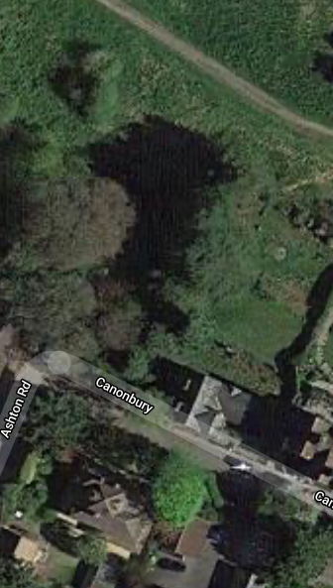

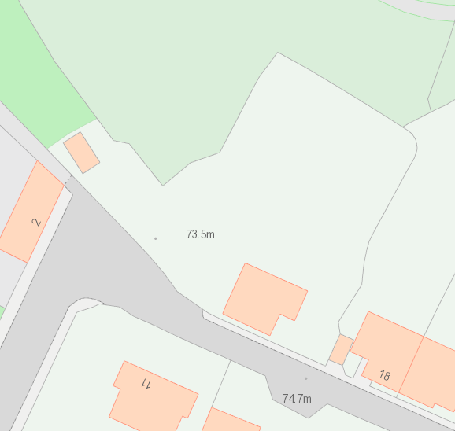
T1
T11
T16
T17
T18
T202
T19
T15
T14
T13
T12
T4
T3
T10
T9
T8
T7
T6
T5
T2

