Design and access statement
New dwelling
74a Roberts Street
Wellingborough
Northamptonshire
Nn8 3hz
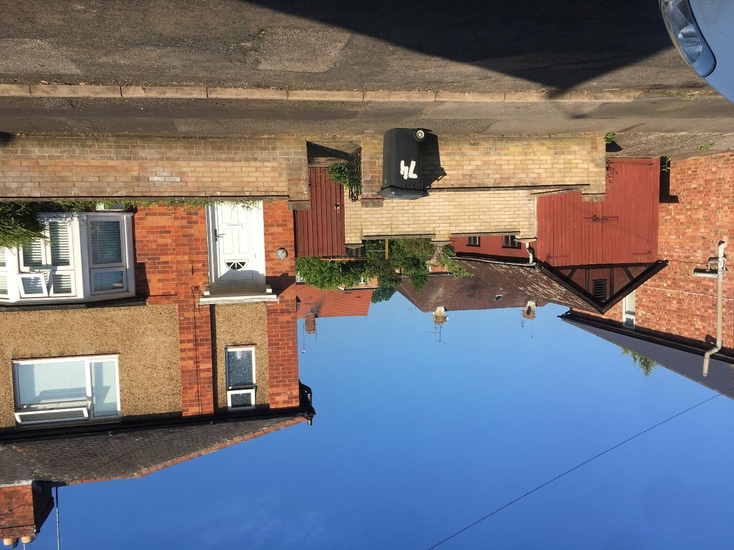
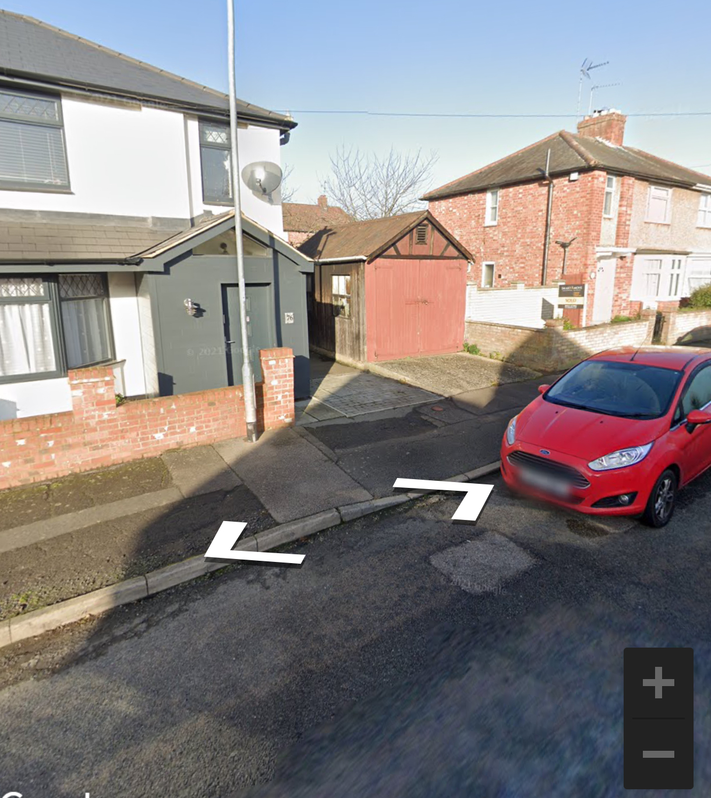

The photos below show the 3 houses opposite the proposed dwelling:
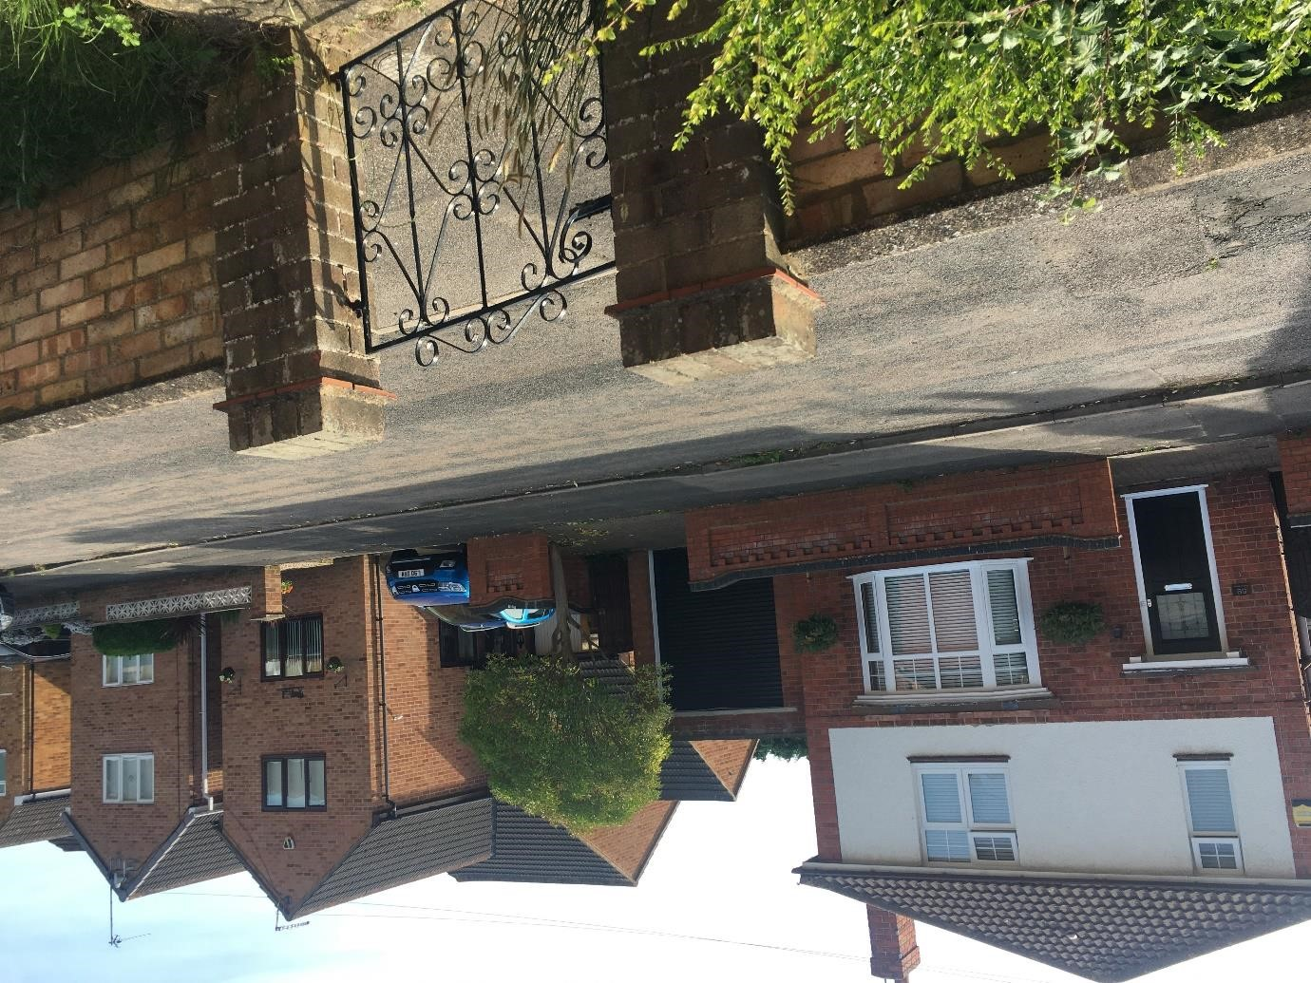
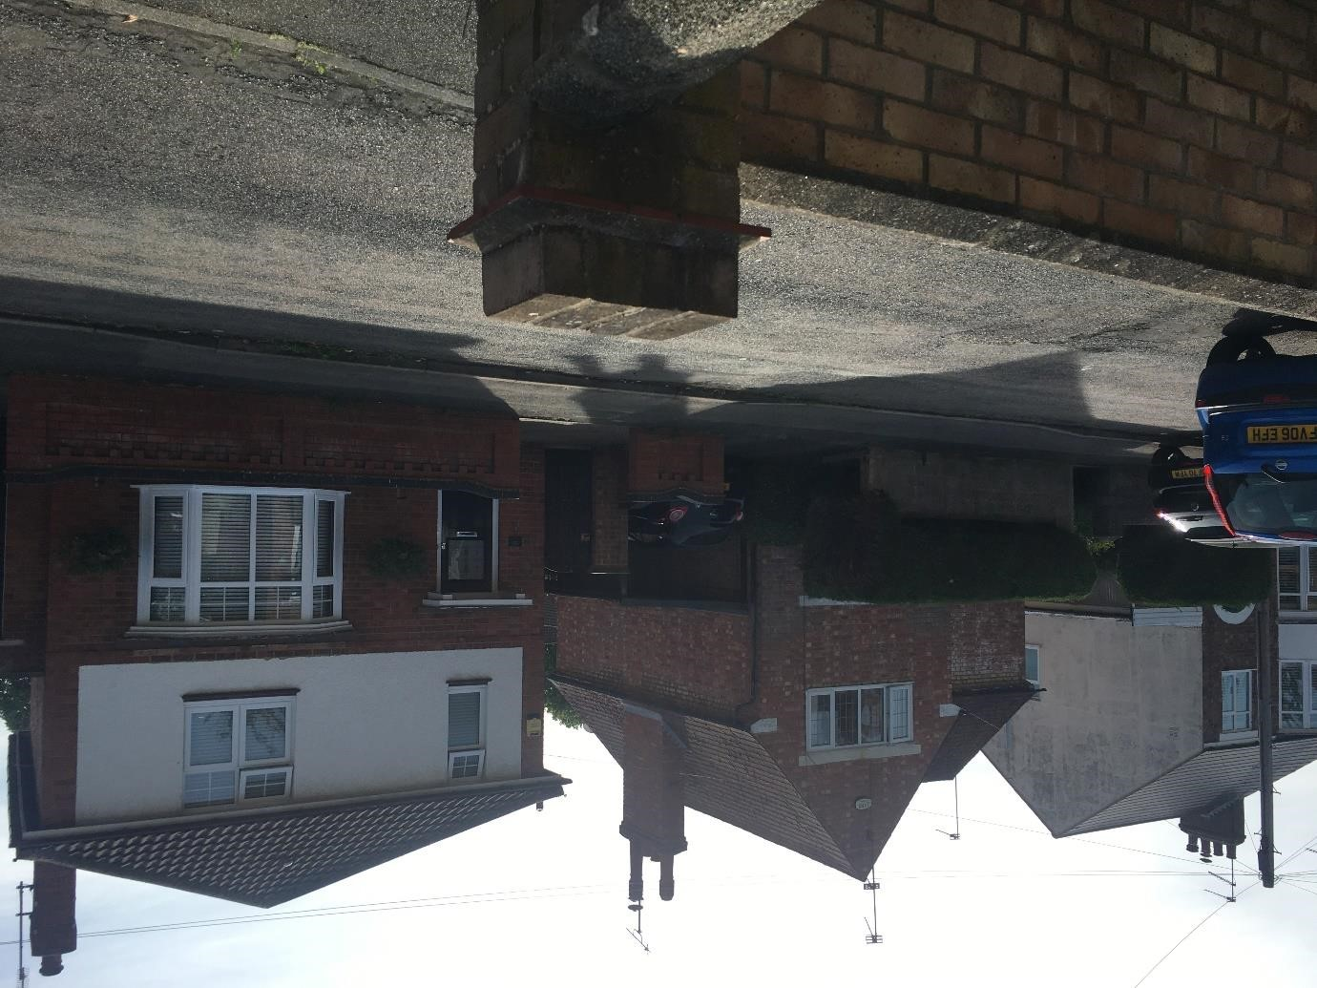

The proposal would see the existing site subdivided and a new 3 bedroom house built. The existing timber garage and potting shed will be demolished to allow for the construction of the new dwelling. The new dwelling would be approximately 14m x 6m wide. These measurements include the front gable projection and the single-storey lean-to. In the last four years, a similar house has been built on the same side of the road on a similar size plot 4 houses away.
The picture below shows 66 Roberts Street nearby :
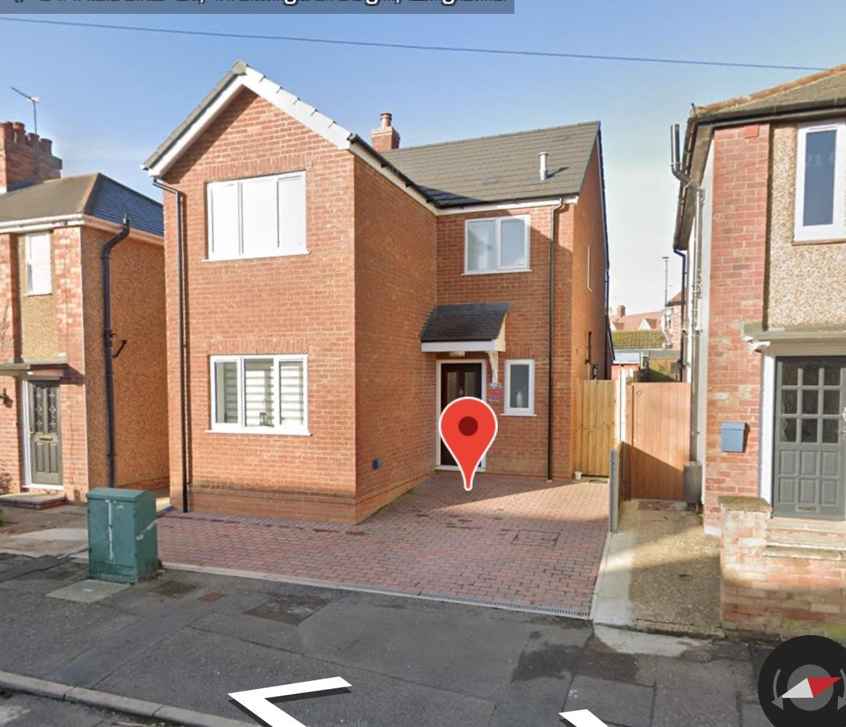

Location
The site is located off Roberts Street, Wellingborough, near the Ashfield Road cross junction. Site edged in red, a new build of similar dimensions edged in yellow.

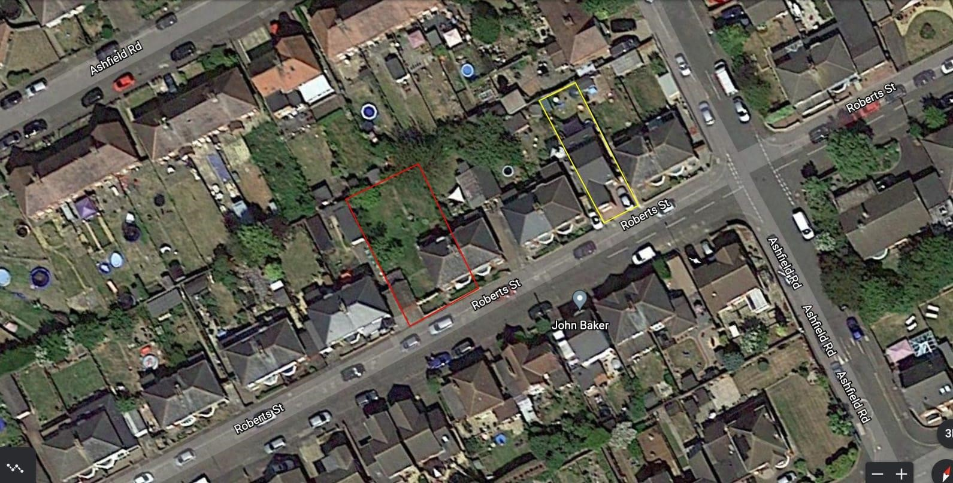

Layout
The existing site is approximately 350m2, including the existing residence. Therefore, we propose an equal split of the site allowing each property to have its own garden access.

Roberts Street housing styles
Roberts Street has a mixture of styles; the existing house on the site has a hipped roof semi-detached pairing with detached houses opposite with various roof designs.
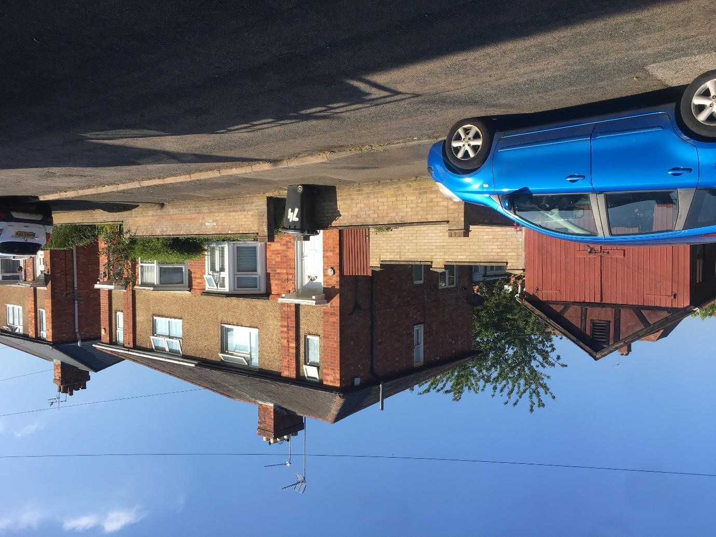

Scale
The eaves and roof height of the proposed dwelling is in line with the current property. The front build line has been followed. The rear of the property is more profound than the neighbouring buildings, the 45 and 60 degree rule has been followed and shown on drawings.

Landscaping
The rear garden will measure approx. 7m wide and 8.5m deep and create 60m2 with a mix of patio and grass, including a shed for bicycle storage. The area at the front of the dwelling will consist of a parking area for 1 car which will be finished in block paving, designed following the highways recommended sizes for parking, access drive and visibility splays.
We will maintain a 1m access to the side of the property to allow easy access to the rear garden. The boundaries to the front of the property will be left open. The boundaries to the side and rear will be constructed in new 1800mm high timber fencing.

Appearance
The original houses along the street are a combination of red brick and course sand colour render, the newer houses down the street are built in buff coloured brickwork.
We propose the new dwelling be constructed red brickwork with black interlocking roof tile and white upvc windows.

Access
The new dwelling would have vehicle access from the front of the site for 1 car parking space which will configure to current regulations.

Flood zone
Roberts street is thought not to be in a flood zone, the proposed dwelling ground floor will be constructed 150mm higher than external ground level.

