Mrs Lorna Slattery
7 Crichtons Way
Armadale, Bathgate
West Lothian

Date: 08/09/2021
Ref: Planning in principle application

The land was previously the old Bridgecastle golf club and parking, housing and permission was granted for this development in 1996 REF: LIVE/0265/P/96, REF: LIVE/0750/FUL/97 and REF: LIVE/0334/FUL/99.
The use of the site has become derelict due the clubhouse being vandalised over time. The site remains an eye sore with overgrown weeds, broken slabs, structural remains and fencing, which has also become a fly tipping area and difficult to maintain, secure and has become environmentally intrusive. (Current Site Images Attached). Therefore, the development will create a significant environmental and visual benefit, as opposed to retaining the site in its current state.
The site is no longer required for its original purpose. The golf course has become overgrown, mole runs, animal damage, and returning it to its original working state, is financially unviable. As such, the golf course closed and therefore, no requirement exists for a clubhouse and parking.
The proposed site will not have an impact on open space or prime agricultural land, as I am proposing a development that re-uses an appropriate redundant building, the old clubhouse and hard-core parking area. The proposed development will make a positive contribution to the landscape and environment, and maximise the use this brownfield site. The aim to create a rural landscape with appropriate trees and garden area.
Access to and from the development are taken off the B8084 from an existing junction. As it was previously the entry and exit for the clubhouse, I don’t see any issues around transportation and roads, or site access provisions.
The proposed site, which is in the countryside but not a greenbelt/greenfield area, I would consider to be restoration of a brownfield site. This proposal will look to reconstitute a previous building area into 1 Dwelling/house of smaller scale, than the area occupied by the clubhouse and parking area, which is sympathetic in design and incorporate modern building techniques in order to make the dwelling / house environmentally friendly. I am not proposing to expand the footprint of the area beyond the current boundary.
The site has existing connections for gas, electricity, telecommunications, water, sewerage/waste and private access road remains. As planning was approved for the clubhouse and parking, which supported up to 100 members, I don’t believe any issues exist with land contamination, mining issues at the site and risk of subsidence. I don’t believe this small development impacts on infrastructure, education, transport or local services. The existing footpath will be renewed for local access.
As with any new development, developer contributions will be required for the catchment area. I am happy to meet these obligations.
Design
I have not submitted any formal design for the dwelling but I will conform to adopting low and zero-carbon generating technologies and sustainability, such as passive house standards and/or the use of solar panels (Thermodynamic, Solar) and/or heat pumps or other energy sources. Additionally, work to create landscaping in keeping with the rural setting.

Working with the LPA, design principles such as, single storey and room-in-roof, new built properties featuring a slate finished roof with a continuous ridge and short overhangs. Ensure natural/high quality reconstituted stone has been demonstrated with vertically elongated window fenestration while including larger panel glazed sections with mullion detailing.

Social Value
It is my intent to source local builders and tradesmen, which will deliver jobs and help the local economy.

Thank you.

Yours sincerely,
Mrs Lorna Slattery.

Current Site Images

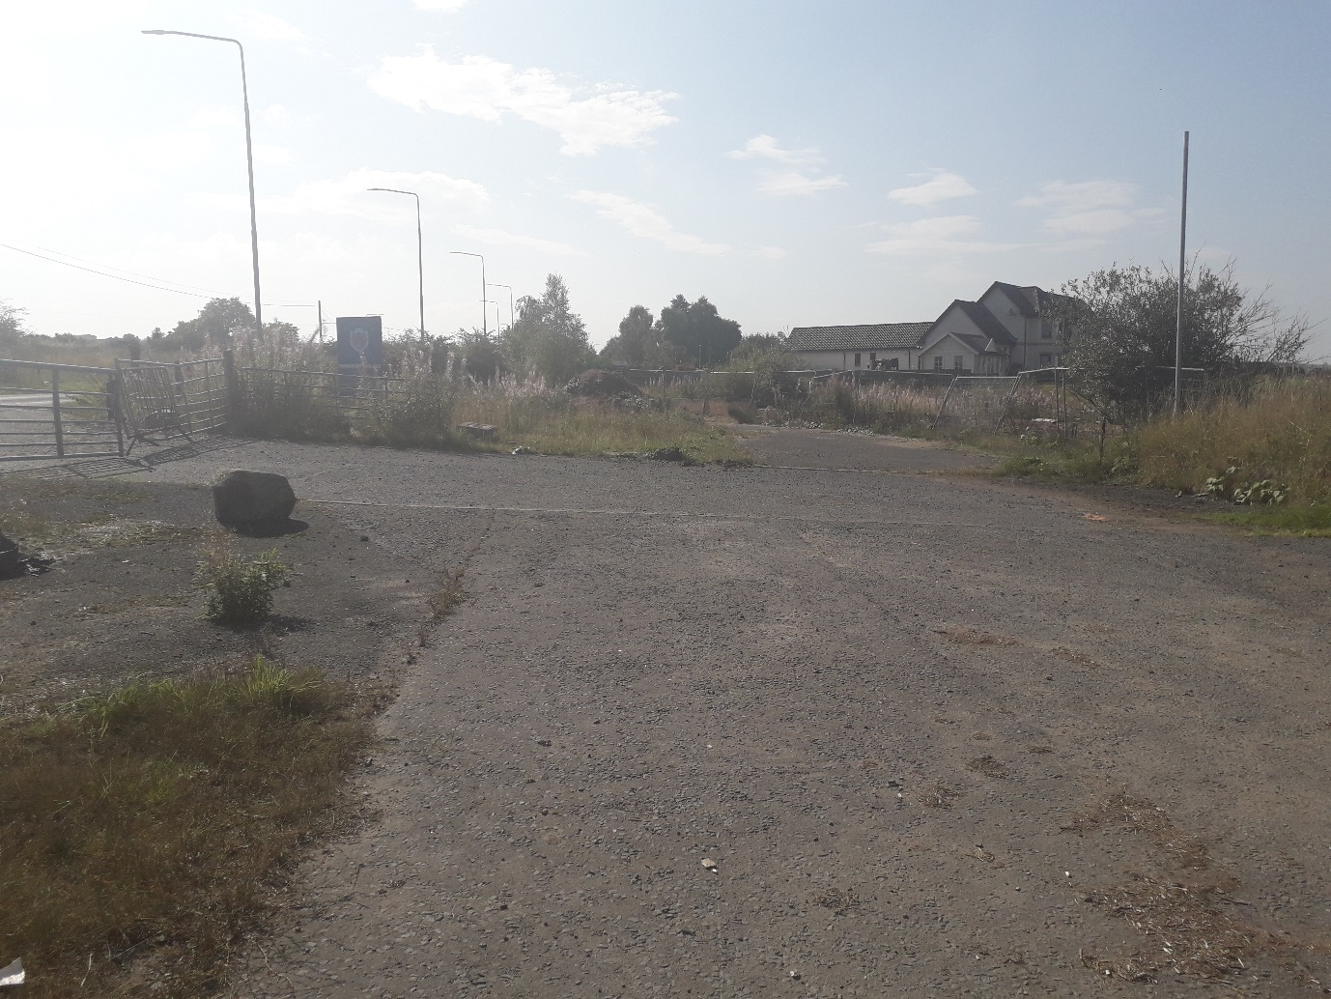

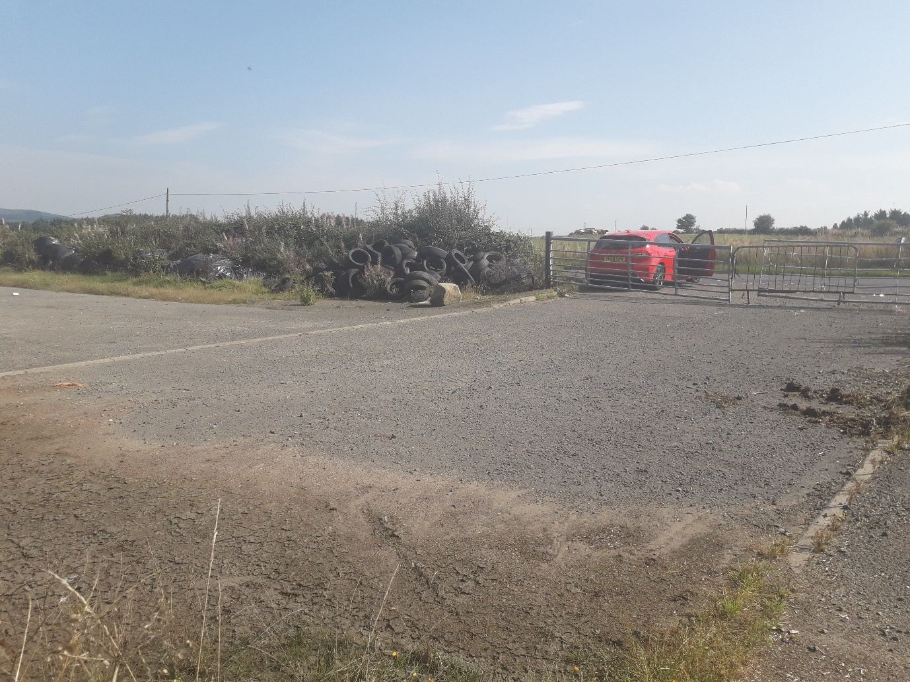

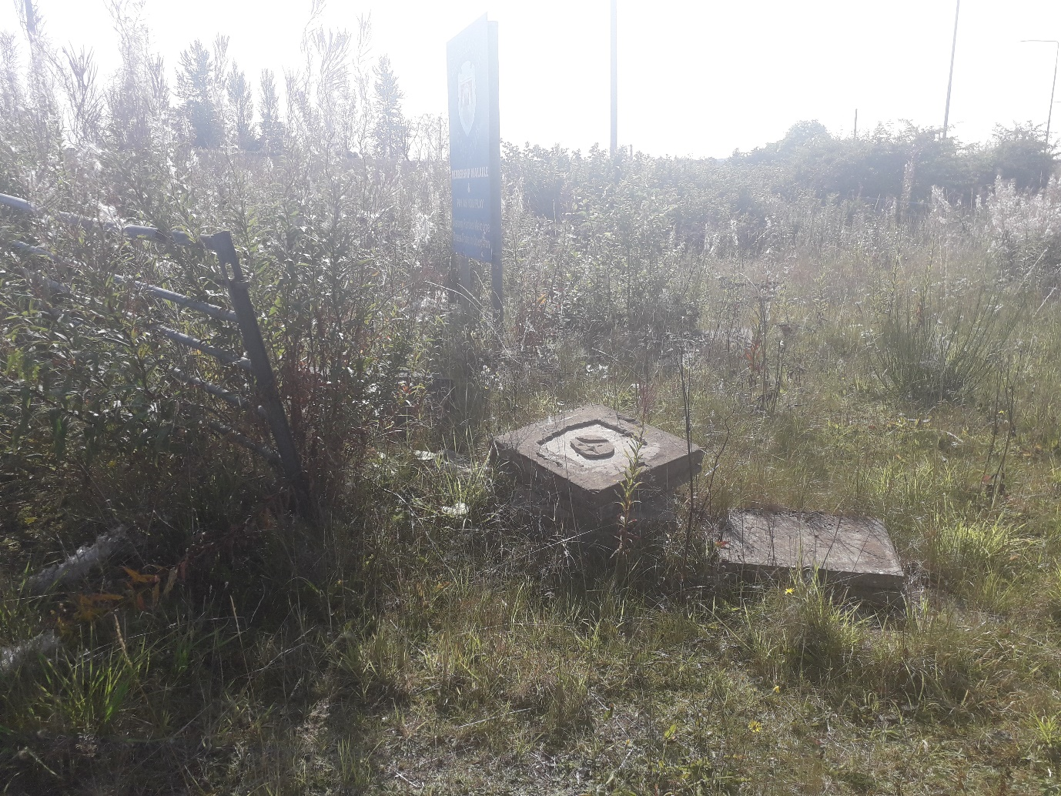

Site Examples and High Level Layout
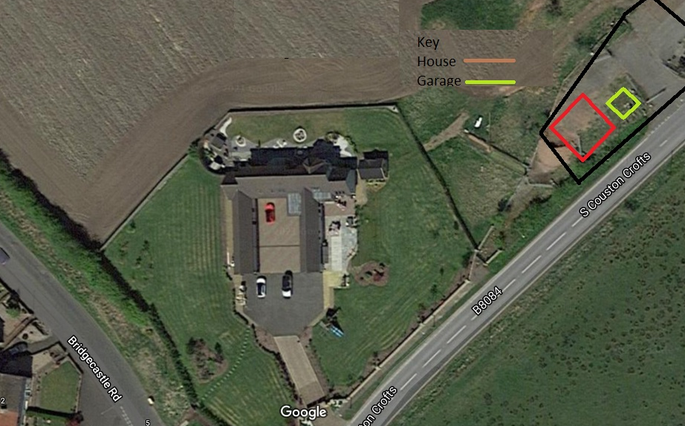
Approximate
House
10m x 10m (1/2 Storey 150m-180m2)
Garage
7m x 7m

