Design and Access Statement

For Stables and an All-Weather
Riding Arena

at
Badley Bridge Barn
Badley
IP6 8RJ

September 2021

Site overview

The application relates to land at the above address, the site areas are located North and East of the house. The wider property consists of gardens, grazing paddocks and a pond. The River Gipping lies to the South Eastern boundary and a railwayline to the North. There are no stables or other equestrian facilities on the site. The site is designated as agricultural use except for the domestic gardens. Previous owners of the Barn have kept horses on site, we are not aware if there has ever been a change of use to equestrian for any of the site.

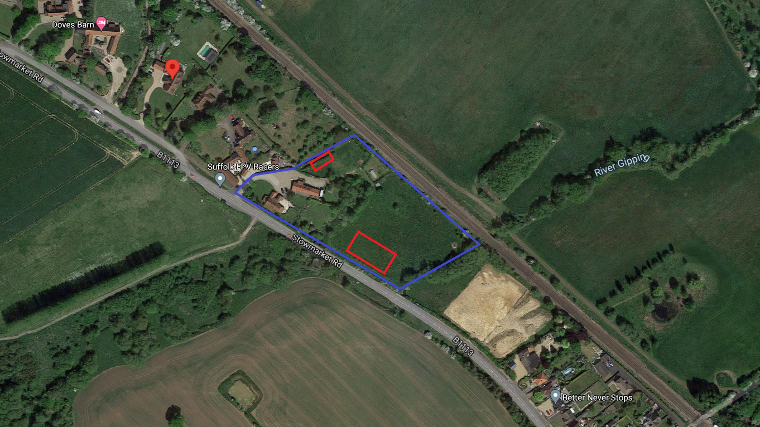
Fig. 1 Boundaries shown in blue with site areas in red.

Project overview

It is proposed to construct an American style barn with a ridge height of circa 3.6m and an eave height of 2.2m. And an outdoor, all-weather horse exercise arena. The arena will be approximately 25m x 60m in size, surrounded by a post and rail fence with a maximum height of 1.4m. The fencing and surface finish of the arena will be of standard, sustainable, materials. The arena finished level will be installed at a position which is level with or below the current natural levels. This is to ensure that construction of the arena does not remove any of the flood plain capacity.
Both site areas have been selected as the most suitable location in consideration of the property and its surroundings, local planning policies, technical execution and practical usage. The area will provide a safe, well drained riding surface that can be used all year round in most weather conditions.
The intended riding surface should be a specialist equestrian sand and fibre additive mix. This is built onto a free draining base of clean local stone, through which surface water filters naturally into the ground. Drainage is therefore just as occurs with the existing grass environment and there is no concentration of water flow created in the design. Any surface water created will be evacuated to the river. The riding arena will not be used as turnout and so no foul run-off will be created.
The exercise area is sized so as to be able to safely accommodate the activities of general schooling, essential fittening work and show jump training and exercise. The structure will be fenced, the surface being retained by simple treated timber boards with a natural finish, which will weather to a green/grey. The site chose for the arena is almost level as it is in a flood zone, this is covered in the Flood Risk Assesment.

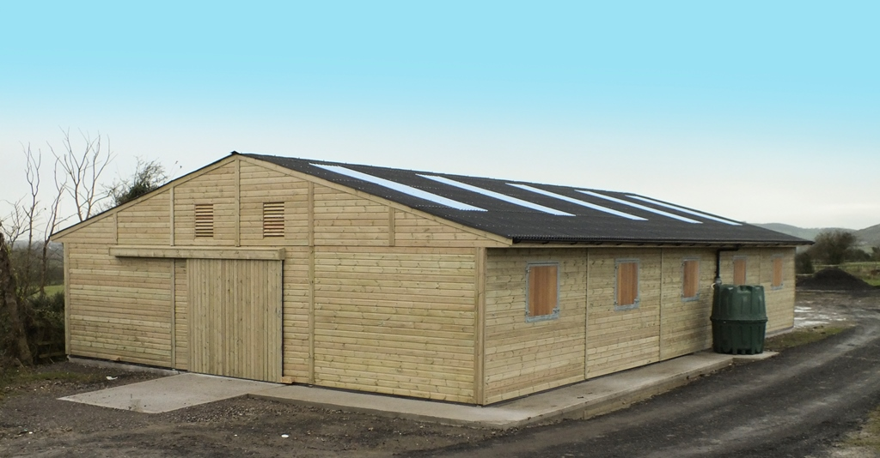
Fig. 2 Similar barn for illustration purposes.

Use

The arena will be used exclusively by the applicant for personal use to train and exercise horses. At no time shall the arena or barn be used for any commercial purpose whatsoever, including for livery, or in connection with equestrian tuition or leisure rides.

Movement

The use is for the enjoyment of The Barn and so the applicant would not have occasion to visit the site using a vehicle, the only additional traffic would be occasional feed and bedding deliveries and visits by a vet or farrier.

Environmental Sustainability

JWS the suppliers of the timber building is a member of TRADA, all timber supplied is only from sustainable resources. Suppliers of their timber are members of the Timber Trade Federation and are signed up to The Environmental Code of Practice. The intended sites are both areas of mainly tended grassland. There is some hedging to be removed, these are integral to the site and are not connecting. Removal of hedging will take place outside of the nesting season (Feb to Aug). There is a separate report with regard to the pond.

Landscaping

The proposed stables will occupy an area which is already well screened by tall hedges, and as the site is already flat, no further landscaping is proposed.

Character

We have kept the appearance of the barn as traditional as possible. The walls will be timber shiplap cladding with a Tanalith finish which is very natural in colour and blends well generally.
The roof is proposed to be corrugated Onduline, finished black, again a very suitable and traditional finish for this type of use.

Access

Access will be made via the existing driveway which, although is suitable for this purpose, will be improved for road safety. Currently the gate for the drive is located about seven meters from the highway, this will be revised as there is a footpath. To keep the footpath clear the gate will be moved to allow seven meters to the footpath. There will be some hardstanding added to connect the barn area to the driveway. There is not a track planned to connect the arena area.

All weather-arena, explanation of need
The exercise facility proposed is considered essential as explained below.
Riding and horse care is without question a potentially dangerous activity. For their own welfare and in order to minimise this danger for those riding and caring for them, all horses need to be well exercised and well trained.
To further expand this point. The riding horse has changed much over past decades, being more and more bred for sporting and athletic ability; these animals are by their nature significantly more highly strung and therefore needing constant workload. A horse which does not receive sufficient exercise will not only suffer with respect to its mental and physical health, it is likely to become bored and less inclined to safely obey its rider/handler.
Traditionally exercise was carried out on grass, but such grassland as exists at the property is needed for grazing and cross country practice In any case, forced use of pastureland for exercise in unsuitable conditions is detrimental to the land itself; causing significant damage and poaching. Not only is this aesthetically to be avoided in landscape terms, it potentially leads to many health problems in the horse. In poor weather conditions, grassland will be too wet, muddy and slippery. Use at such times will soon plough up the ground, adding unevenness. This can cause trips, slips and wrenches, injuring muscles and tendons and also resulting in falls which can in some instances be fatal.
In ‘good conditions’ without rainfall the ground will fast become too hard, potentially causing injury through percussion. In frosty conditions, exercise without suitable frost tolerant surfaces is impossible. Bridleways and other horse-permitted public routes, when not hard surfaced are affected by variable weather conditions in much the same way as grassland. In snow, frost, and foggy conditions, venturing out along such routes or onto the public highway, is impossible. Hard surfaces, such as the tracks available in the area and the roads themselves, provide only limited potential for safe exercise and limit work to walking and moderate activity in trot.
In all scenarios the risk of injury to the horse, often causing total loss of use and sometimes leading to destruction, is extremely high. Serious injury to the rider is also very possible.
As well as anxiety about working valuable and sensitive animals on unsuitable and unsafe surfaces, the use of purpose built horse exercise areas is now part and parcel of a growing awareness amongst all horse users and competitors of the need for their animals to be ‘well schooled’ and hence mentally and physically healthier, more predictably behaved and obedient and, overall, far more safe. This is particularly crucial in a case where there is a need to practice dressage and jumping to a very high level.
In an open field or on a publicly accessed route, with uncontrollable and unpredictable distractions, such carefully controlled training is simply not feasible. It should be noted that the provision of private horse exercise facility does in fact serve as a public plus: by reducing the need to use public routes, there is an indirect though significant benefit to the wider community and environment in that the total horse traffic on such routes is significantly reduced. Hence wear and tear in the public domain is reduced, as is the possibility of potential conflict with other legitimate users, such as dog walkers and cyclists.
Assessment
This application seeks to comply with all relevant planning policies, it is well thought out and uses all possible existing resources to maximise its sustainability. The building work will be carried out on areas where there is no important habitat and the buildings are well screened by existing hedges.
The arena will not negatively impact the flood zone on which it is located.
Conclusion
We feel that there is no significant loss of habitat or amenity either in the local or wider area and that any impact on the character of the surrounding landscape has been lessened and mitigated where possible. The building is of a scale commensurate with the use, landholding and needs of the property. The building is well designed and we hope this is an acceptable proposal.

