Planning Statement

for

The conversion of the existing attached garage to provide dining room accommodation.

at

The Limes : 3. Red Lion Close : Hoxne : Eye : Suffolk : IP21 5AW.

for

Mr & Mrs Mike Cane
Waterloo House : Church Street : Stradbroke : Suffolk : IP21 5HT.

Job ref. MC/1791 1st. September 2021

The Approach to the Design Element

Introduction

This supporting Planning Statement has been prepared by Mr Andy Love of Andrew P R Love architecture.design.planning Ltd. on behalf of Mr and Mrs Mike Cane.

This statement accompanies a detailed Householder planning application for the conversion of the existing attached single garage to provide dining room accommodation to the existing dwelling.

The site, as a whole is owned by Mr and Mrs Mike Cane.

Mr and Mrs Mike Cane is the Applicant, and this application is submitted, as Agent, by Mr Andy Love of Andrew P R Love architecture. design.planning Ltd.

The Planning Portal application reference no. is PP-10184690.

The Site and Surrounding Area

The application site is located on the south side of Red Lion Close, a private road, within the village of Hoxne, in the administrative area of Mid Suffolk District Council.

It is understood that part of the application site access road falls within the Conservation Area enclosing the former Priory. As part of the site is within this Conservation Area it is necessary to submit a formal Householder planning application.

There are neighbouring residential properties to the north-west and north-east of the application site which are oriented north/south.

The curtilage of the application site extends to approximately 1180 square metres, including the access road.

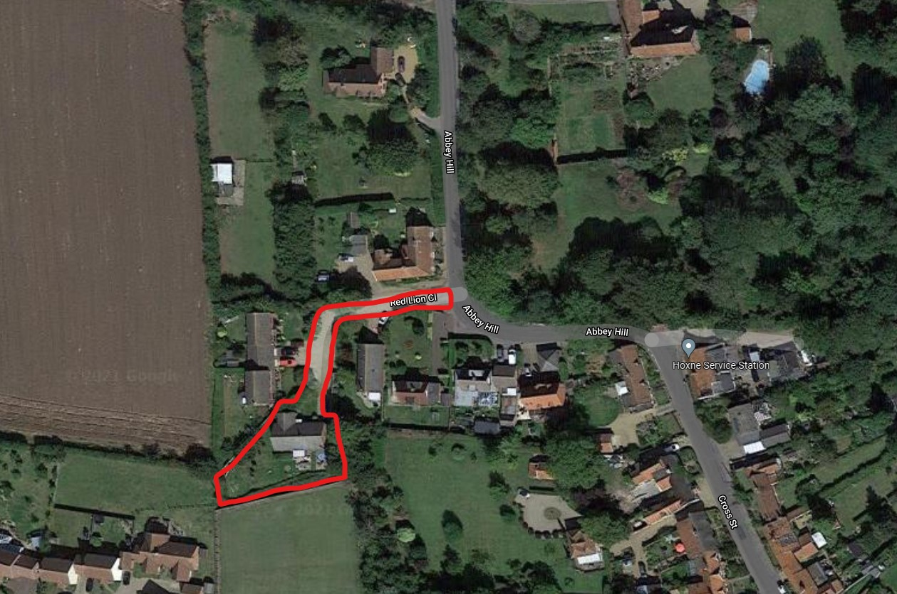

Figure 1: Google Maps extract showing the site location

The Design Brief and Concept

The project brief called for the conversion of the existing single garage, attached to the existing single-storey dwelling, to provide dining room accommodation, access directly off the existing sitting room.

Application Discussion Process

The agent took the time to contact the planning department of Mid Suffolk Council to discuss the proposal.

Due to the Conservation Area issue the advice was to prepare and submit a formal Householder planning application.

A formal planning application would not have been required for the proposal were the site outside the Conservation Area.

External Materials

The following external materials and finishes are proposed.

- Red clay facing brickwork to the in-filled garage door, to match the existing
- Brown uPVC timber window units to match the existing.

Landscaping and External Works

The existing vehicular access, parking and turning areas are unaffected by the proposed works.

The existing boundaries are to be retained and are unaffected by the proposed works.

There are no landscaping or external works proposed as part of this application.

Environmental Impact

The new development project will be insulated to a high standard, above the level required within the Approved Documents, and all new windows will be at least double glazed.

All new windows are to be fully sealed within the new openings in accordance with the Building Regulations Approved Documents.

Low-energy light fittings will be installed throughout the development.

The existing foul- and surface-water drainage will not be affected by the proposed development.

All space heating to the development will be provided by extending the existing hot water heating system.

Flood Risk

The application site is located within flood zone 1 and outside flood zones 2 & 3 as designated by the Environment Agency as shown in Figure1 below.

The site is at little, or no risk, of flooding.

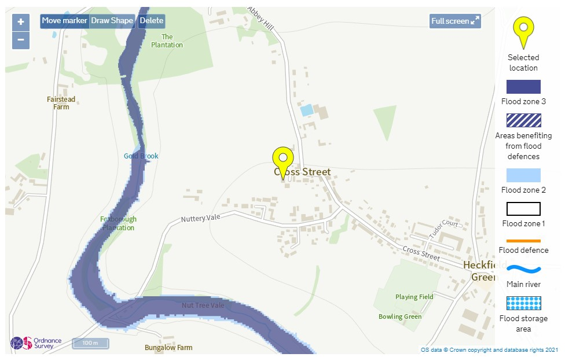

Figure 2: Flood Map extract provided by the Environment Agency

The Approach to the Access Element

Vehicular Access

The existing vehicular access, parking and turning area will not be affected by the proposed development.

Inclusive Access

The proposed development will be wheelchair accessible wherever possible in accordance with Lifetime Home standards.

The new internal door will comply with all the relevant Building Regulations Approved Documents including Part M where applicable and practicable.

Provision for the following will be included:

Means of escape: the provision of a safe means of escape from the building is to be provided via compliance with Building Regulations Approved Document Part B.

Door width and opening: Door width and opening to meet the minimum requirements of Approved Document M and BS 8300 (for clear openings, type and height of handles, vision panels, door closers etc).

This Planning Statement is also to be read in accordance with the following drawings and documents.

- MC/1781 9900 - site location plan
9901 - existing block plan
9902 - existing layout – survey drawing
9903 - existing elevations – survey drawing

SK01 - proposed layout – scheme drawing
SK02 - proposed elevations – scheme drawing

Planning Statement

for

The conversion of the existing attached garage to provide dining room accommodation.

at

The Limes : 3. Red Lion Close : Hoxne : Eye : Suffolk : IP21 5AW.

for

Mr & Mrs Mike Cane
Waterloo House : Church Street : Stradbroke : Suffolk : IP21 5HT.

Job ref. MC/1781 1st. September 2021

