Trees at Pier House, Swains Lane, Bembridge PO35 5SR

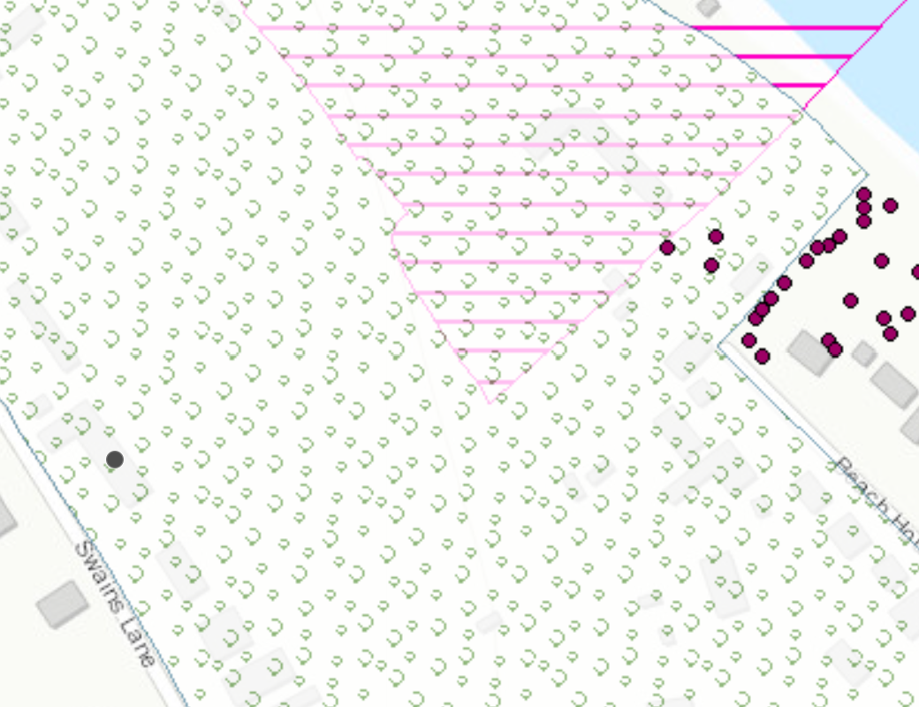
Group of various trees.

