Site plan layout and proposed shed for 25 Pevensey Close, Aylesbury, Bucks. HP21 9UB

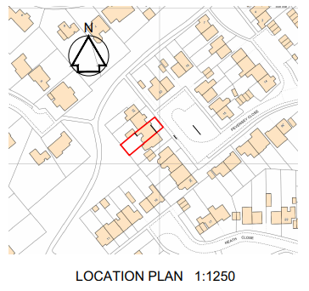

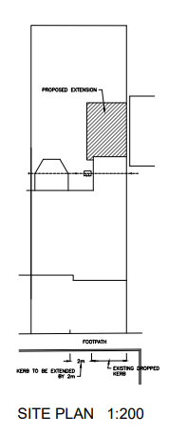

Current layout

Proposed position of shed