**DESIGN AND ACCESS/HERITAGE STATEMENT**

for

**REPLACEMENT OF ENTRANCE LANDING/STEPS SURFACE**

at

**11 WYNDHAM PLACE, LONDON, W1H 2PX**

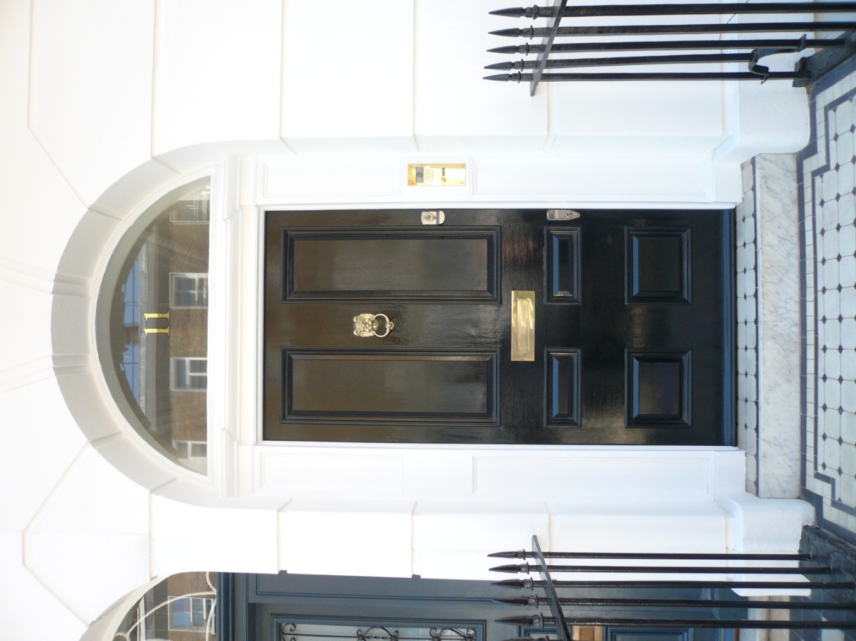



221036 August 2021

**INTRODUCTION**

Permission is sought for the replacement of tiled surfaces to the steps and landing approach to 11 Wyndham Place, W1H 2PX

**CONTEXT**

11 Wyndham Place is a Grade II Listed Building and the site is located within the Portman Estate Conservation Area.

The subject property forms part of a continuous frontage/4 storey façade to the west side of Wyndham Place. The front (east) elevation of the property features brick upper storeys over stucco finish to the entrance and basement levels.

*Location*

*Statutory Address:*

*9-13, WYNDHAM PLACE W1*

*County:*

*Greater London Authority*

*District:*

*City of Westminster (London Borough)*

*Parish:*

*Non Civil Parish*

*National Grid Reference:*

*TQ 27634 81627*

*Details*

*TQ 2781 NE CITY OF WESTMINSTER WYNDHAM PLACE, W1 43/82 21.4.83 Nos. 9 to 13 ( consec. ) (Including No. 94 Crawford Street) G.V. II Terraced houses. c.1811-20 as part of J.T. Parkinson's Bryanston Square Portman Estate development. Stock brick with stucco ground floors, channelled except for Nos. 9 and 10,concealed slate roofs. 4 storeys and basement. 2-window wide fronts; No. 9 with shop front to return and 2 windows wide above. Semicircular arched doorways, to left on Nos. 9 to 11 and to right on Nos. 12 and 13, panelled doors in pilaster jambs and fanlights. Recessed sashes, Nos. 9 and 13 retaining glazing bars, under flat gauged red brick arches. Plat band finishing off stuccowork. Crowning stucco cornices and blocking courses to Nos. 10 and 12; parapets with stone copings to rest. Cast iron balconettes to No. 9 and continuous geometric patterned cast iron balconies to Nos. 10, 11 and 12. Cast iron arrow head railings with urn finials.  
  
Listing NGR: TQ2763081637*

The dwelling is approached by a landing between the pavement and the entrance door to the dwelling which bridges over a lightwell to a basement storey. In the case of the subject property the landing is linked to the same arrangement to 12 Wyndham Place.

The existing situation features steps rising from the pavement level and at the entrance door. Painted metal railings provide guarding to the pavement edge/ landing and separation on the Party Wall line between No.s 11 and 12. The latter are configured to a plinth detail, half of which has it seems been removed to the north side of the landing.

At present the landing and steps are finished in patterned, black/white tiles with flush marble nosings. The latter are poorly detailed and not in keeping with original materials for the period and aesthetic of the building.

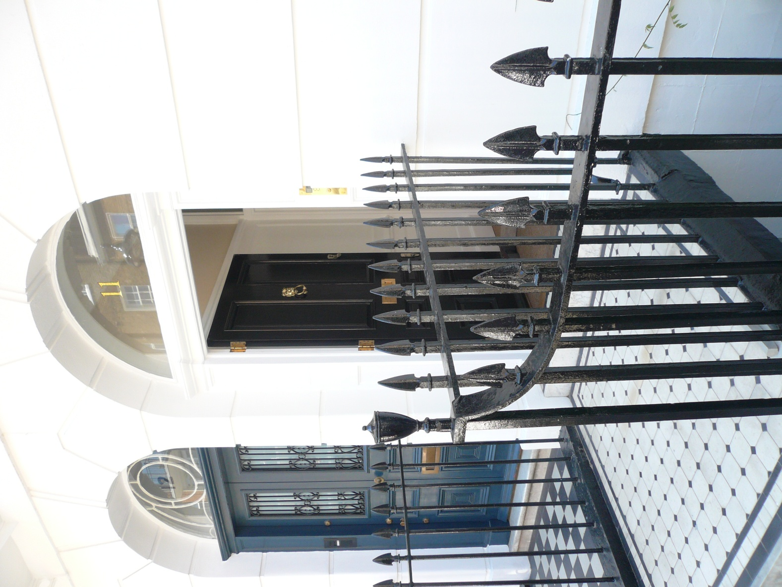 *Photograph as existing*

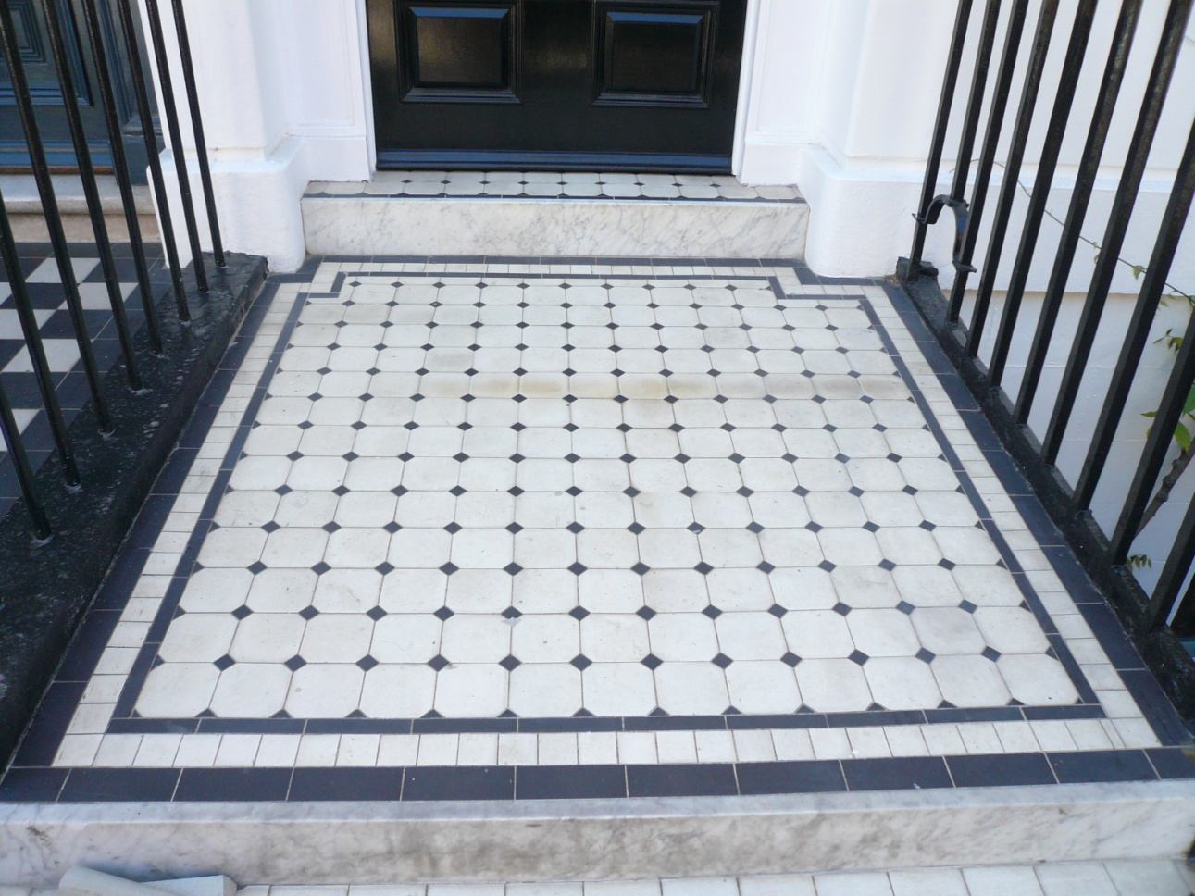

*Photograph of landing showing existing tiling*

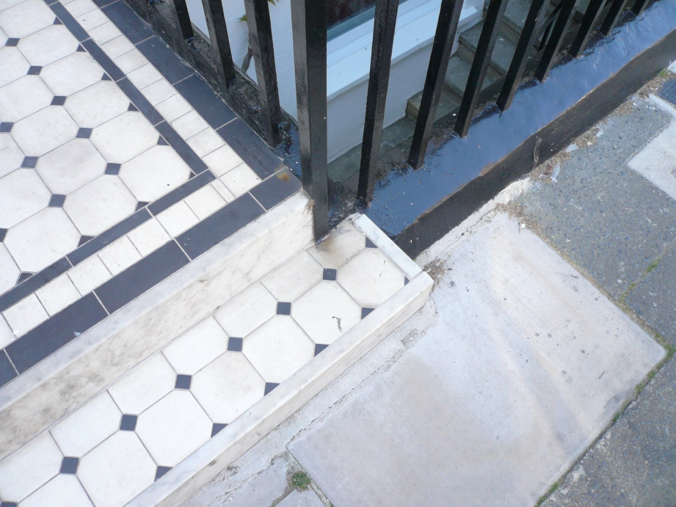

*Photograph showing poor detailing of existing finish (note. half of plinth to the north side railings removed)*

**THE PROPOSAL**

It is proposed to remove the existing tiles and refinish the landing and steps in York Stone paving with nosings to treads/steps detailed appropriately with projecting bullnose leading edges.

The works will include the reinstatement of the plinth to the north side railings in form/finish to match existing.

The works will not affect the existing railings, front door/joinery and front elevation of the property which will remain as existing.

**QUANTUM**

The proposal will not cause any increase in floor area/accommodation provided by the dwelling.

**ACCESS**

The proposal will not affect existing arrangements for access and servicing to the dwelling

**SUMMARY**

No.11 Wyndham Place forms and integral and important part of the streetscene to the west side of Wyndham Place.

The proposal to replace the existing finish with more appropriate, natural material and detailing will enhance both the immediate impression and setting of the Listed Building and the wider Conservation Area.

It is submitted that the proposal accords to the Council’s overarching Policy DES 7L in relation to the restoration of original building features, in this particular case the reversion to materials of higher quality and more in keeping with the period of the subject building.