Site-specific Flood Risk Assessment for the embankment between Fox Corner and Penwethers East Rail Bridge

A site-specific flood risk assessment should be provided for development in Flood Zone 1 on land which has been identified by the Environment Agency as having critical drainage problems.

Site address
The location of the site is on an abandoned railway embankment to the southwest of New County Hall in Truro. The site location is shown outlined in red in Figure 1, below. The site lies within the River Tinney Critical Drainage Area. The details of this are in Appendix A.
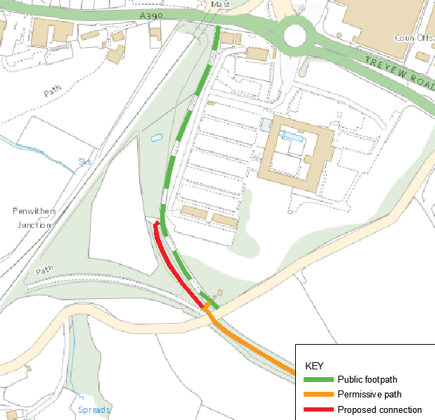
© Crown copyright and database rights 2021 Ordnance Survey 100049047
Figure 1 – Site Location

Description of Development
The Newham Trail is a Cornwall Council owned permissive path. The section from Penwethers East Rail Bridge to Old Falmouth Road is currently only for pedestrian access. On the section from Old Falmouth Road to Gas Hill, cycling is also permitted. This scheme will upgrade the trail to allow cycling on the whole route.
It is necessary to improve the connection between the public footpath (shown in Figure 1) and the Permissive path. The connection is currently a narrow steep ramp, shown in Photo 1, below. This is not suitable for cycling or wheelchair access. The access can be greatly improved by bringing back to use a section of former railway embankment which is shown in red on figure 1. This will allow a 3m wide path to be installed along the embankment which has a longitudinal gradient of 1 in 100, making it ideal for cycling and wheelchair access to the trail. This embankment is shown in Photo 2.
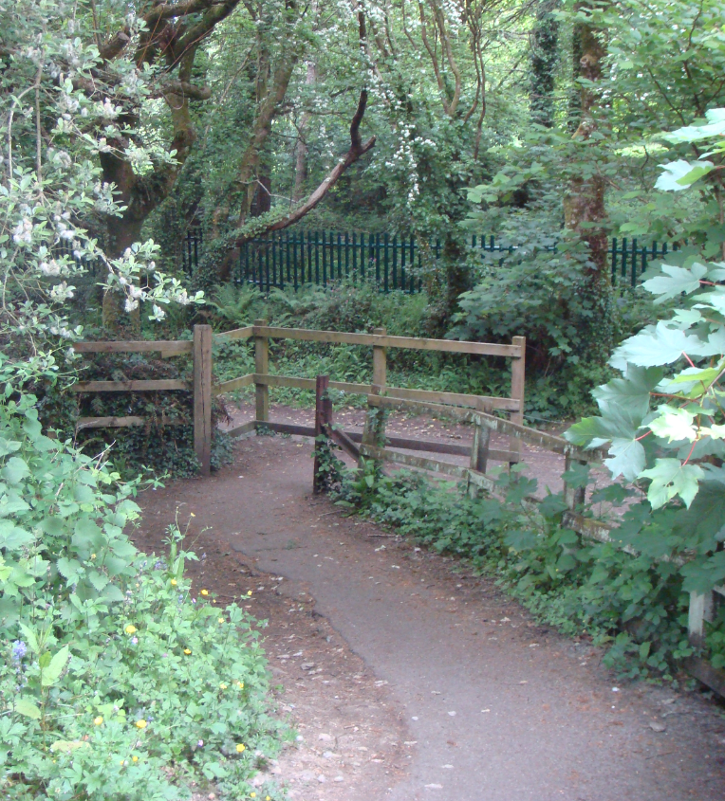
Photo 1 – showing the steep, narrow existing link between the public footpath, behind the timber fence and the permissive path from where this photo has been taken.

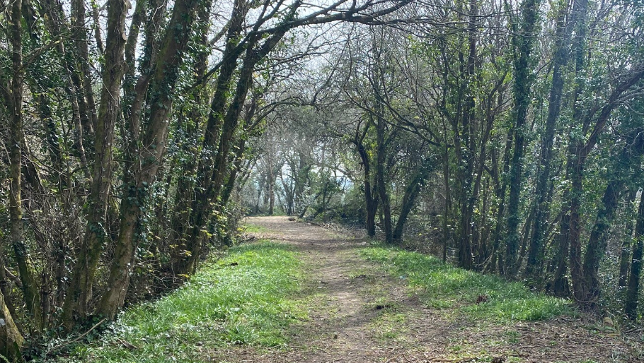
Photo 2 – View towards the south along the embankment.
As the embankment is not currently part of the Newham Trail permissive path, Cornwall Council have decided that planning permission is required to include the embankment as part of the trail.
Ground investigation has shown the topsoil to be around 150mm deep. Testing has been carried out and no contaminated material has been identified in this embankment.
There are many trees on the embankment slopes. In order to protect tree roots it is proposed to use Cellweb (or similar) ‘no dig’ root protection method. A cross section of the proposal is shown on drawing EDG1691-CSL-HGN-SW819433-DE-D-2003-P01.

Risk to development from River or Sea Flooding
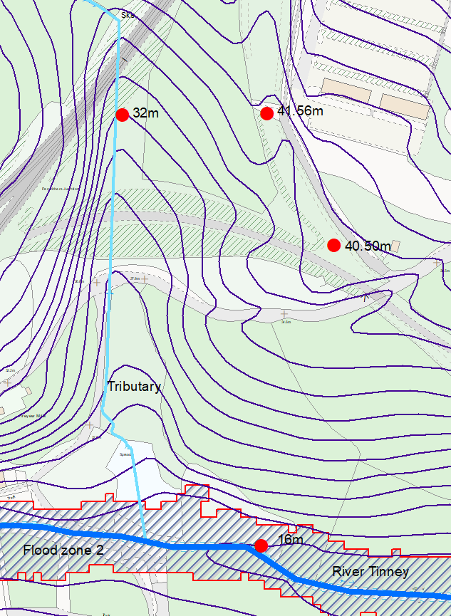
© Crown copyright and database rights 2021 Ordnance Survey 100049047
Figure 2 – Flood Risk Map
The site is on an existing embankment at 41.56m to 40.50m AOD. These levels are shown on Figure 2, above.
The River Tinney lies at a level 24.5m lower the site. Flood zone 2 of the river is at least 20m below the site level. There is another small watercourse to the west of the site which is 9.5m below the site level at its nearest point. With these levels the risk of flooding from the sea or from watercourses is extremely remote.

Risk to development from Surface water Flooding
Environment Agency mapping shows that the risk of flooding from surface water is low. There is an area to the east of the site showing flooding potential. This is on the existing public footpath / access track. The ground level here is 38.5m AOD, which is a low spot on the footpath. This is approximately 2.5m below the top of the embankment. The embankment is protected from this flooding by an existing wall shown on drawing EDG1691-CSL-HGN-SW819433-DE-D-2003-P01.
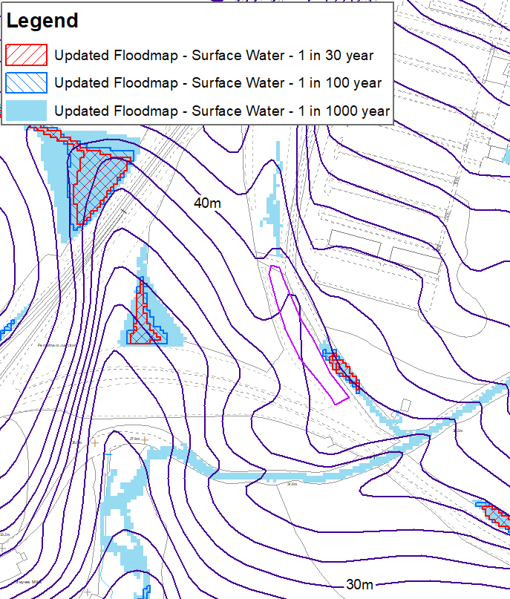
© Crown copyright and database rights 2021 Ordnance Survey 100049047
Figure 3 Environment Agency – Updated Floodmap (risk of flooding from surface water)
One potential route for surface water to enter the site is from a bitmac surfaced path running down the hill to the north of the site. There is no existing drainage system for this path. It is proposed to create betterment for the CDA and reduce the flow of surface water down this path. The path has a crossfall to the western side. Along this side the vegetation and topsoil will be gently scrapped back to create a shallow (200mm max) V-shaped ditch. This will not be continuous but will be created where tree roots will not be damaged, under the supervision of an Arboriculturist. The aim is to shed water from the existing path and provide an opportunity for is to soak into the ground.

Flood Risk from the development
The cross section of the proposal is shown on drawing EDG1691-CSL-HGN-SW819433-DE-D-2003-P01.The aim of using the stone filled Cellweb topped with the rolled unbound aggregate is to allow moisture to percolate through the surfacing to the roots. It also prevents compaction and damage to the roots. At the sides of the Cellweb path the path surface will be tied in with the existing embankment surface using aggregate which is only lightly compacted, in order to avoid damaging tree roots. This material will be permeable. There will be a one metre strip of existing topsoil remaining unaltered on both sides of the path. This will also be permeable.
The use of the permeable materials has 3 aims:
- To ensure there is no increase in surface water runoff rate or volume in the River Tinney Critical Drainage Area.
- To keep the moisture content of the historic former railway embankment unchanged in order to reduce the risk of the failure of the embankment.
- To protect existing trees.

Conclusion
- There is an extremely low risk of river or sea flooding.
- There is a low risk of flooding from surface water.
- There will be no impact on the River Tinney Critical Drainage Area.

