T2 Tree 001551- 18meter chestnut adjacent to AstroTurf tennis courts on Townley road. (Where Alleyn school minibus parks)

Large rot pocket 4 meters up, where an old bough once sat. Full of water and protruding a good foot or more into the middle of hardwood. New rot visible at this location. More rot pockets in the top of the tree only visible by climbing.
Tree is located very close to playing courts for children and proves to be a risk.
Tree is 800mm in diameter and between 15-18meters tall (estimate).
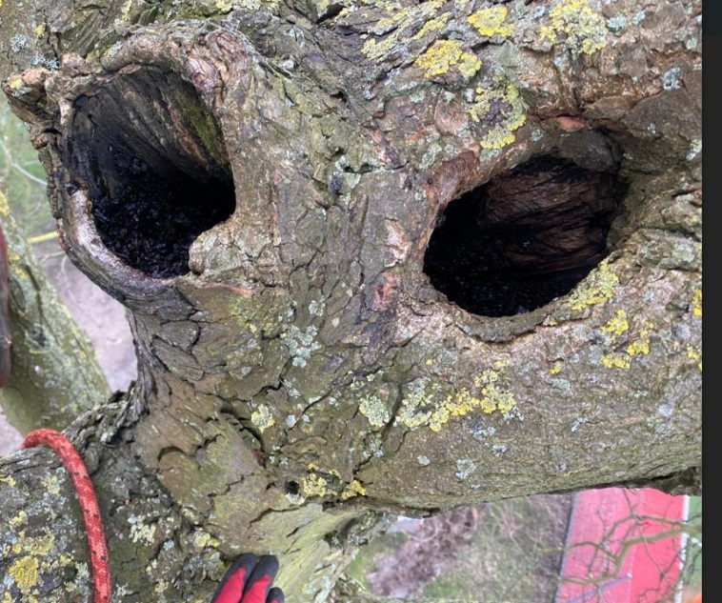
Scar running 15meters from floor to top down one side.
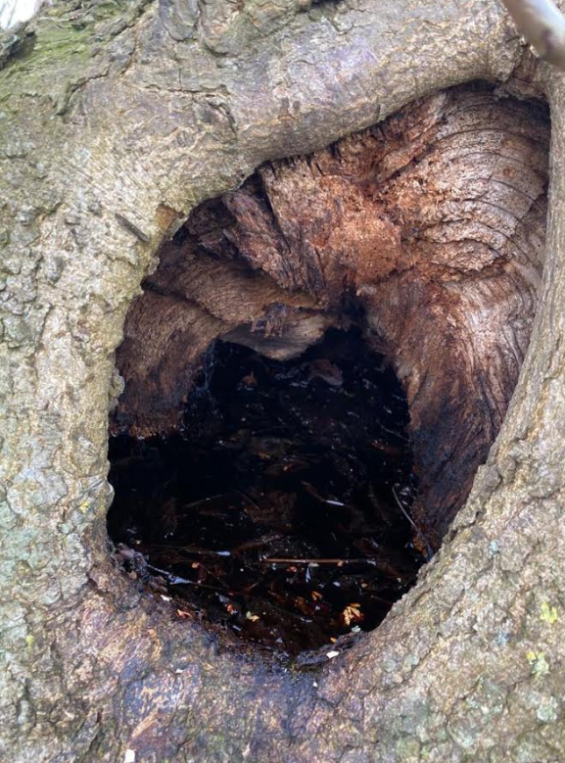

T1 Tree 001553 15meter maple

Small hole visible on left hand side of the tree (as looking at AstroTurf)
A measuring stick goes in 700mm in places and angling up and down it goes deeper.
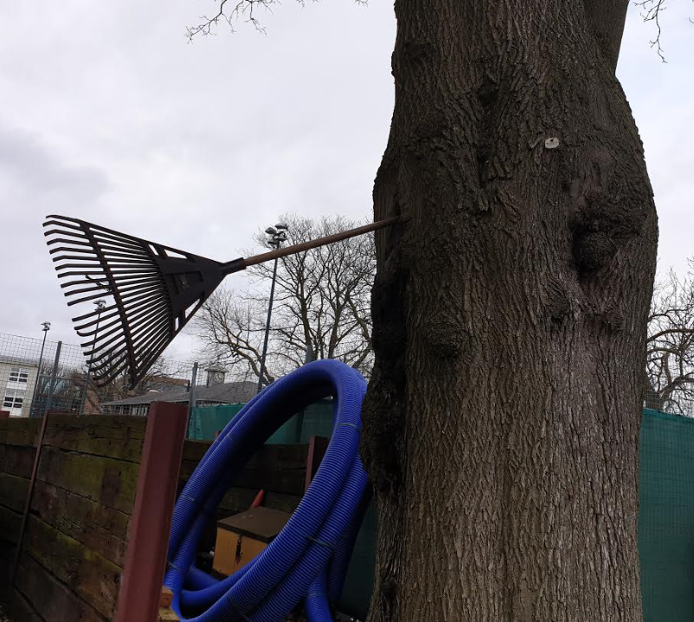
The extent of the rot is not known without a tree scan but being the location is so close to the playing fields we would recommend it be checked ASAP.
