To,
Case Worker
Planning Department,
Swindon Borough Council

Ref: Application for LDC, 5 Balmoral Close, Lawns, Swindon SN3 1HR

Dear Case Worker,
We, Mr. Rajesh Singh and Mrs. Jagruti Thakore, have been using the Swimming pool at our residence, 5 Balmoral Close, primarily for recreational purposes with our friends and family and for the training of our two sons who compete for Tiger Sharks ASC. Ancillary to this use, during the past few months, owing to the current conditions, we have also used the pool to impart training to our friends who were apprehensive of using public pools during these Covid times. We would like to continue with this ancillary use of the pool under lawful use to impart private swimming lessons to those students who are apprehensive of using public pools or have anxiety in the presence of public. Post covid, there are more and more of these. These students due to their apprehension or anxiety will otherwise never get a chance to learn this life saving skill unless it’s in a private home pool.
Mrs. Jagruti Thakore, is ASA Level 2 qualified for Teaching Aquatics, holds National Rescue Award for Swimming Teachers and Coaches and is registered with The Institute of Swimming (IoS) to run a swim school. Her Swim School by the name of “Swindon Swim Academy” already operates in Swindon since 2015. She also teaches Swimming for some of the Primary Schools in Swindon at the Better Group pools. While the Swim school, Swindon Swim Academy, will continue to operate as is from the existing facilities that she rents, as stated, Mrs. Jagruti Thakore intends to personally teach few Private students from this home pool.

Proposed Scope of use of the pool for Swim School:
It is proposed to use the swimming pool for private lessons for local community during the week days, Monday to Friday only. No lessons will be run over the weekend as the family uses the pool mostly on weekends for recreation purposes. The lessons will run as private 1 to 1 session or as Group sessions of no more than 3 students at a time with 1 instructor. As estimation, the number of students at any given point of time will be 3 students at the maximum side (assuming private group) and 1 student (assuming 1 to 1 private student) on the minimum side.
The lessons will run between the hours of 4pm to 7pm, on weekdays only, with each lesson being of 30 minutes duration at a time. The property benefits from parking space for at least 6 cars on the front drive, although it is anticipated that there will be no more than 4 cars on the drive at any given time. Whilst, most of the students are expected to be from local area, the parking provision is there should they arrive in their own private cars.
The lessons will be carried out by Mrs Jagruti Thakore, herself, who as stated earlier is ASA Level 2 qualified for Teaching Aquatics, holds National Rescue Award for Swimming Teachers and Coaches and is registered with The Institute of Swimming (IoS). No external staff will be employed. The property will continue to be used principally as a dwelling house and as the applicant’s main residence.

Summary of LDC Case:
The use of the swimming pool for private lessons will be moderate and will be ancillary to the main use of the property as a C3 private dwelling house. The property will remain a private dwelling and its character and appearance will not change.
Lessons will run for 30 minutes at a time and involve private 1to1 or groups of up to 3 pupils. Lessons will be provided by the applicant and no staff will employed. There will be no signposts or banners for this activity in or around the neighborhood. Lessons will take place between the hours of 4pm – 7pm on weekdays only.
Parents may drive to the property to take their children to the lessons and will stay there for the duration. However, there is a large front driveway with parking for at least 6 cars. However, it is anticipated that there will be a maximum of four cars on the drive at any time.
The swimming pool is enclosed and is suitable for swimming teaching. The teaching of swimming lessons is not considered unusual or disruptive to a residential area. The lessons will not cause noise or any other disturbance to neighborhood. Lessons will take place late afternoon/ early evening, which is not at a time which would be unsociable or anti-social.
On this basis we seek confirmation from the Council under this application.

Finally, swimming is a Life Skill. A service providing towards teaching of this life skill is much needed in the community and should be promoted. There is already a shortage of public pools in Swindon to impart this life saving skill. Teaching from home pools is the only way to overcome this shortage. Moreover, this is the only way to include those who haven’t yet learned this life saving skill due to their apprehension or anxiety to use public pools and can’t afford the expensive private health clubs.
We wish to impart this service in the most considerate way by being sensitive of the neighbors and request the Council and authority to provide us the required LDC.

Yours Sincerely,
Mr. Rajesh Singh and Mrs. Jagruti Thakore
5 Balmoral Close, Swindon, SN3 1HR

Appendix:
- Pictures showing the parking, pool and changing facilities:

- End of close house - Driveway with car parking space for 6 to 8 cars
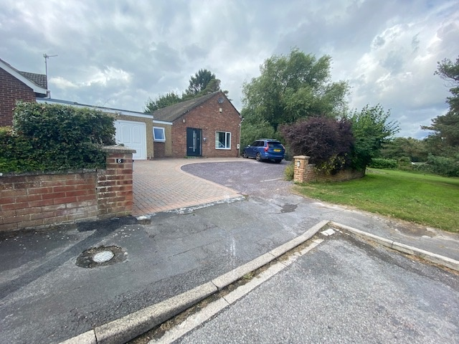

- Independent Side access to pool building via garden
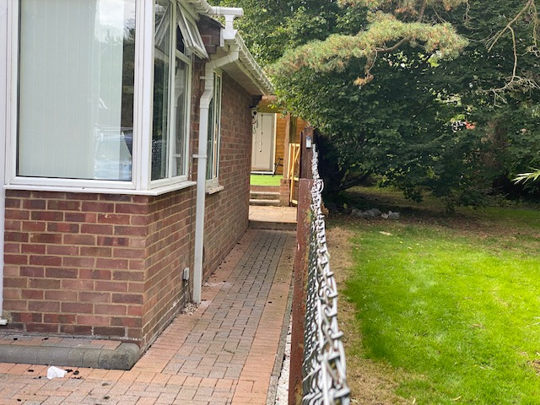

- Pool Building at the end of garden
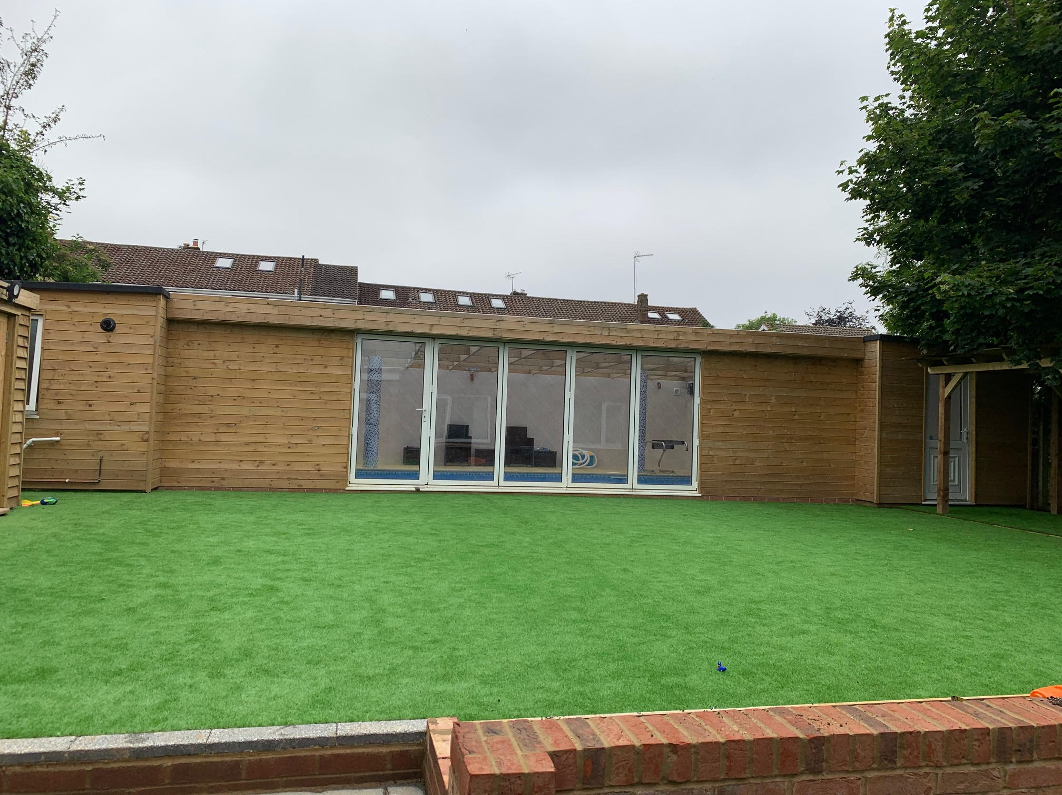

- Pool inside Picture – 1mts depth constant sloping to 1.5mts on deep side
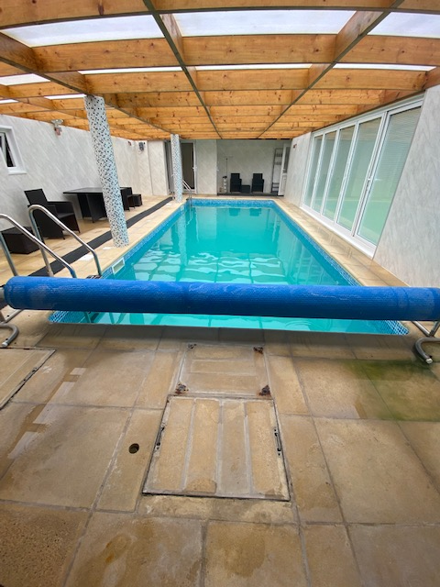

- Changing rooms with shower – X3
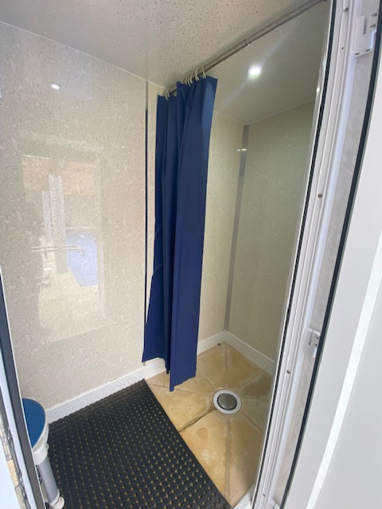

- Toilet – 1X
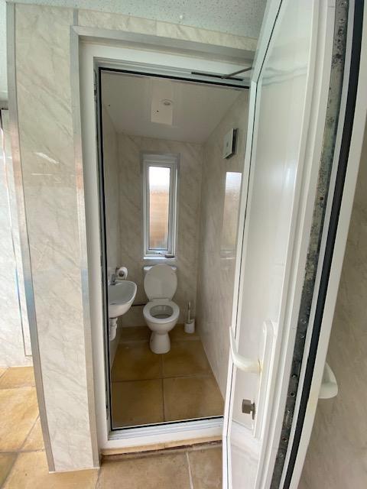

- Mrs Jagruti Thakore’s professional certificates to teach Swimming

- Mrs Jagruti Thakore’s membership to Institute of Swimming to run Swim school activities

