Proposed Pergola
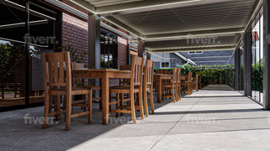
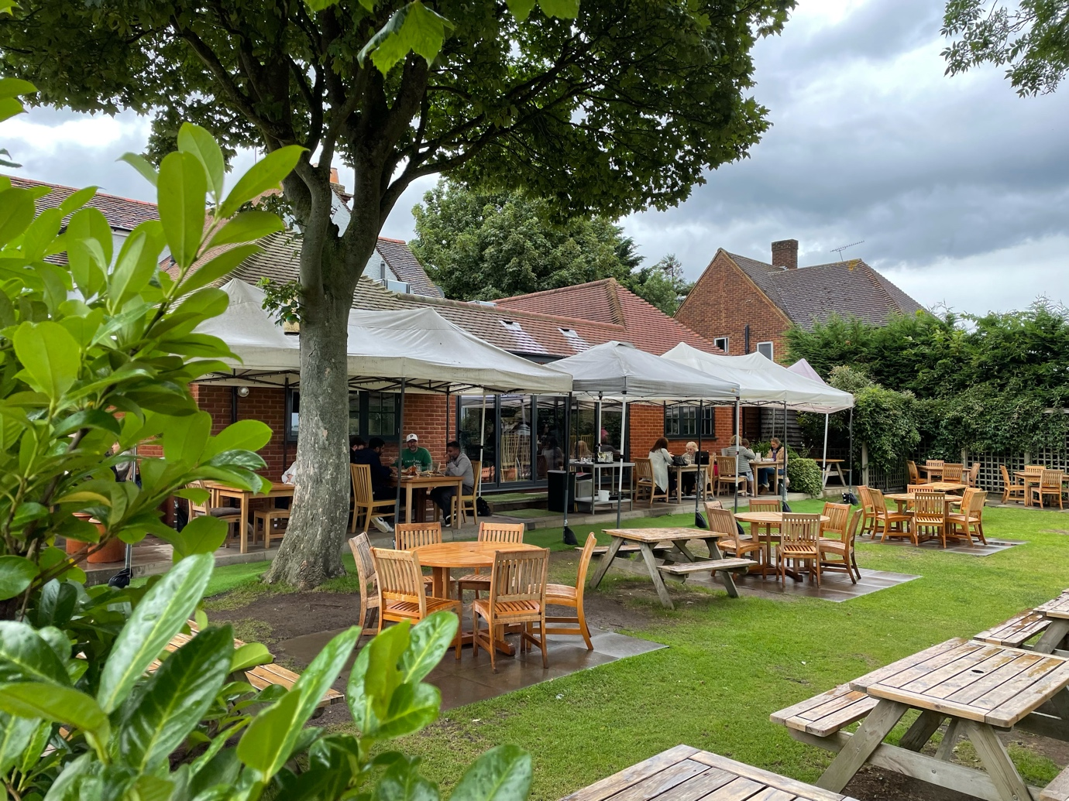
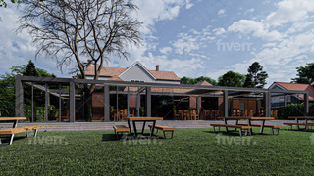
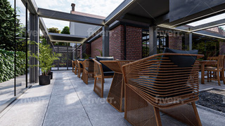
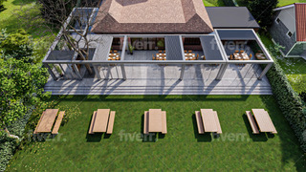
Existing

The Old Guinea Restaurant , Ridge, Potters Bar EN6 3LH
Document Prepared for Hertsmere Planning Dept.

Prepared by Toni Bartholdi. 23rd July2021

SUMMARY
1/ Why do we want to build a pergola
2/ Outline of proposed structure
3/ History of the business
4/ Trading difficulties
5/ Growth in Employment vs loss of jobs
6/Seating capacity external 75%, internal 25%
7/A big step in helping our business- 180 seats outside only 60 seats inside
8/No visible impact on neighbours
9/Business support needed in this sector
10/ Disabled toilets and improved access

1/ Why we want to build a pergola and ask for consultation with Planning Officer.
Business Viability & Support in the Sector
The Old Guinea Restaurant is a popular venue which has lovely views over the countryside at the rear from the garden with 180 seats. It also has 60 seats available inside.
The business faces a serious problem each year because it is not viable during the colder months of the year when customers only want to be seated inside the building. Understandably nobody wants to sit outside when the weather is bad. Effectively we lose 180 seats in Winter months which is 75% of our seating capacity when the weather is poor.
Additionally in the warm months we gear up our staff levels to handle the maximum customer numbers but then as soon as the weather changes we need to let staff go because there is no work for them.
We put a lot of effort into training staff and more so now than ever before it is very difficult to recruit staff when we need them again
When we can use only 25% of the seating on the inside the business loses money and is not viable.
This restaurant/ hospitality business sector, and this includes us, needs as much support as possible to maintain business as has been identified by the Government.

A solution which goes a long way to help solving this loss of revenue would be to be able to provide more internal seating area and we have a way of doing this with the pergola without having to expand the overall site
We are therefore hoping to be able to build a pergola along the rear wall and partially up the side of the existing building, an area all of which is currently covered with temporary style umbrellas and gazebos which do not require planning consent but which quite frankly look unsightly and are not very effective .

To be viable throughout the year we need to fill 50% of all the seats at the restaurant for most of the time including the Winter months, which means we need the potential extra 60 extra seats for inside provided by the pergola. The pergola plans would cover existing outdoor seating areas but make them properly covered and therefore useable in poor weather.

Loss of Employment:-
We currently employ 42 members of staff (full and part time) during the warm months, but when trade slows down in Winter we normally have to reduce employees to about 25 people.
We train staff to the best level we can and keep them employed for as long as possible and so we then find it galling to have to let them go. It is also becoming far more difficult to recruit staff to work in the restaurant trade , so we are desperate to retain existing staff if possible.
Being able to host more customers in the cold weather makes employment sense because we have more work for the staff and can keep them employed.

2/ Outline of proposed structure and reason for it
The proposed pergola is constructed of a powder coated aluminium frame and roof with some glass side panels and sliding glass doors on the sides, all of which are totally weatherproof when closed. The roof is made from adjustable aluminium louvres which can be opened or closed as desired.

The location of this ‘L’ shaped structure, which is fully demountable, would be along the rear of the existing building and partially up one side between the existing building and the car park.
This pergola would replace the fabric collapsible umbrellas and gazebos which have been in use since the restaurant reopened after the Covid shutdown periods. These collapsible umbrellas are by their nature not properly water or weatherproof, are flimsy and subject to being blown away in poor weather. They also do not look good, collapse in bad weather, are flimsy and look dirty very quickly

The proposed pergola would cover the same floor area as the fabric and more temporary equipment, but the high quality, contemporary design and finish would look much better and be at a level more suitable for an upmarket establishment and area.

3/ Trading History of The Old Guinea
The owners of The Old Guinea, Neil and Sylwia Johnson bought the business as a traditional style pub in need of renovation in March 2011 and Sylwia has steadily grown the business to become one of the leading ‘destination’ restaurants in the area.
The Johnsons offer secure ownership with good provenance and a desire to carry out any work to a high standard and genuinely want to comply with the wishes of the villagers wherever possible.

4/ Trading difficulties, closures and viability
The restaurant has of course faced many problems along the way and never more so than recently with all the Covid restrictions and shutdowns with resultant increased costs and falls in income.
Unfortunately we have seen many other pub/ restaurants fail (we all can mention a few) and most recently our immediate business neighbour The White Hart has announced closure and The Black Horse is only opening 3 days per week.
It is insufficient that the business is profitable during Summer in order to be loss making during the Winter
The business needs to be viable and should we not be able to improve on sales over the Winter the proprietors will need to consider the alternatives to maintaining a restaurant on the site and give consideration to the best way forwards.

5/Growth in Employment vs loss of jobs
Our current 42 employees are a mixture of mostly full time and some part time staff and this makes us one of the larger employers in the area .
We are currently actively trying to recruit more people to help cope with business in the normally busy period up to the end of September whilst we can make full use of the garden seating
If we are able to build the pergola it is possible that we would need to employ up to 10 more staff longer term as we would undoubtedly be serving more breakfasts inside and the availability of inside seating will attract more customers . These extra staff would be a mix of full and part time people

Realistically we would expect to be employing 50 people within 3 months of completing the pergola

6/ Seating Capacity
The garden area has 180 seats which during fine weather are often fully occupied and this represents 75% of our total capacity
Internally we currently have only 60 seats representing 25% of total capacity
If people book outside expecting fine weather and then it turns out not to be so, we can only reseat a total of 60 people inside including those people who pre-booked the inside, so many people get disappointed and leave or cancel and we lose the business from them.
We have a big problem brought about by only having so few seats inside.

7/ The advantage of the proposed pergola over the temporary umbrellas & gazebos currently used
The whole concept of this pergola is that when everything is open people will feel very much outside in the garden and sunshine and be able to see the countryside view unobstructed. When closed customers will feel like they are inside a lovely glass sided room with solid ceiling. Best of both worlds!

The proposed pergola is attractive, contemporary in design and unobtrusive either from the front of the building, from either side for the neighbours or even from any view at the rear of the building. It is designed to replace the temporary equipment which has been used in the same area of the garden since lockdown restrictions for COVID were put in place.
We have commissioned drone photography of the building and surrounding area to show how unobtrusive the proposed pergola might be by showing the existing umbrellas etc. which are far more evident than the pergola that this is the case

The proposed pergola roof has louvres which can be tilted electronically and which can be totally closed making the roof weatherproof.
The glass doors slide sideways to open or close also making the pergola weatherproof. Some of the side glass panels are solid and are not intended to be openable.
By virtue of the pergola design we can adjust the roof and doors to make customers feel like they are sitting outside when everything is open, or by closing the roof and doors it becomes weatherproof and suitable for Winter use.

Should the COVID restrictions be reintroduced, with this pergola we would be able to comply with legislation by opening everything to provide ventilation and facilities as though people are sitting outside.

7/ A big step in Helping our Business

This pergola proposal offers a really effective and pleasant solution to our problem of having only 25% of total seats inside the building under cover.
By adding 60 seats under cover in thisvway we thereby increase covered seating to 50% of our total capacity ie 120 seats out of 240 and can make trade in cold weather viable

This would be a really positive step in helping us to even out our seasonal capacity variations and it will help us to keep all our staff employed throughout the year. We will be able to service 50% of total capacity throughout the bad weather months instead of only25%.

8/ No visual Impact by Pergola on the Neighbourhood.
The proposed pergola construction is not visible from any part of the road at the front of the restaurant, nor by neighbours on either side of the restaurant as sight of it is hidden by the building or is covered by trees and shrubbery , however it is almost all behind the existing building so really has no impact whatsoever on the locality. The pergola is less visible than the current umbrellas and gazebos being used and would certainly look more upmarket

We commissioned drone photography of the rear of the site which shows that from as far away as ½ mile as well as close up it is really difficult to see the umbrellas and gazebos used on site at the moment and these are far more obvious than the proposed pergola. These drone photographs also show that it would probably not be visible from any publicly accessible areas, so impact on the area would be minimal

Having the pergola would not mean an increase in the total volume of customers to more than at the moment, it would only mean more customers at periods of slow trading which by definition would be no more than 50% of maximum volume

9/ Business support needed
We believe that at The Old Guinea we have a higher rateable value on the building and therefore pay more rates than any comparable businesses in the locality and cannot see why this should be? Conversely it also seems that we don’t get a proportionate amount of business support until now this being despite the Government directive to support our business sector which is the hardest hit of all in the UK economy. We hope this changes to our benefit

10/Disabled Toilet Facilities Needed

Part of the ongoing requirement for the restaurant is the provision of disabled toilet facilities with improved access into the premises for the elderly, both types of customer forming a large part of our clientelle.
We subsequently wish to apply for improved disabled access and toilet facilities which we cannot currently accommodate

We urgently ask Hertsmere Planning Dept to assist us with advice in trying to take forward this business and would like to receive suggestions on the best way forward.

