Heritage Statement
for
Twatling Farm,
19 Twatling Road, Barnt Green. B45 8HX

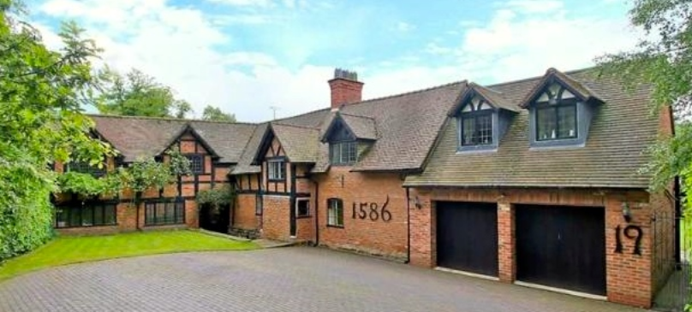

Description of the building

The house is composed of buildings from 3 different eras. The original section of the house outlined in red below was constructed in the 16th Century and was a farm. The construction of this section of the house is timber frame and brick.

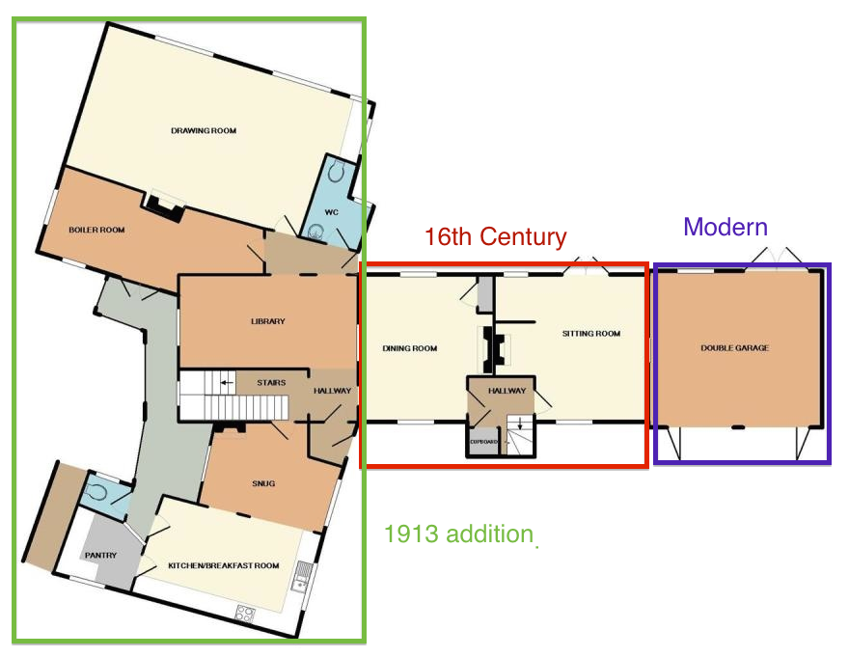

The area of the house outline in green was added in 1913 and designed by CE Bateman. Originally it is believed these were farm buildings and a barn. This area of the house is predominantly brick construction.
The area outline in purple is a modern garage extension to the house.

The 16th Century section of the house has two rooms heated originally from large back-to-back fireplaces in central axial stack with sandstone jambs and chamfered timber bressumers with hollow step stops; chamfered ceiling beams and exposed joists.

Features of the 1913 remodeling include fireplaces, staircases and a corridor on first floor over loggia with segmental vaulted plaster ceiling. Some exposed timber-framing, and tie-beam roof structures exposed in the two outbuilding incorporated into the 1913 remodeled house.

It is believed that Twatling Farm was one of the original farms in the area. Currently it represents one of the older listed buildings in the area.

Although the building was potentially a functioning farm it has been used as a domestic residence since 1912 and still continues to be a residential address.

The impact of proposed work
There will be no externally visible impact of the proposed works.
The internal change will be the restoring of the beams to their original colour.

Justification
The current appearance of the beams is not faithful to their original appearance. The black colour coupled with the low ceilings makes the rooms very dark and returning them to their original state would increase light in the room and allow the appreciation of the craftmanship of the original construction.

