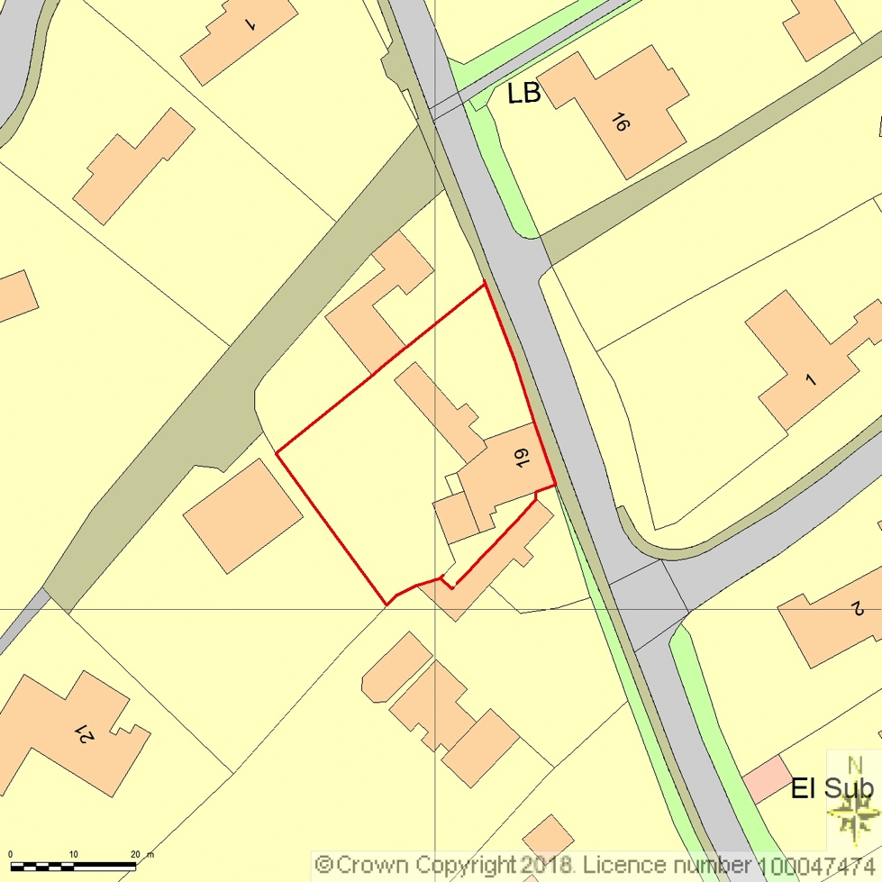
SITE LOCATION PLAN
AREA 2 HA
SCALE 1:1250 on A4
CENTRE COORDINATES: 399601, 274127

Supplied by Streetwise Maps Ltd
www.streetwise.net
Licence No: 100047474
14/02/2020 14:59

