Design and Access Statement

We purchased the house 3 years ago because we fell in love with the character and the features within the property. We are committed to preserving the house both for ourselves but also for future generations.

Works to be undertaken

The following photographs illustrate the two room where the beams will be restored.

Lounge/sitting room:

Dining Room:

These two rooms can be seen in the floorplan below – located in the red outlined area marked 16th Century.

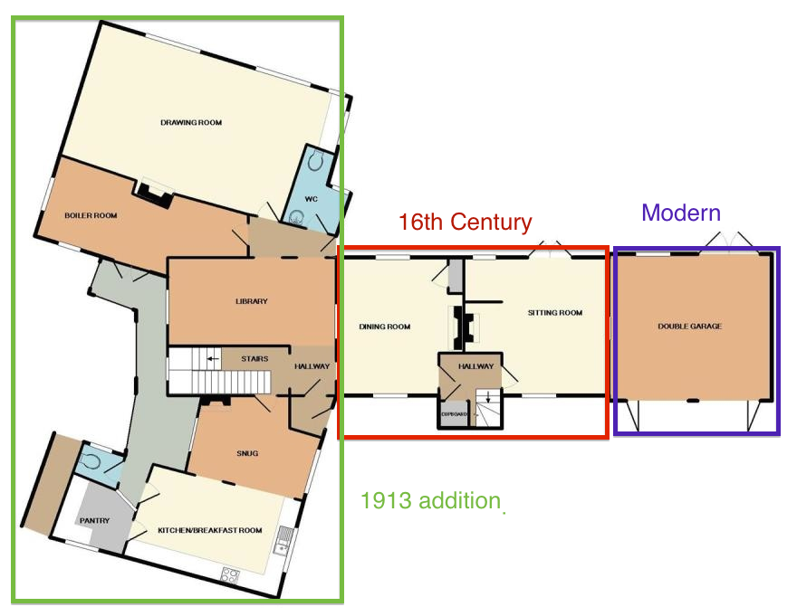

Method statement:

The following is taken from information provided by the company who would undertake the work:

As seen on Channel 4’s George Clarke’s ‘OLD HOUSE NEW HOME’ Sunday 5th January 2020

METHOD STATEMENT
&
Why Other methods should be dismissed.
This method statement is written primarily for the cleaning and stripping of oak and timber beams, floors, doors, etc., however the process is in-keeping for other projects styles that we undertake. This includes, stone and brickwork cleaning; internal and external, panelling, architraves, cast iron cleaning.
Micro Stripping is a gentle, low pressure, air and media stripping clean, using dry medias of which we have several to choose from to ensure the correct and perfect finish is achieved. It is a gentle process of removing products from delicate surfaces, layer by layer, with a controlled flow of non-abrasive, chemical free and dry media. (When working outside we can use a mist of water that will supress the dust.) The superfine media is angular in shape and produces a soft scraping action that cleans without damage, removing the paint, varnish, rust, smoke damage, dirt or grime effectively, without creating any abrasion to the timbers and will not raise the grain. These gentle processes do not remove original features such as carpenter tool marks or carvings. We can use soda (bicarbonate of soda) or chemical free aluminium silicate (different grades are available), both medias leave non-abrasive finishes, the choice of which one to use will be determined by the surface we are working on and around and the product to be removed.
The machine operates with a precise metering of media; which would not be possible using sandblasting techniques. All the equipment conforms to European Pressure Equipment Directive (PED). We do not work at pressures above 18psi (but can do as necessary) – a sandblaster will work at over 100psi. Generally we aim to work at pressures of 15 – 18 psi and will always start at the lowest point possible. We can control the flow of the media, unlike traditional sandblasting methods and it will not damage surrounding areas of the rooms like plasterwork, floors etc.
Operatives wear correct protective safety gear as well as air fed helmets. The equipment is operated using a compressor which needs to be parked as close to the property as possible.
Our operatives are not sub contracted and are highly experienced having been working with Beam Clean & Restore for 9 years +
All areas worked in are protected, all waste is removed and taken away with us for disposal and on completion a thorough clean will take place.
- Prior to any project commencing, a small sample area is carried out to ascertain whether the product can be stripped completely without leaving any residue or creating any surface damage. This enables to us to confirm with the customer that they are happy with these results and more importantly to ensure that we can proceed with the project without causing any damage to the surface we are working on.
- The pressures used to begin with will be as low as possible – around 15psi, and this can be adjusted as necessary throughout the process.
- The equipment we operate has an on/off nozzle (Deadman’s switch) and this ensures that at any time we can stop the flow of media immediately. This is also an added benefit when moving from one area to another as the flow is stopped and then started when in the correct position to continue.
- There is no damage to the surrounding areas such as ceilings and walls or floors, when working inside. The process is such low pressure that even new plasterwork is not marked. There is no need to protect the surrounding walls and we cover floors and areas we are working in to ensure they are protected from any working platform (which will have rubber safety feet), and the movement of equipment.
- If the surrounding walls are of a delicate nature such as wattle and daub, or have historical paintwork, markings or carvings then these areas will be protected with heavy duty plastic sheeting.
- Should the technician notice that the product is not stripping away or in the unlikely event of an issue then the Deadman’s switch will be switched off and the flow of media will stop immediately.
- Should a technician have a serious issue, such as a fall or becoming ill then the equipment again will stop the flow of media immediately the minute the Deadman’s switch has no pressure on it.
- The pressure can be reduced or increased as necessary.
- The skill in this process is down to the expertise and experience of the operators.
- At all times we work closely with the customer and Conservation Officers, who are welcome to visit site at any time to witness and/or approve the process.

Other methods that could be considered for paint removal:
Sandblasting. This method is operated at high velocity and no matter what type of media is used it will result in damage to the surface of the timber, removing all original features, leave an abrasive finish, smooth out the surface and damage the surrounding areas. Traditional sandblasting machines cannot control the flow of media and will work at pressure of over 100psi.
Water washing & steam stripping. This would raise the grain of the timbers and would not be suitable for use inside a property as it would affect electrics, damage the surrounding walls which could have coverings of historic wallpaper or artwork. Even after water washing you would then have to scrape or scrub the paint away creating further damage to the surface.
Chemical poultices, liquids and gels. These are not suitable for delicate timbers. They are not only a health hazard and can be toxic if inhaled or cause skin irritation, but chemicals are also generally flammable and extreme caution will be required. The chemicals can potentially penetrate deeper into timbers causing permanent damage. Chemicals will need to be washed off once applied and again this is not advisable as it will raise the graining of the beams and again create issues with water inside a property.
Mechanical methods. Sandpapers & tools such as disc sanders and drum sanders are very abrasive and there is a tendency to ‘overwork’ in areas of thicker paint or varnish which will in turn mean you are removing the surface of the timber and taking away original features. These methods are not controlled and again will leave an abrasive finish.
Heat guns and burning off methods. These are not advisable on timbers due to the fire hazards involved and the potential to scorch the surface of the beams.

All our technicians are highly experienced and trained. We do not continue any project until several small sample areas have been carried out and agreed by the customer and the operatives and where necessary a Conservation Officer.
References/testimonials can be found on the website along with numerous photos and videos however below are a small number of references received by our customers and a Conservation Officer.
Dear Julie,
Thank you for your email.
In my experience of working with timber framed buildings at several local authorities, we have usually asked for a small sample area of beam to be tested, provided we are satisfied in the first place that the methodology and specification is not abrasive, leading to irreversible damage to the timbers. However, we always err on the side of caution because old timbers are very sensitive to any chemical application and would generally advise against any type of abrasive or chemical cleaning, and particularly that of a high velocity.
Additionally, where methods of cleaning have been fully assessed and granted approval on listed properties, these case studies are useful as good practice examples.
The works carried out at the White House, Little Neston were to remove a dark brown paint application from beams and other timbers in the property, such as door lintels and architraves. Having inspected the materials to be used in the cleaning, the methodology and a sample of an area of cleaned timber, I was satisfied that the process was sensitive to the special integrity of the building. It is worthwhile noting that many of the timbers have suffered extensive damage from beetle infestation (no longer active) and the operation to remove paint did not result in any further damage to the timbers.
Hope this is of help.
Kind Regards,
Jenny Tunney
Conservation & Design Officer
Cheshire West & Chester Council

Hi Julie
I just wanted to say that we are totally delighted with our beams, they look fantastic! But also Kevin and Ross were brilliant, they worked so hard and they were very friendly, they were a pleasure to have around, please relay or thanks to them.
It's been a very positive experience all round and I appreciated your support during the booking phase.
Many thanks from all here
Lesley
Hi Julie and co,
We wanted to thank the guys for doing a fabulous job of stripping our painted oak beams for us. We are delighted with the results and our home has a new warm, natural wood feel in every room.
They were professional, hardworking, courteous and friendly at all times and cleaned up after themselves brilliantly.
We will definitely recommend your company to friends and family.
Jenny and Graham Johnson

The following reference was from a customer to a potential new client and she mentions the carpenter tool marks and sensitivity of the process – this was after a project in an old windmill.
Dear Anne and Doug

We had an excellent experience from beginning to the end of the job. Ours is not a normal house and we had huge black painted timbers to be stripped, as well as a small staircase, a door and skirting’s.
The result has been a vast improvement and we are very pleased with how previously gloomy rooms have become so much lighter and the work attracts many compliments.
The timbers were not damaged at all, in fact carpenter's marks were revealed, which shows how sensitive the process is.
The two-man team were excellent and respectful of ours and our 4 cat’s needs.
I have no hesitation in recommending Beam, Clean & Restore.

Best wishes
Carole Leith

