Photo Montage 5249/21-AP1
To be read in conjunction with drawings:
5249-21-PL001-P5
5249-21-PL002-P5
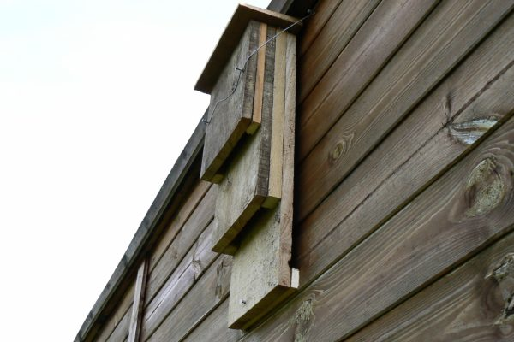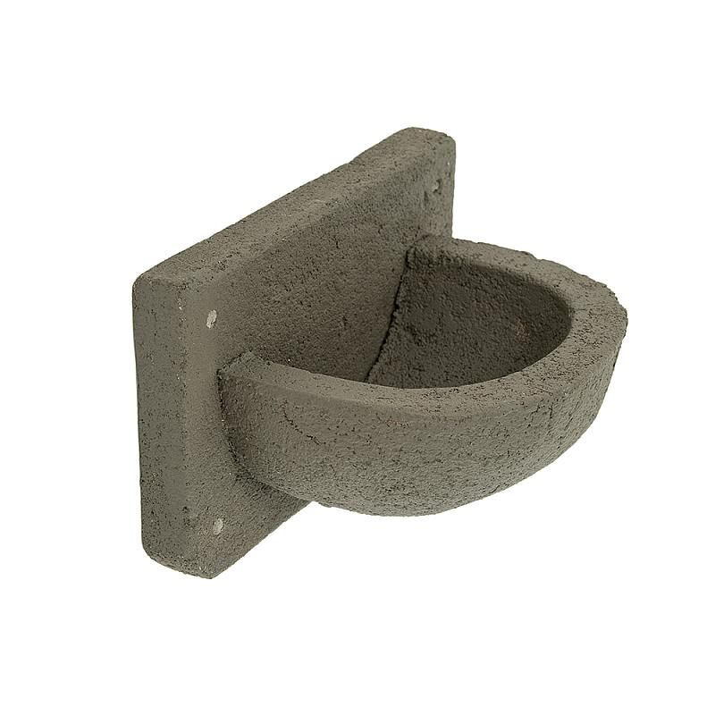
- Bat or Bird Box
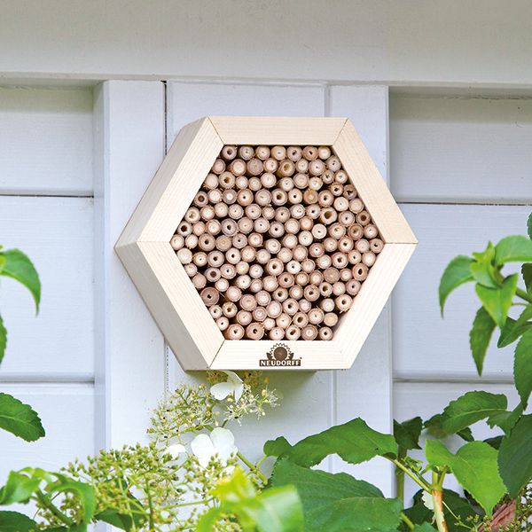
- Insect Box
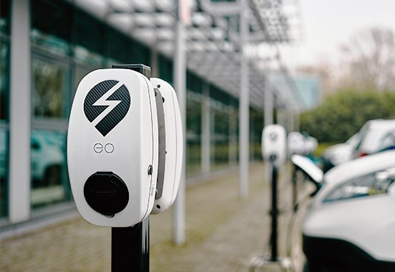
- Electric Vehicle Charger Point

