The pictures below show where the new door would be. The size of the window would change from 1.91 m x 1.41m to 1.91m x 2.00m.
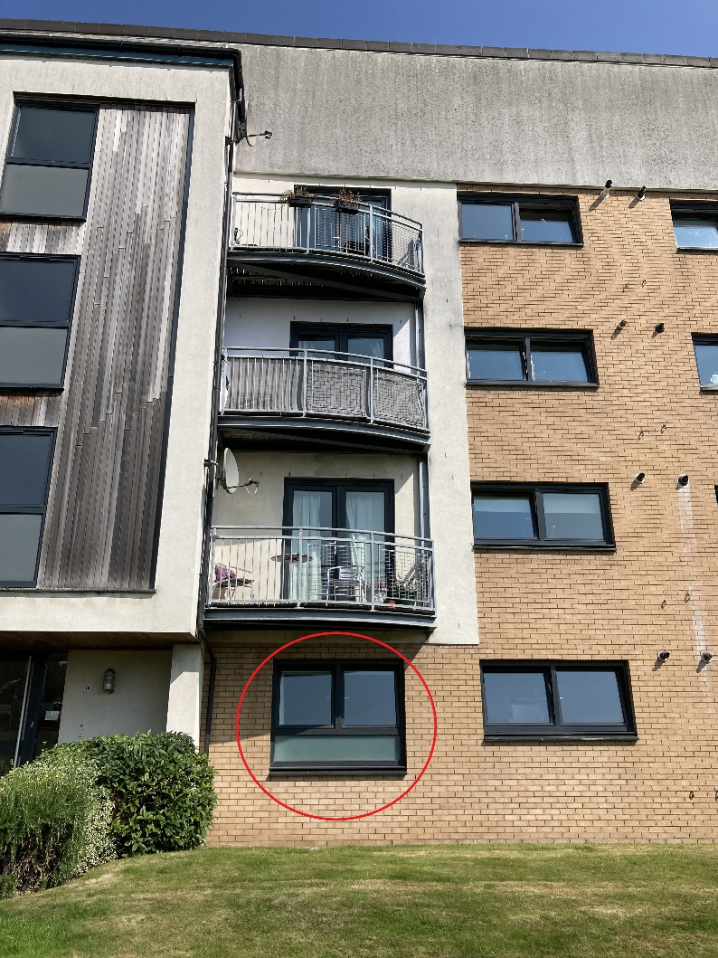

The below pictures show the patio doors and balconies of the other properties.
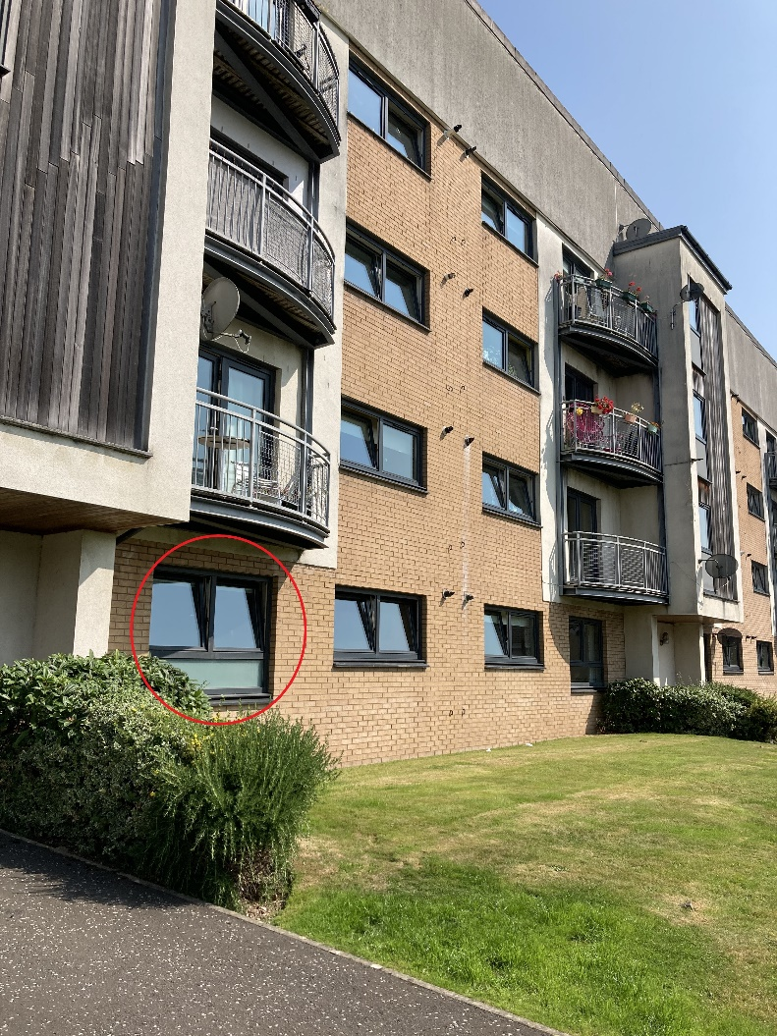

The site overlooks no other residentail propery as shown below.
