Planning condition number 2 : You must apply to us for approval of samples and specification of the facing materials you will use, including glazing, and elevations and roof plans annotated to show where the materials are to be located. You must not start work on the relevant part of the development until we have approved in writing what you have sent us. You must then carry out the work using the approved materials. (C26BD)

Sample 1: Penrhyn County Slate
Application: New Welsh slate roof covering St Marylebone Parish Church
Supplier: Welsh Slate Ltd, Penrhyn Quarry.
Product reference: Heather Blue, County grade.
Size: 500mm x 300mm.
Head-lap (minimum): 105mm.
Fixing: Two nails each slate.
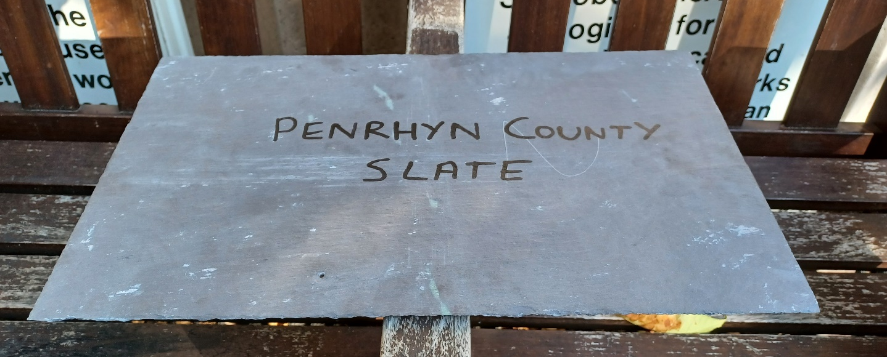

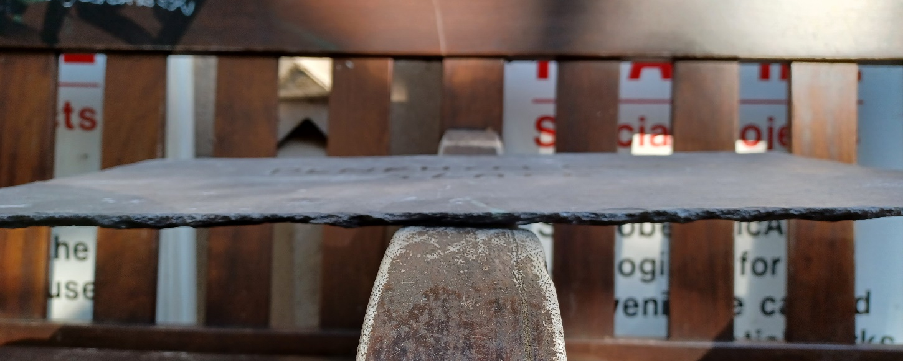

Sample 2: Lead, code 8 to be milled.
Pre-treatment: Chalk emulsion paint by Rowan Technologies Ltd
Application: Lead weathering to cornice, lead guttering, lead platform for M&E plant, guttering, caping to parapets, lead covered timber rolls to the ridge and hips, covering to transept roofs, soakers, lead covered finial & new ventilation turret clad in lead with lead upstand.

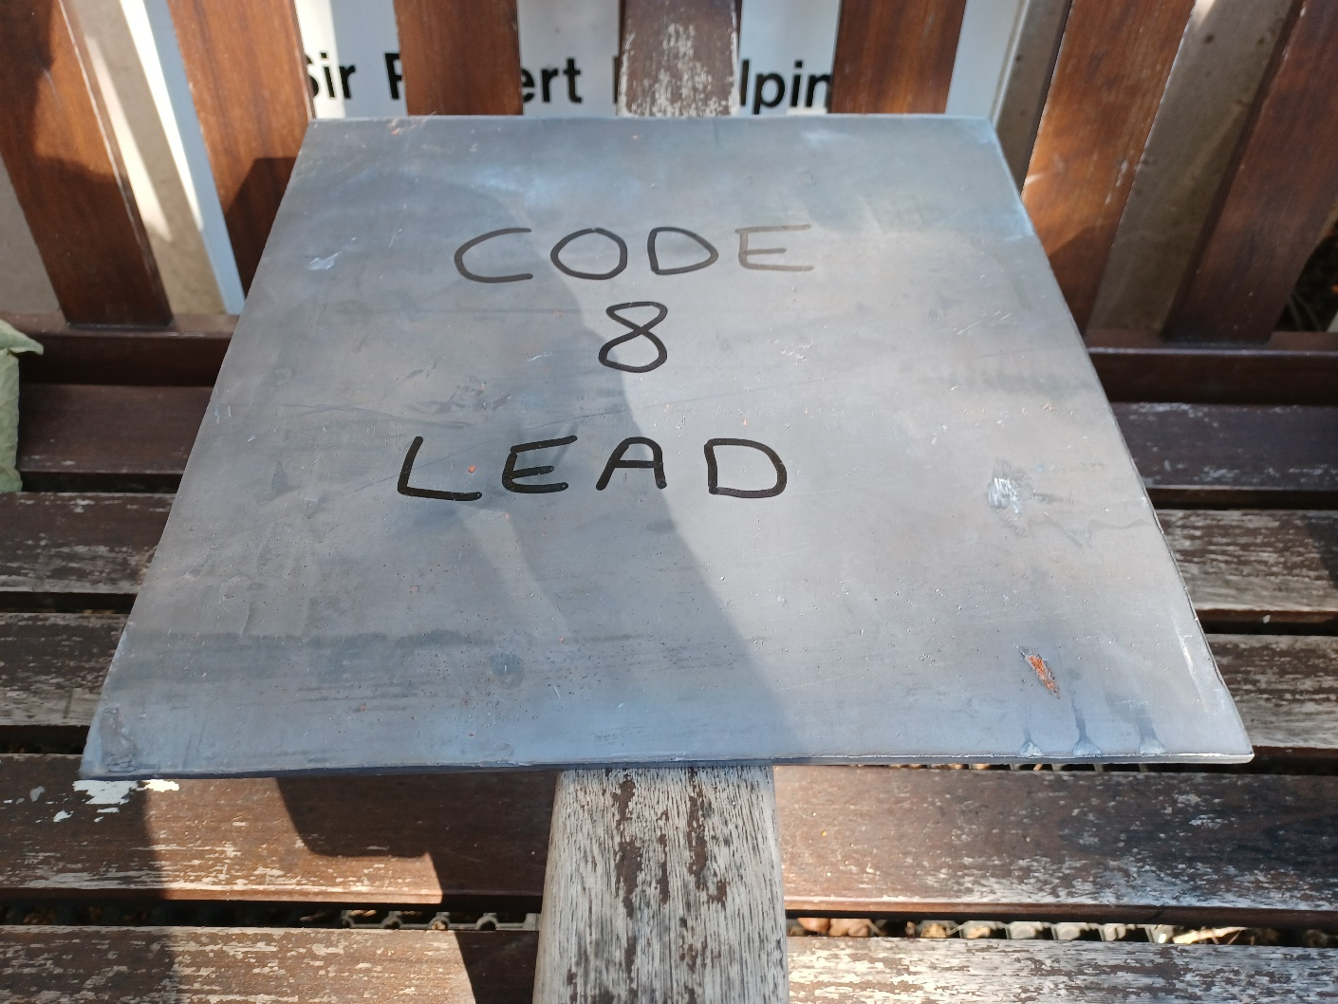
If required, the samples can be sent to WWC (please provide address) or inspected on site.

