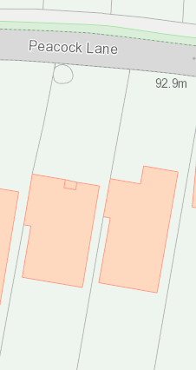
84

Not To Scale
N

T1
T1 – Semi mature ash tree that stands at 8m tall over the entrance to the drive of number 84 peacock lane. There is evidence of a heavy reduction from several years ago. The canopy hangs over the road and drive. The vigour is low and there is deadwood throughout the crown. The tips are dying back all round the crown showing evidence of Chalara Infection. The tree is shedding deadwood over the drive and road. It posses a risk to the safety of the public, the residents of number 84 and the neighbours at 82.

