NOTES:
With regards to approval for the sewage treatment plant, previous planning approval has been granted for this in application PA20/03320.
My only reason for mentioning this in the current application is that the works have yet to be undertaken so wanted to ensure this carried forwards.
In the previous application, percolation tests were agreed to be undertaken at Building Regulations stage, as the approval for the detached office with bathroom may impact on the size of the plant required. We will work in line with this and undertake these tests upon approval of the planning application and when we know if the office also gets approval.
It is not possible to connect to the mains sewage in the area as it is over 200 metres away from the proposed dwelling. Please see email for separately attached details from South West Water. I have circled the site in red on both the mains water and sewage maps.

The site is not within a Source Protection Zone:
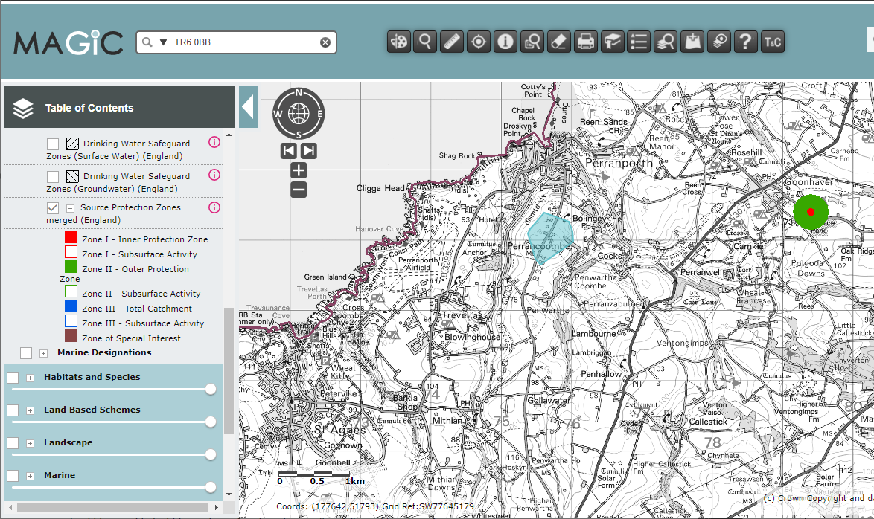
(Pale blue marquee shows location of site)

The client has said the water treatment plant will be a Klargester BioDisc domestic water treatment plant (or similar spec from a competitor) which does not discharge anything other than clean water. The unit will be professionally installed by certified installers.

Many of the neighboring properties have these types of systems in place, as there is no access to sewage connections in the vicinity.

