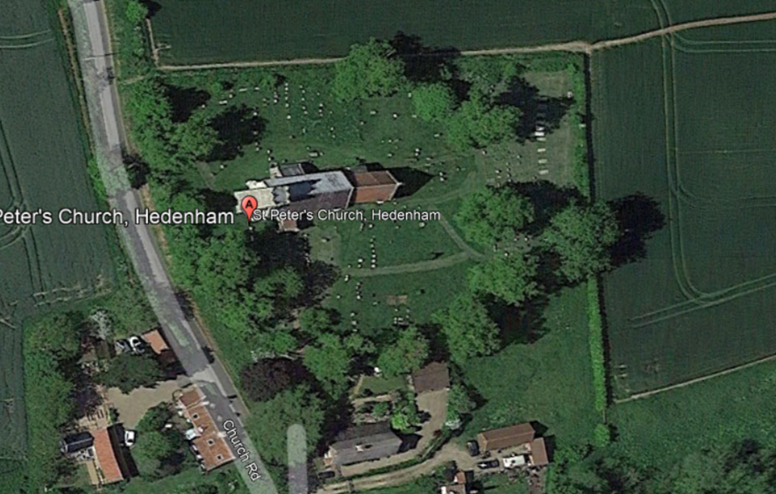
T13
T12
T11
T100
T9
T8
T7
T6
T5
T4
T3
T2
T1
T1 (Tilia sp.) – Remove epicormic growth, crown lift to give 2.5m clearance with the ground. Remove top 8m of deadwood – high risk of failure if left.
T2 (Tilia sp.) – Crown lift to provide 2.5m clearance with the ground and remove any deadwood.
T3 (Tilia sp.) – Remove epicormic growth, crown lift to provide 2.5m clearance with the ground.
T4 (Tilia sp.) – Crown lift to provide 2.5m clearance with the ground and remove any deadwood.
T5 (Tilia sp.) – Crown lift to provide 2.5m clearance with the ground and remove any deadwood.
T6 (Fraxinus excelsior) - Crown lift to provide 2.5m clearance with the ground and remove any deadwood. Sever ivy and remove 1m section from base of tree.
T7 (Tilia sp.) - Crown lift to provide 2.5m clearance with the ground, remove epicormic growth and remove any deadwood.
T8 (Tilia sp.) - Crown lift to provide 2.5m clearance with the ground, remove epicormic growth and remove any deadwood.
T9 (Tilia sp.) - Crown lift to provide 2.5m clearance with the ground, remove epicormic growth and remove any deadwood.
T10 (Tilia sp.) - Crown lift to provide 2.5m clearance with the ground, remove epicormic growth and remove any deadwood.
T11 (Tilia sp.) - Crown lift to provide 2.5m clearance with the ground, remove epicormic growth and remove any deadwood.
T12 (Tilia sp.) - Crown lift to provide 2.5m clearance with the ground, remove epicormic growth and remove any deadwood, reduce overall height and lateral branches by 2-3m.
T13 (Prunus avium) – Crown lift to provide 2.5m clearance with the ground and reduce by 1m over footpath.

