Householder extension Design and Access Statement

Proposal
Two storey side extension removing existing workshop/garage, and adding porch, garage, family room, guest room and principal bedroom.

Features of existing property
This house built in 60s/70s is on a hill overlooking several other properties that have been built since. It is brick built, with a full flat roof. Windows are a mix of aluminium and uPVC double glazed and original single glazed windows (under replacement to Aluminium double glazed windows and doors).

This house is a smaller house in a road and general area of medium to large houses. There is no specific design in the area from ultra modern, standard brick and tile and mock Georgian/Tudor in place. All built with a mixture of brick, render, painted brick and cladding (tile, timber and composite).

Access to the house
The existing drive remains, with the new entrance porch providing level access via new step free path. Rear garden access changes from narrow stepped door to sliding doors to provide level access, allowing amenities of the garden to be utilised, not currently feasible.

Environmental impact
Insulation added to the property including spray foam to existing roof and cavity wall insulation. Adding UFH and insulation to ground floor in conjunction with a retrofit Heat recover& ventilation system to provide efficient and comfortable heating.
Avoid excess transportation to and from site by utilising on site rubble and earth for hardcore and landscape levelling.
Built utilising timber for greatest efficiency in overall insulation and environmental stored energy.

Scale/appearance of the proposed design
In consideration of neighbouring outlooks the elevations are to run in parallel with the existing walls as opposed to the fence line. This, in addition to stepping back of the first floor and having no elevation beyond existing front and rear walls, ensures the extension is subordinate to the original house and of appropriate scale to its neighbours. The new front and side elevation are a rendered ground floor (ie K-REND “causeway”) with silvered wood cladding to the upper floor such that to neighbouring properties the design “sinks” into the trees in the area. With new trees/bushes added along the boundary to soften the house.

The extension reflects some of the essential characteristics and quirkiness of the original house and its neighbours without being a pastiche of the designs.

Side windows
The existing house has 8 windows to the side, originally overlooking the valley (Figure 1), however, the newer neighbouring houses and their extensions are now in full view. In consideration of neighbouring privacy only 2 new windows remain to the side elevation with a sill height at 1.7m above internal floor level to maintain secondary light source and visibility of the sky/tops of trees and not gardens.
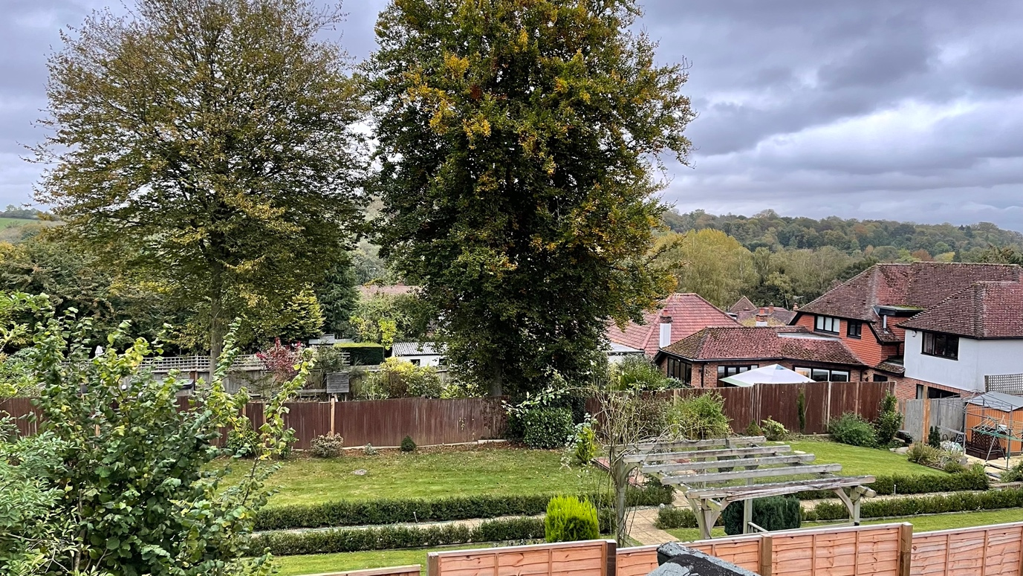
Figure 1 View from existing side windows to be removed with windows at 1.7m sill height

Front Windows
With the first floor stepped back over the garage roof there is no downward view to gardens.
With new trees/bushes added along the boundary to break visibility. IE Amelanchier Alnifolia, that don’t grow too tall as neighbours were keen to have fence. Further, proposed to allow existing bushes to gain further height to ensure existing windows maintain privacy in both directions.

