Heritage Statement for Christ the King Church Notice Boards

Proposal:

Install two notice boards near the external boundary pf the church property for the purpose of communicating church activities to the local community.

Assessment of Heritage significance

The church is listed as Grade 2. It was first listed on 21st July 1987 (National List Entry Number 1201589). Note – This church was formerly listed as BECKWITH STREET – Church of St Anne.
The church was recently reordered, reopening March 1991 as a Church with Community Centre.

Assessment of Impact

The notice boards will have minimal impact on the church building as a heritage asset. They are to be situated adjacent to the exterior boundary wall of the church property. They will be freestanding and not attached to the boundary wall itself - there will be no material impact on the existing church fabric.

The Notice Boards look like this:

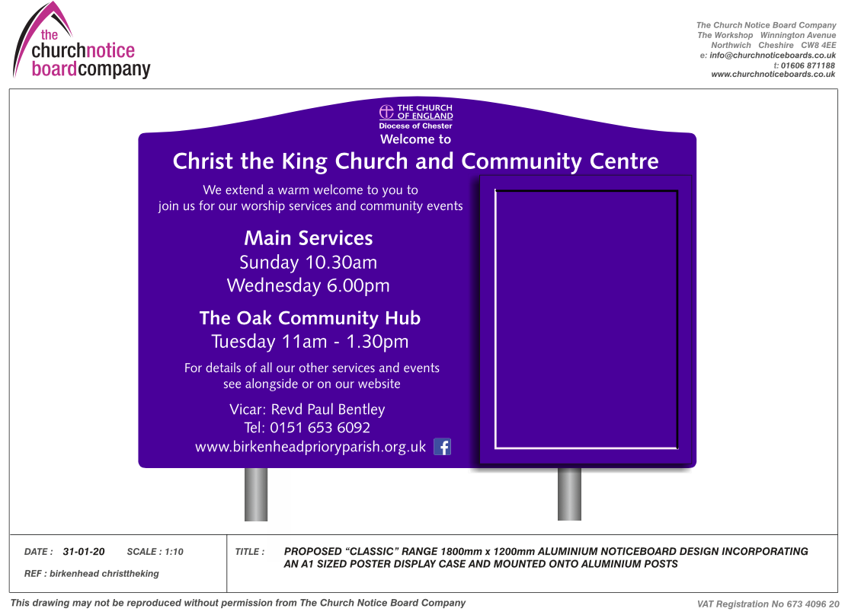

They have been produced by the Church Notice Board Company, and so are of a very high standard of manufacture (including extra cost of anti-vandal paint) and are an ‘off-the-shelf’ size common for churches (1800mm x 1200mm).

The notice boards comprise fixed information, together with an area for current information which can be changed regularly and reflect current activities.

The notice boards will be located in two opposite corners of the church property, within the boundary wall, facing diagonally out onto Beckwith Street, as indicated in the photos below (not to scale).

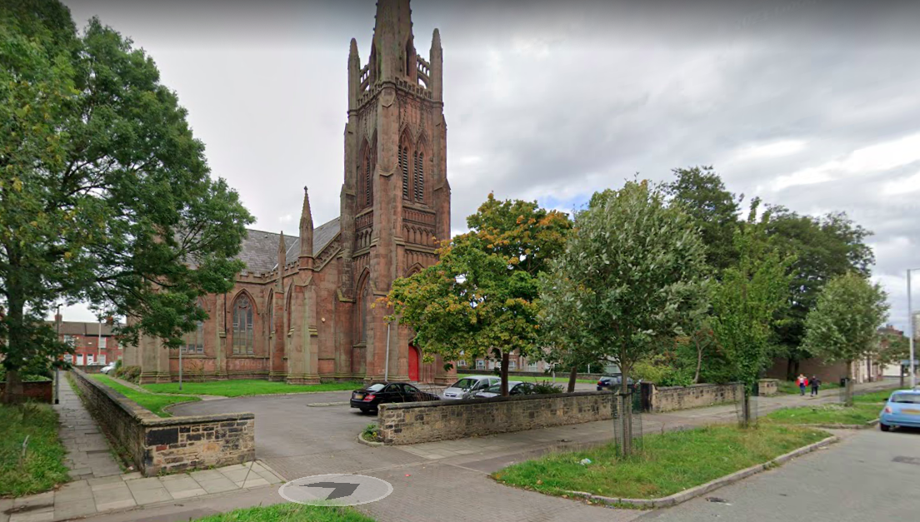

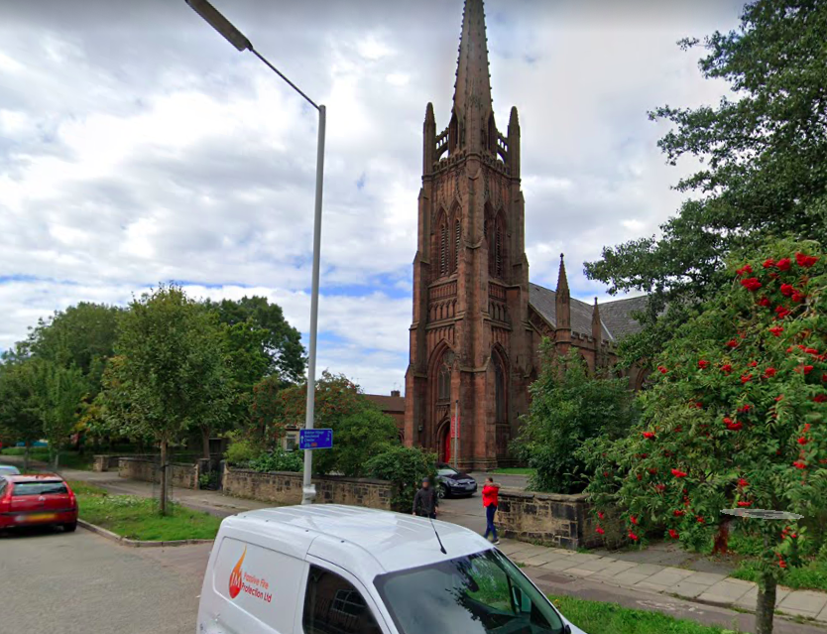

Mitigation

We have chosen notice boards that use the standard colour palette, font and design features for Church of England notice boards.

The notice boards will be installed approximately 21m away from the building and 40m away from each other, resulting in minimal aesthetic impact on the building.

We have consulted our Church Architect (from Ainsley Gommon Architects, assigned by the Diocese of Chester) about these notice boards. He has supported our plans, both in that the notice boards will not detract from the architectural aesthetics of the building, but also that they will help the building fulfil its designated function as an active Community Building, rather than a historic monument.
We have also consulted our neighbours and received no negative feedback to our proposed notice boards.

Previous church notice boards have been affixed to the church building itself at high level, which made it very difficult to see the information unless right next to the building. These new notice boards will be located at ground level to the exterior of the grounds, with a priority on making current information available to the local community as they pass.

We feel that the benefits of installing these notice boards outweighs any potential negative impact on the building. We are driven by a passion for seeing people’s lives improved, for connecting with disenfranchised people and providing opportunities and a framework for people to find a way out of loneliness and social and economic poverty, issues endemic to our area. If people don’t know about these opportunities, they cannot benefit. These notice boards are part of our commitment to ongoing engagement with, and service to, our local community.

