Photo 1: Front Elevation of Hillside Cottage showing the 5 front windows to have secondary glazing
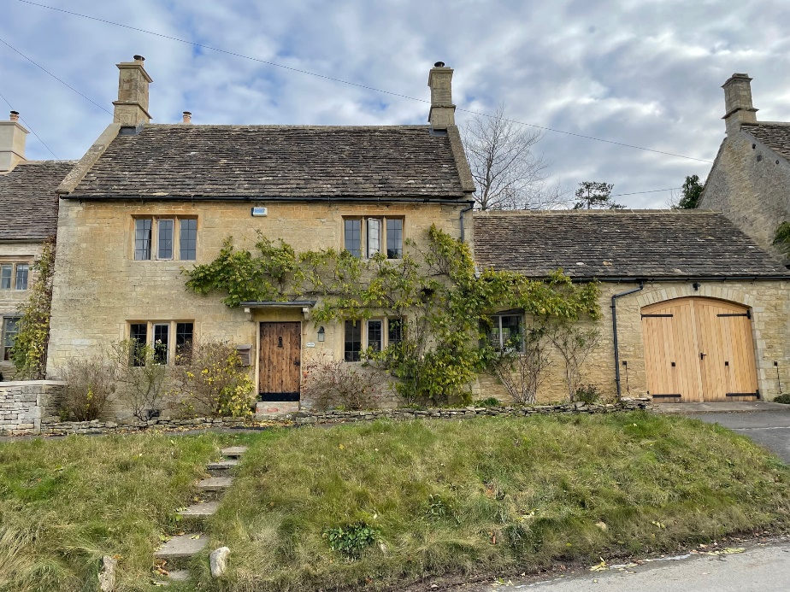

Photo 2: RHS elevation showing 2 second floor windows to have secondary glazing
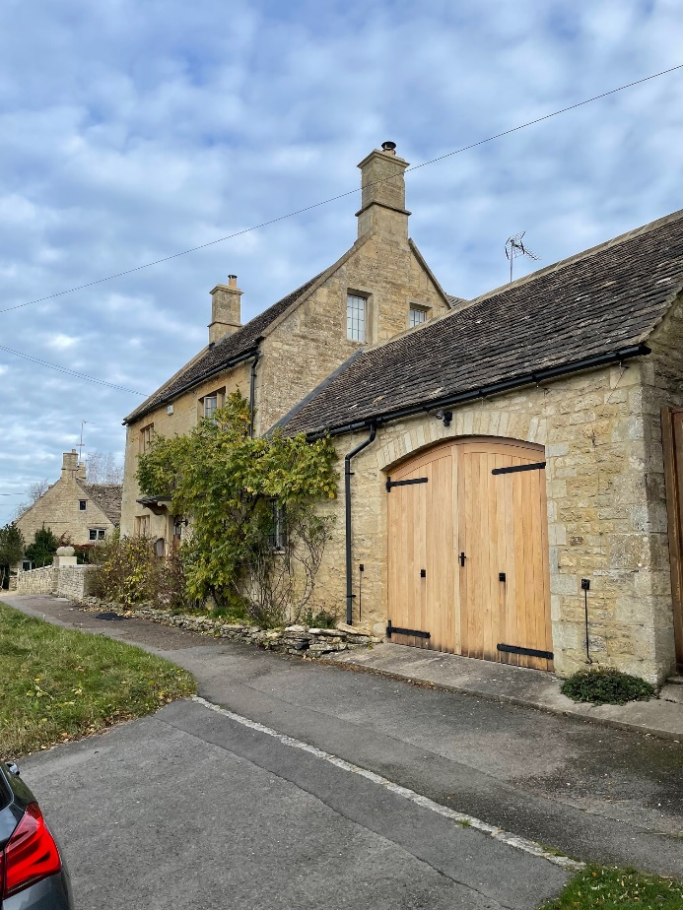

Photo 3: LHS elevation showing 1 second floor window to have secondary glazing
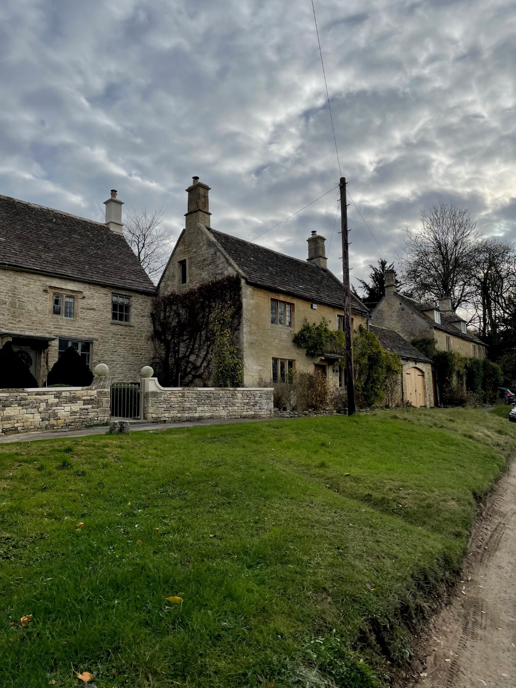

Photo 4: Front and RHS elevation from across the village green showing the front windows and RHS windows to have secondary glazing
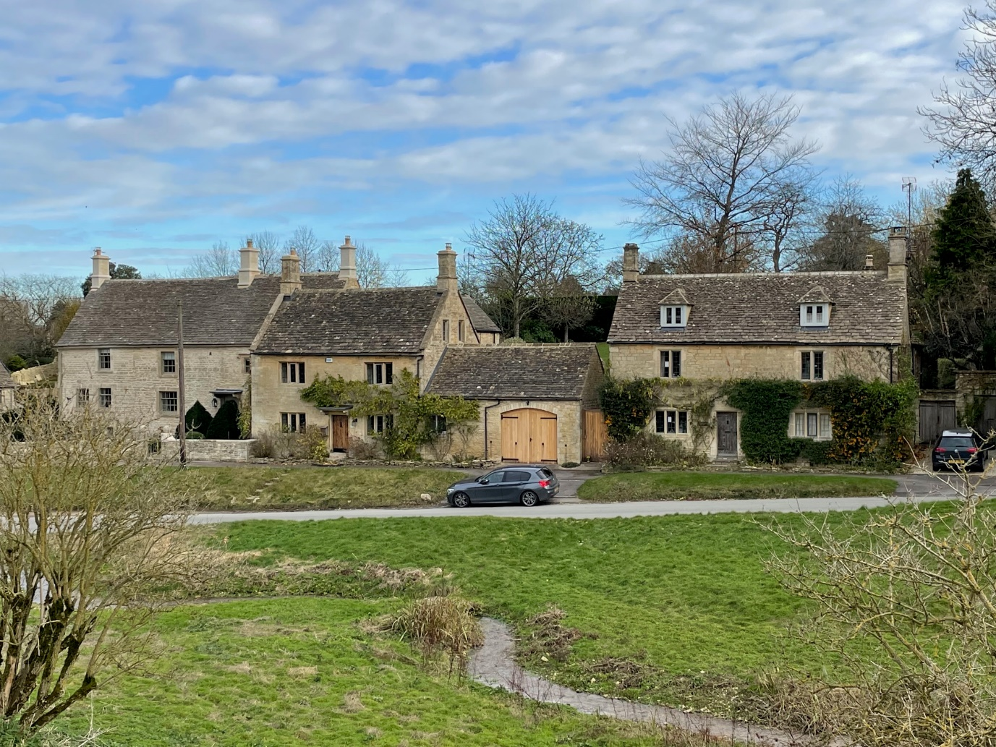
Photo 5: LHS elevation from afar showing second floor window to have secondary glazing

