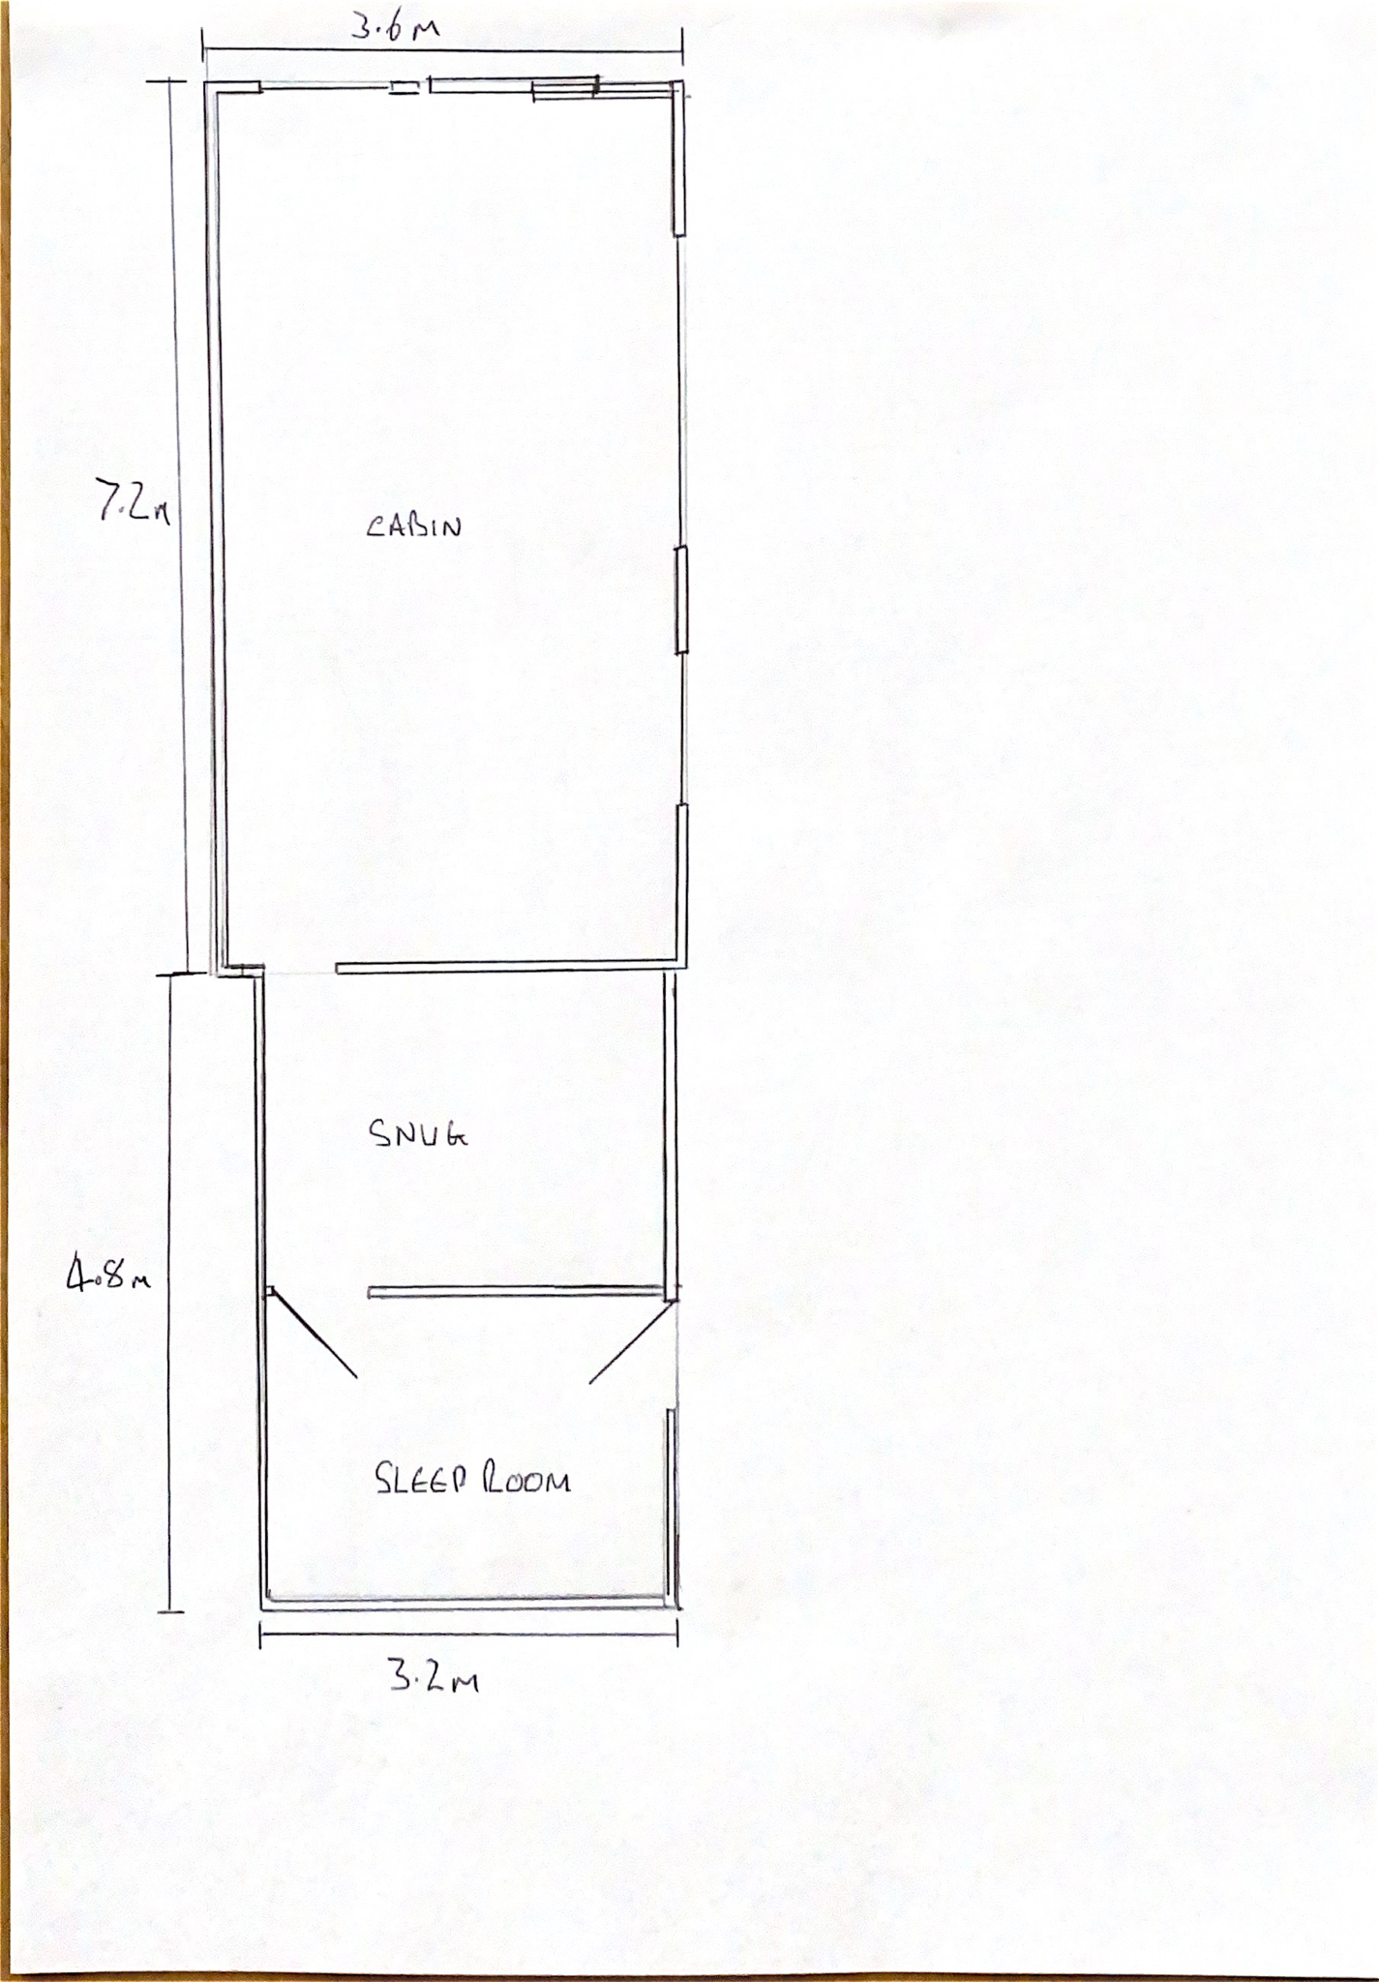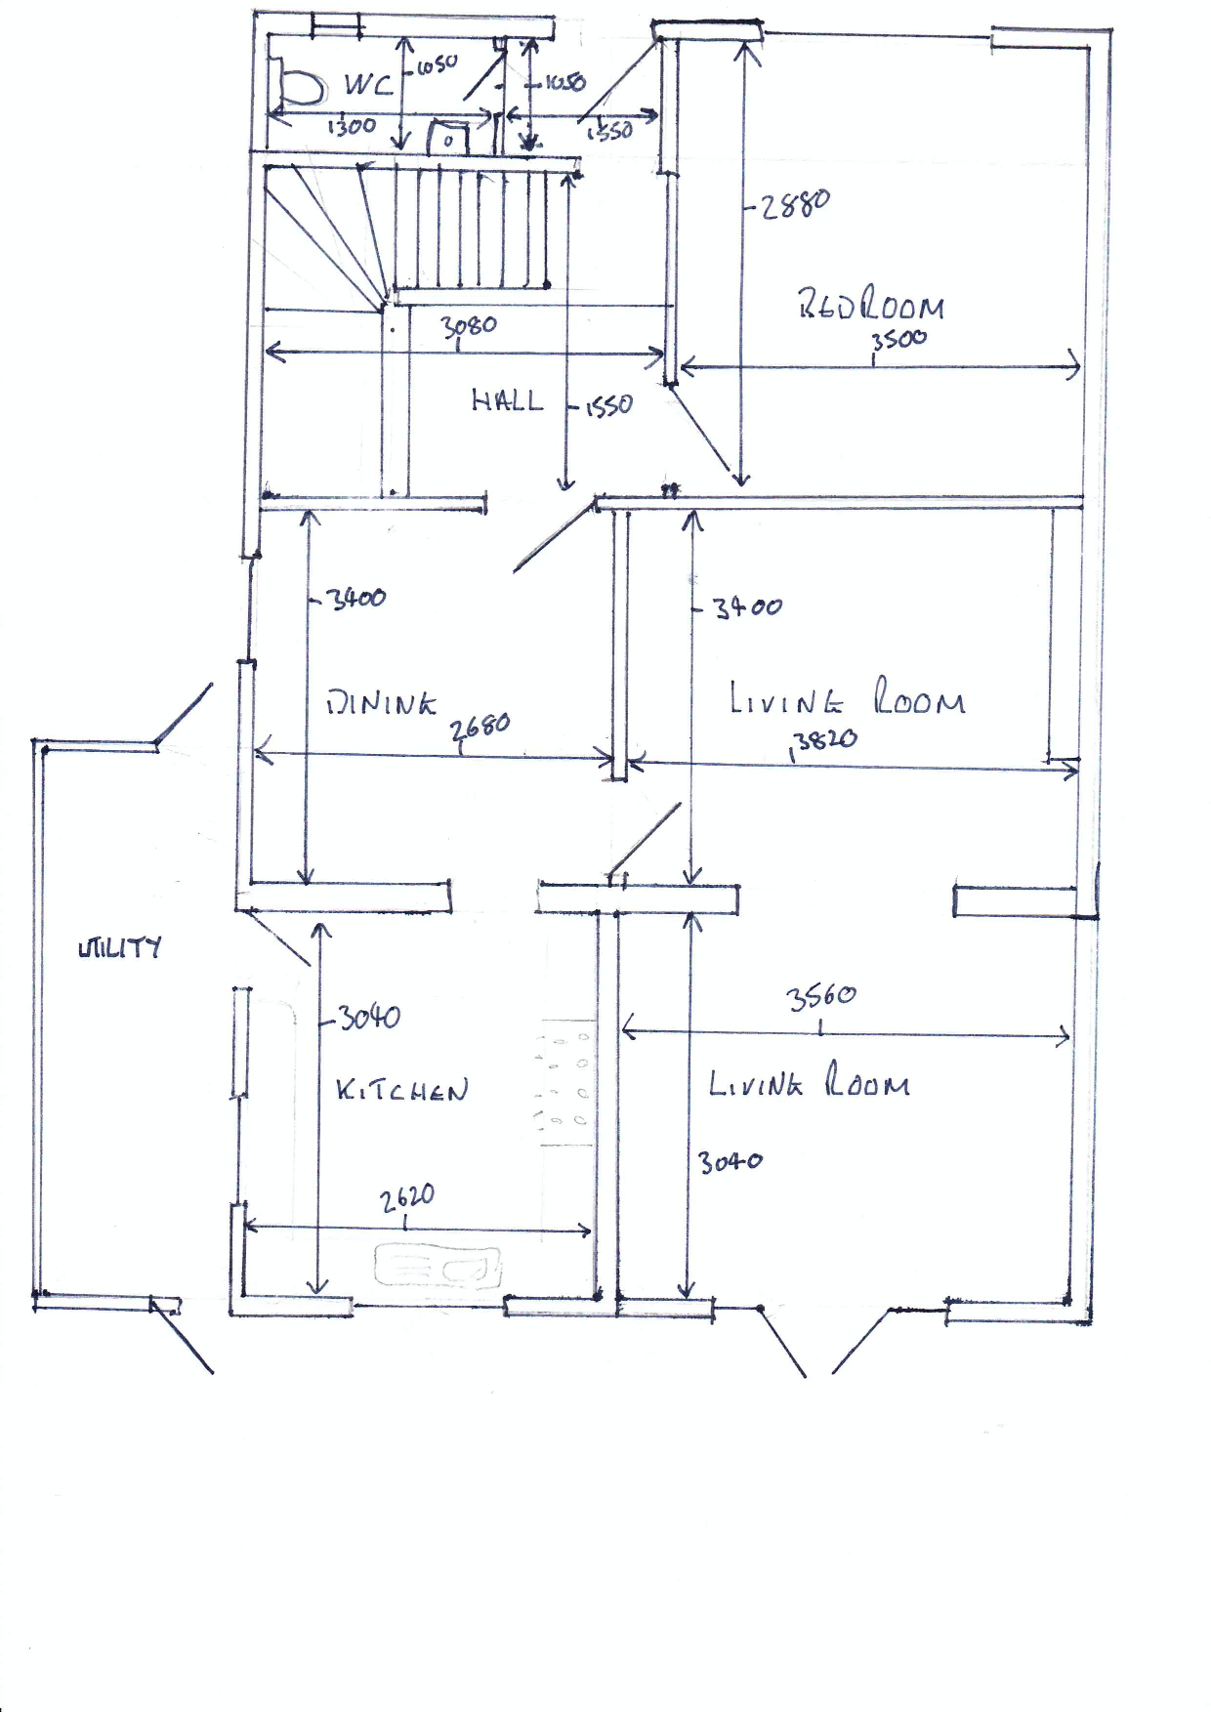

Parking for 3 cars

Storage Area

Grass

Decking area

Cabin aprox 4.8m from house