Design and Access Statement

4 Beverley Court, Stourport, Worcs, DY13 8SB

Full Planning Consent Application for:

Converting one dwelling into two dwellings.
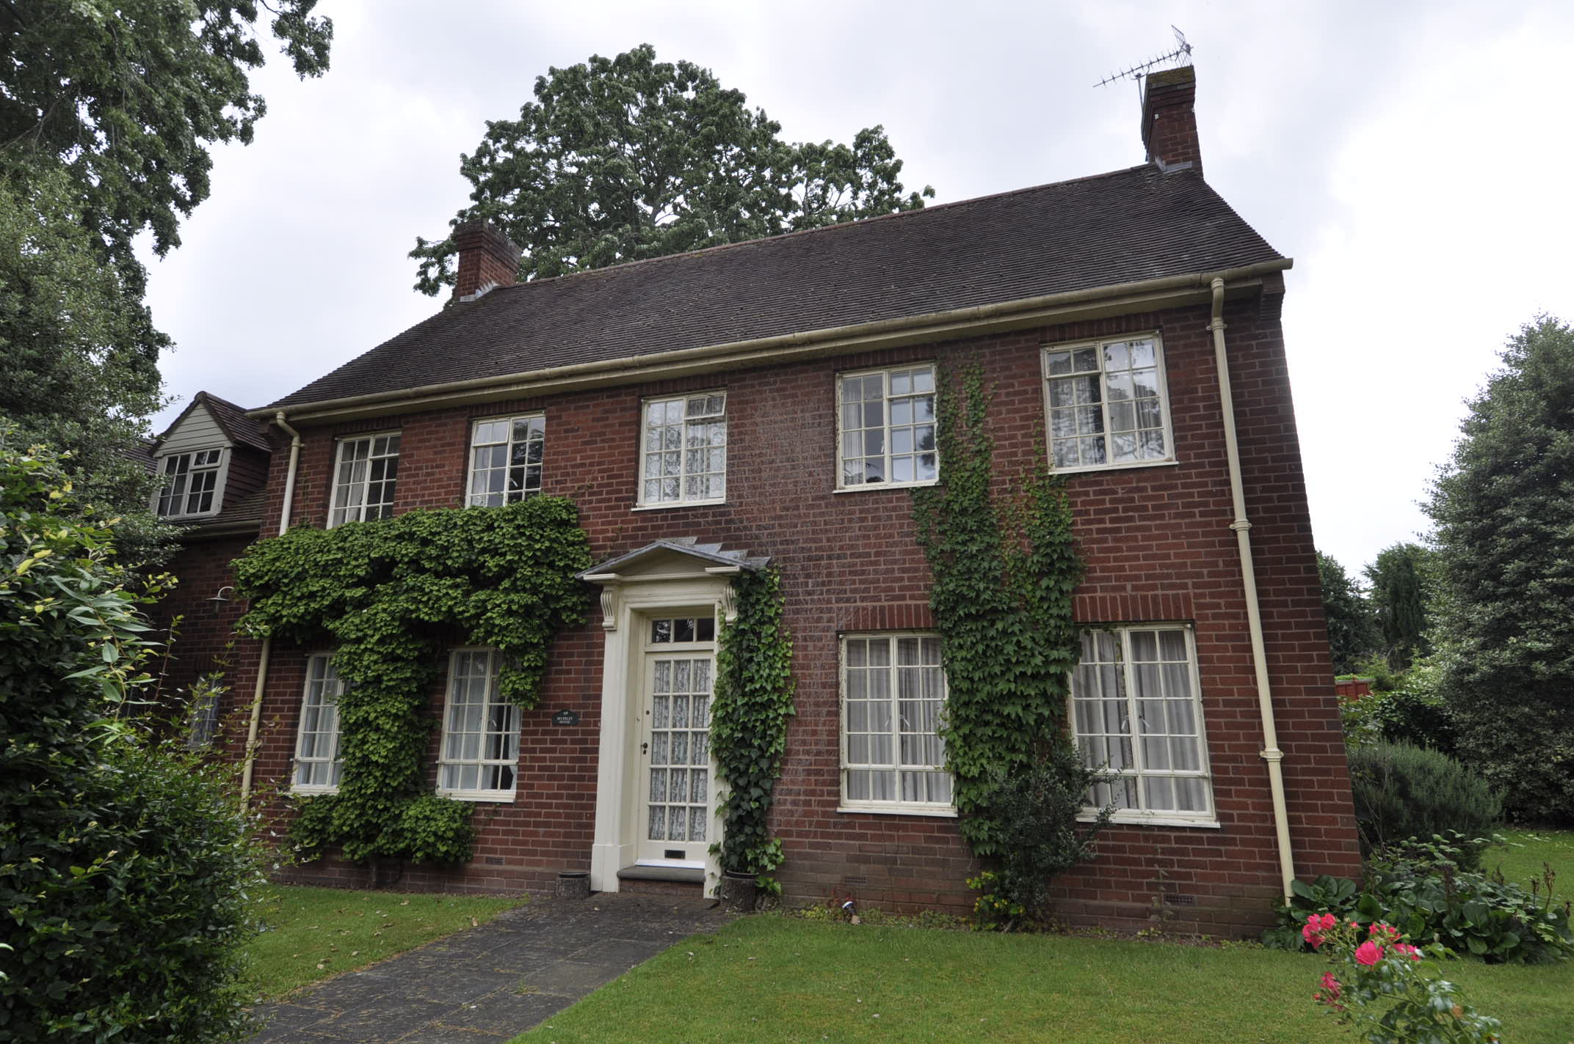

January 2022

Use
The current use of 4 Beverley Court is a single dwelling. The dwelling is currently unoccupied.
The proposed changes to 4 Beverley Court are to separate the current dwelling into two.
The building sits within a residential area in the centre of Stourport.

Amount
The building will be subdivided into 2 dwellings which fits with the current internal space. A modest kitchen extension will be added on to No4 which will be within permitted development rights.

Layout
The dwellings will be separated along the line of the roof step. The main living accommodation will be on ground floors. The bedrooms and bathrooms are situated on first floors and in the loft space. Both units have a generous rear garden size.

Scale
The scale of the building remains the same with no change to the massing of the building. There will be an addition of three dormers to main house facing east.

Landscaping
New fencing will be added to provide the new boundaries between the two dwellings. Additional parking is provided in line with current planning standards. The parking area is separated off from the rest of Beverley Court for privacy, and makes use of the existing driveway and footprint of the demolished shed.
A new pathway will be provided to the principal entrance doors of both dwellings, this will be in porous block paving and no-dig construction in RPA areas as shown on the tree protection plan.

Trees
Trees to be removed are T01 Deodar Cedar and T03 English yew. Wyre Forest District Council’s Arboricultural Officer Alvan Kingston has been consulted on this matter and accepts that T03 can be removed to facilitate development and that T01 can be removed due to overshadowing of properties and that limbs have fallen in the past dangerously close to the buildings.
Both trees will be replaced in consultation with Alvan.

Appearance
The appearance will remain the same. The new dormers will match the current style of the existing dormers on the building. In addition to this, the new dormers will be added into the loft space to gain more light into the proposed bedrooms.
A new window will be inserted in to 4a where currently there is a garage door.
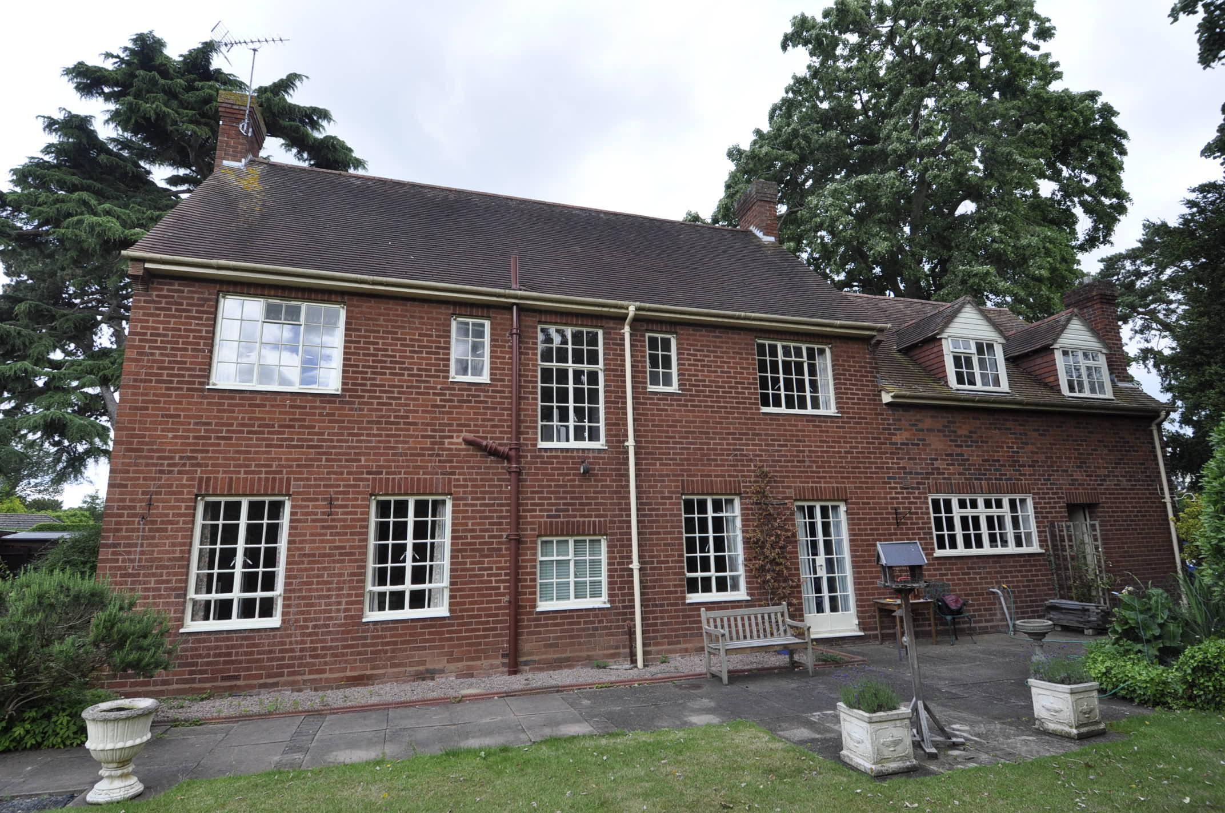
Rear of 4 Beverley court

Access
Access to the site will be off the communal drive to Beverley Court.
Parking spaces will be off the communal drive.
New paths from the parking areas to principal entrances will be constructed to form a level access.

