Design, Access and Heritage Statement

Chimney Repair
The Grange, Norwich Road
Stonham Parva, Suffolk, IP145LX
About the Grange
The Building and its significance.
The Grange dates back to the early 16th century and is of timber frame construction. This former farmhouse is two storey and T shaped in plan.
House, built in 2 main stages, early C16 and late C16. 2 storeys. Timber- framed and plastered; the framing is exposed along the upper front elevation, with plaster infill. Close-studding, with exposed joist-ends giving evidence for a formerly jettied upper floor along the front of both phases (the second phase, to left, is distinguished by ogee-curved arch wind-braces). Concrete plaintiled roofs; an axial chimney of c.1600 with flattened hexagonal shafts of red brick. Mainly C20 casements with transomes. C19 6-panelled entrance door, with a C20 enriched architrave in the C18 manner. Late C20 plaintiled gabled timber-framed entrance porch. The early C16 phase to right is a 3-bay parlour cross-wing; heavy unmoulded framing with altered crownpost roof, one crownpost being of cross-quadrate form with broach-stops. A small integral wing to right has an exposed moulded gable tie-beam. A number of blocked diamond-mullioned windows. The hall range was rebuilt in late C16 with heavy unmoulded framing. A lintelled hall fireplace and another with a plastered arch in a chamber. A number of blocked roll-and-cavetto moulded mullioned windows. 2-tier butt-purlin roof with wind-bracing. The pond is thought to have been part of an early moat. There is evidence of a previous jetty arrangement and the property has significant quantity of the original 16th century framing remaining which forms the basis for its historic interest.
Setting
The building lies to the west of Stone Street, a Roman road that connected Coddenham to Caister in the 1st Century. (Now the A140). The Grange is set within a wide area of arable land behind boundary hedging. Waltham hall (a grade 2 farmhouse) lies to the east.

Description of Proposed Works.

Please see the attached plans provided by the structural engineer.
Essentially the work in summary was to underpin the chimney with screw piles to prevent further subsidence, which had resulted in significant deterioration to the masonry (photo shows 1st floor east wall)
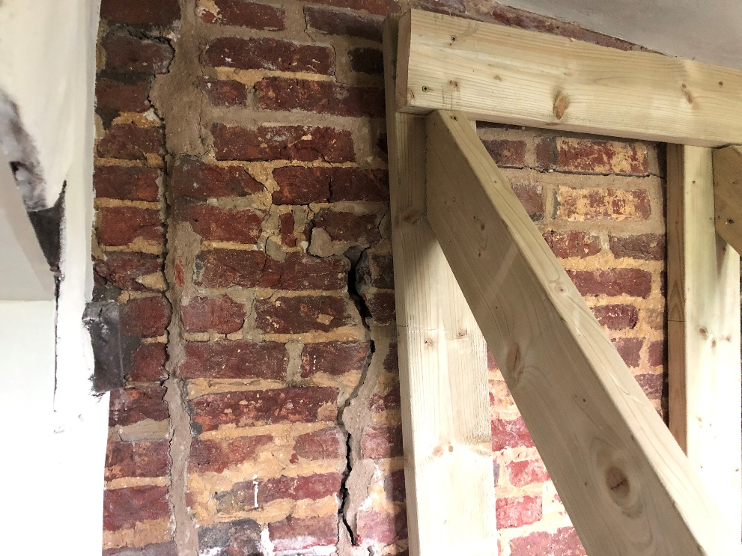
Photo below shows ground floor east chimney wall:
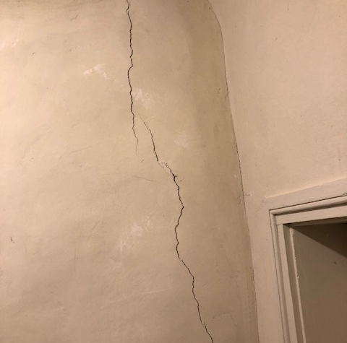
Impact on the significance of the building.
The screw piles are under the ground and will support the chimney foundations and wont be seen.
The first floor bedroom wall has been rebuilt using innkeeping/period brickwork.
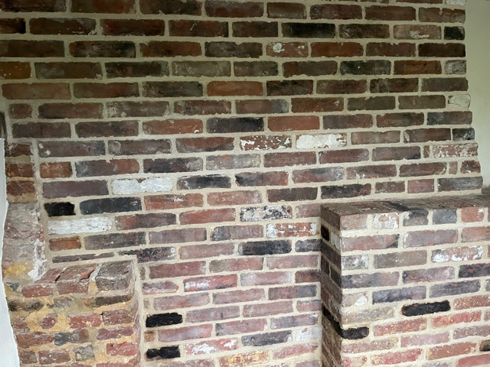
The impact is thus minimal.
Justification.
The chimney (and thus house) was in serious danger of collapse due to settlement, most likely caused by increased wet/dry weather (sitting on clay), exaggerated by water run off (from the tarmac road), traffic vibration (close to the road). There was no option but to carry out the works.
Mitigation
No harm will be caused to anything of historic significance, most of the original bricks were reused and further innkeeping bricks were purchased locally.

Access to the Property.
This will remain unaltered.

