Heritage Statement
For the replacement windows to be carried out at
6 Ponsonby Place, London SW1P 4PT
Current use:
This residential building is in a terrace row of properties located within the Millbank Conservation Area (28), is of 4 storeys including a basement. There are no Article 4 directions for this area.
An extract of the Conservation Audit for the immediate area is as below:
4.19 The properties along Ponsonby Terrace and Place leading off Millbank are less grand. They retain a uniform appearance and are of stock brick with typical detailing including channelled stucco ground floors and Italinate style window surrounds, many retaining the flat pediment with brackets. Simple cornice details remain to the parapet completing the composition of the facades. The roofline remains remarkably intact, with London roofs set behind the parapet cornice and the regular rhythm of the chimney stacks and pots providing interest to the skyline. The slight projection of some properties provides a subtle detail and overall structure to the terraces. Painted, timber single glazed sliding sash windows of the original design predominate. Many original timber panelled doors also remain. Further guidance on repair and alteration to these properties can be found in the Westminster City Council’s ‘Pimlico Design Guide’.
Proposal
It is proposed to remove and replace the existing vertical sliding sashes to the front and rear in hardwood to match the existing sections with double-glazed panes to provide improved u-values. The interior fixtures and fittings will be replaced, if necessary, with goods to match the existing. The finish will be white painted gloss or satin. Sash window spiral balances will be used to replace the pullies and sash cords.
The Appearance will not be detrimental to the existing structure, appearance and the surroundings
The Heritage Assets will not be affected by the proposals
Sustainable Design Principles will be used throughout.
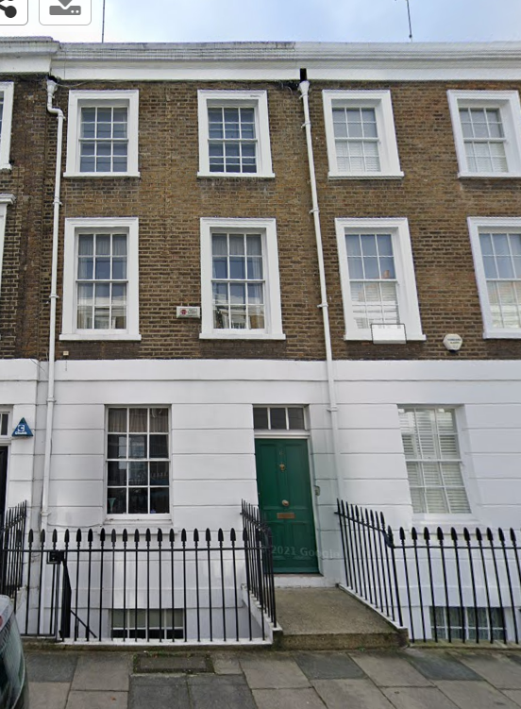
Anyards Designers & Surveyors Ltd
Ref 4313

