MEE'S WOOD
19D St Peters Road
Wellesbourne
Warwickshire
CV35 9PJ
Tel: 01789 638654
Mob: 07763 092535
07789843624 (Shelbee)
Jack-meeswood@outlook.com
www.meeswood.co.uk

Incorporating
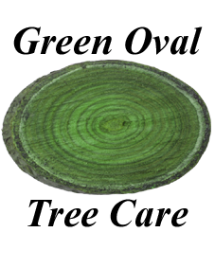

To whom it may concern,

The trees are situated in the hedge on the steep canal bank. I have split my assessment into the individual trees, starting in the far corner of the garden.

T1. Lime tree, showing signs of previous pollarding but overall healthy condition. I would recommend re-pollarding to prevent excess load on the cambium growth.

T2. Lime tree, showing signs of previous pollarding but overall healthy condition. I would recommend re-pollarding to prevent excess load on the cambium growth.

T3. Sycamore, long history of heavy pollarding. Decay at all old cuts. I recommend re-pollarding to prevent excess load on the cambium growth.

T4. Sycamore, long history of heavy pollarding. Severe decay at old cuts and showing fruiting bodies of Laetiporus and significant decline as a result. I recommend re-pollarding to prevent excess load on the cambium growth and heavily decayed unions.

T5. Sycamore, long history of heavy pollarding. Severe decay at old cuts and showing fruiting bodies of Laetiporus and significant decline as a result. I recommend re-pollarding to prevent excess load on the cambium growth and heavily decayed unions.

Jack Mee

Meeswood

