Planning application – W22/0418 - Heritage Statement – 23 St Mary’s Crescent, Leamington Spa. CV31 1JL

Proposed alterations and a single storey extensions to the rear of the property.

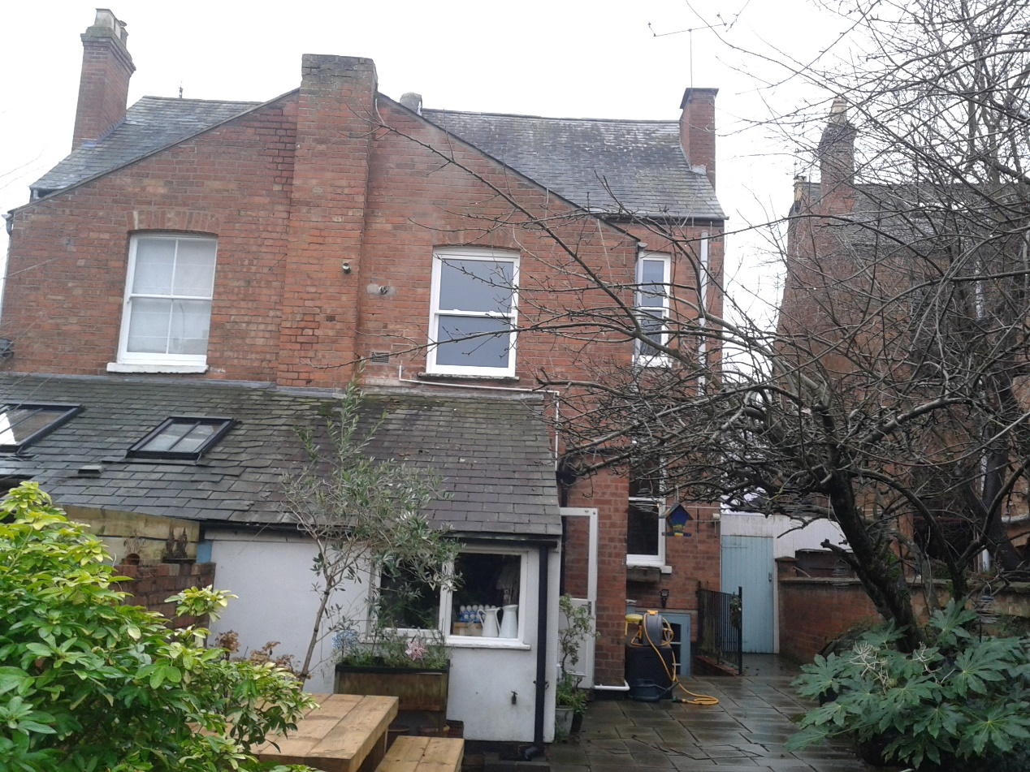

Existing rear elevation

The site:-

The application site comprises of a semi detached property located in a predominantly residential area. The main amenity space is to the rear of the application property.
The property not listed following checks on the Historic England website but the application site is located within the Leamington Spa Conservation Area.

The proposal

The proposals are small in scale and consist of removal of the existing mono pitched roof element to the rear of the existing building. Re build this element of the building on a slightly wider footprint with a raised roof line. There will be a parapet wall formed on the boundary abutment to the neighbouring property to provide a weathered roof line interface.

The proposed re built element / extension will be formed from facing brickwork, style and colour to match existing with a slate roof tile to be similar to match the existing property. The rainwater goods will match the existing building. The windows and doors will be formed in white aluminum with conservation roof lights formed in the slate roof covering.

Please refer to accompanying drawings which illustrate the size and location of proposed works.
Some pruning will be required to a tree located on the site which we understand will be carried out under a separate application.w21/1349

Assessment of the impact

The proposals are small in scale and will replace a rendered element of the structure with a more in keeping brickwork façade. The proposed works are to the rear of the existing building and will not affect the street scene appearance of the building or affect any historically elements of the building or local area. The proposed raised roof line will enhance the internal headroom space within the enlarged room.

Proposed mitigation measures

The proposed extension / alterations will be formed in matching materials to the existing building, for example reclaimed brickwork and a slate roof covering. The proposed parapet wall will also be formed in brickwork with a blue brick coping section. The proposed new roof lights will be a conservation style. The proposed new glazed elements will be white painted aluminium which will attractive in appearance and slimmer in profile than a upvc window or door. The glazing will be double glazed to enhance the thermal performance of the building. In additional the slightly increased footprint of the extension will be in balance to the existing building.

The proposed alterations / extension element will not impact upon the street scene as it will be visible from the rear of the property. The design and scale are considered to be acceptable as this in keeping with the style of the existing structure at the rear of the building and similar to the neighbouring properties. The proposal is not considered to have a detrimental impact upon the character of the house and conservation area as the design follows the palette of material from the existing dwelling.

In our view of the design, sitting and massing of the proposal it accords with development plan policies. With regards to overlooking and impact on neighbouring properties, it is considered that the proposed alterations / extensions is partial screened by the existing neighbour’s building on the boundary.

Overall, the development does not cause any notable harm to the amenities of neighbouring residents and it is considered that the proposed development accords with WDC planning policies.

S.H.Architectural Services Ltd 14.3.22

