The Mews Studio
Peter Ebsworthy MCIAT Architectural Consultant
Contact  The Mews Studio,  3a Fore Street,  Northam, Bideford,  Devon EX39 1AW  l/line; (01237) 475668  mob; 07484172083  admin@mews-studio.co.uk |  | Statement in support of Wildlife Trigger List,  Proposal, 2 storey extension to existing cottage,  Address, Kings Head Cottage, Fore St. Northam, Devon, EX39 1AW  The completed Wildlife and Geology Trigger List attached to this application identifies that the proposed works will affect an existing roof.  Although the roof to this property originates from its build date in the mid 1960’s it is still in good condition, with tightly fitting asbestos cement type slate finish and terracotta ridge pieces.  There are also close fitting upvc fascia boards and soffits to front and rear elevations, and barge boards to both gable ends.  I refer to the attached photograph below.  The occupant advises that they have not observed any bat or bird activity around the roof area.  Therefore in my professional opinion I do not believe that bats or birds will be affected by the proposed works.  Yours sincerely  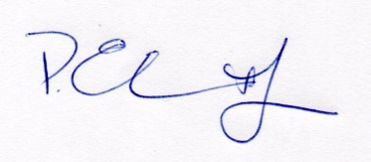  Peter Ebsworthy MCIAT
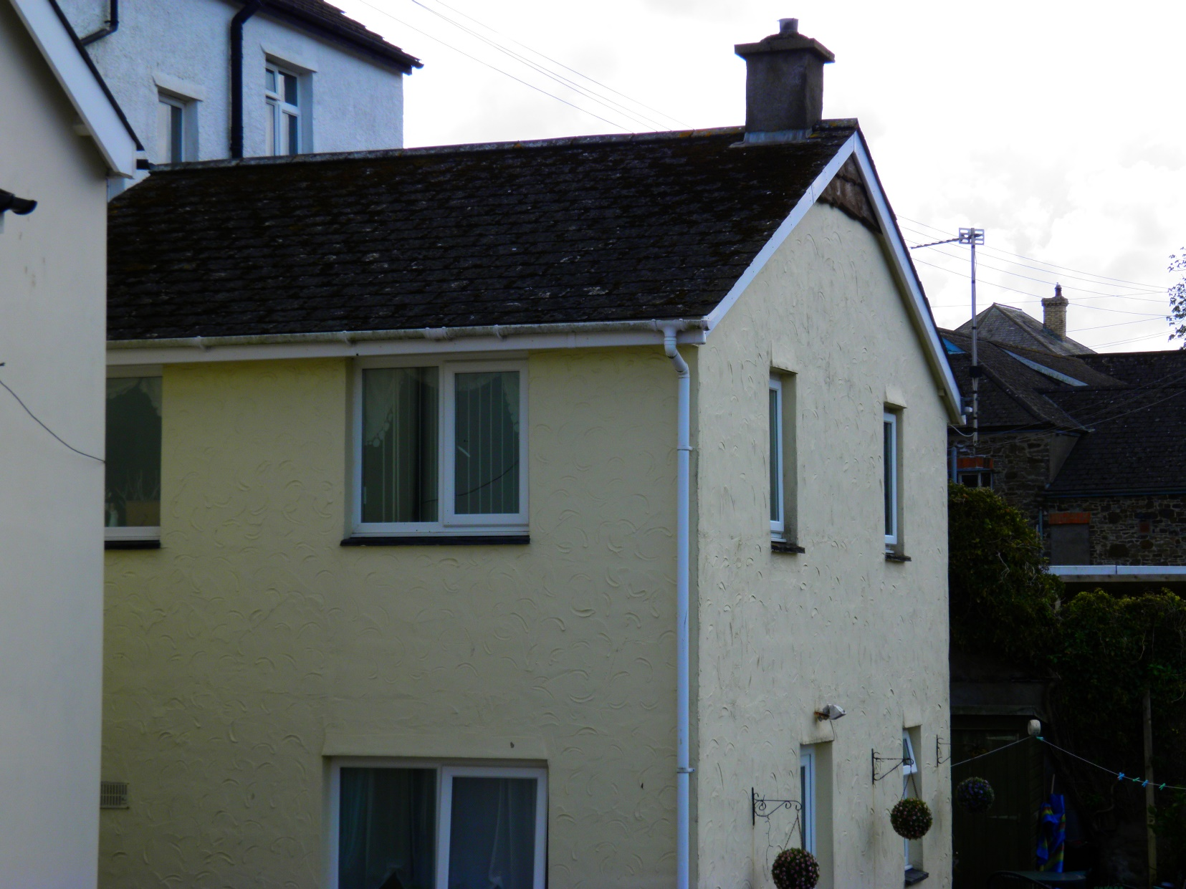

North elevation of Kings Head Cottage, Fore St, Northam.
Asbestos/man-made slate roof covering together with upvc fascia boards etc.

