Design and Access Statement
for
The Rosery, Bulls Road.
Hemingstone. Suffolk. IP6 9RF
Rosery is a grade 2 listed building. The proposed solar array area is to be located in the rear of the garden to the North of the main house. The array will not be visible from the Listed property as it is obscured by the garage and the extension, tall mature trees and hedges and is approximately 45m away. It will also not be visible from any road, public right of way or the nearest residential property.
The underground electric cable from the solar array will be put in a 150mm wide trench at a minimum depth of 500mm, covered with electrical warning tape and back filled with sand. The underground cable will connect the array to an building to the North of the house. The mains electricity (and this new electric solar supply) will use existing cabling to supply the main house and so no new connections are needed to be made to the main house.
The solar frames are adjustable through the seasons in order to utilise as much available sunlight as possible. The photo below shows the difference between the Winter position of 60 degrees (closest to the camera) and Summer position of 15 degrees. The winter position produces 15% more energy through the winter months at the steeper angle.
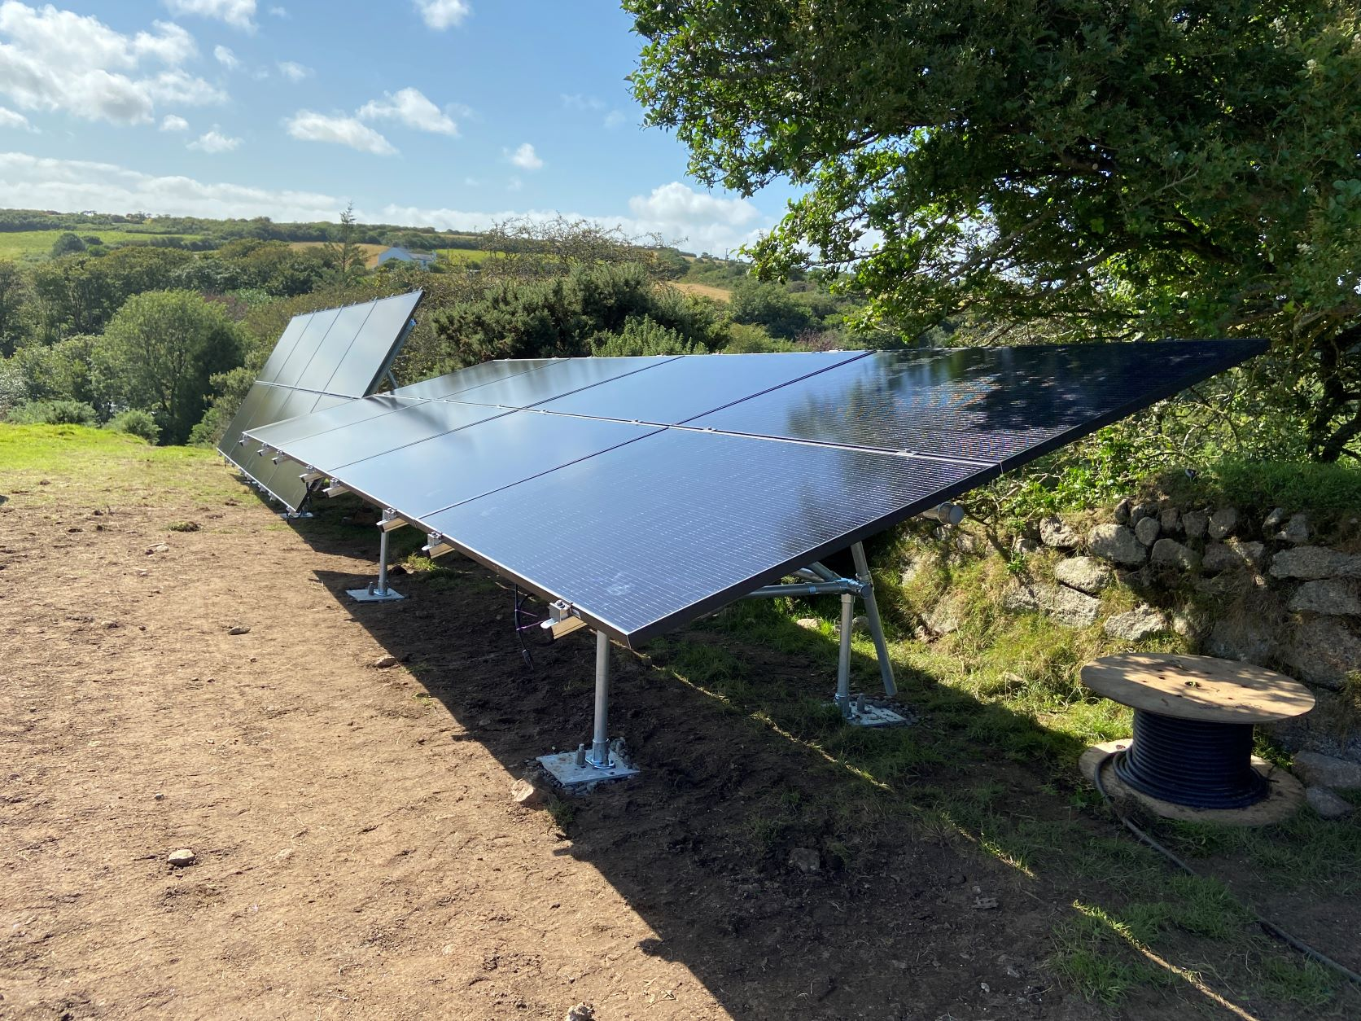

The photo shows an example of what is being proposed at The Rosery using the same black framed solar panels proposed. The frames are going to be in South facing orientation as per the scale drawing. There will be approximately 100mm between the frames for tilting between the seasons. No concrete will be used at all in the installation and this British system can be easily dismantled and recycled at the end of its useful life.

