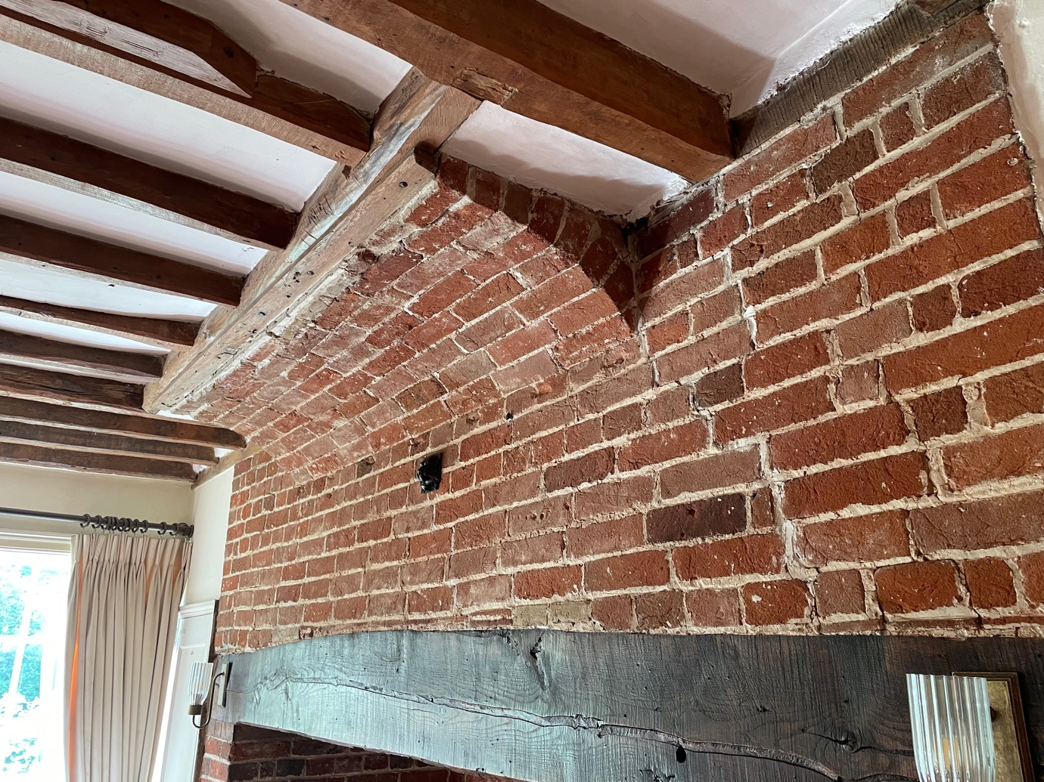

Chimney arch in living room where the work is to be carried out.

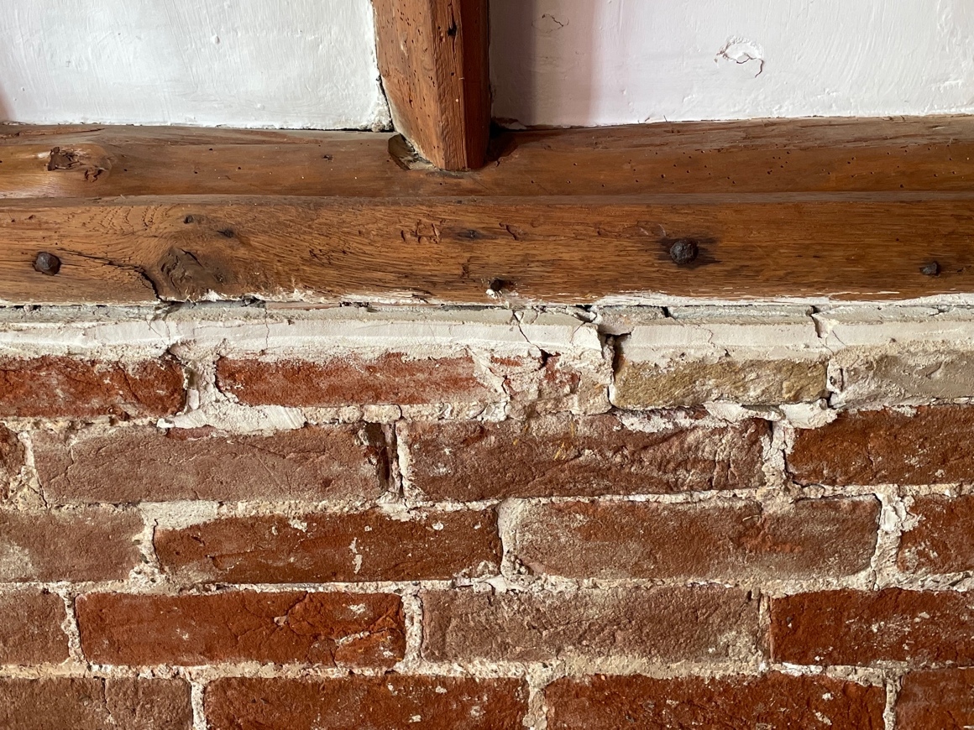

Bricks here have dropped noticeably (by up to 20mm) with sections of the original lime mortar becoming loose and detached. An arch former will be erected, hearth upstairs will be lifted and chimney arch dismantled. Arch will be rebuilt using lime mortar, NHL 3.5 and medium sand 1:2 mix, reusing existing bricks (as seen in photos) and upstairs hearth will be re-laid.

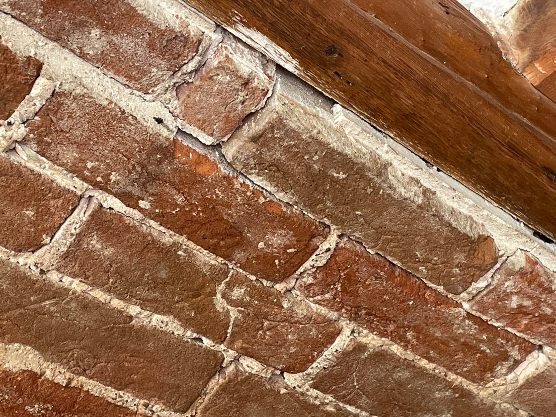

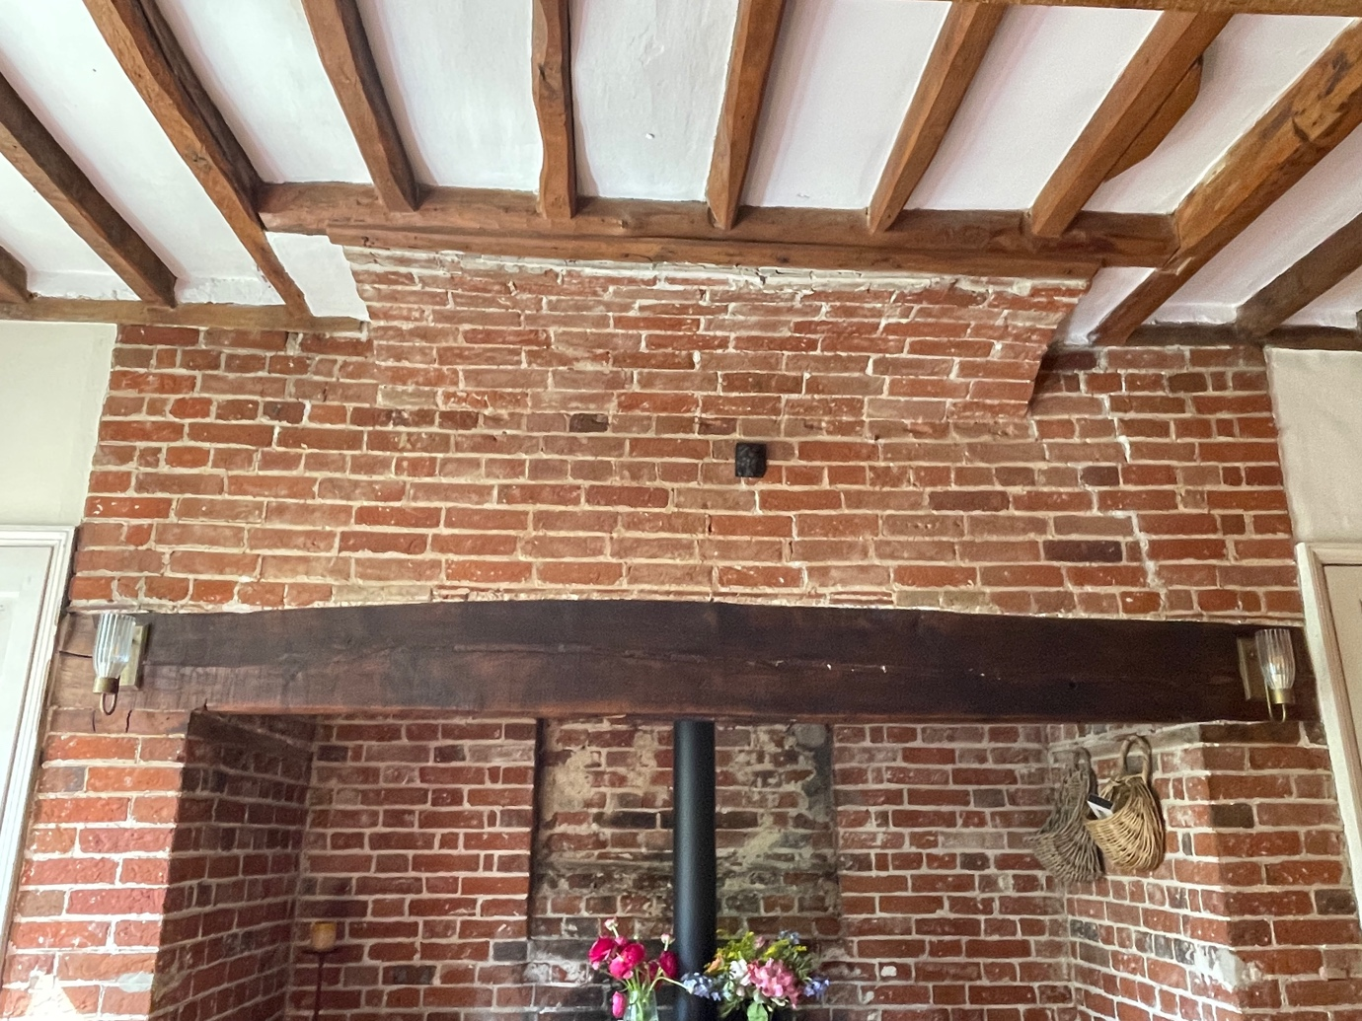

Chimney arch in living room where work is to be carried out.

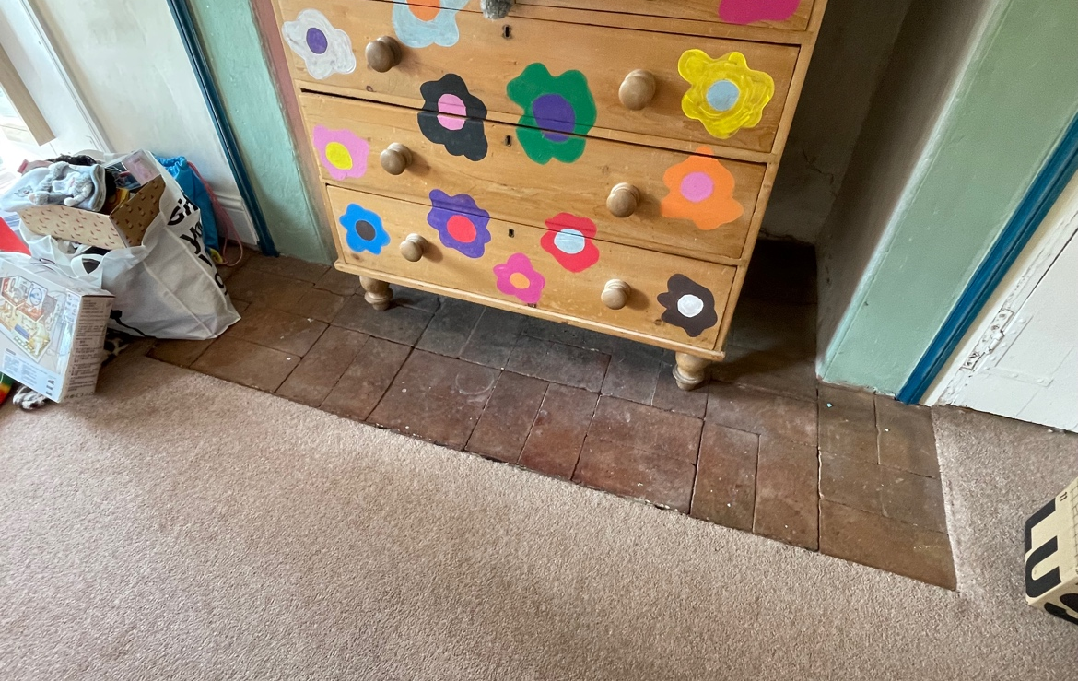

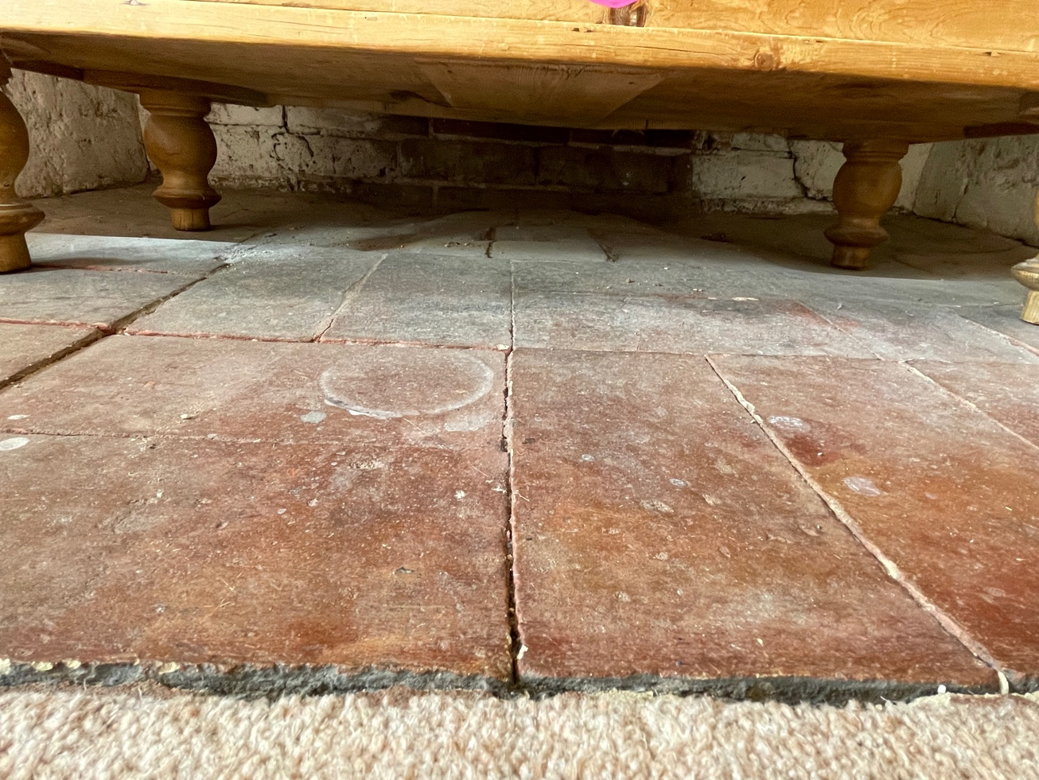

Upstairs bedroom hearth immediately over the living room chimney arch where the work is to be carried out. Noticeable drop in the floor level across the brick hearth in this room with a number of hearth bricks having cracked above the line of the ground floor frontage. Hearth will be lifted and arch taken down and when repaired the hearth will be re-laid.

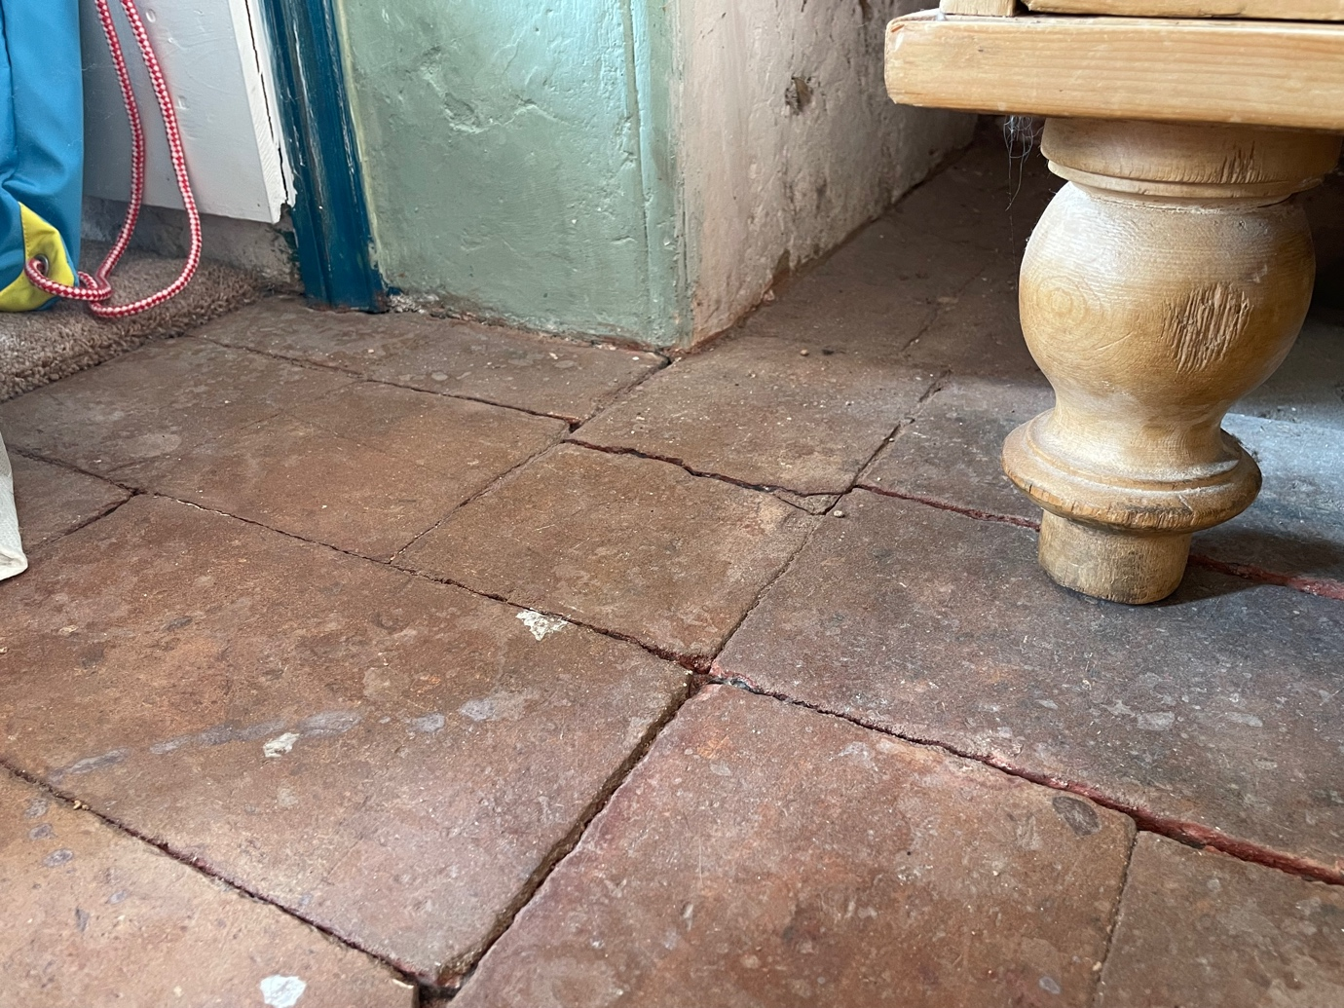

Cracked tiles in upstairs bedroom hearth.

