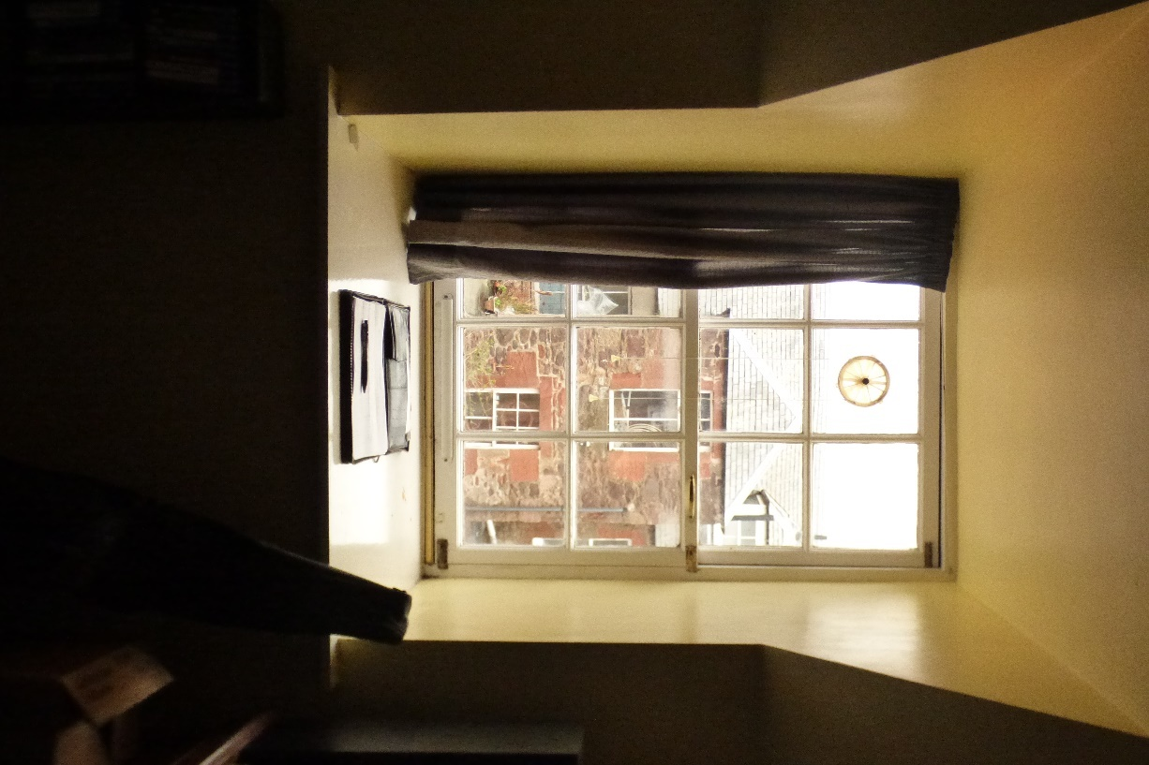

Photograph 5: Showing Window 1 a mock sash and case window side hung. Not an original window. Poorly converted and allowing water ingress into the property.

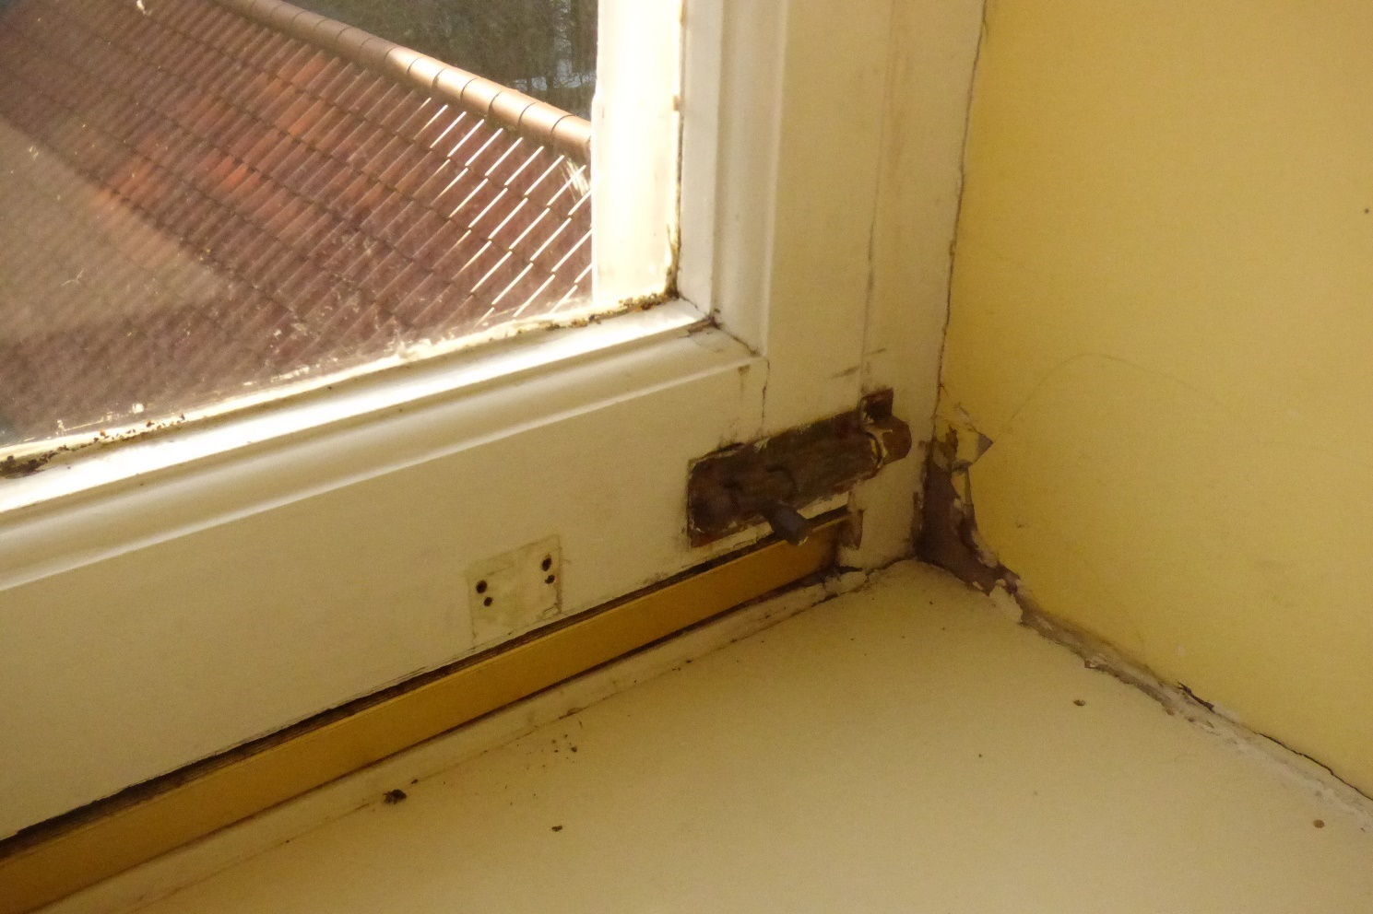

Photograph 6: Showing Window 1 with completely soft timbers around the bottom rail section. Not an original window. Poorly converted and allowing water ingress into the property.

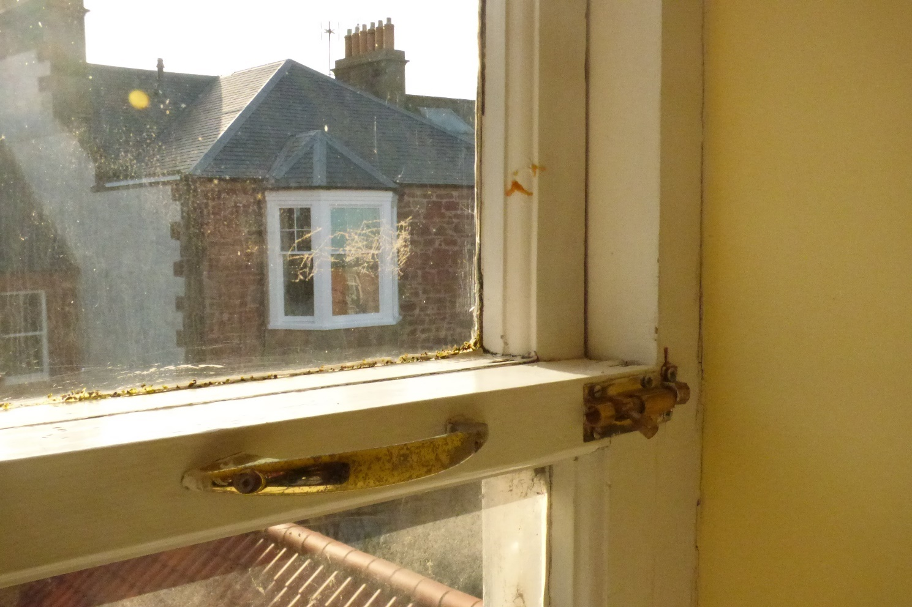

Photograph 7: Showing Window 1 a mock sash and case window side hung. Not an original window. Poorly converted and allowing water ingress into the property.

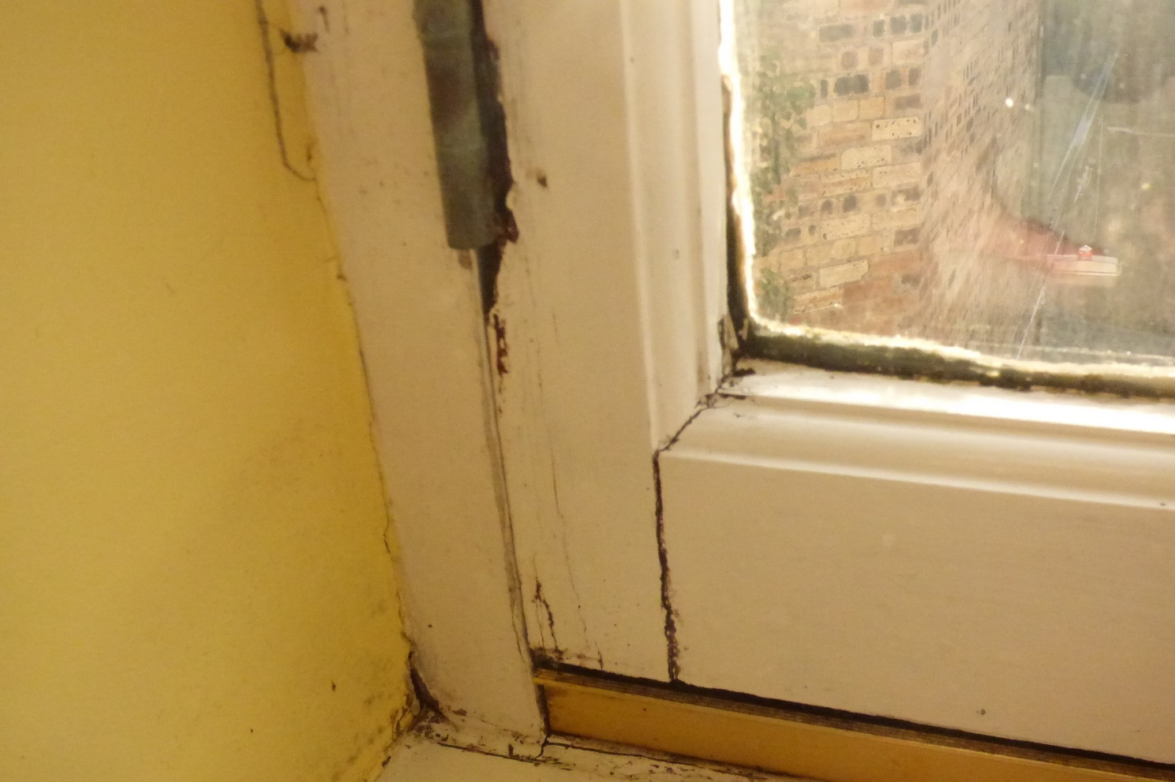

Photograph 8: Showing Window 1 with completely soft timbers around the bottom rail section. These timbers are rotten and beyond repair. This section is beyond repair and requires immediate replacement.

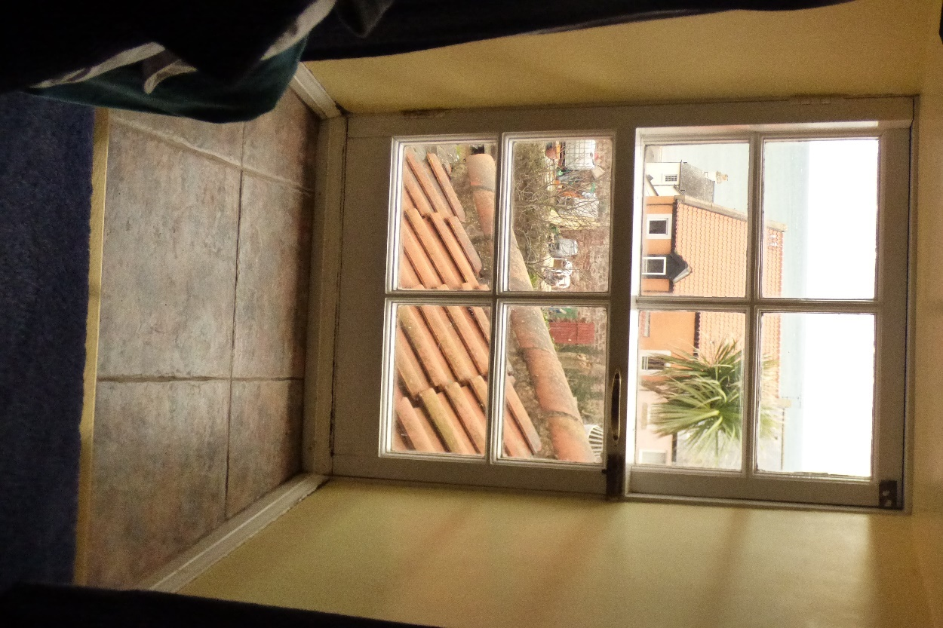

Photograph 9: Showing internal view on Window 7.

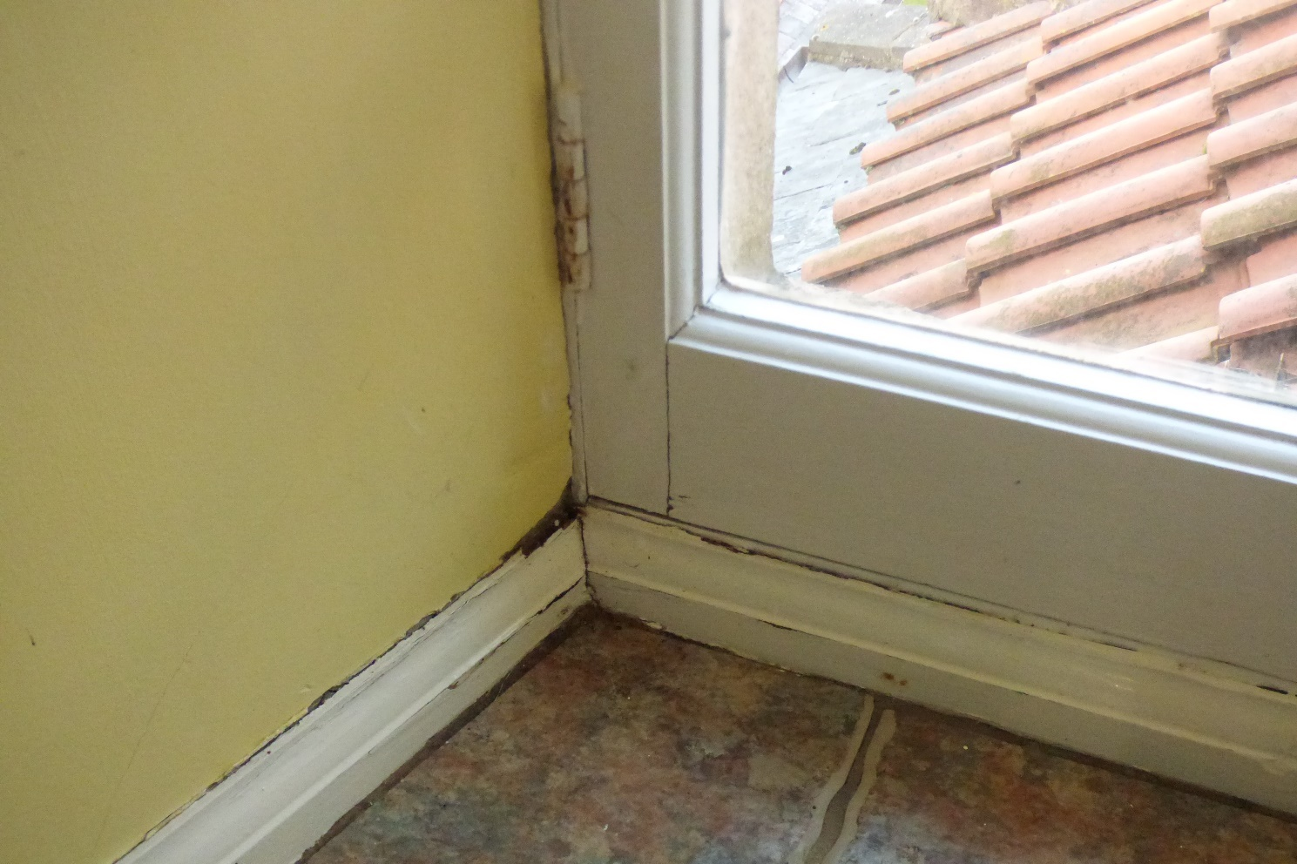

Photograph 10: Showing Window 7 with completely soft timbers around the bottom rail section. These timbers are rotten and beyond repair. This section is beyond repair and requires immediate replacement.

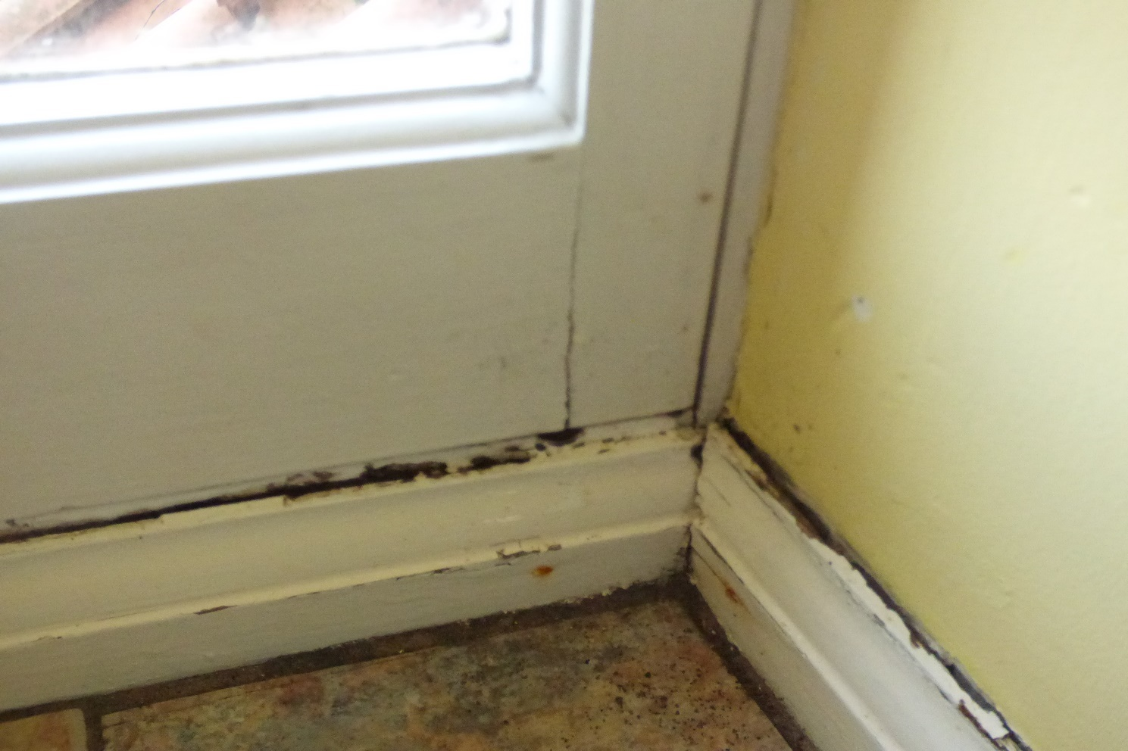

Photograph 11: Showing Window 7 with completely soft timbers around the bottom rail section. These timbers are rotten and beyond repair. This section is beyond repair and requires immediate replacement.

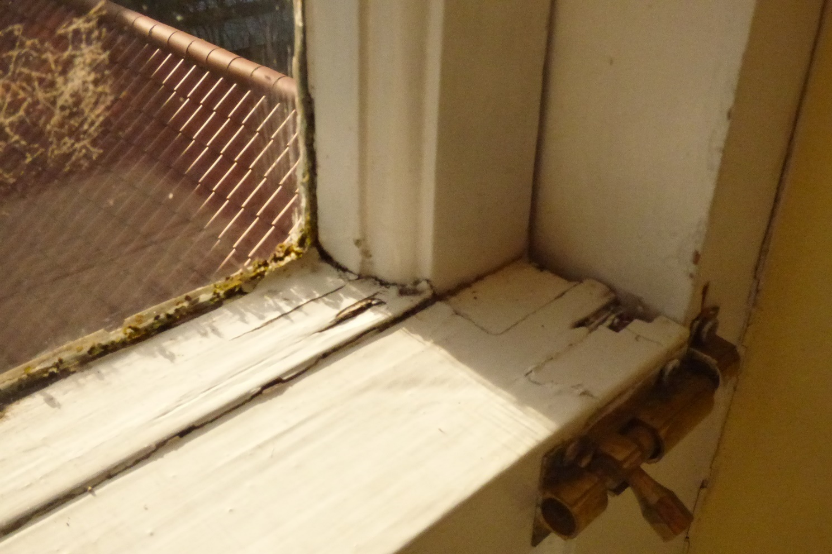

Photograph 12: Showing Window 7 with completely soft timbers around the midrail section. These timbers are rotten and beyond repair.

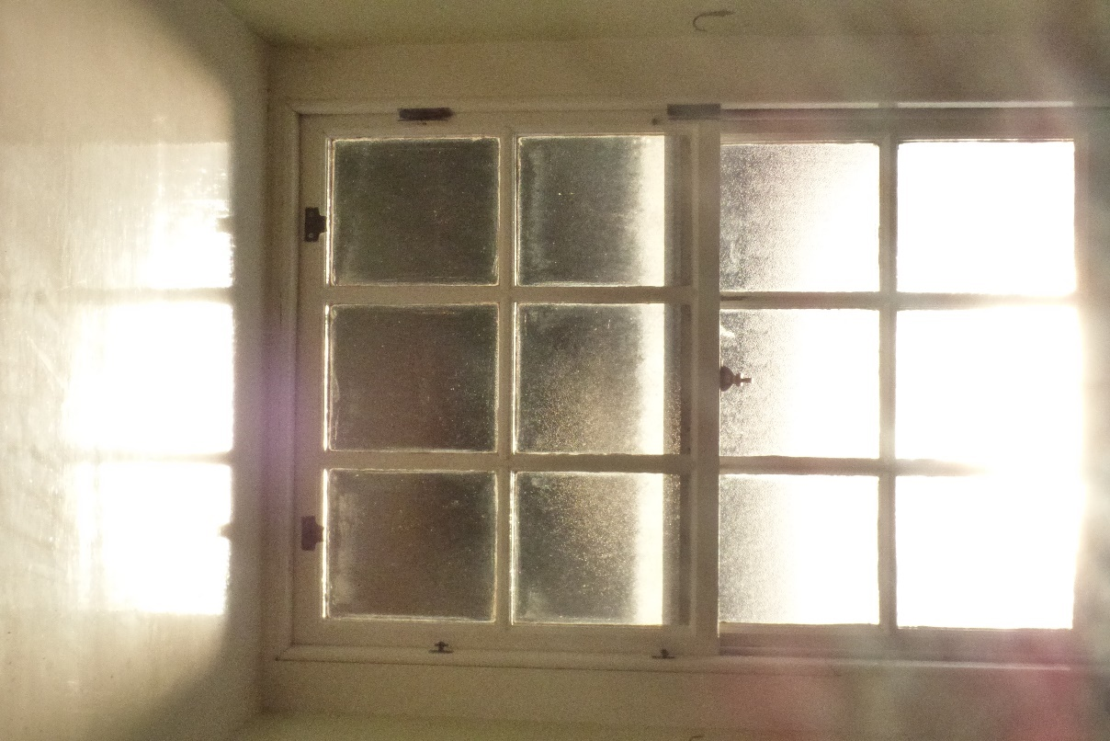

Photograph 13: Showing internal view of Window 2.

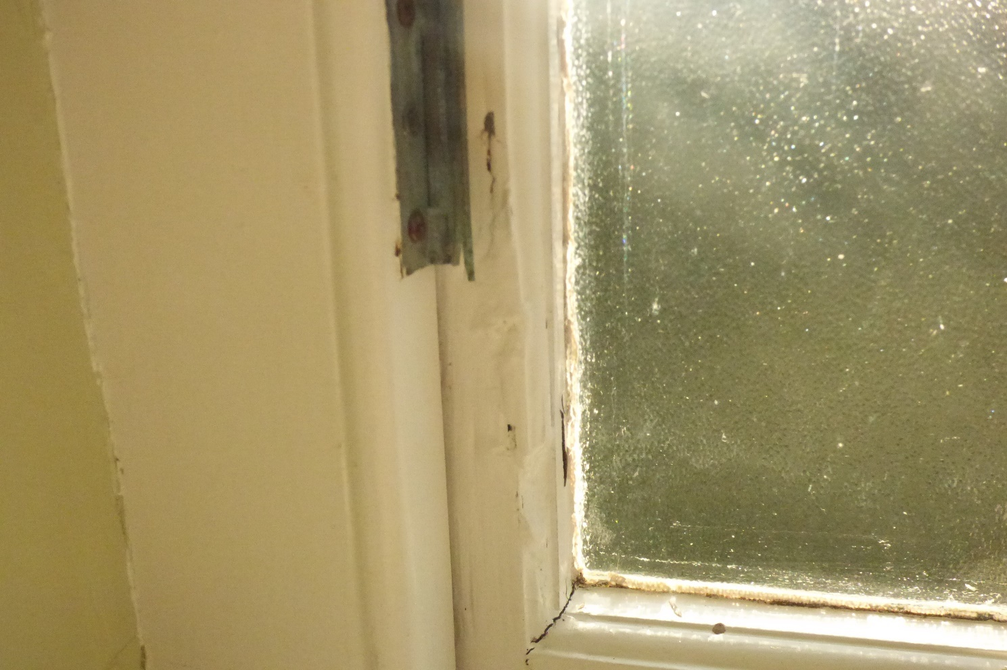

Photograph 14: Showing Window 2 with completely soft timbers around the stile section. These timbers are rotten and beyond repair.

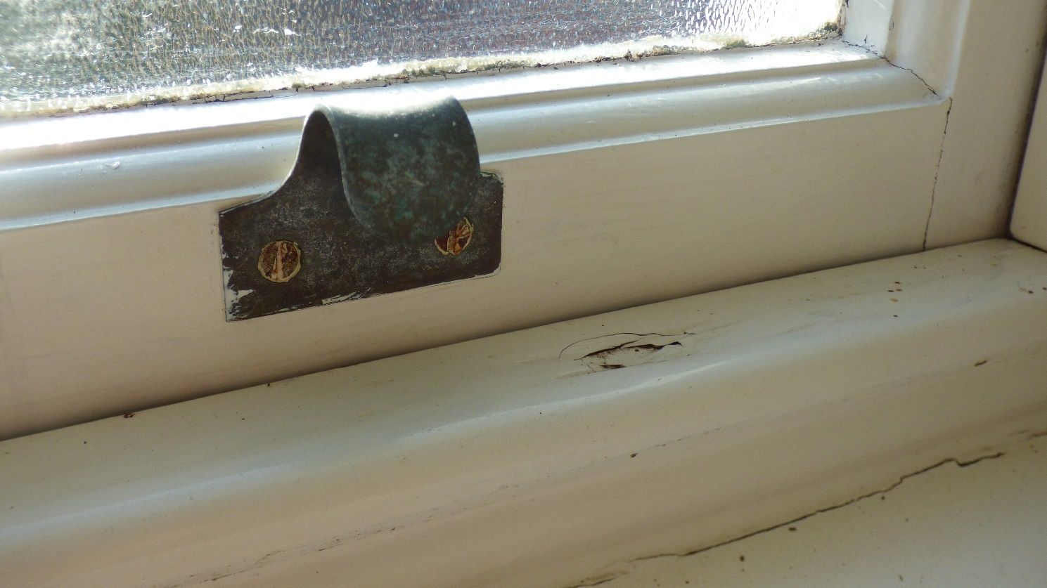

Photograph 15: Showing Window 2 with completely soft timbers around the bottom rail section. These timbers are rotten and beyond repair.

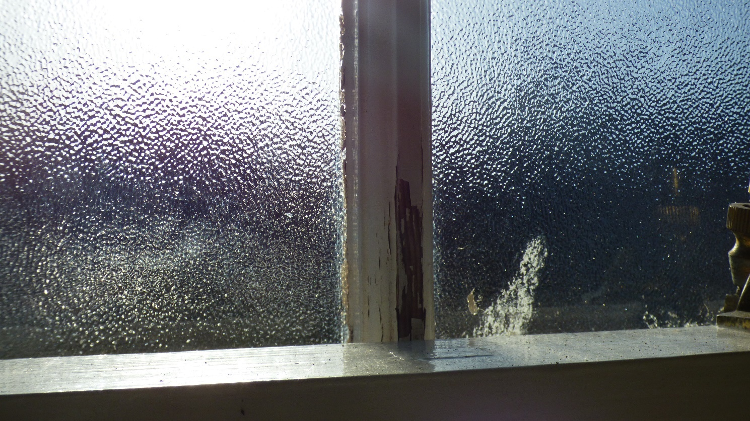

Photograph 16: Showing Window 2 with completely soft timbers around the astragal section. These timbers are rotten and beyond repair.

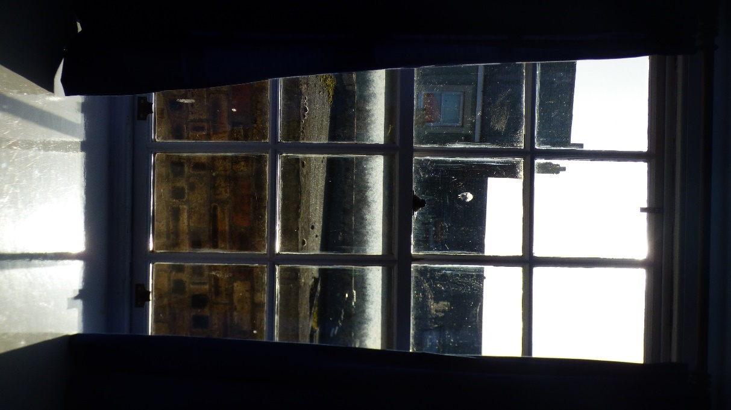

Photograph 17: Showing internal view of Window 3.

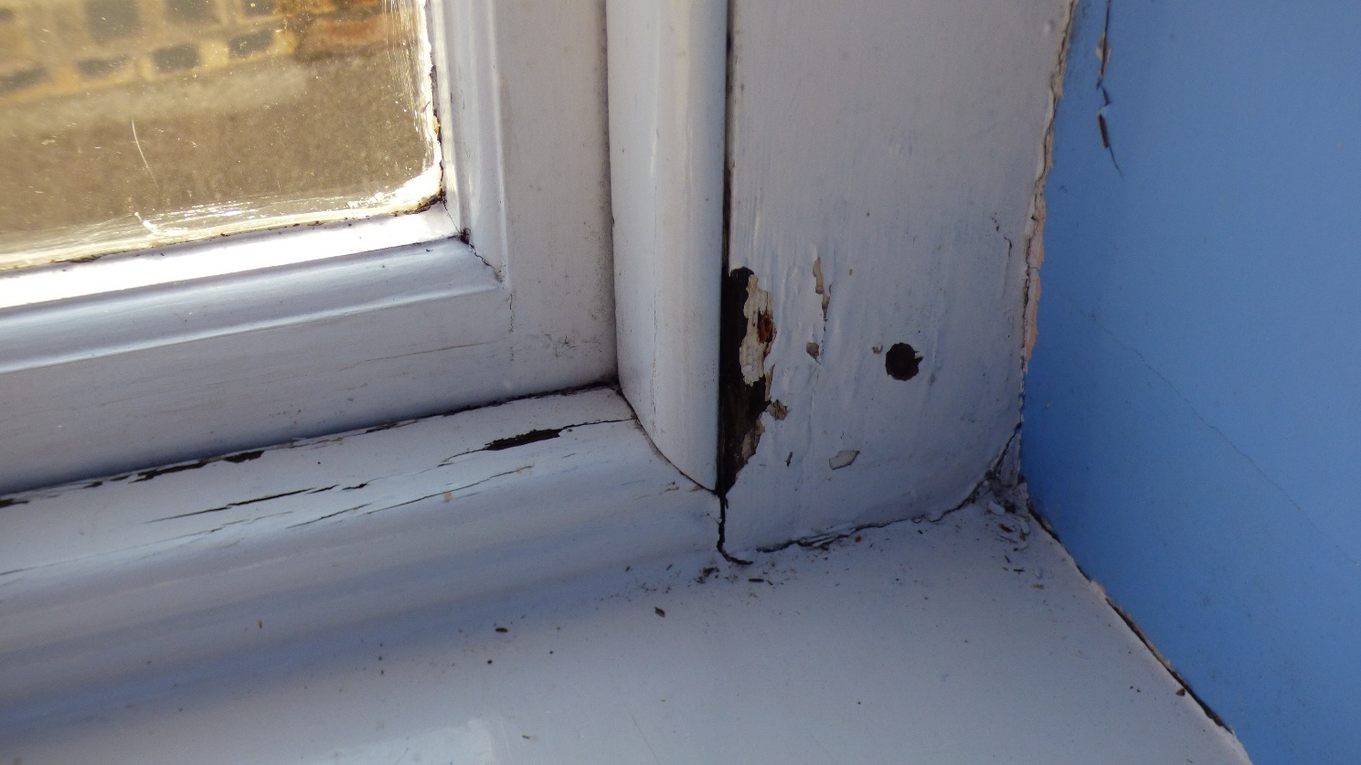

Photograph 18: Showing Window 3 with completely soft timbers around the bottom rail and casement sections. These timbers are rotten and beyond repair.

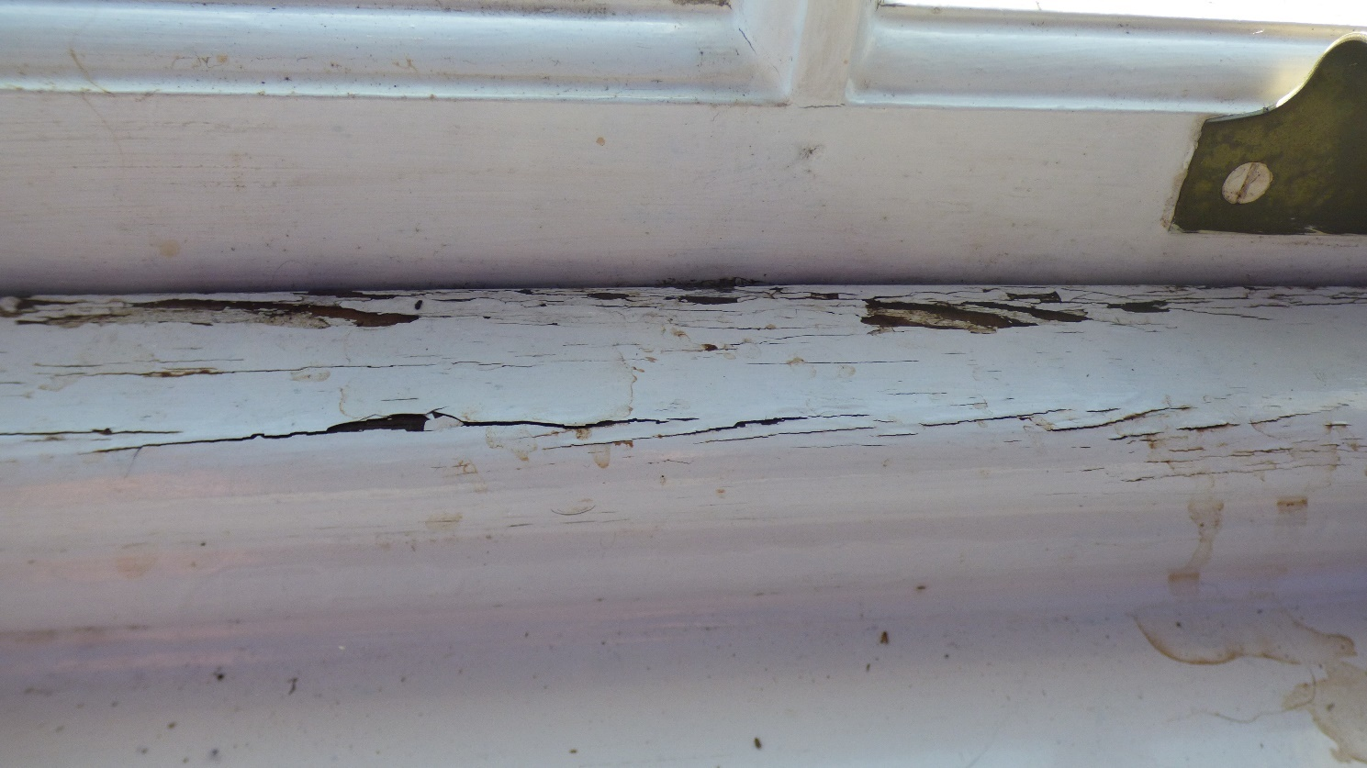

Photograph 19: Showing Window 3 with completely soft timbers around the bottom rail and casement sections. These timbers are rotten and beyond repair.

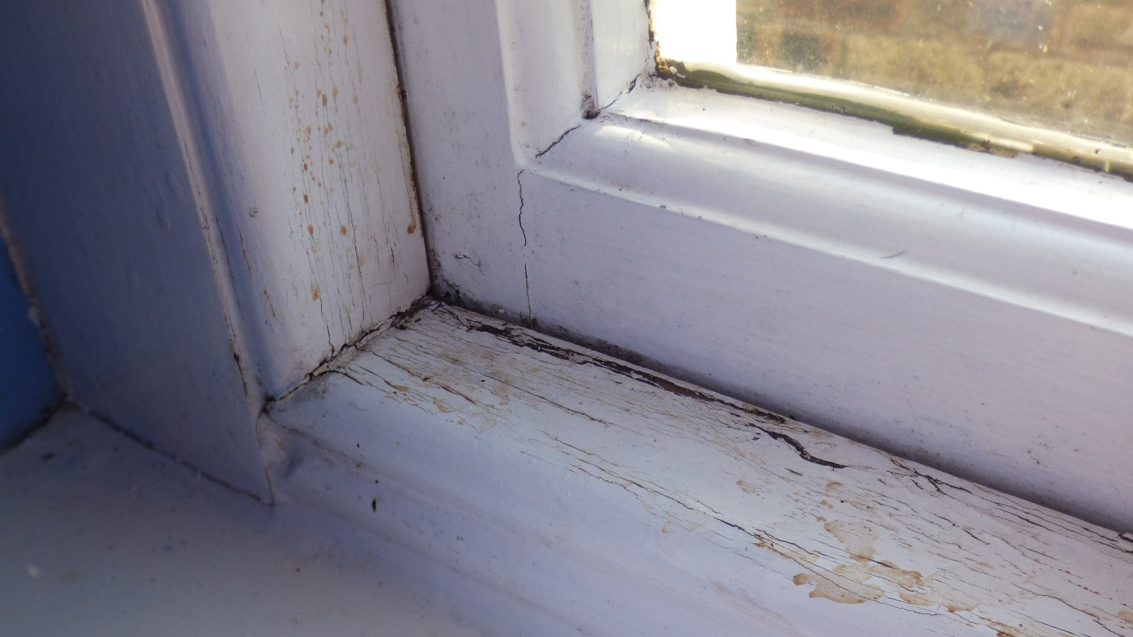

Photograph 20: Showing Window 3 with completely soft timbers around the bottom rail and casement sections. These timbers are rotten and beyond repair.

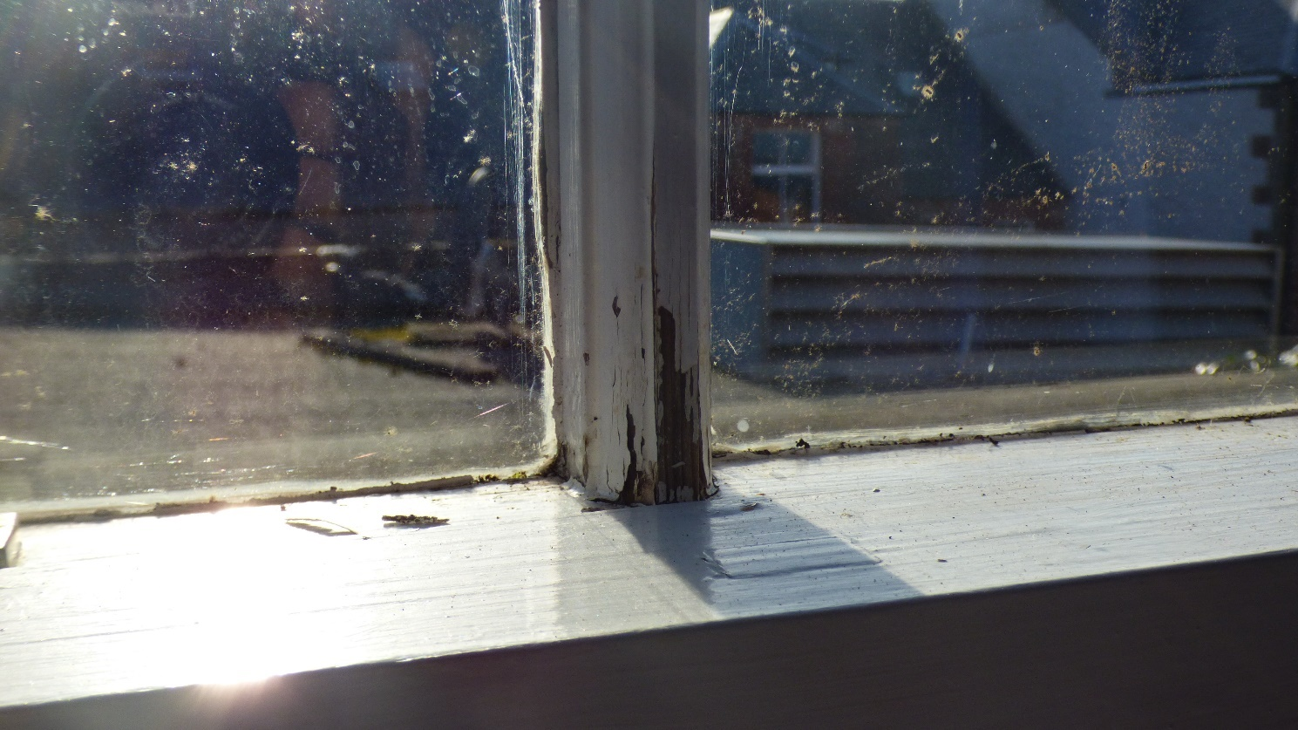

Photograph 21: Showing Window 3 Astragal detail. Due to water ingress the joints have swollen and begun to deteriorate.

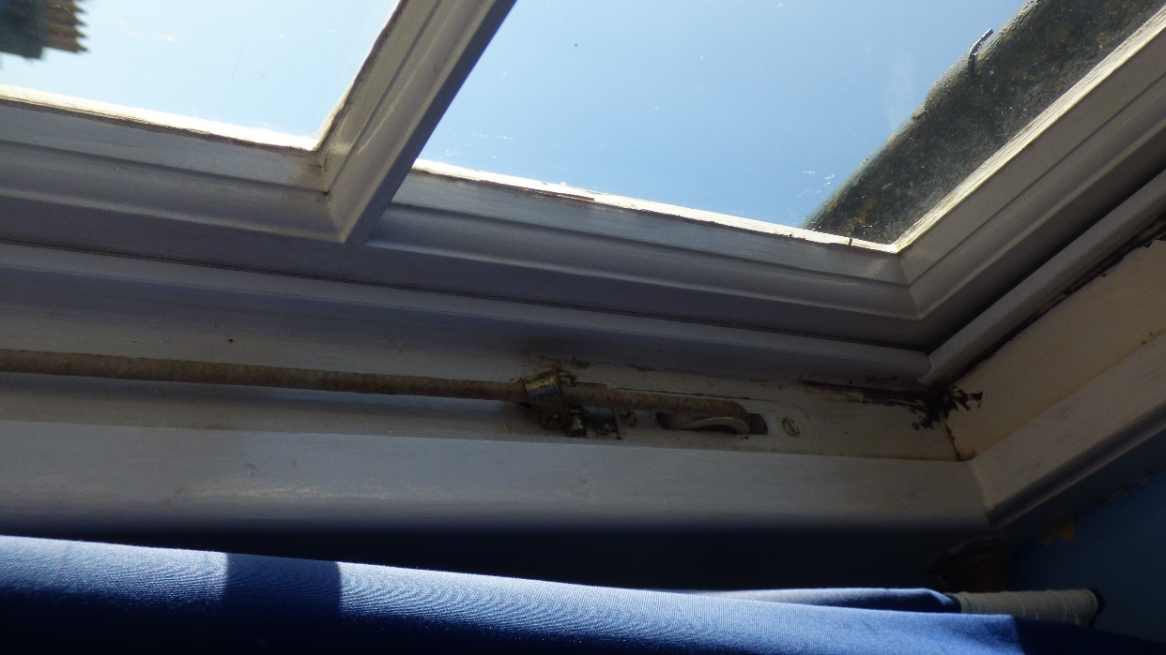

Photograph 22: Showing Window 3. Modern pulley wheels, further evidence the windows are not original to the building.

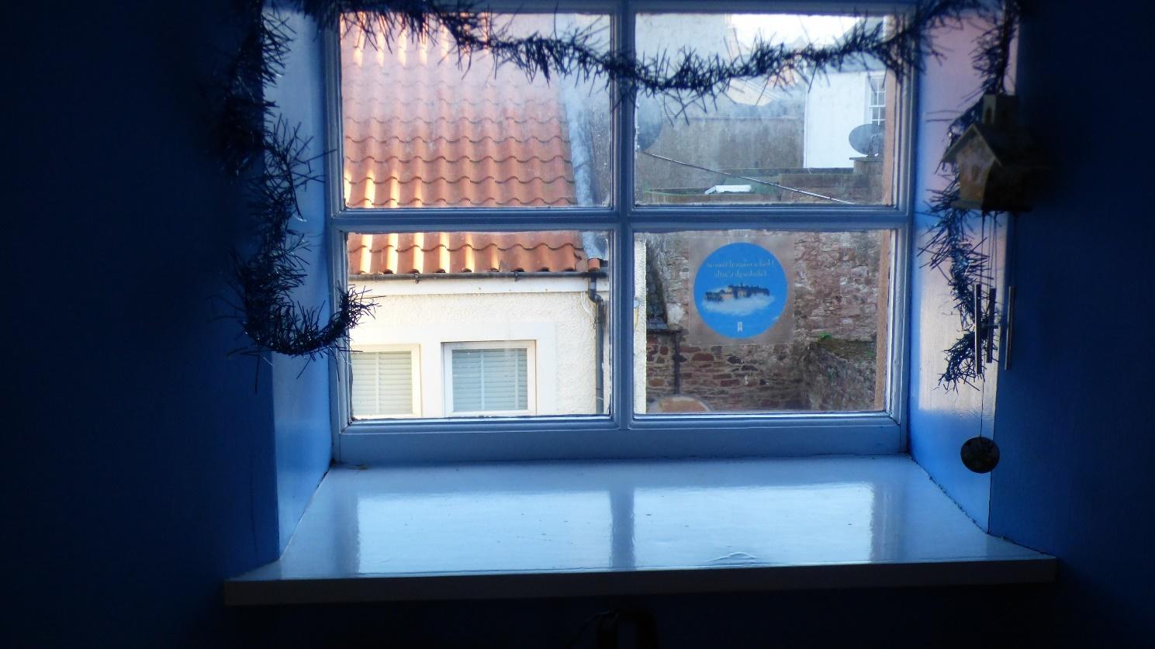

Photograph 23: Showing internal view of Window 5.

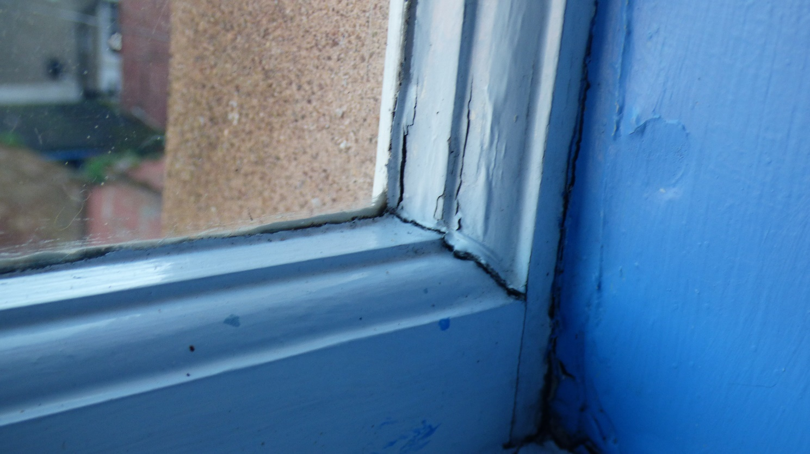

Photograph 24: Showing Window 5. Due to external water ingress, the bottom rail timber is extremely soft, the original mortise and tenon joint has swollen and cracked the surrounding timbers.

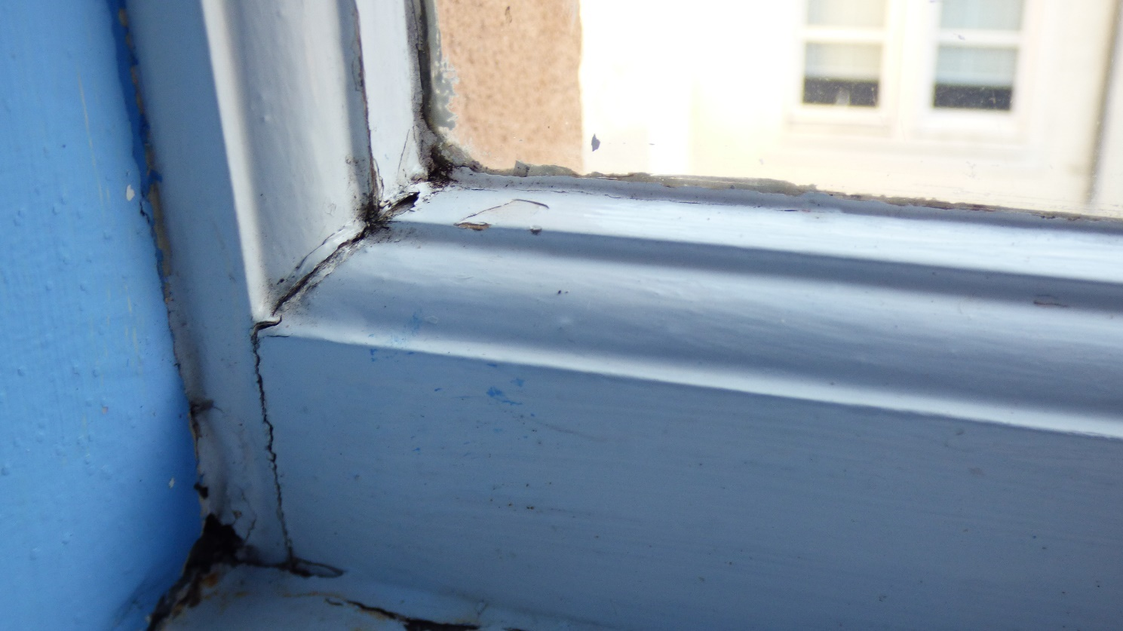

Photograph 25: Showing Window 5. Due to external water ingress, the bottom rail timber is extremely soft, the original mortise and tenon joint has swollen and cracked the surrounding timbers.

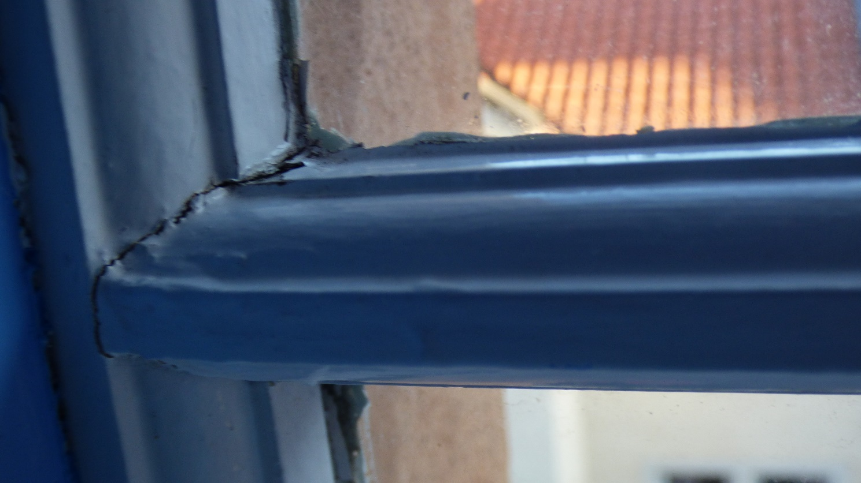

Photograph 26: Showing Window 5. Due to external water ingress, the Astragal timber is extremely soft, the original mortise and tenon joint has swollen and cracked the surrounding timbers.

