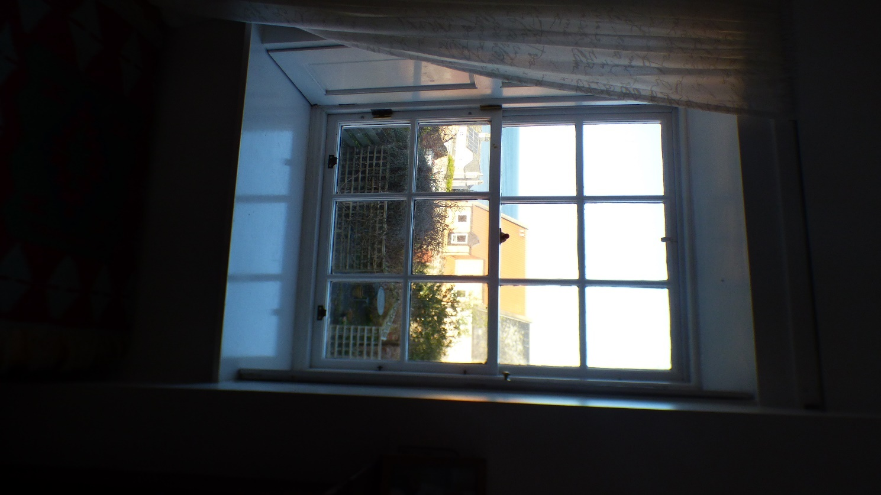

Photograph 46: Showing internal view of Window 12.

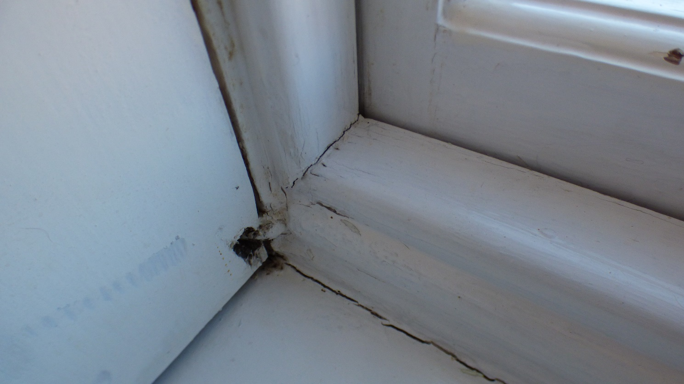

Photograph 47: Showing internal view of Window 12. Due to external water ingress, the bottom rail timber is extremely soft, the original mortise and tenon joint has swollen and cracked the surrounding timbers.

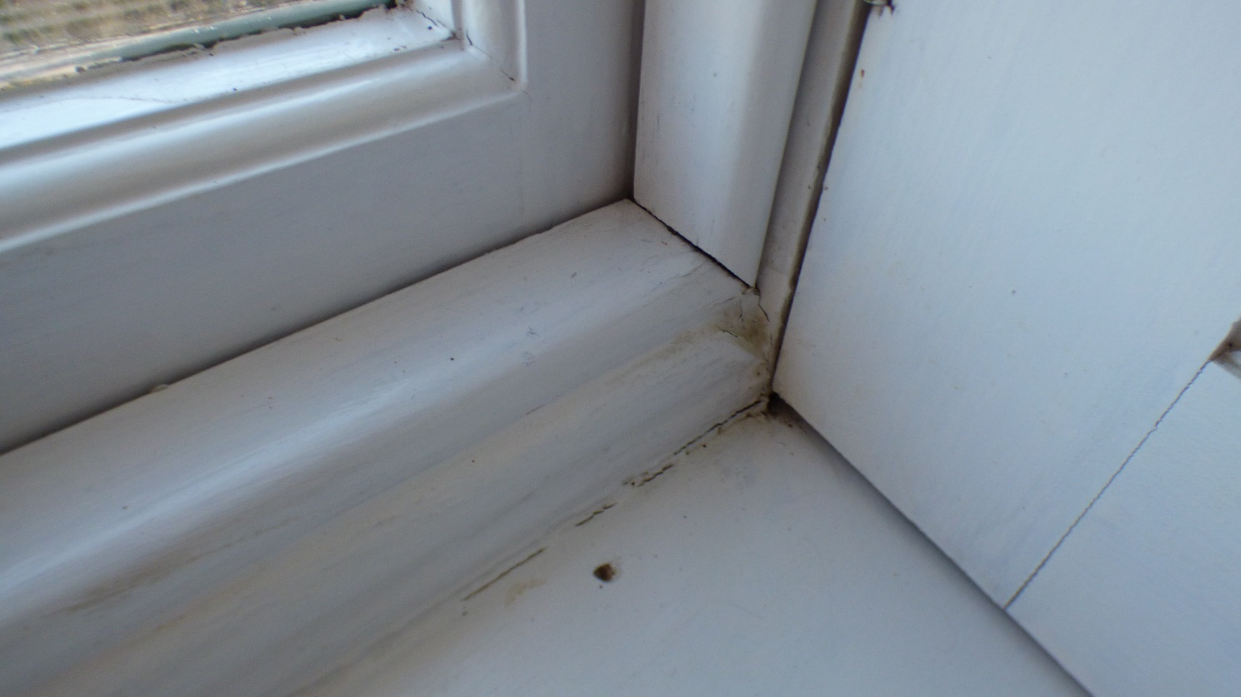

Photograph 48: Showing internal view of Window 12. Due to external water ingress, the bottom rail timber is extremely soft, the original mortise and tenon joint has swollen and cracked the surrounding timbers.

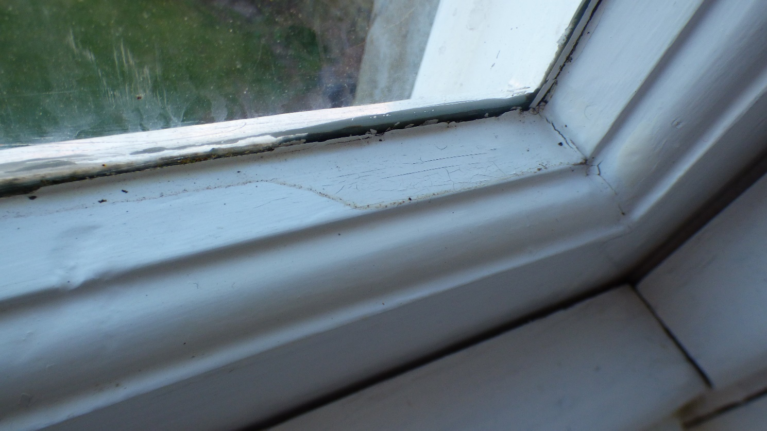

Photograph 49: Showing internal view of Window 12. Due to external water ingress, the bottom rail timber is extremely soft, the original mortise and tenon joint has swollen and cracked the surrounding timbers.

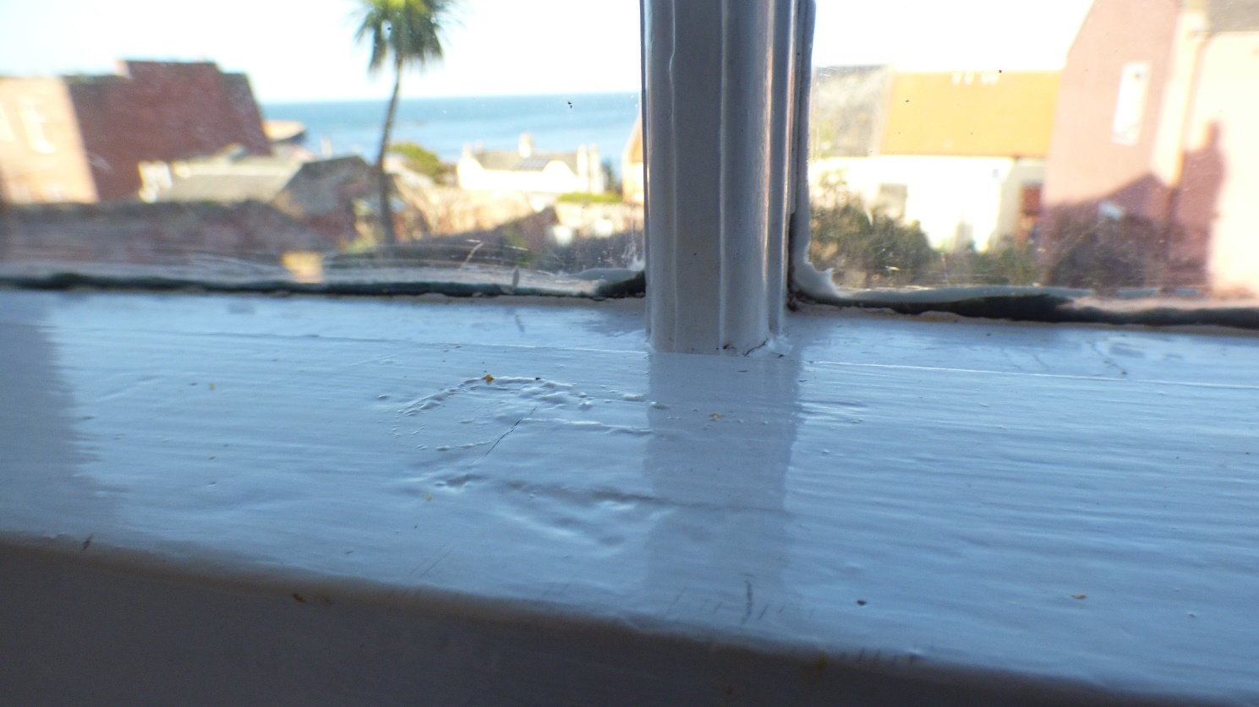

Photograph 50: Showing internal view of Window 12. Due to external water ingress, the midrail timber is extremely soft, the original mortise and tenon joint has swollen and cracked the surrounding timbers.

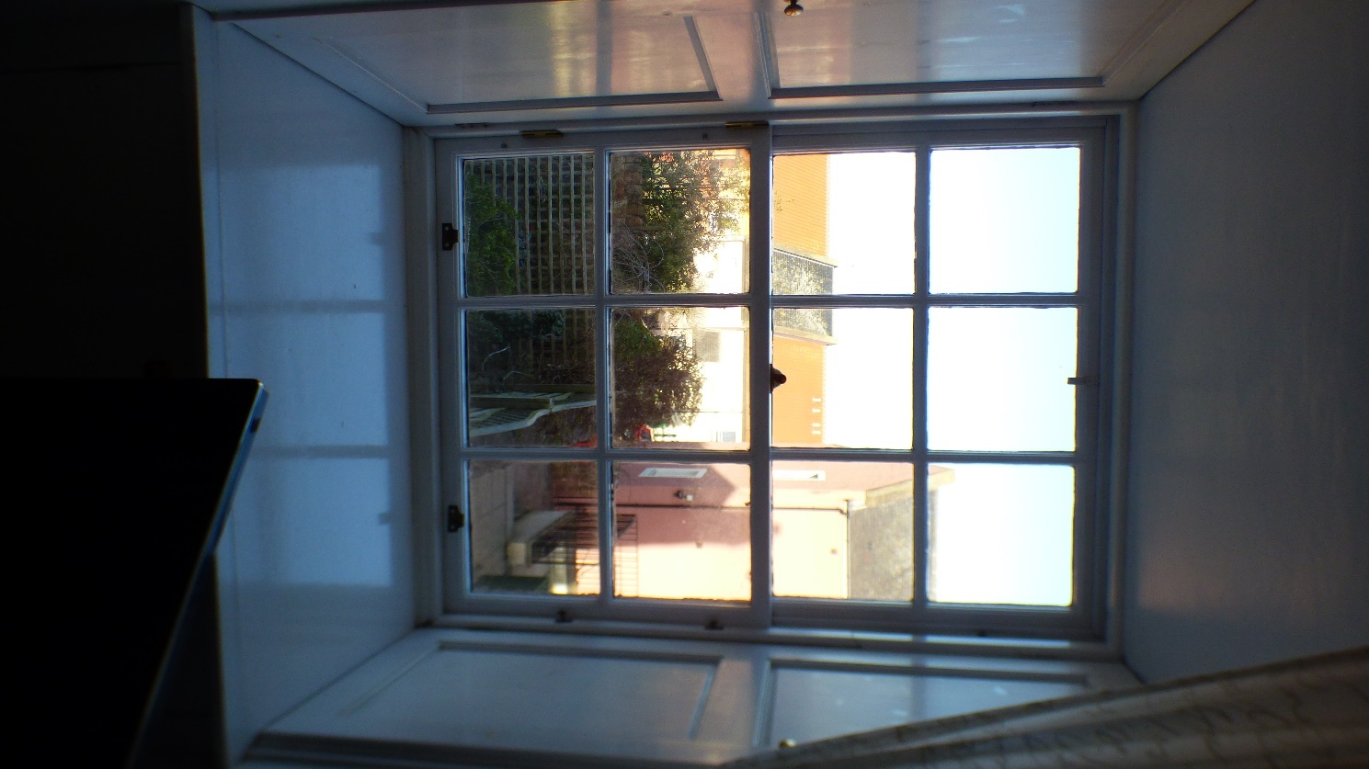

Photograph 51: Showing internal view of Window 11.

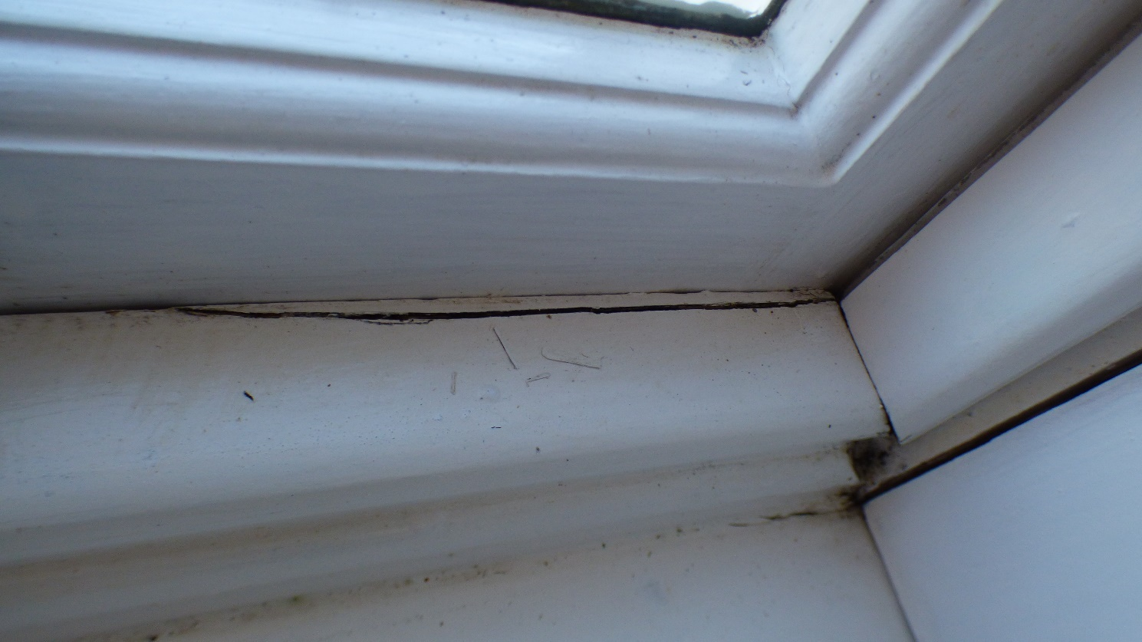

Photograph 52: Showing internal view of Window 11. Due to external water ingress, the bottom rail timber is extremely soft, the original mortise and tenon joint has swollen and cracked the surrounding timbers.

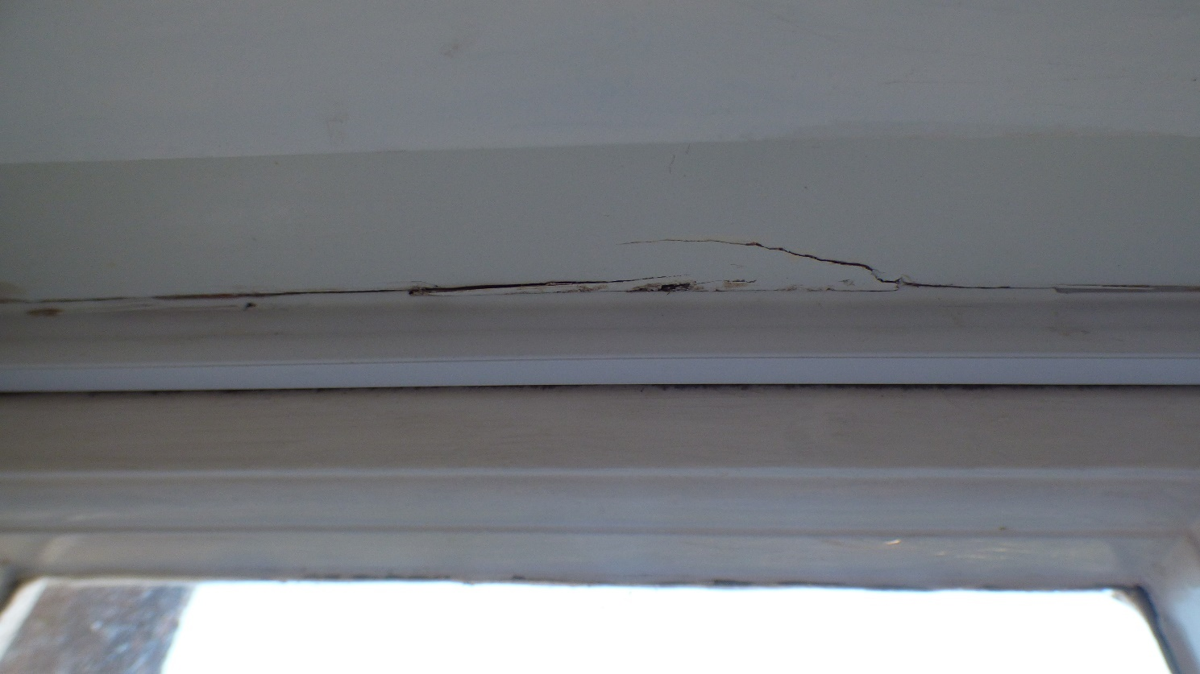

Photograph 53: Showing internal view of Window 11. Due to external water ingress, the casement timber is extremely soft and now requires immediate attention.

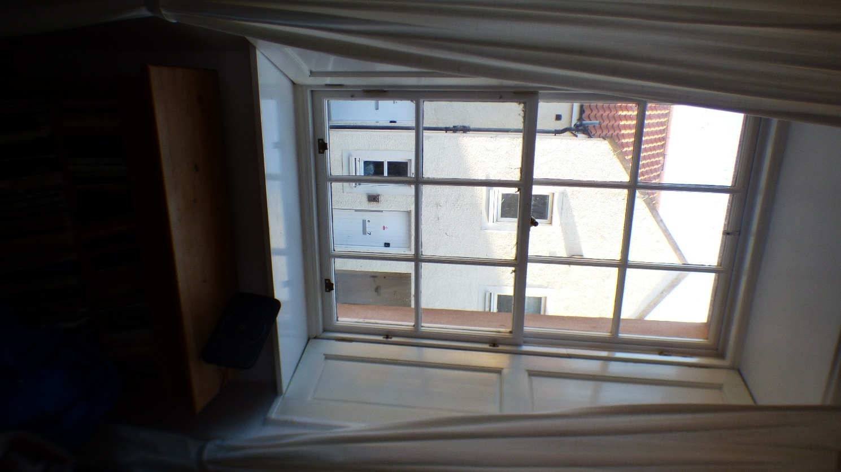

Photograph 54: Showing internal view of Window 10.

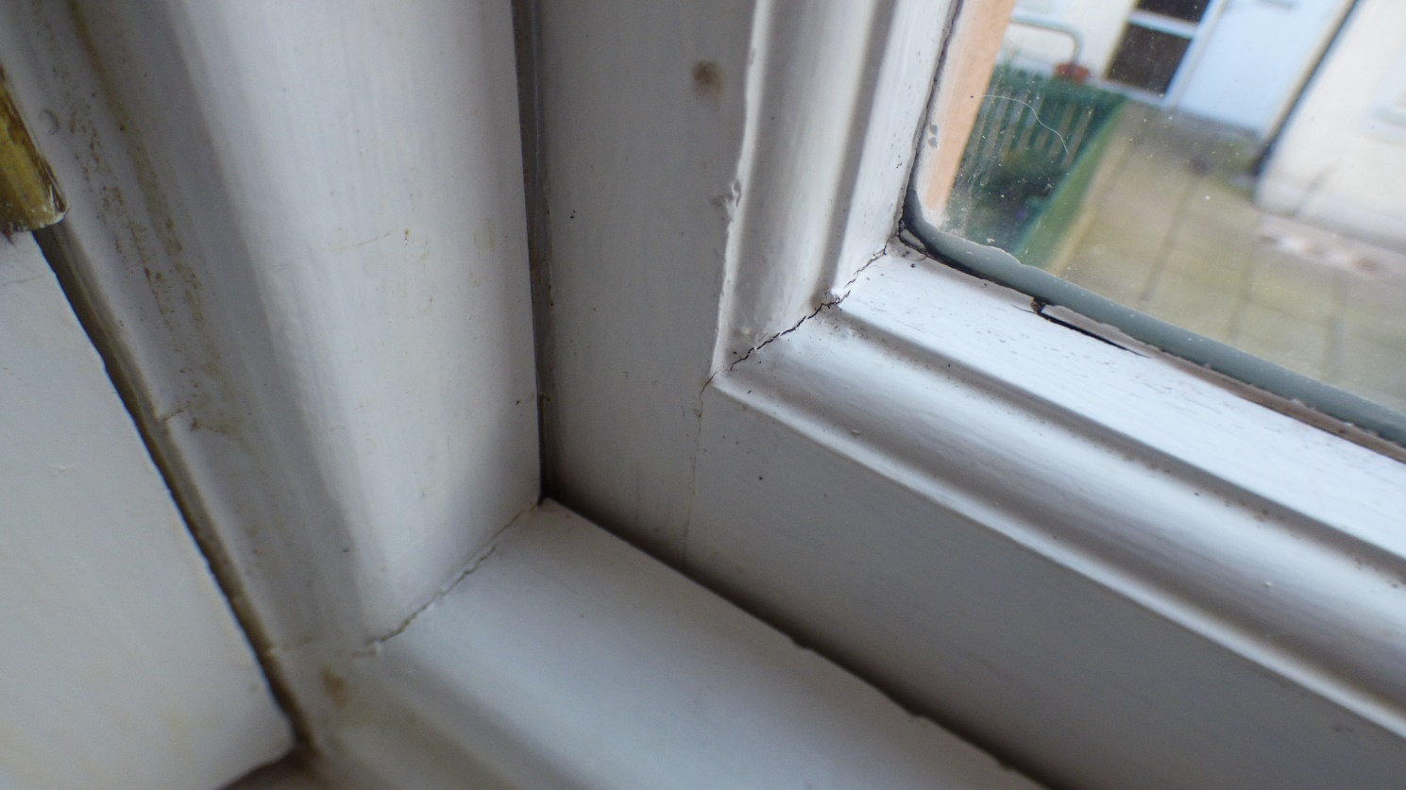

Photograph 55: Showing internal view of Window 10. Due to external water ingress, the bottom rail timber is extremely soft, the original mortise and tenon joint has swollen and cracked the surrounding timbers.

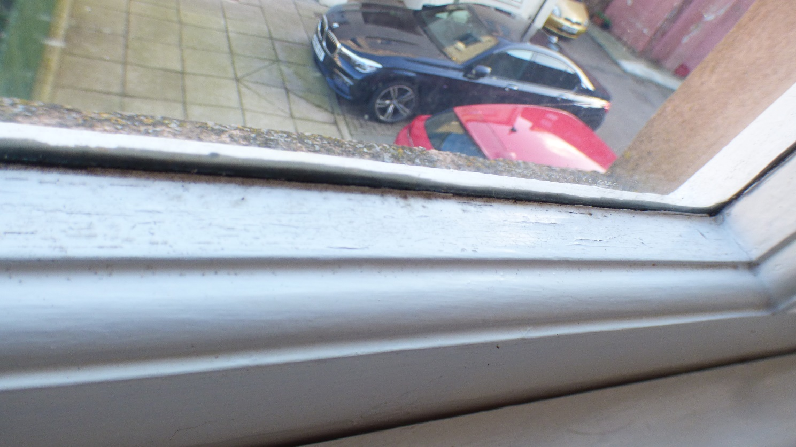

Photograph 56: Showing internal view of Window 10. Due to external water ingress, the bottom rail timber is extremely soft, the original mortise and tenon joint has swollen and cracked the surrounding timbers.

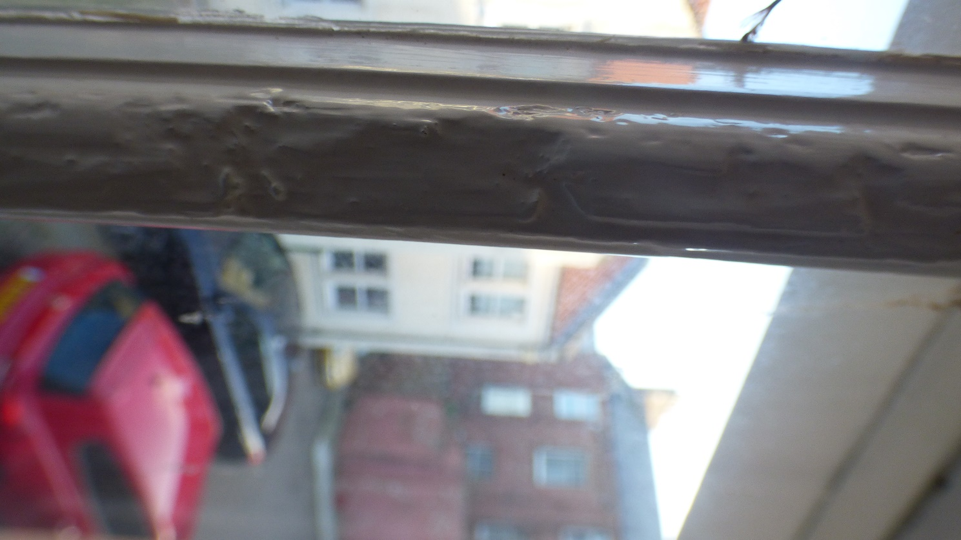

Photograph 57: Showing internal view of Window 10. Due to external water ingress, the astragal timber is extremely soft, the original mortise and tenon joint has swollen and cracked the surrounding timbers.

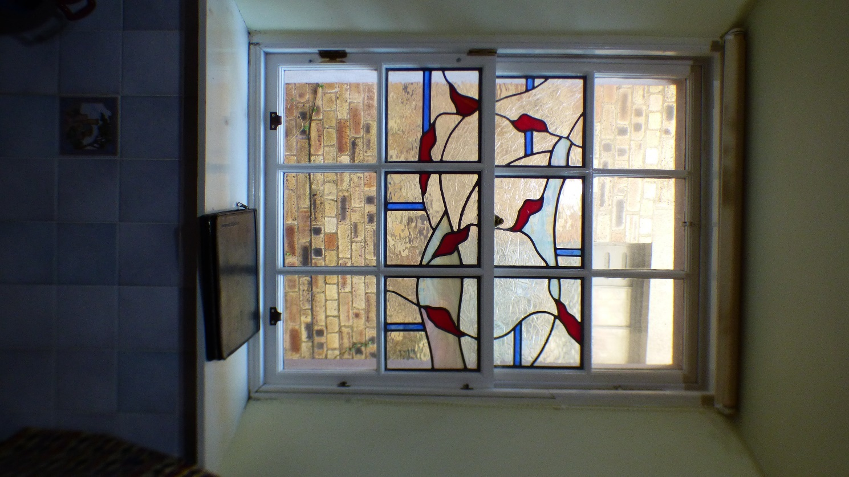

Photograph 58: Showing internal view of Window 9.

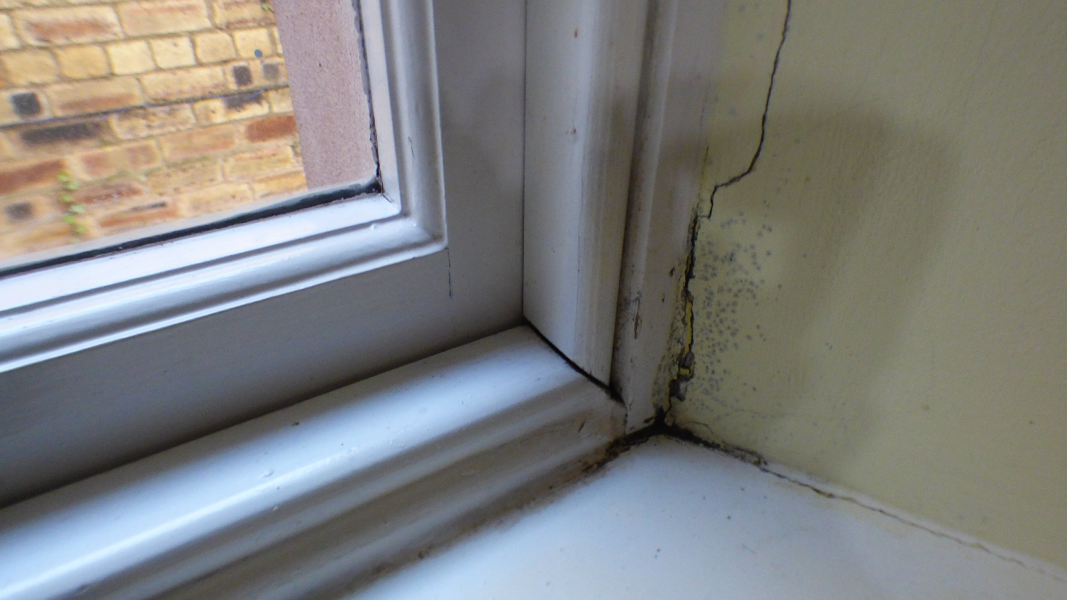

Photograph 59: Showing internal view of Window 10. Due to external water ingress, the bottom rail timber and surrounding areas are extremely soft, the original mortise and tenon joint has swollen and cracked the surrounding timbers.

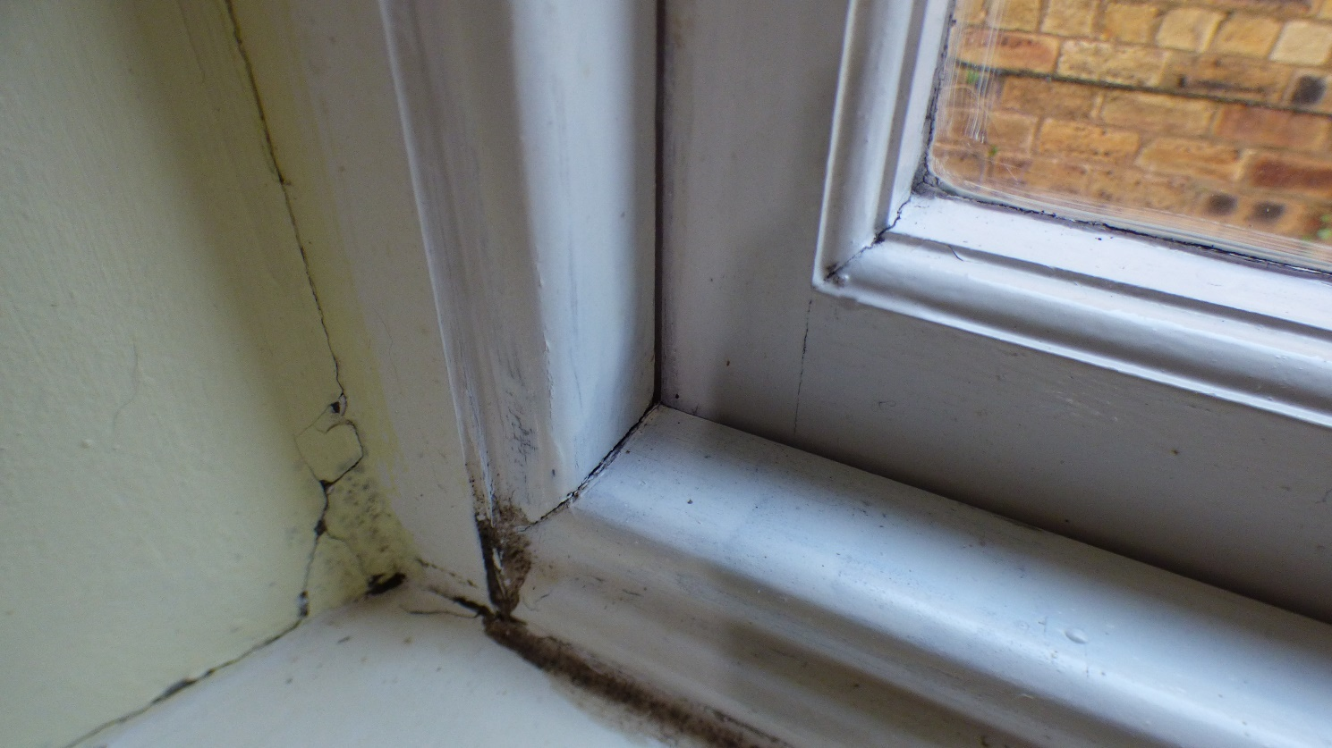

Photograph 60: Showing internal view of Window 10. Due to external water ingress, the bottom rail timber and surrounding areas are extremely soft, the original mortise and tenon joint has swollen and cracked the surrounding timbers.

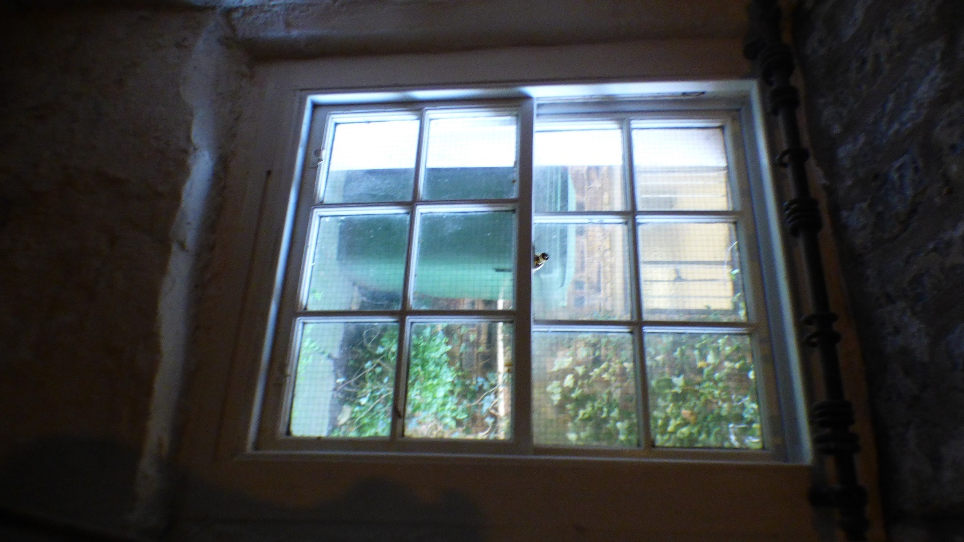

Photograph 61: Showing internal view of Window 17.

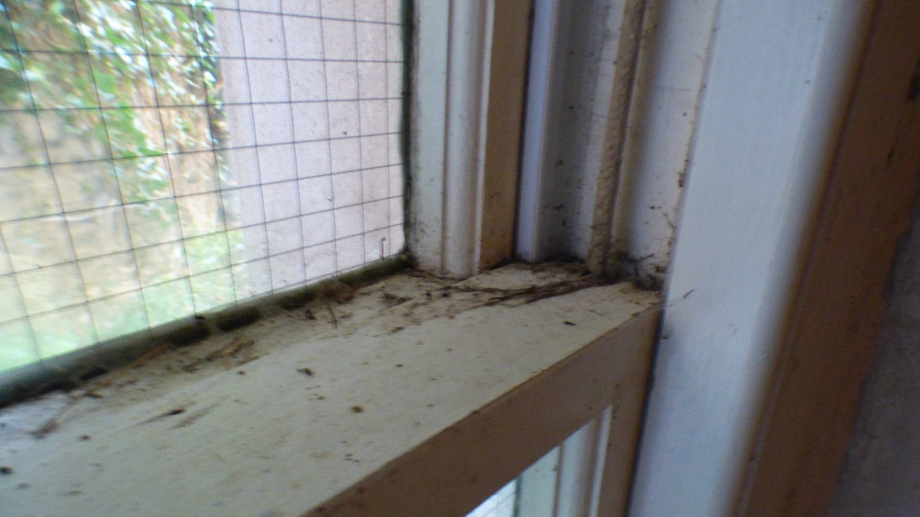

Photograph 62: Showing internal view of Window 17. Due to external water ingress, the midrail timber and surrounding areas are extremely soft, the original mortise and tenon joint has swollen and cracked the surrounding timbers.

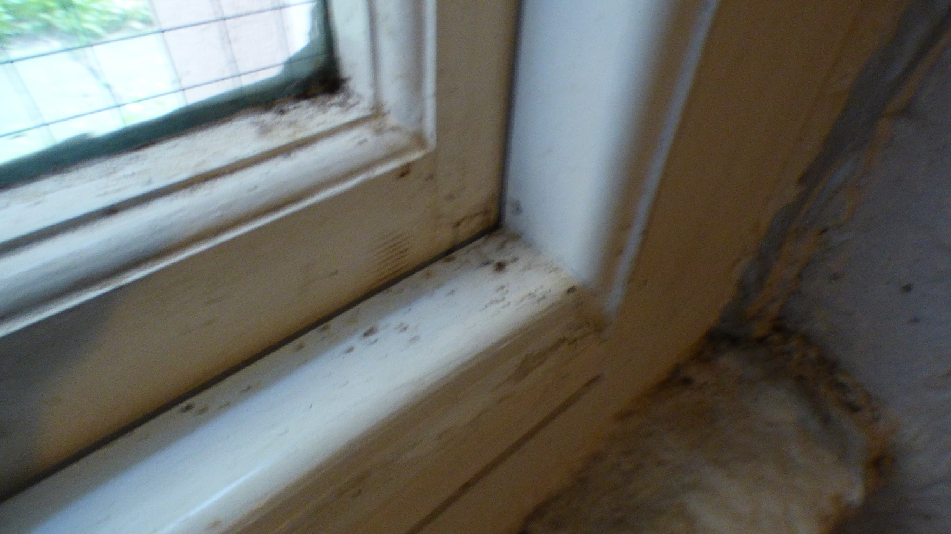

Photograph 63: Showing internal view of Window 17. Due to external water ingress, the bottom rail timber and surrounding areas are extremely soft, the original mortise and tenon joint has swollen and cracked the surrounding timbers.

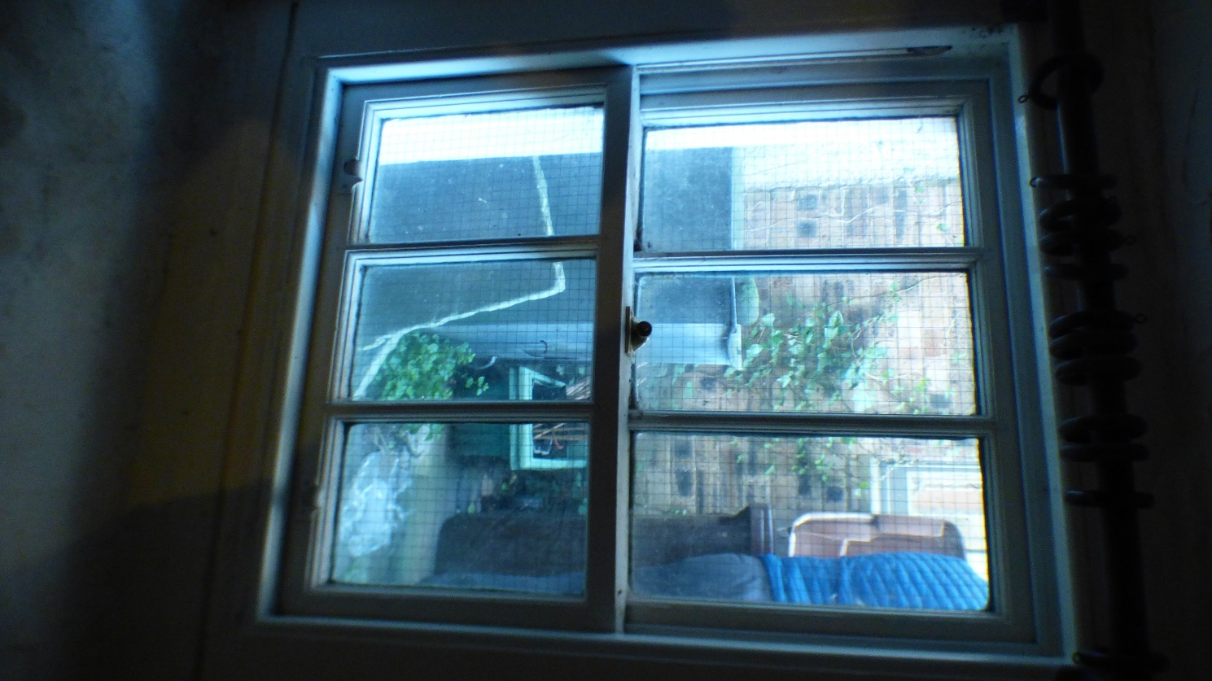

Photograph 64: Showing internal view of Window 16.

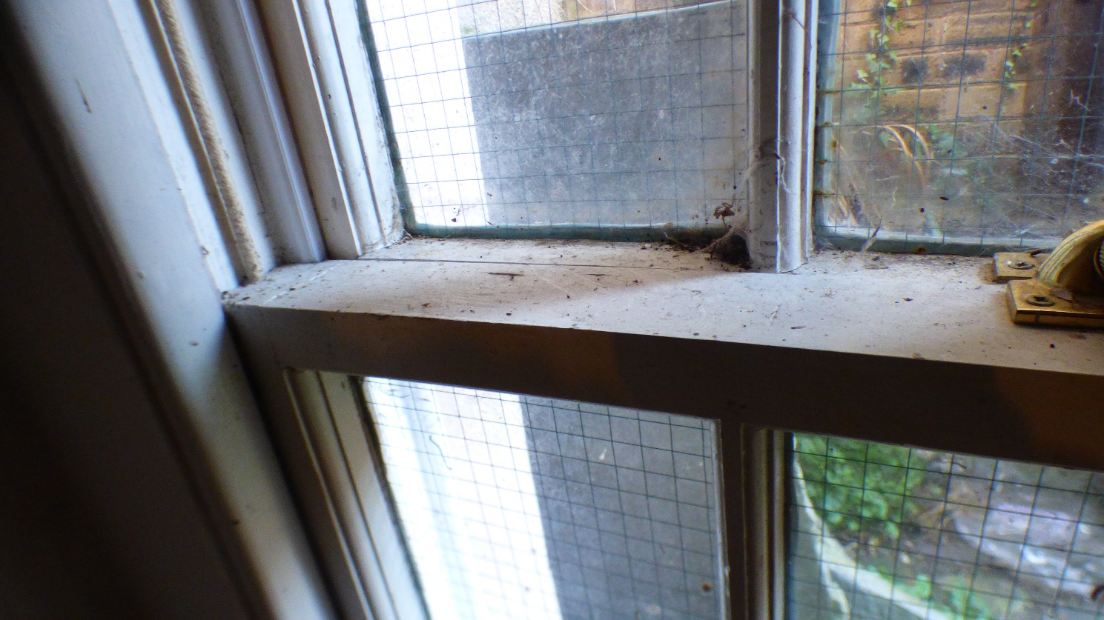

Photograph 65: Showing internal view of Window 16. Due to external water ingress, the midrail timber and surrounding areas are extremely soft, the original mortise and tenon joint has swollen and cracked the surrounding timbers.

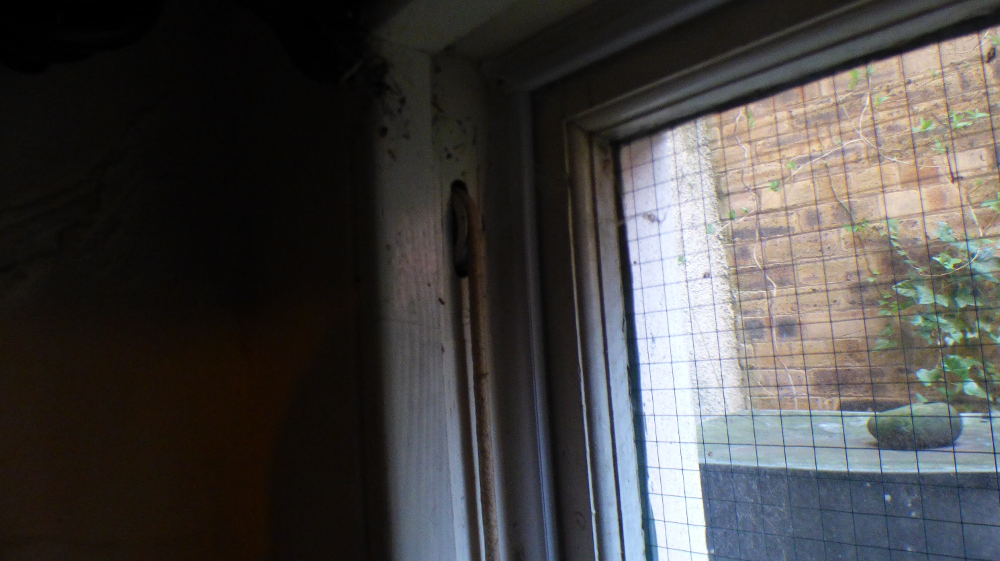

Photograph 66: Showing internal view of Window 16. Showing modern pulley wheels, further evidence that the windows are not original to the building.

