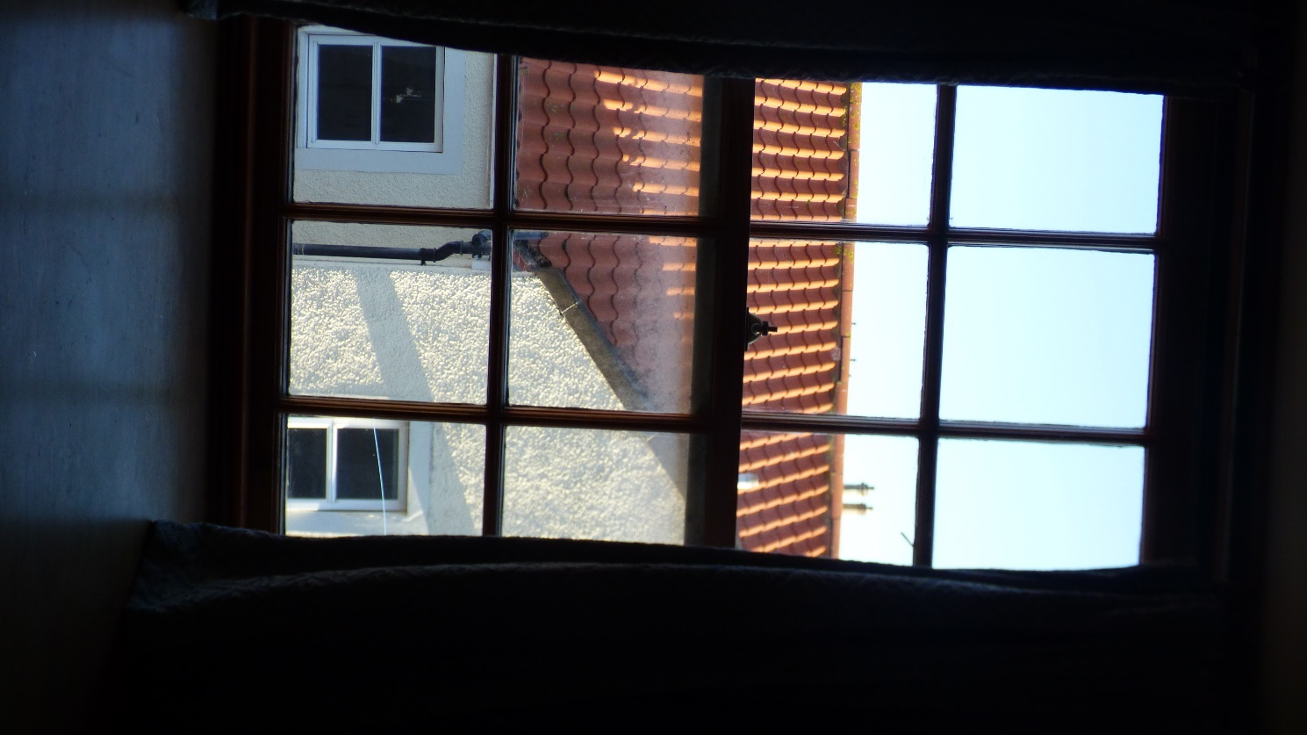

Photograph 27: Showing internal view of Window 4.

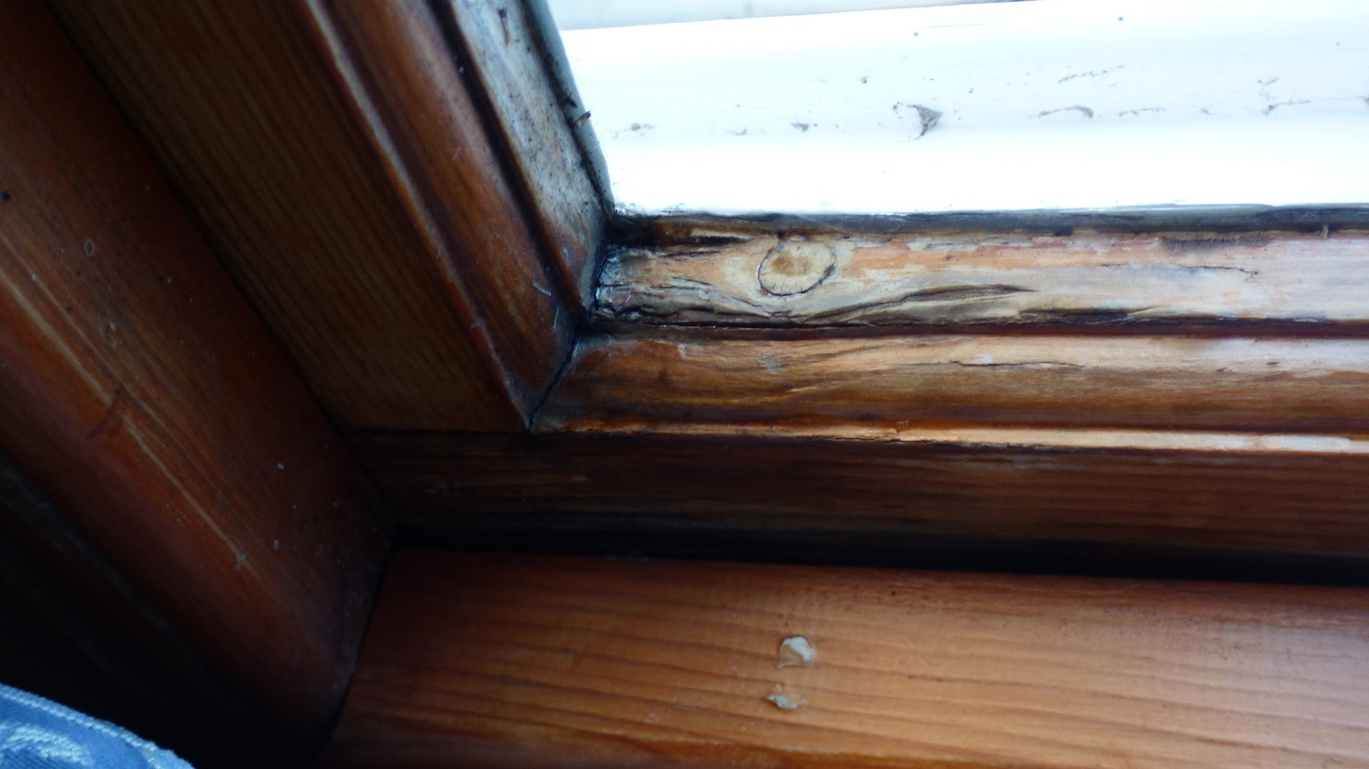

Photograph 28: Showing internal view of Window 4. Due to external water ingress, the bottom rail timber is extremely soft, the original mortise and tenon joint has swollen and cracked the surrounding timbers.

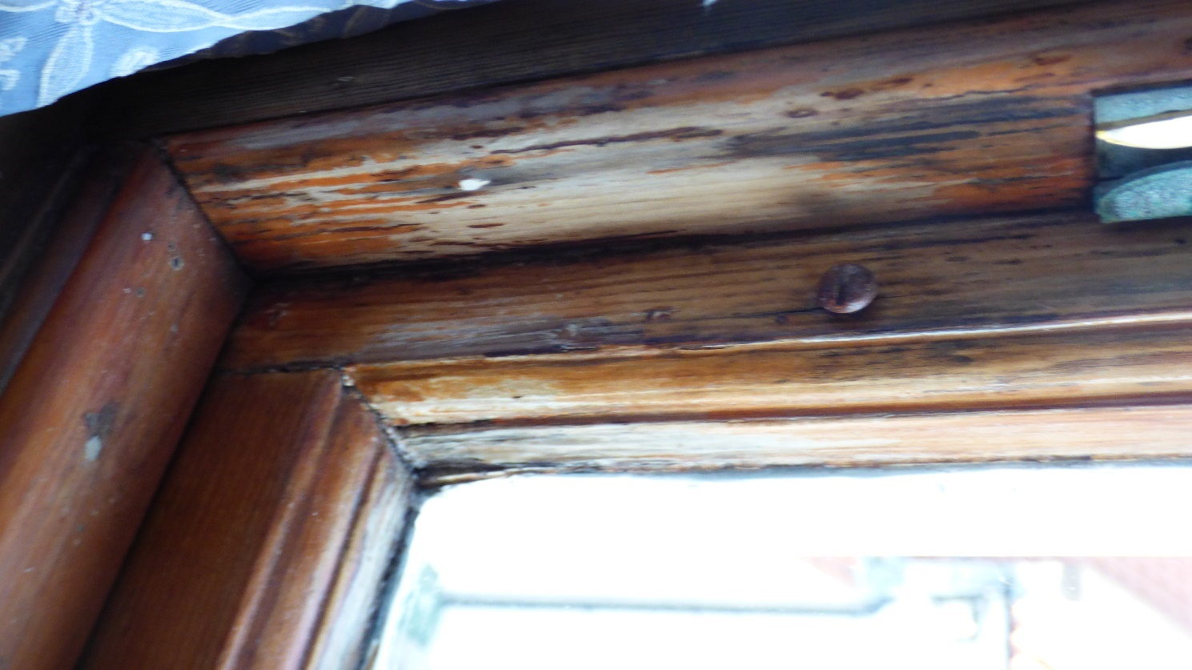

Photograph 29: Showing internal view of Window 4. Due to external water ingress, the bottom rail timber is extremely soft, the original mortise and tenon joint has swollen and cracked the surrounding timbers.

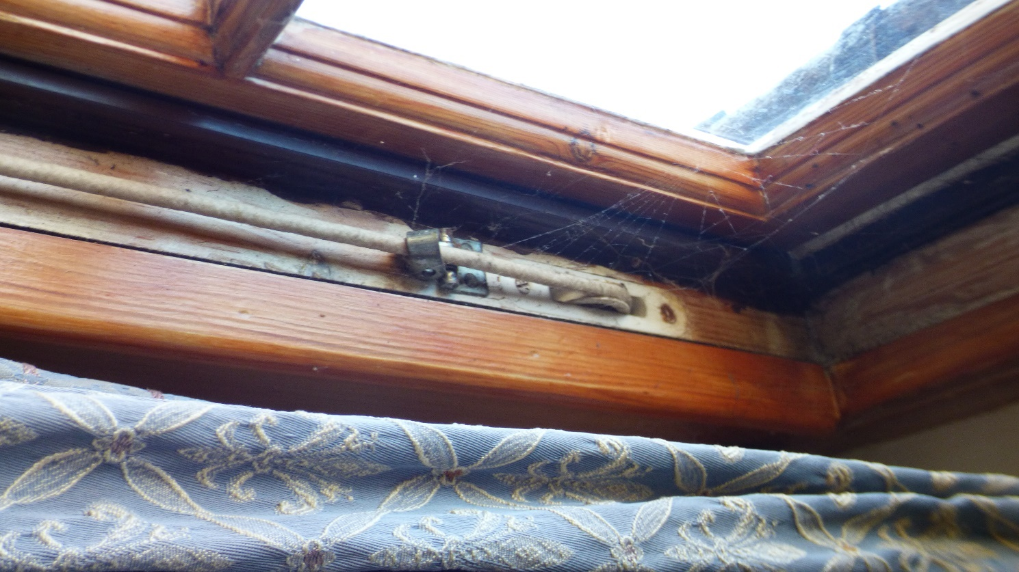

Photograph 30: Showing internal view of Window 4. Showing modern pulley wheels, further evidence the windows are not original to the building.

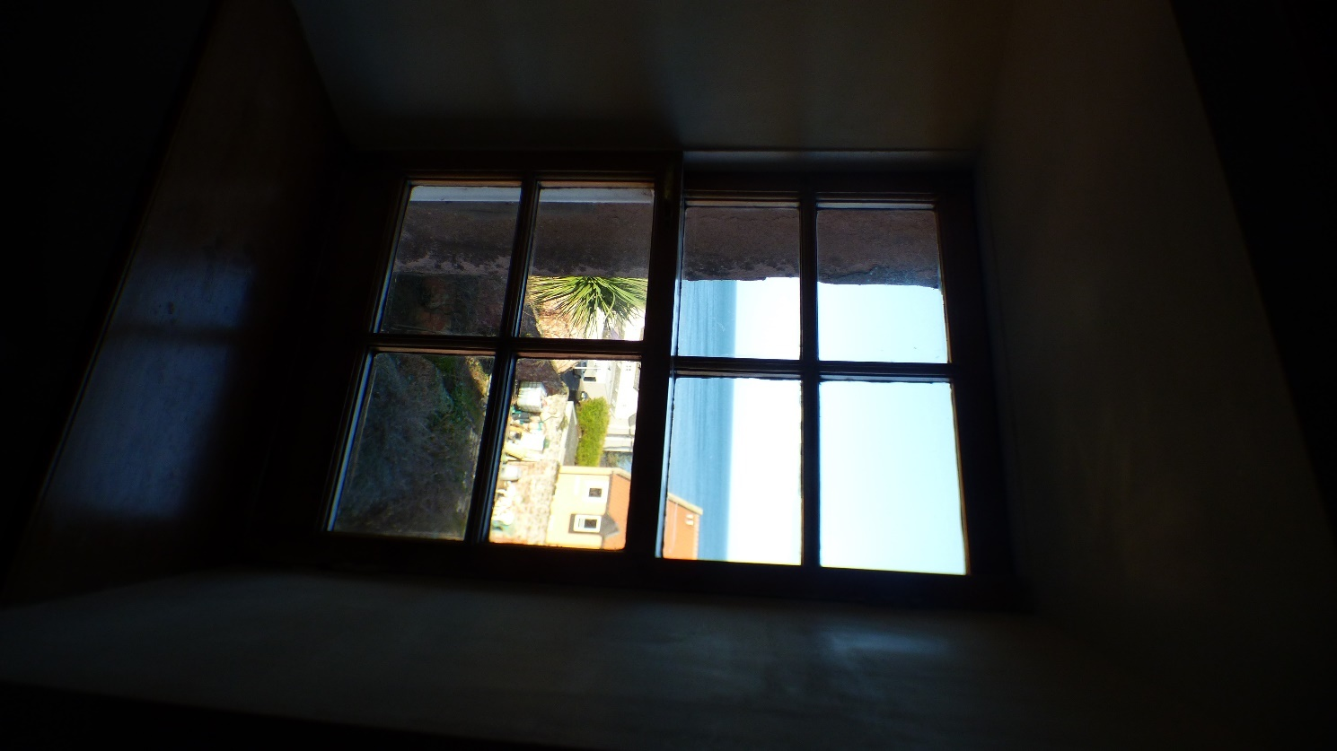

Photograph 31: Showing internal view of Window 6. Currently 8 panes. Hermitage Window Ltd propose altering to a 6 pane casement. 6 panes would look more in proportion to the other 6/6 style sash and case windows.

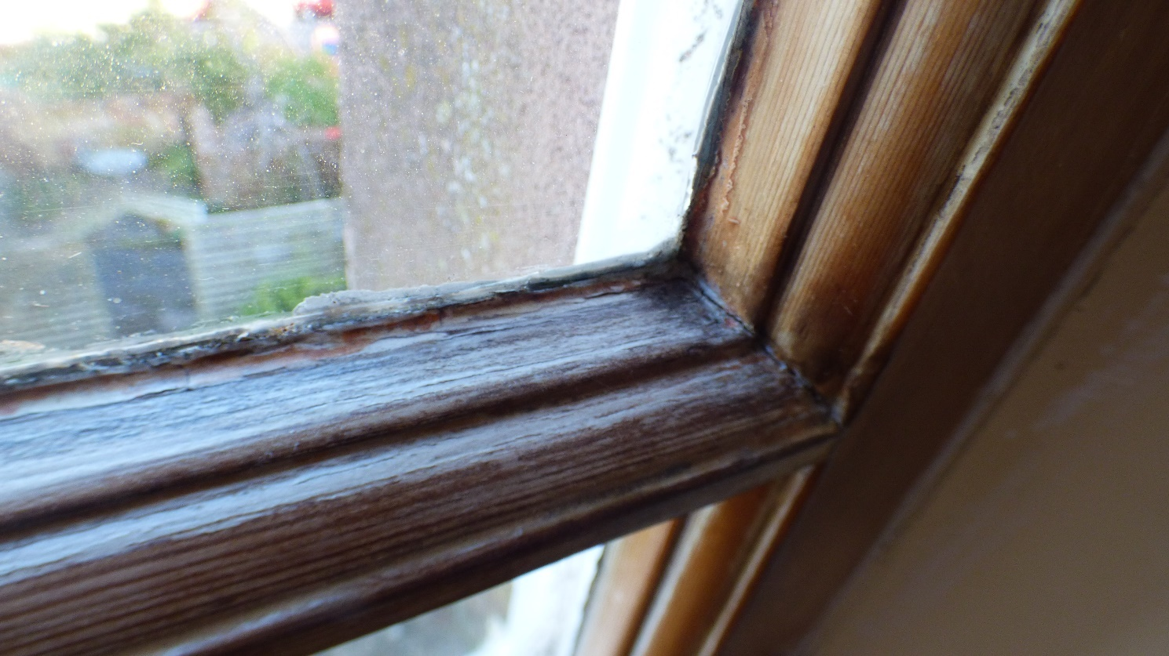

Photograph 32: Showing Window 6. Due to external water ingress, the Astragal timber is extremely soft, the original mortise and tenon joint has swollen and cracked the surrounding timbers.

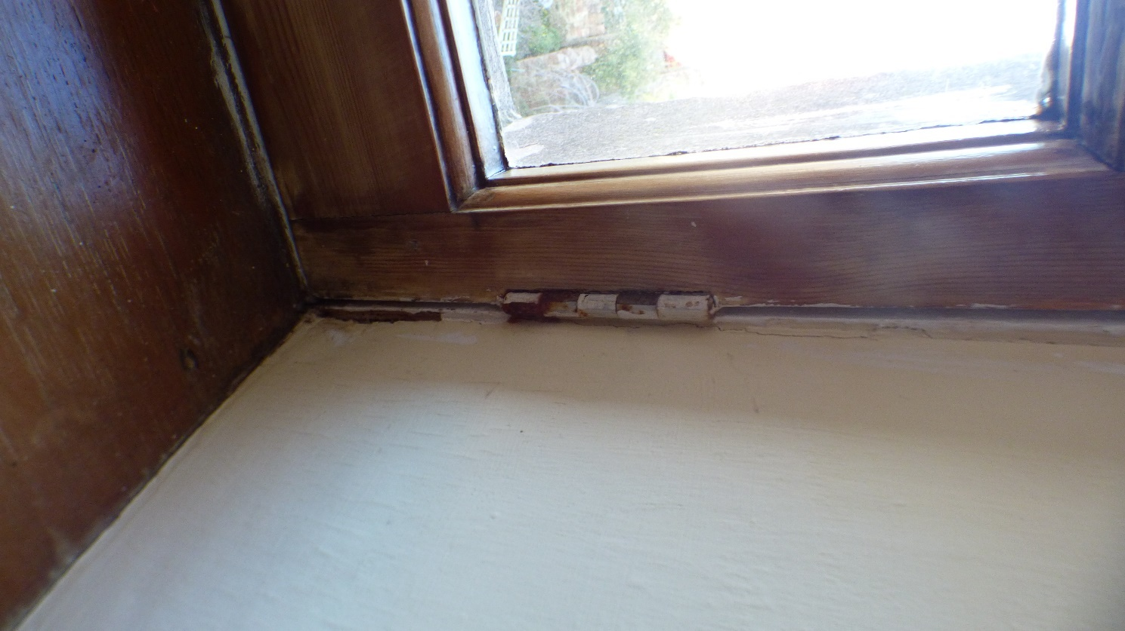

Photograph 33: Showing Window 6. Side hung casement window.

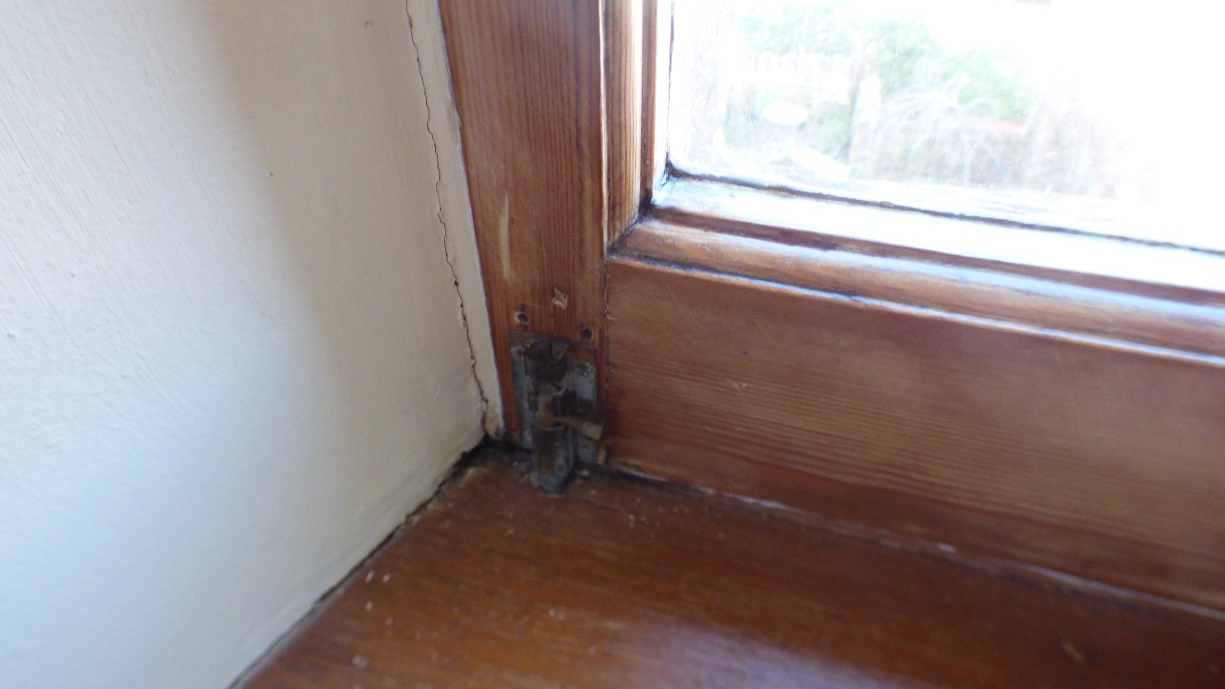

Photograph 34: Showing Window 6. Side hung casement window.

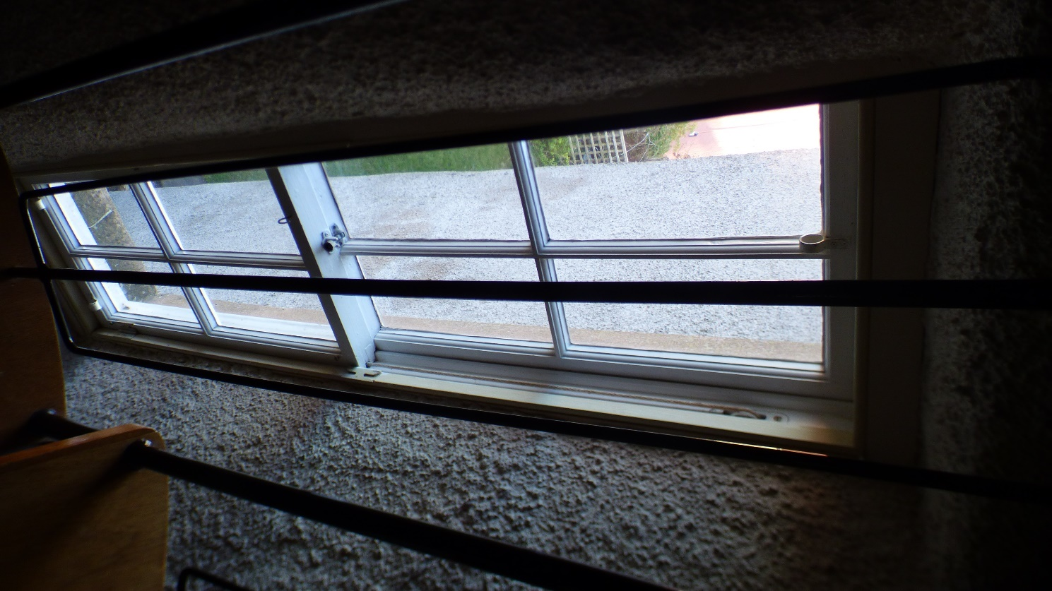

Photograph 35: Showing internal view of Window 15.

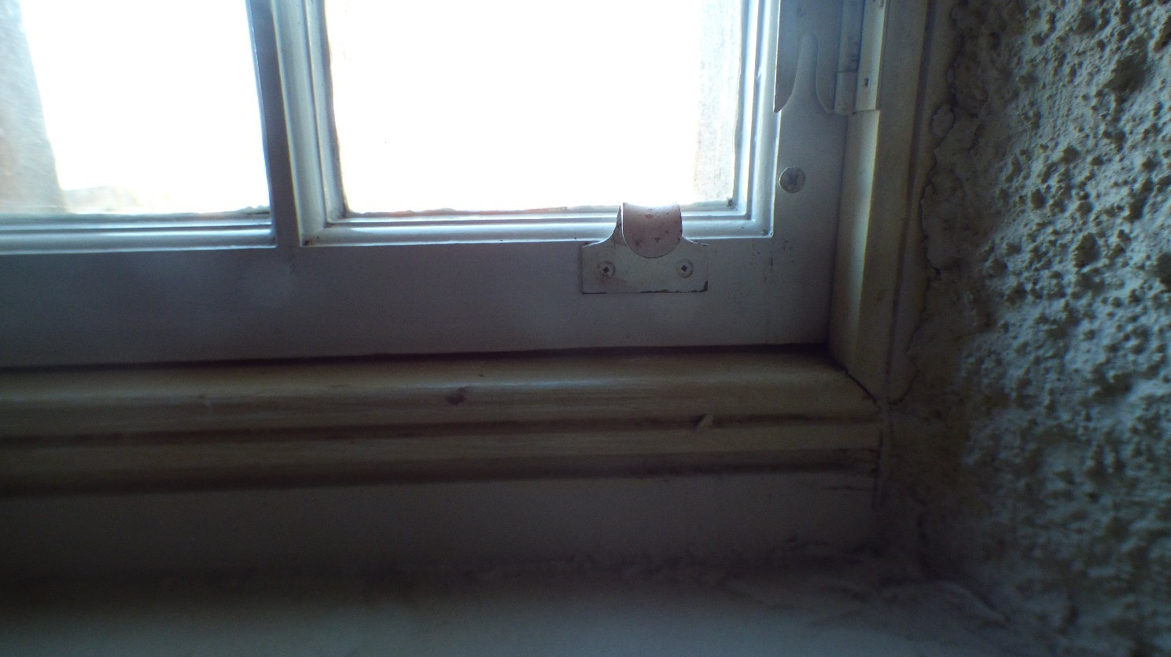

Photograph 36: Showing internal view of Window 15. Photographic evidence of a modern astragal detail. Further evidence the windows are not original to the building.

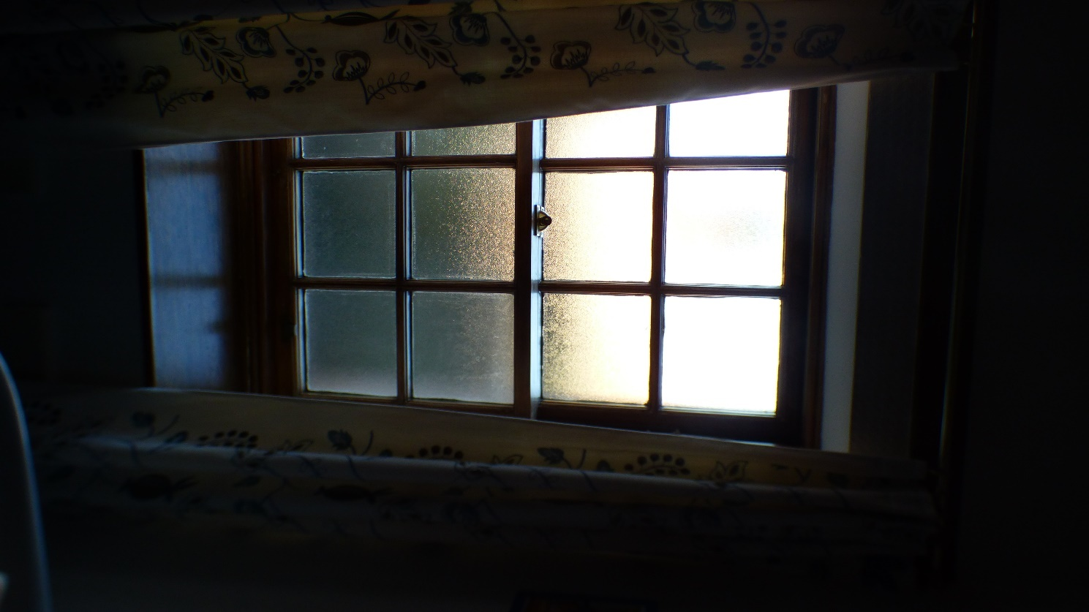

Photograph 37: Showing internal view of Window 13.

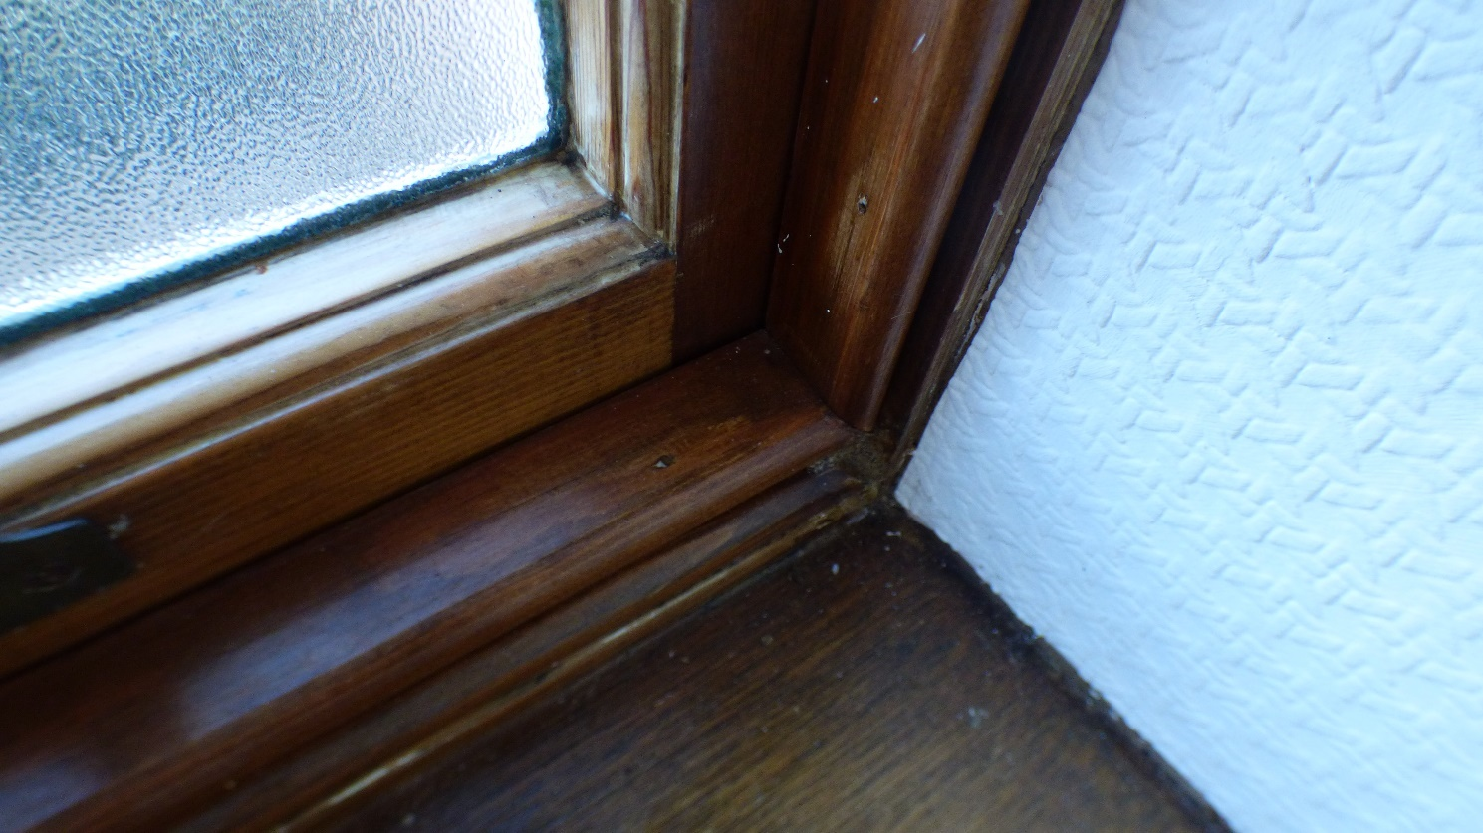

Photograph 38: Showing internal view of Window 13. Due to external water ingress, the bottom rail timber is extremely soft, the original mortise and tenon joint has swollen and cracked the surrounding timbers.

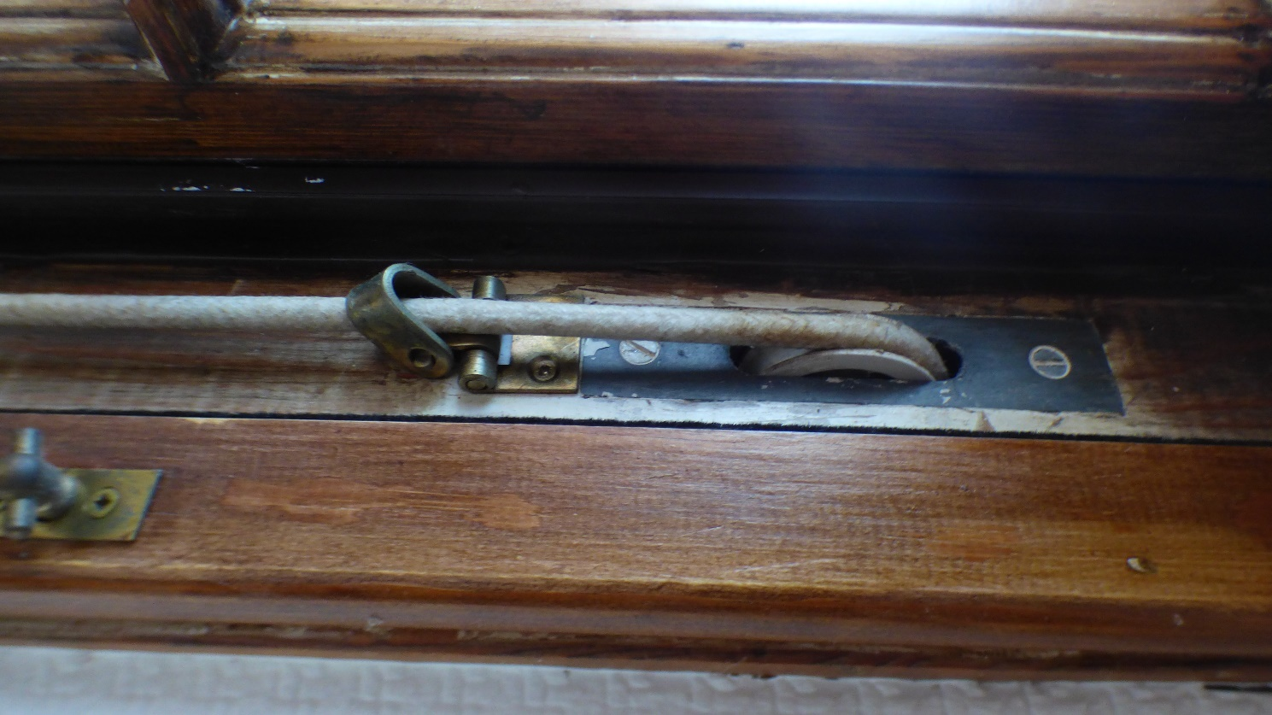

Photograph 39: Showing internal view of Window 13. Showing modern pulley wheels. Further evidence the windows are not original to the building.

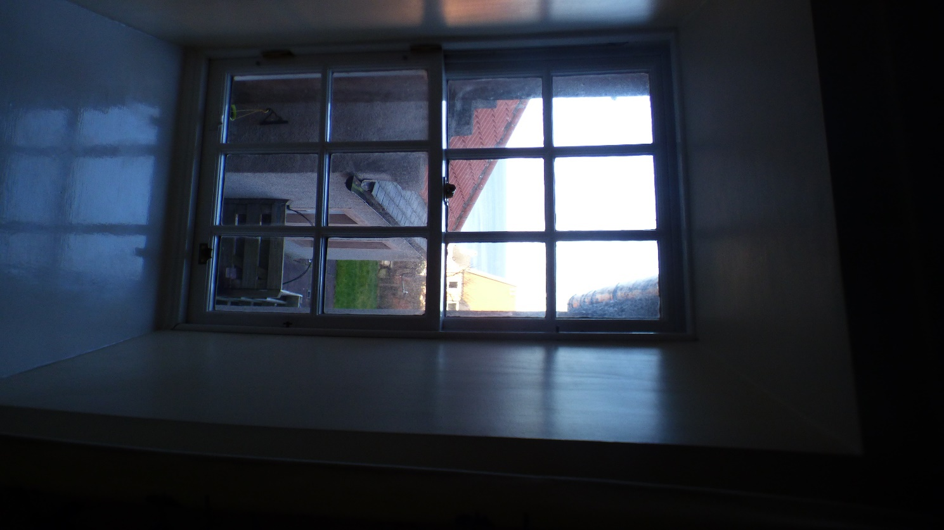

Photograph 40: Showing internal view of Window 14.

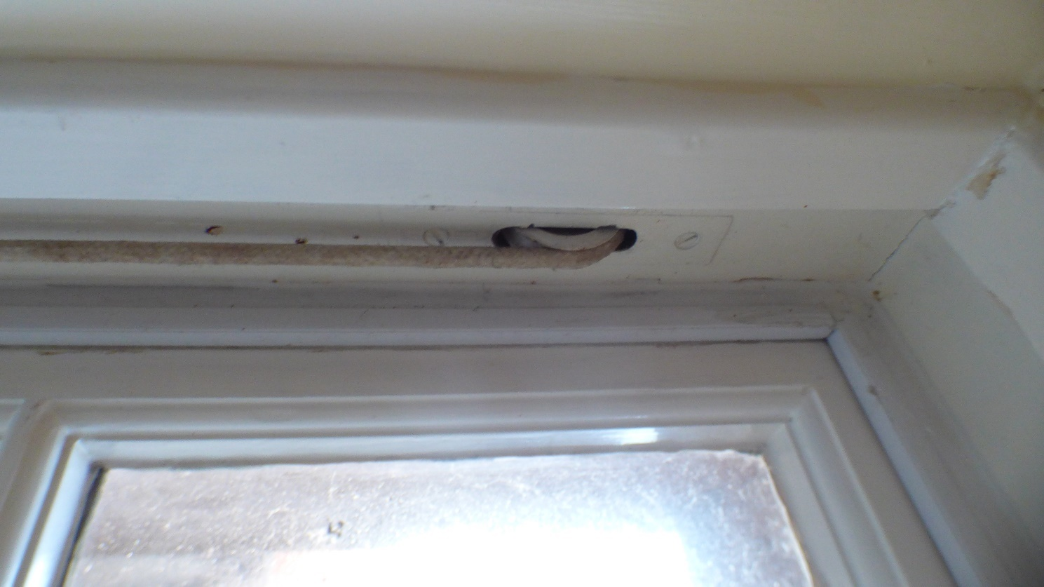

Photograph 41: Showing internal view of Window 14. Showing modern pulley wheels. Further evidence the windows are not original to the building.

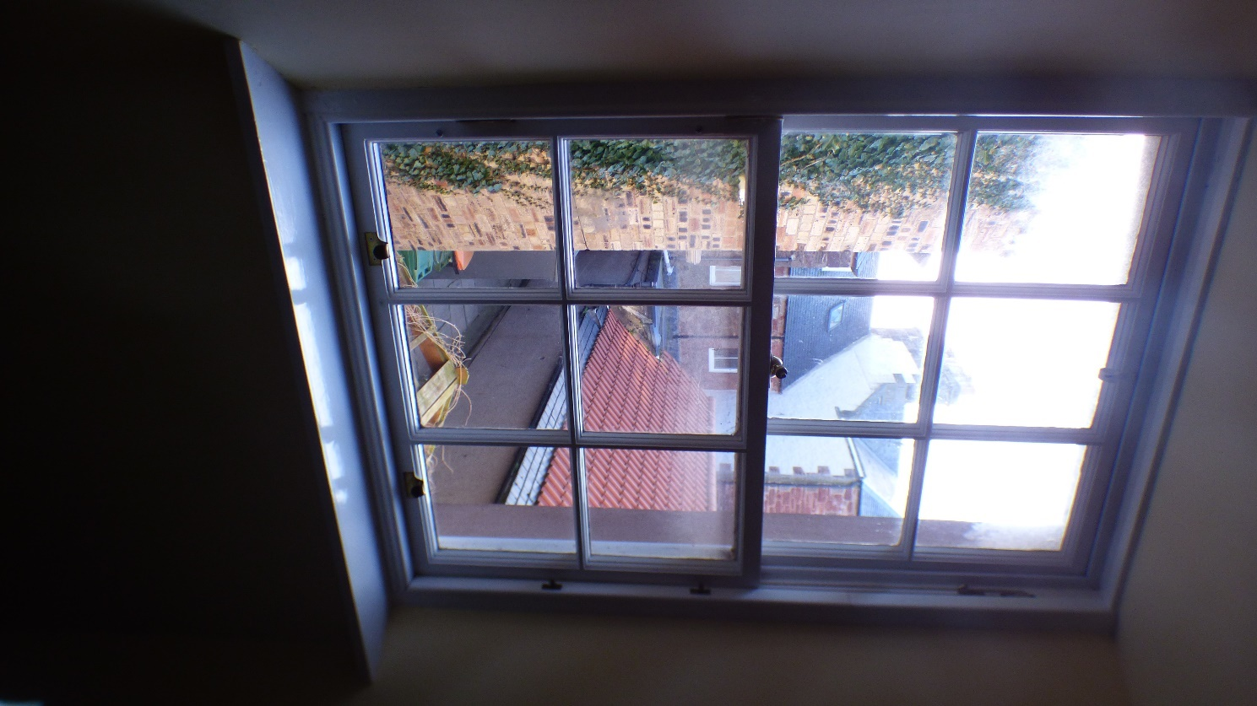

Photograph 42: Showing internal view of Window 8.

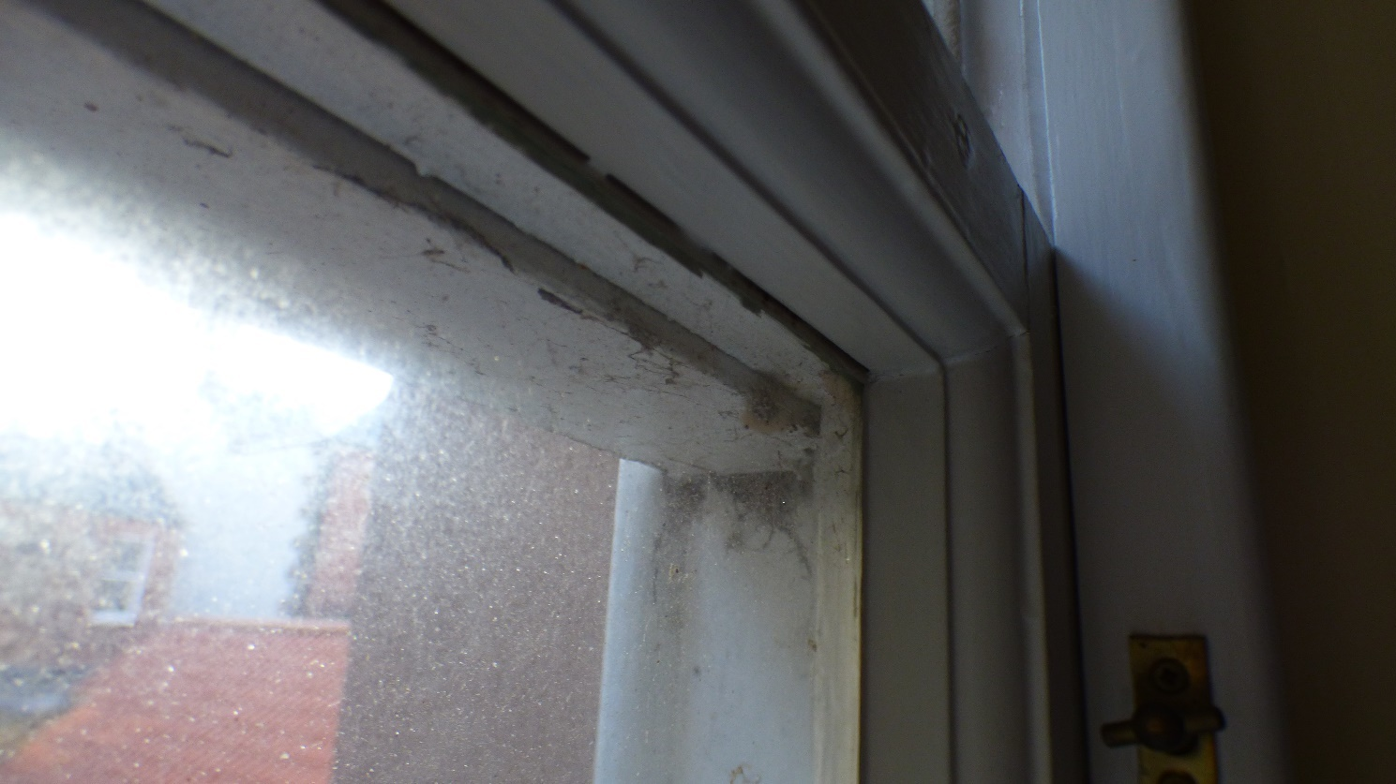

Photograph 43: Showing internal view of Window 8. Due to external water ingress, the midrail timber is extremely soft, the original mortise and tenon joint has swollen and cracked the surrounding timbers.

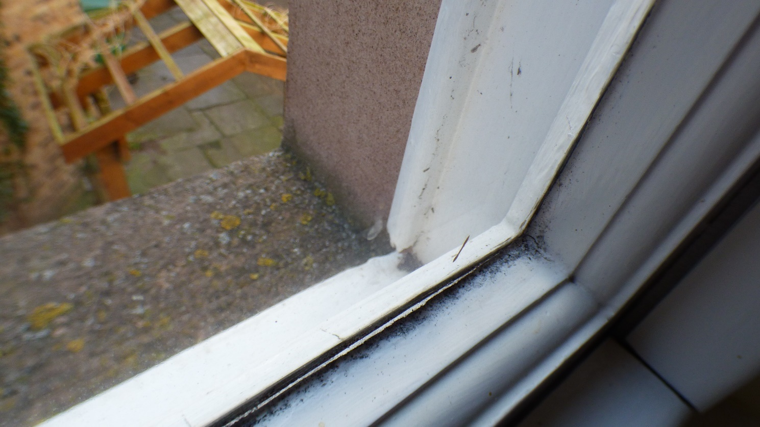

Photograph 44: Showing internal view of Window 8. Due to external water ingress, the bottom rail timber is extremely soft, the original mortise and tenon joint has swollen and cracked the surrounding timbers.

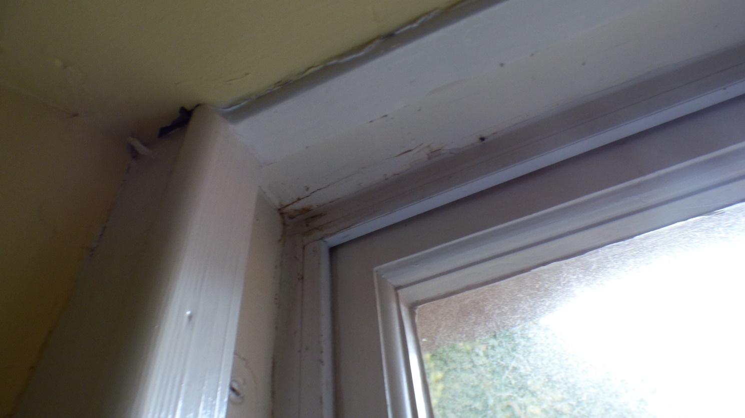

Photograph 45: Showing internal view of Window 8. Due to external water ingress, the casement timber is extremely soft and requires immediate attention.

