Windows: White UPVC https://www.modernupvcwindows.co.uk/ - Heritage Profile

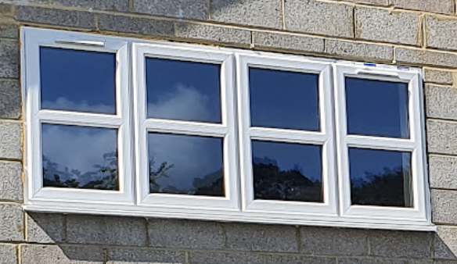

Guttering: Black UPVC – Floplast :
https://www.floplast.co.uk/product/gutter
Fascia & Soffit: – White UPVC – Eurocell:
https://www.eurocell.co.uk/fascia-boards/replacement-fascia-18mm/225mm-x-18mm-fascia-board-in-white-x-5m
https://www.eurocell.co.uk/soffit-board/flat-soffit-board-9mm/200mm-utility-board-in-white-x-5m
Weatherboard: Cedral White [C01] Lap. Southern Sheeting.
https://www.southernsheeting.co.uk/products/cedral-weatherboard-lap-classic-woodgrain-c01-white-ew1wb-c01.html?filter_set[]=1&o[]=1,1
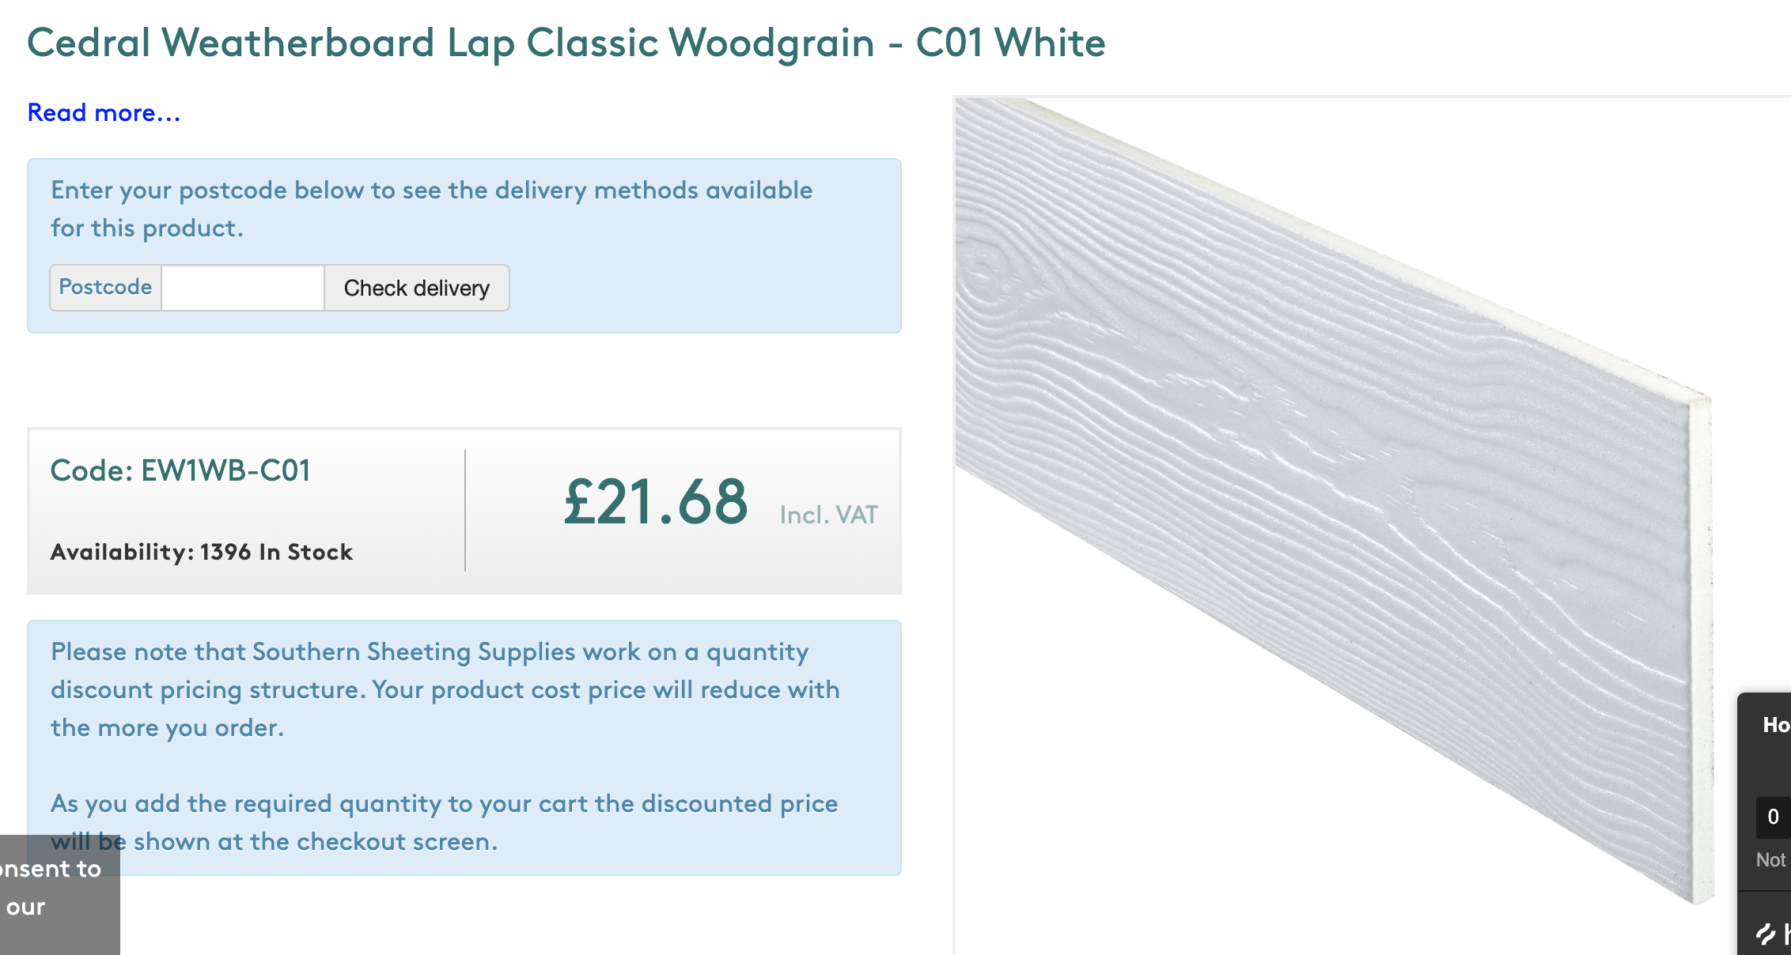
Brick finish: 'Old Lambeth’ brick slips. Kucci Design. https://www.kucidesign.co.uk/product-page/old-lambeth-brick-slips
