Material Schedule

From: | Jack Bayliss LRTPI
CC: | Peter Leamy
Date: | 8th February 2022
Re: | Material Schedule for Moat Barn House, Oldwich Lane East, Fen End, CV8 1NR

This Material Schedule considers the hardstanding materials for Moat Barn House, Oldwich Lane East, Fen End, CV8 1NR.

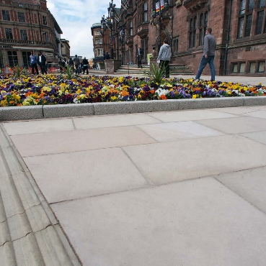
Brackendale Sandstone – Marshalls https://www.marshalls.co.uk/commercial/product/brackendale-sandstone
Finish: Blasted finish.
Material: Sawn sandstone.
Colour: In shades ranging from pale grey/ beige to pale buff with red/ brown streaks and subdued banding.
Nominal sizes: [200 x 100 mm] [300 x 100 mm] [300 x 150 mm] [300 x 200 mm] [450 x 450 mm] [900 x 450 mm]
[900 x 600 mm] [900 x 600 mm].
Slip Resistance: Dry slip resistance (to BS 14231): 98. Wet slip resistance (to BS 14231): 78.
Breaking load: 27.5 MPa (Mean value to EN 12372: 2006 (Lev = 22.5 MPa)).
Water absorption (maximum): 1.2% (Mean value to EN 13755: 2008 (Hev =1.2%)).

10mm Gravel – Hanson https://www.hanson-packedproducts.co.uk/en/products/base-aggregates/10mm-gravel
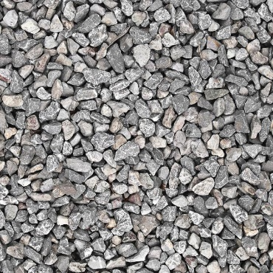
10mm single sized gravel aggregate conforming to the requirements of BS EN12620: 2013.
Typical moisture content: 3%
Particle size: 4-10mm
Shell content: ≤ 10%
Chloride content: ≤ 0.01%
Acid soluble sulphate: ≤ 0.8%

