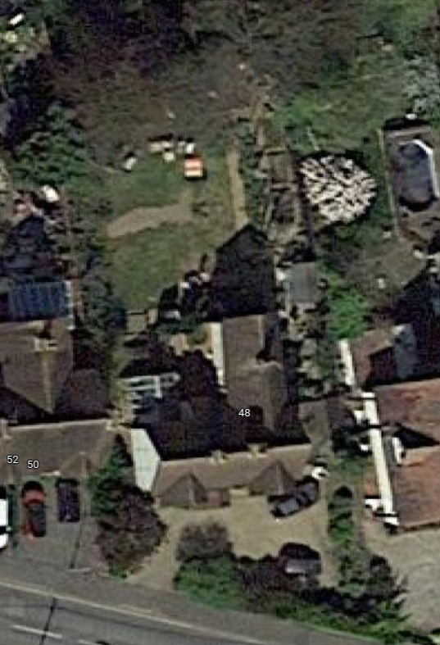
Limes x3
Plan indicating the tree location at 48 Avenue Road, Witham, CM8 2DP.

