Percolation Test
Wellbuilt Construction Ltd undertook a percolation test to determine soil infiltration rates at Land at south end of Victoria Street and west of Hope Street, Rawtenstall Lancashire BB4 7PT using the BRE 365 methodology (2016) to assess the viability of disposal of surface water from the site via infiltration.
Percolation testing was undertaken in accordance with the requirements set out in BRE 365 (2016). In total two test pits were excavated at the site. One test was undertaken within each pit in April 2022 during dry conditions.
In accordance with BRE 365 ‘the trial pit should be 0.3 to 1 m wide and 1 to 3 m long. It should have vertical sides trimmed square and, if necessary for stability, should be filled with granular material. Fill the pit and allow it to drain three times to near empty; each time record the water level and time filling. Calculate the soil infiltration rate from the time taken for the water level to fall from 75% to 25% effective storage depth in the pit, using the lowest f value of the three test results for design.’
The trial pits were excavated using a HITACHI excavator to a maximum depth of 1.00 m with the sides trimmed square. Water was discharged into pit using a local neighbour’s hose pipe.
The test pit dimensions are as follows:
Table 1: Test Pit Dimensions
Test Pit No. | Length (m) | Width (m) | Depth (m) | Area (m3)
SA1 | 1.2 | 1.2 | 1.2 | 1.44
SA2 | 1.2 | 1.2 | 1.2 | 1.44

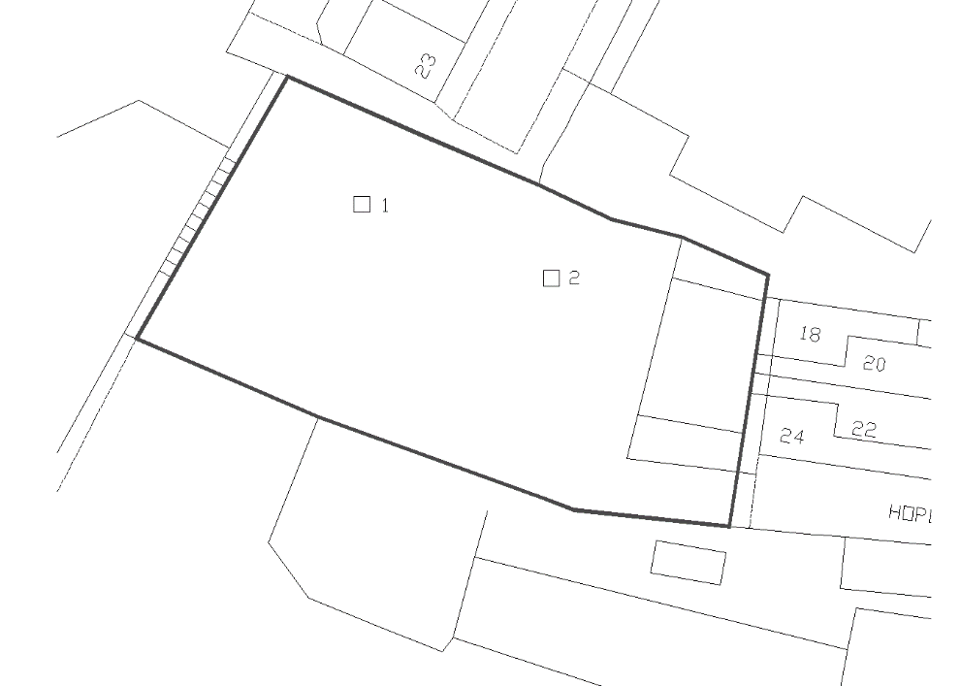
In total two infiltration tests were undertaken at the site. The location of the trial pits is included below.

The ground conditions at the site of both trial pits excavated at the site comprised of brown clayey sand/sandy clay. Water was discharged into each pit and the time taken for the water to infiltration into the soil was recorded as shown within the table below:
Infiltration Test Results
Infiltration Test 1
Depth to water at start of test: 0.20 m
A summary if the percolation test is shown within the table below:
Time (minutes) |  | Depth to Water (cm) | Notes
0 |  | 0.20 | Start of Test
5 | 0.20
10 | 0.20
20 | 0.20
30 | 0.20
60 | 0.20
90 | 0.21
150 | 0.22
240 | 0.22
300 | 0.23
330 |  | 0.24 | End of test
It can be seen from the above table that the water did not reach 75% effective depth after 5.5 hours of the test. Furthermore, 3 tests are required to be undertaken with the slowest infiltration rate used for design purposes therefore the test is considered to have failed
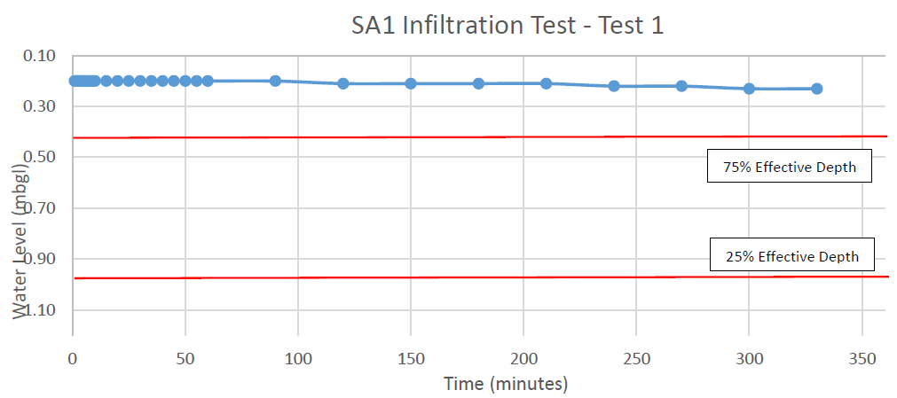

Infiltration Test 2

Depth to water at start of test: 0.30 m

A summary of the percolation test is shown within the table below:
Time (minutes) |  | Depth to Water (cm) | Notes
0 |  | 0.30 | Start of Test
5 | 0.30
10 | 0.30
20 | 0.30
30 | 0.30
60 | 0.30
90 | 0.30
150 | 0.31
240 | 0.33
300 | 0.34
330 |  | 0.35 | End of test
It can be seen from the above table that the water did not reach 75% effective depth after 5.5 hours of the test. Furthermore, 3 tests are required to be undertaken with the slowest infiltration rate used for design purposes therefore the test is considered to have failed
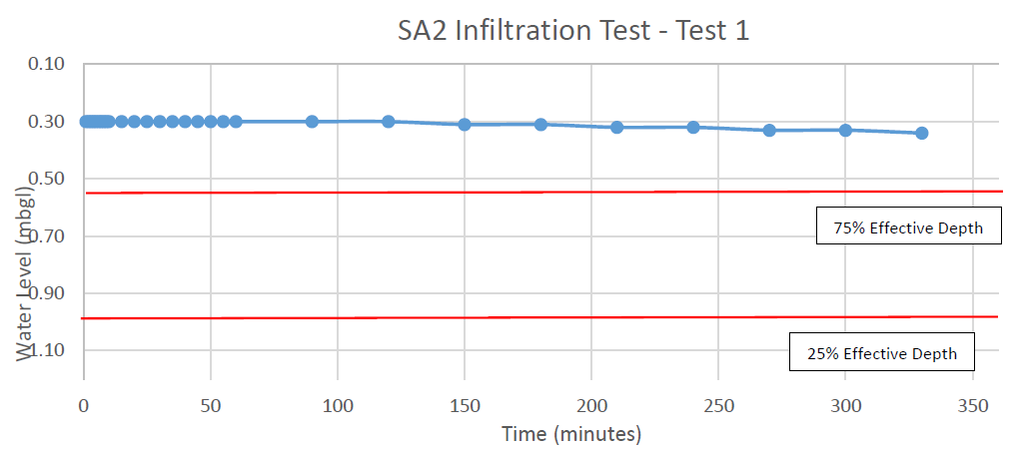
Conclusion
Two infiltration test trial pits were excavated at the site at Land at south end of Victoria Street and west of Hope Street, Rawtenstall Lancashire BB4 7PT and two infiltration tests in accordance with BRE 365 (2016) were undertaken by Wellbuilt Construction Ltd.

After 5.5 hours of the tests, the water level had failed to reach 75% effective depth therefore the tests were deemed to have failed and discharge of surface water from the site via infiltration methods is not considered to be viable at the site at the site.

