Construction Management Plan

Contents

1. Scope of Works
2. Enabling Works/Formation of Site Perimeter
3. Site Parking & Storage of Plant & Materials
4. Management of Vehicle Access/Egress & Deliveries
5. Wheel Wash Facility
6. Management of Dirt & Dust
7. Excavation and Ground Works
8. Protection of Existing Trees to be retained
9. Recycling/disposing of waste resulting construction work
10. Noise Control

1.0 Scope of Works
1.1 The scheme involves the construction of one domestic house at Land at south end of Victoria Street and west of Hope Street, Rawtenstall Lancashire BB4 7PT
2.0 Enabling Works/Formation of Site Perimeter
2.1 At commencement the perimeter of the site will be established and securely protected
with good quality Heras security fencing to HSG151 standard to the whole of the
perimeter of the site complete with all necessary signage in accordance with HSE
requirements.
2.2 The site area is to be stoned to provide a hardstanding for site vehicles, storage of
materials, site cabins etc.
3.0 Site Parking & Storage of Plant & Materials
3.1 All contractor’s vehicles will park within the site area in a designated parking area on
the hard standing.
3.2 All materials and plant will stored within the fenced site area. Materials such as cement
and equipment will be stored in a secure site cabin.
4.0 Management of Vehicle Access/Egress, Deliveries & Loading/Unloading of Plant Material
4.1 Access to the site will be via Hill End Lane and then Victoria Street.
4.2 The access route to the site will be dug out and stoned to provide a hard standing for
contractor’s vehicles. A turning circle will be provided and kept clear on site for
delivery vehicles.
4.3 Delivery/tipper wagons will be accompanied onto and from the site by a banksman
who will be in advance of the wagons at all times. Generally deliveries will be by
smaller wagons and the contractor will make merchants aware of the site restrictions
when arranging deliveries.
4.4 Construction traffic routes will be kept a safe distance from trench works at all times.
Prior to leaving the site, vehicles will be inspected and the wheels be washed on the
hard standing using a Karcher type jet wash unit.
4.5 The contractor will manage the risk of any road contamination by regular monitoring.
Should the road become contaminated any debris will be removed by spade and jet
Wash. 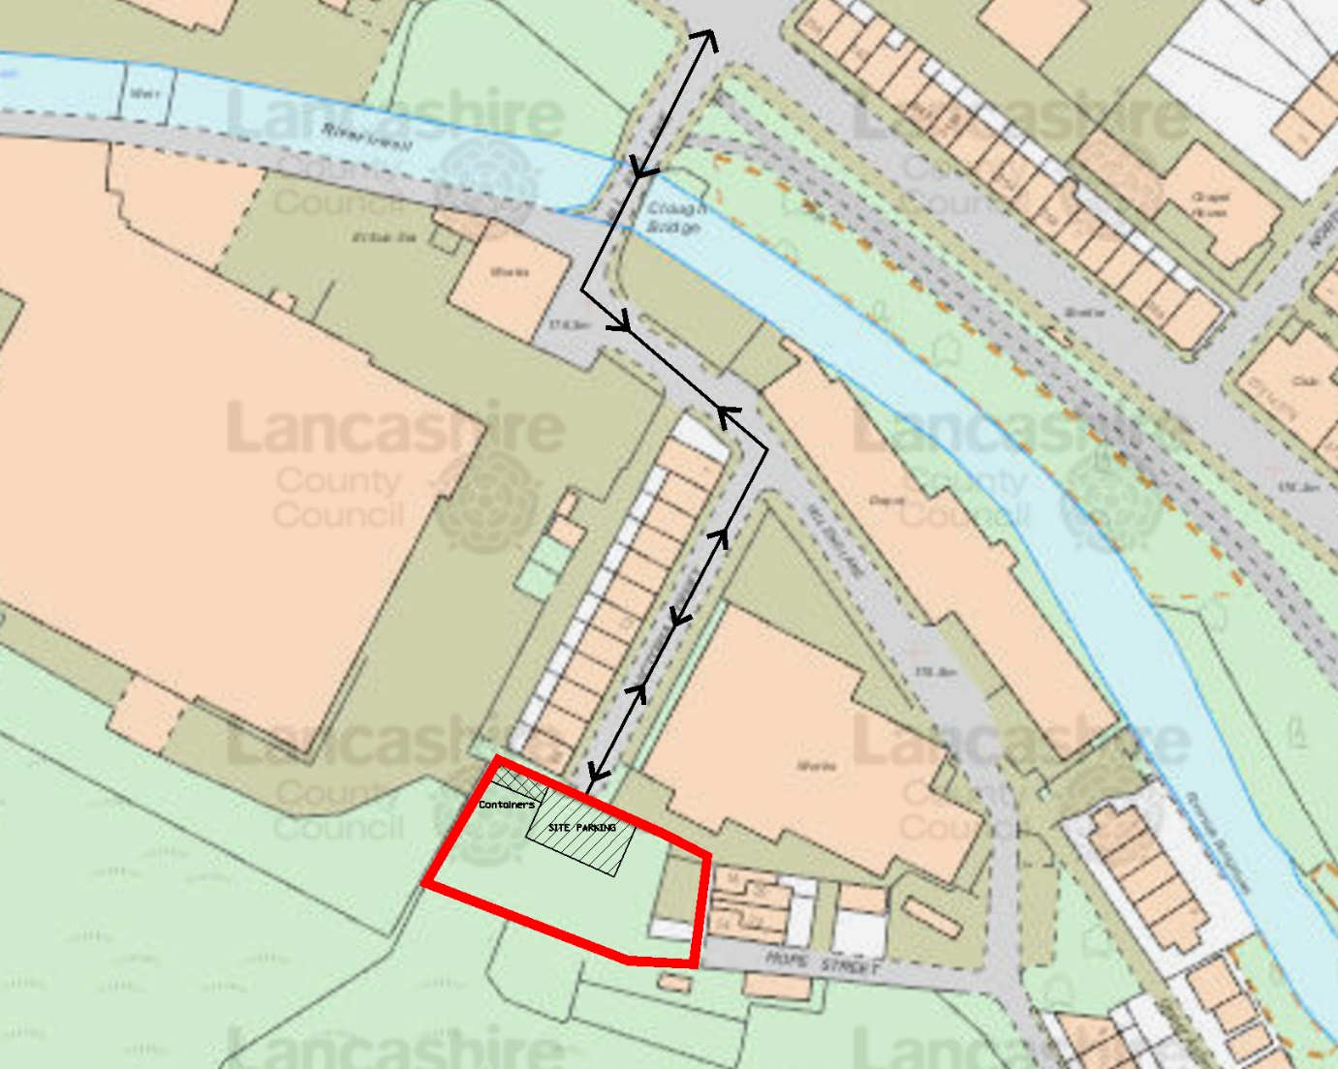

5.0 Wheel Wash Facility
5.1 Prior to leaving the site, vehicles will be inspected and the wheels be washed on the
hard standing using a Karcher type jet wash unit.
5.2 The contractor will manage the risk of any road contamination by regular monitoring.
Should the road become contaminated any debris will be removed by spade and jet
wash.
6.0 Management of Dirt & Dust
6.1 If dust emissions are generated in dry period the contractor will use water spray to wet
the material and suppress the dust.
6.2 The site manager will take account of weather conditions and prevailing wind direction
when organising operations to prevent and minimise dust nuisance to neighbouring
properties.
6.3 All site staff will be trained and be aware of the Dust Management Strategy.
6.4 The access road is to be stoned to provide a good, clean working platform and prevent
road contamination.
6.5 In the event of a complaint form a neighbouring property in respect of dust there
concerns will be considered and action taken to prevent future occurrence.
6.6 All site staff will have appropriate PPE to protect them from the effects of dust.
7.0 Excavation and Ground Works
7.1 Location of underground Services
- Prior to commencing excavations the site area will be checked for overhead and
underground services.
- Service plans will be obtained from Utility providers and the site area checked
over using a locating device.
- Once identified service routes will be identified and clearly marked. If markings
are lost during the working operation the exercise will be repeated to ensure
service routes remain clearly marked as required for the duration of the works.
- Works will be undertaken in accordance with the HSE Guidance Document,
Avoiding danger from underground services.

7.2 Excavations
- Trenches with a depth exceeding 1m will be either battered back or suitably
shored and the shoring maintained.
- Trenches will be inspected regularly and excess groundwater pumped out
regularly during inclement weather.
- Vehicle plant will be kept a safe working distance from the trench to prevent
potential collapse.
- No site staff will work below an excavator.
8.0 Protection of Existing Trees to be retained
8.1 Protection will be provided in accordance with BS5837-2012. Heras fencing will be
sited around the trees to prevent site operations affecting root growth etc. at a
minimum distance of half the height of the tree or to the extent of the canopy of the
tree, whichever is greater and maintained for the duration of the construction works.
Protection will be principally as detailed in Appendix A.
9.0 Recycling/disposing of waste resulting construction work
9.1 The land is a green field site so there will be very little waste material from demolition.
In respect of the construction work, the following measures have been identified to
minimise the quantity of waste produced during this project:
- The experienced site manager will be responsible for identifying and segregating
waste on site.
- All waste resultant from the works will be segregated on site.
- Resultant hard core will be re-used where possible in the substructure.
- Re-usable materials will be identified on site and removed for storage and re-sale.
- Recyclable materials will be removed from site for processing in licenced facilities.
10.0 Noise Control
10.1 Whilst working on site the contractor will adhere to the recommendations of BS 5228-
1, clause 9.3 to minimize noise levels during the execution of the Works.
10.2 The project is a relatively simple housing scheme with no notable works which would
cause significant noise pollution. The close proximity of residential housing has been
noted and there will be no operation of heavy plant etc. outside normal working hours
of 8.00am – 5.30pm.

