28 North End Road, Steeple Claydon, Buckingham, MK18 2PG
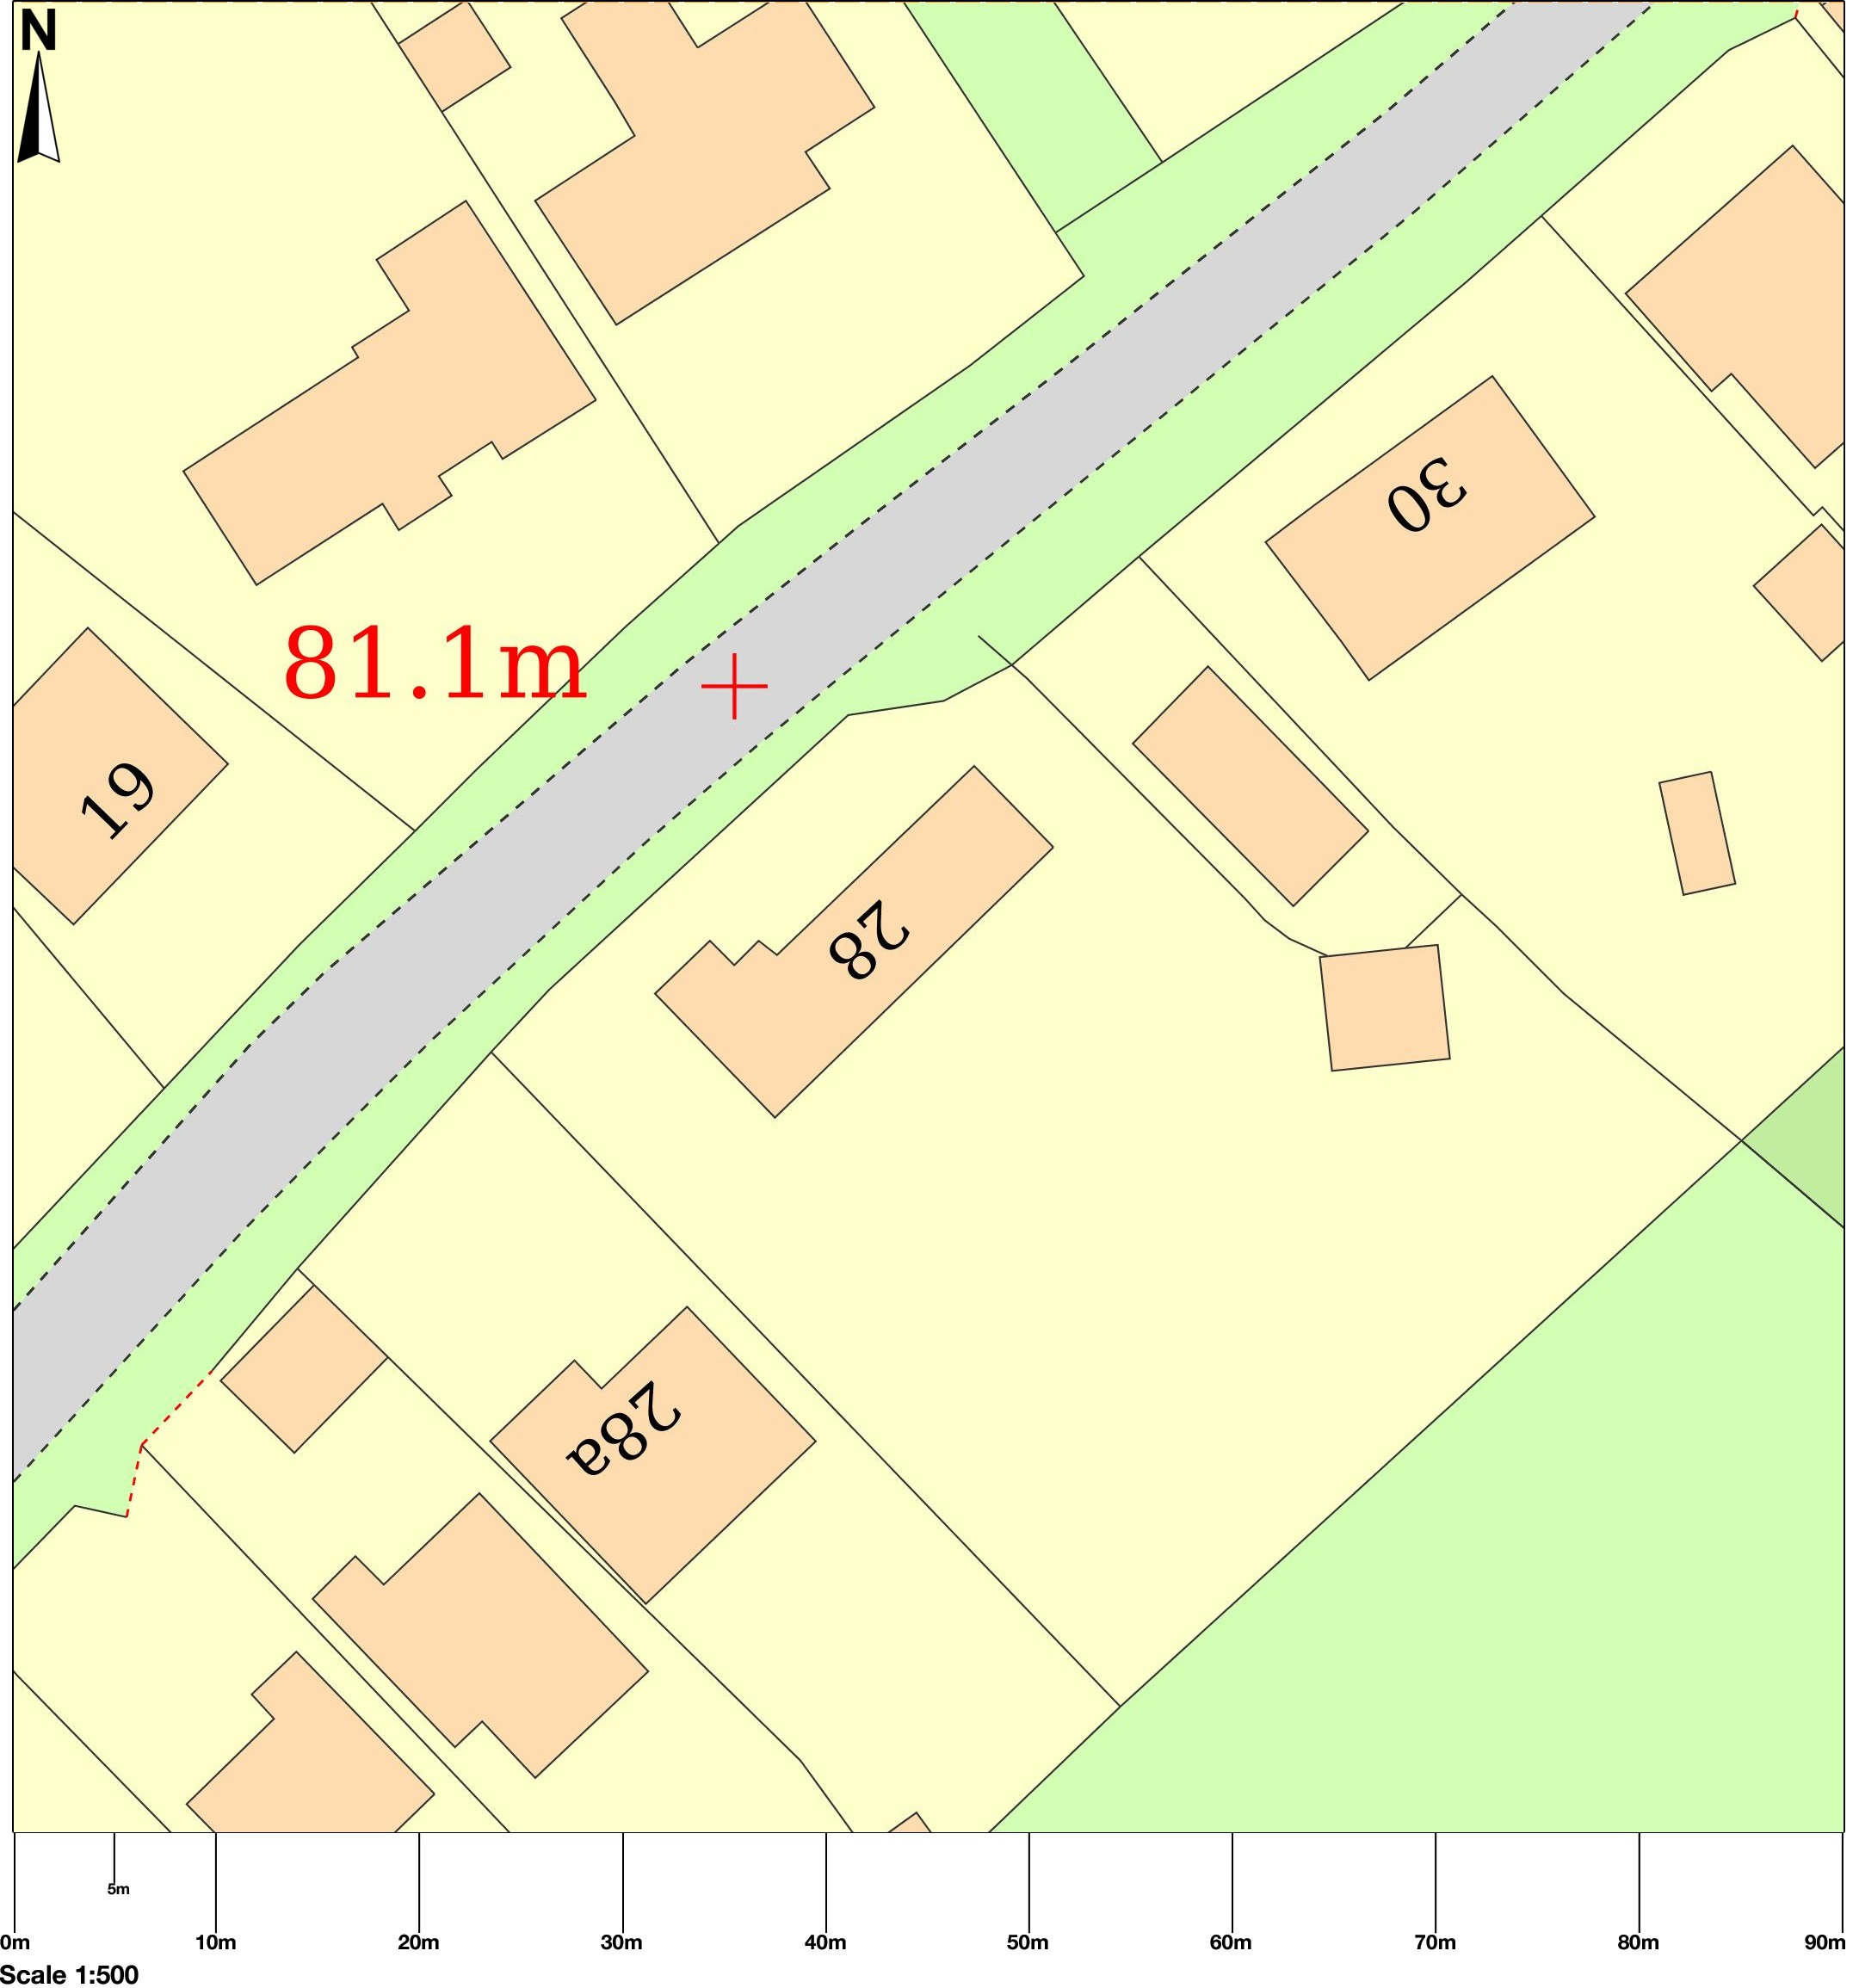
Pedestrian gate
Gable End & Sole Plate where all repairs will be conducted
Curtilage of 28 North End Road
Parking for up to 6 cars
Map area bounded by: 469878,227335 469968,227425. Produced on 16 May 2022 from the OS National Geographic Database. Reproduction in whole or part is prohibited without the prior permission of Ordnance Survey. © Crown copyright 2022. Supplied by UKPlanningMaps.com a licensed OS partner (100054135). Unique plan reference: b90c/uk/798516/1079568

