The Thatch, Lartington.

Replacement of Greenhouse to South West Elevation.

The Thatch and Smithy Cottage, Lartington. LISTED BUILDING
Lartington CONSERVATION AREA

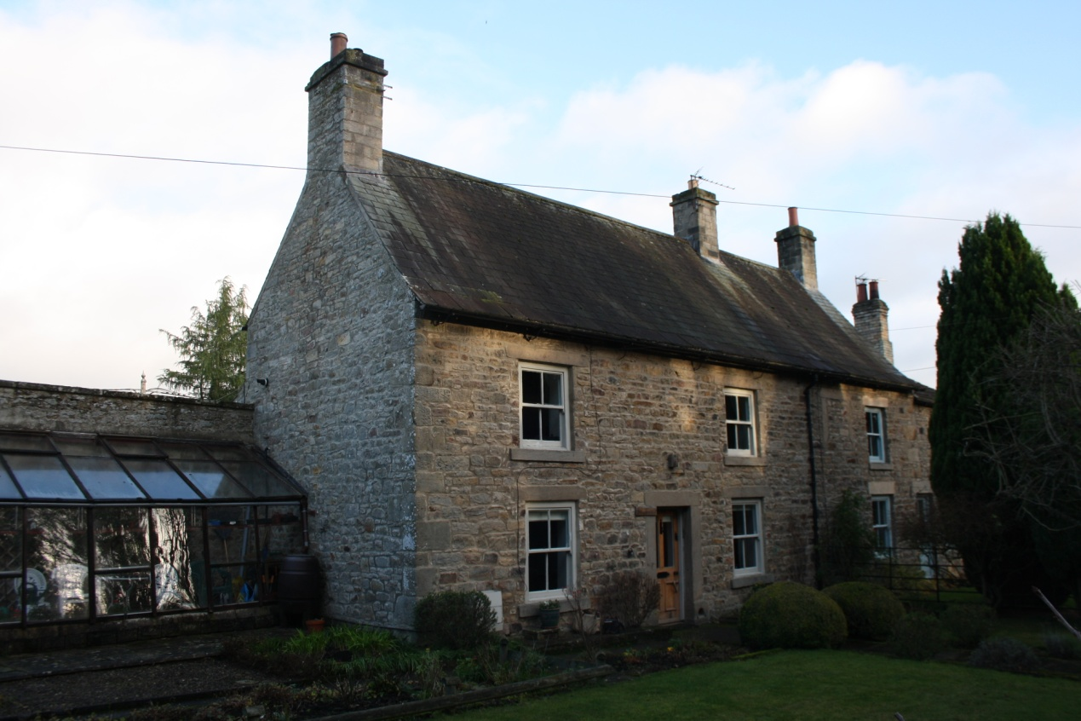

Heritage Statement.

The Heritage Statement.
- This statement is prepared for Mrs. Dart of The Thatch, Lartington in support of an application for the replacement of the deteriorating and collapsing greenhouse set at the southwest corner of the house at The Thatch. The development proposes to include the grade II listed building known as The Thatch and Smithy Cottage, Lartington, and lies in the Lartington Conservation Area. A heritage statement is therefore required.

- The report is prepared in line with advice given in the Durham County Council guidance on Heritage Statements of May 2014. Also of relevance is the updated NPPF guidance of February 2019, notably section 16, paragraphs 189 to 192 regarding proposals affecting heritage assets, and paragraphs 193 to 202 on consideration of potential impacts on heritage assets. Regard has also been had to Historic England Guidance notably Good Practice Advice in Planning Note 3 and Advice Note 12 on Analysing Significance.

- It will identify the application site and its heritage status, describe the heritage assets subject to the proposal detailing their history character and appearance and set out the extent of the assets and their context. A comment on the statutory heritage protection of the property will be included setting out the statutory status of the listed building itself. A general appraisal of the immediate surroundings, important views of the building and its place within the townscape will be discussed in this section.

- A statement of the significance of the asset will follow and the proposal will then be described in detail.

- Analysis of the impact of the proposal on the listed building will be provided followed by a final conclusion. Appendices will include statutory designations and identified heritage assets in the locality.

The Application Site – Location And Description.
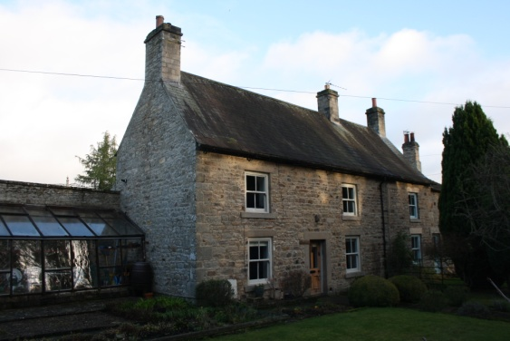
- Lartington is a small village lying 3km west of Barnard Castle in Teesdale. It comprises a single street of houses, the majority of which lie on the north side of the road, and Lartington Hall at the east end of the settlement. The Thatch lies towards the centre of the designated Lartington Conservation Area on the north side of Lartington Lane, the principle street through the historic village. The building is a substantial two storey stone house with a notably steeply pitched roof covered in diminished coursed green roof slates although these are now largely stained dark grey. The building comprises two properties, The Thatch forming the west part of the building which is a three bay structure with very pleasingly arranged windows, two upstairs and two downstairs flanking the front door. The eastern section is a separate property, Smithy Cottage, comprising the eastern bay of the main house with a further extended section on the east gable. There are three chimneys to the main building all set on the ridge line, one to each gable and one to the cross wall between the two houses. The greenhouse stands at the western end of the building set back from the frontage and backing onto the existing rear wall of the back kitchen extension.

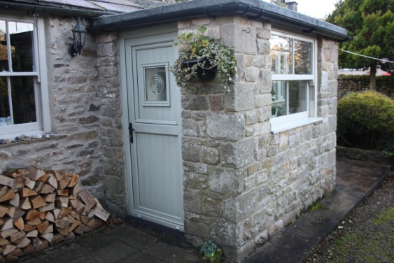
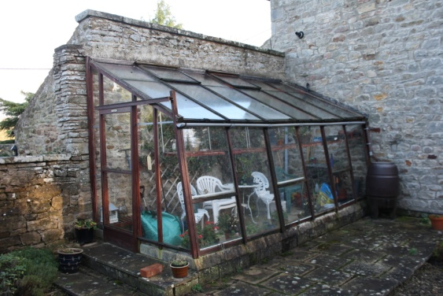
- The site is dominated from the road by the substantial hedge and a series of ornamental trees within the front garden of The Thatch which create an important feature in this part of the conservation area. The house itself is set back well from the road but its scale and steep roof give it a presence in the streetscape. The chimneys define the property and provide prominent elements within the composition whilst much of the front garden is hidden behind the hedge. Pedestrian access to the property is from the front gate but a secondary shared access for vehicles runs around the eastern end of the building via the access to Smithy Cottage. To the rear the house exhibits a range of pent roofed additions and alterations producing an interesting and varied elevation largely in keeping with the character of the house. A substantial early addition at the west end is fronted by the lean to green house whilst the central portion of the rear elevation has a more recent porch addition providing the back door to the property.

- The site is bounded by the footpath and Lartington Lane to the south, by neighbouring gardens to east and west and by a paddock and open field to the rear, beyond which lies the former route of the railway and Waskerly Wood and Spring Wood, two areas of plantation woodland. The neighbouring houses are traditionally constructed stone properties of varied designs and ages, there being no uniformity of design to the houses along the street, however common materials, roof forms and the scale and massing of buildings combine to create a unified sense of place which defines the character of Lartington.

- The greenhouse is a timber and glass construction with a shallow pitched roof rising from the sloping front wall. It comprises six panels of glazing along the length of the structure all of which are completely glazed. There are two opening roof lights in the roof and a sliding door on the end elevation however the main walls are all fixed glazing leading to difficulty providing ventilation to the space. There is a low plinth wall on which the structure sits and this comprises a shallow stone footing with a large cement fillet to the foot of the glass house. The internal floor comprises modern concrete flagstones. The building is finished in a timber stain colour although this is now much deteriorated, and the structure itself has decayed beyond the point of repair. The recent high winds and storms last winter caused significant damage and the structure is considered no longer safe to entre. Accordingly it has been made safe and is mostly dismantled.

The Heritage Asset.
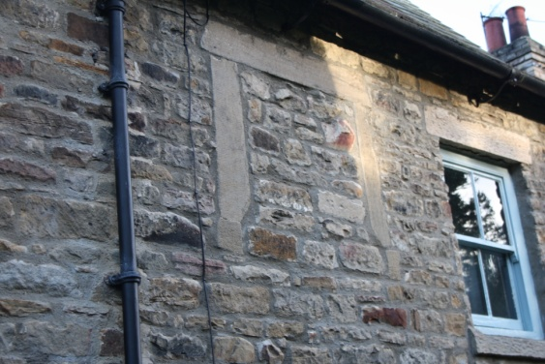
- The Thatch is a significant vernacular building in Teesdale and was one of the last to lose its heather thatch roof covering in the 1930’s. The house is believed to date from the early 18th century according to the listed building description and the scale and form of the building would have made it a substantial and higher status property at that time if it were in a single ownership. Its original appearance would have been substantially different when constructed as the original fenestration was wider and not as tall as the current windows. The over-square openings may have been fitted with plain sawn stone surrounds possibly with either multi paned sash windows or with central mullions to double side hung casements. A surviving early window surround remains between The Thatch and the adjoining Smithy Cottage, suggesting how the windows may have appeared and a more detailed examination of these remains may reveal whether they were originally two part windows with a central stone mullion or early sashes. The stonework around the present windows reveals some areas of mismatched masonry where the stone surrounds have been removed and the window openings changed in shape to update the appearance of the property. It is believed that this was undertaken in the late 19th century and this work would have been typical of the type of “improvement” made at that time either by the Lartington Estate or by a new owner seeking to present a more modern property frontage.

- The second major change to the appearance of the house was the loss of its original heather thatch in the 1930’s. The vernacular use of heather as a thatching material was wide spread in the upper dales as long grown heather was widely available from the moors and provided a cheap roof covering. It was reasonably versatile and could be found on a range of buildings from barns through to substantial houses such as The Thatch. Heather is not a long lasting roofing material and would have required maintenance on a regular basis, however the materials and skills were reasonable readily available. The vernacular alternative was to use locally sourced stone slates however this was a much more expensive material and tended to be used on higher status houses. Grey slate imported into the region and pan-tiles imported from the coats to the east would not make an appearance in Lartington until the second half of the 19th century with the arrival of cheap transport by rail. The heather thatch on The Thatch would have been a thick heavy roof with the depth of thatch up to 900mm thick to achieve a waterproof covering. The heather eaves would overhang and be a rounded shape however the roof verge to the gable would have been contained within the stonework, the heather rising above it and forming a roll at the edge of the stone wall. The chimneys would rise through the thatch and would be flaunched with mortar to prevent fires.

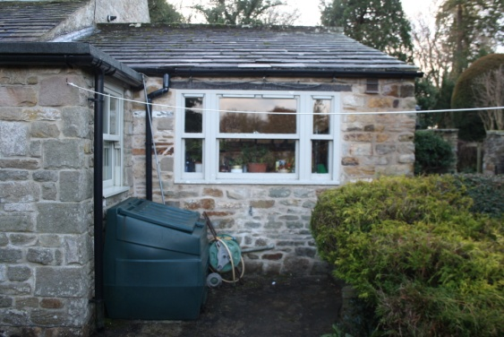
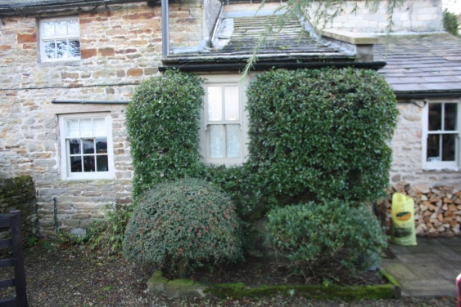
- At the rear of the property there have been at least three phases of additions to the house, two older pent roof extensions one now containing the kitchen and one the pantry, and a third more recent extension providing a porch to the back door. A further long narrow extension stands on the boundary to Smithy Cottage and now provides a downstairs wc. At the back of the house the windows are of a more recent date gaining consent in 1990 (application 6/1990/0171/DM/LB) and the back door is a modern item set in the new porch which was permitted in 1992 (Applications 6/1992/0234/DM and 6/1992/0235/LB).

- Historically the house was a licensed public house called the until the 1840’s, however village pubs in this period were often little more than an extra room to someone’s house from which drinks were served. Examples of this type of pub are now very scarce but did exist until the late 1980’s at The Hart at Dufton over the Pennines in Cumbria, and at The Strathmore Arms outside Middleton in Teesdale which has recently closed as a result of the COVID pandemic. It is also recorded that Smithy Cottage next door was used for a period as the village post office although early maps show the post office as being situated in a building to west, possibly in Marian Cottage. This designation has disappeared by the end of the 19th century which may coincide with a smaller post office facility moving to Smithy Cottage closer to the centre of the village.

- As is to be expected of a house of the age of The Thatch it appears on the first edition OS map surveyed in 1854 and published in 1857. At this time there are fewer properties along the north side of Lartington Lane but some still remain to the south side of The Green defining the extent of the early settlement. The Thatch is shown at a widened section of the road with outbuildings to the rear which are known to have become used at some time as the village smithy (hence Smithy Cottage), however the designation of a smithy on this map lies further to the east at the southeast corner of The Green.

- The 1894 OS map shows that the buildings to the south of the green have largely been removed and that the dispersed character of the village is changing with infilling with additional houses along the north side of the street, a process which continues through subsequent editions of surveys to the present day. On the 1894 map the location of the smithy has changed and it is now located adjacent to The Thatch with the former smithy building appearing with a different footprint possibly as a result of rebuilding as part of the landscaping works which so changed the appearance of the village green. Later editions of the OS maps show the gradual addition of a few individual houses in spaces within the village but changes are largely limited to the regrettable loss of village facilities such as the post office, school and smithy and the closure of the railway line which passes to the north and west of the village.

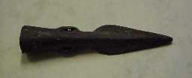
- The County Durham Historic Environment Record and the Keys to the Past site show evidence of pre-historic activity in the area with cup-and-ring carved stones found on Lartington Moor to the west of the village and worked flints being found at Towler Hill. Most notable was the find in 1994 of a bronze age spear tip at The Old Smithy site next door to Smithy Cottage.

- The Greenhouse is a modern addition to the building being constructed in 1992 and supplied by Alton’s Greenhouses. It is a softwood construction and is not considered to be of any historic value. Its form is functional and does not relate to either the style of the host building nor does it have any historic precedent, being much more of a functional structure aiming at providing the most glazed area possible within the given footprint. It is not considered that the form or style of the current greenhouse is appropriate to the site and the proposed replacement aims to provide a structure more in keeping with the historic setting.

The Building in a Statutory Heritage Context.

Lartington Conservation Area
- The building lies within the boundary of the identified Lartington Conservation Area, a designation aimed to protect the historic village from development that would harm its character, which had been identified as being of special architectural or historic interest within County Durham. The conservation area was designated in 1984 and a Conservation Area Appraisal was undertaken in 2012, the final report being published in December 2012.

- The Conservation Area is extensive taking in Lartington Hall and its setting to the east and extending along Lartington Green Lane to the west encompassing all of the buildings within the village and a substantial part of the setting to both north and south. The Thatch lies in the central portion of the conservation area defined in the Appraisal as the Village Green - Character Area 2 of the study. The Village Green Area takes in the character defining linear arrangement of properties on the north side of Lartington Lane and extends to the south covering the area which previously formed the green which was historically enclosed by houses on both sides, those to the south being lost by the 1840’s when the area was remodelled as part of the works to the landscape of Lartington Hall.

- The appraisal identifies The Thatch as one of the latest surviving “Black Thatch” roofs in the district with its original form of heather thatch remaining intact until the 1930’s. Coupled with Smithy Cottage these two properties form one of the key significant buildings in the character area and mention is made of its former 19th century use as licensed pub and the previous use of The Smithy as the village Post Office.

- The Appraisal defines a series of views through and around the village but notably the main views are along the main road and it is noted that they are defined by the trees and hedges lining the street and curtailing wider views of specific buildings. The conservation area boundary map is attached at Appendix 1.
Listed Building Statutory Designation.
- The building is listed (Grade II) and was added to the list of Buildings of Special Architectural or Historic Importance on 17th June 1986. A summary of the Listed Building entry appears at Appendix 2.

Extent of the Asset.
- The heritage assets relevant to the application are the listed building and the conservation area. The listed building extends to cover the property and its surrounding domestic curtilage which is well defined by the surrounding boundary walls. The conservation area is a wider designation the extent of which is shown in the boundary plan at Appendix 1.

Statement of Significance.
- The Thatch is a good example of a vernacular building which has been subject to evolutionary changes over many years. In this regard it has a moderate degree of significance within Teesdale as it contributes to the stock of 18th century houses which retain their traditional form with legible changes in their details. Internally the building has been altered in certain areas to create a contemporary house but the scale, form and proportion of the rooms remains legible. The thatched roof structure has been lost many years ago however the steep pitch of the roof and the details of the eaves and verges suggest there may be retained timbers present which relate to the historic vernacular roof covering. This raises the significance of the building as few thatched buildings remain in the north of England although survivors with replacement roof coverings are more numerous.

- The proposal relates to the replacement of the modern greenhouse at the southwest side of the building. This structure is considered to be of no historic significance and its modern utilitarian appearance does not contribute to the quality or appearance of the building or its setting in the conservation area.

The Proposed Works.
- The proposal seeks consent for the replacement of the modern greenhouse. This is a modern structure dating from 1992 and is in poor condition and not to a designed in sympathy with the host building or its setting. The existing greenhouse structure is to be removed completely and replaced with a purpose designed structure more in keeping with the building.

- The proposed design is based on a three bay structure each divided into three to create smaller panes of glass. The lower section is to be boarded using a tongue and groove boarding to provide a more solid appearance to the structure and create a screened storage space. The bays each feature a single top hung opening light which can be reached from the ground level thus allowing better and easier use for ventilation. The roof conforms to the three bay structure again with three panes to each bay however the opening roof lights of the existing building have been deleted as they are not easy to use form ground level. A low plinth is provided to position the structure on and this is to be constructed using the salvaged stone form the existing greenhouse structure. The gable end of the building will comprise a hinged door rather than the sliding style currently in use. This door is positioned to give a bench width to the front of the structure and to leave a wider area to the rear capable of accommodating a small sitting area.

- The green house will be finished in a timber stain to replicate the finish of the existing building and will be agreed as part of the application submission.

Analysis – The Impact on the Asset
- It is important to examine three aspects to the impact of the work, the physical impact on the building itself, the impact on the character of the listed property, and the wider impact on views of the building within the Conservation Area.

- The current greenhouse dates form 1992 and is not considered to have any heritage value. Its appearance does not maintain or enhance the building or its setting and the style and form is not historic or compatible with the listed building. It is considered that the loss of the existing greenhouse structure will have no impact on the historic fabric of the house as a whole, particularly given the retention and survival of the rest of the historic fabric and the recent date of the greenhouse structure.

- With regard to the character of The Thatch and its setting and context this includes other listed buildings and its position within the conservation area, and the impact on these aspects of these should be considered. Visually the removal of the current greenhouse is considered to be an improvement to the character and setting of the house and its position in the conservation area and the replacement structure has been designed in a more tardfitional form to be in keeping with its location and setting. It is considered that there will be minimal but positive impact on the character or setting of The Thatch or in the wider context of the other listed buildings in the vicinity.

- In assessing the impact on the street scene as part of the Lartington Conservation Area it is considered that the replacement greenhouse will result in a minimal but positive impact on the conservation area and immediate streetscape.

Conclusion.
- The current greenhouse at The Thatch is of no historic importance and could be considered to be slightly detrimental to the appearance and character of the listed building in its current modern style. The replacement has been designed as a more traditional form with a more solid component to the lower sections and a more traditional door opening to better assimilate with the house. The existing structure is in poor condition, now mostly collapsed or removed as result of exposure to the recent storms and high winds of last winter. It is considered that the proposed replacement does not detract from the setting or appearance of the building and allows the retention of the greenhouse as a feature of great benefit to the occupants.

Appendices.

Appendix 1 Conservation Area Map.
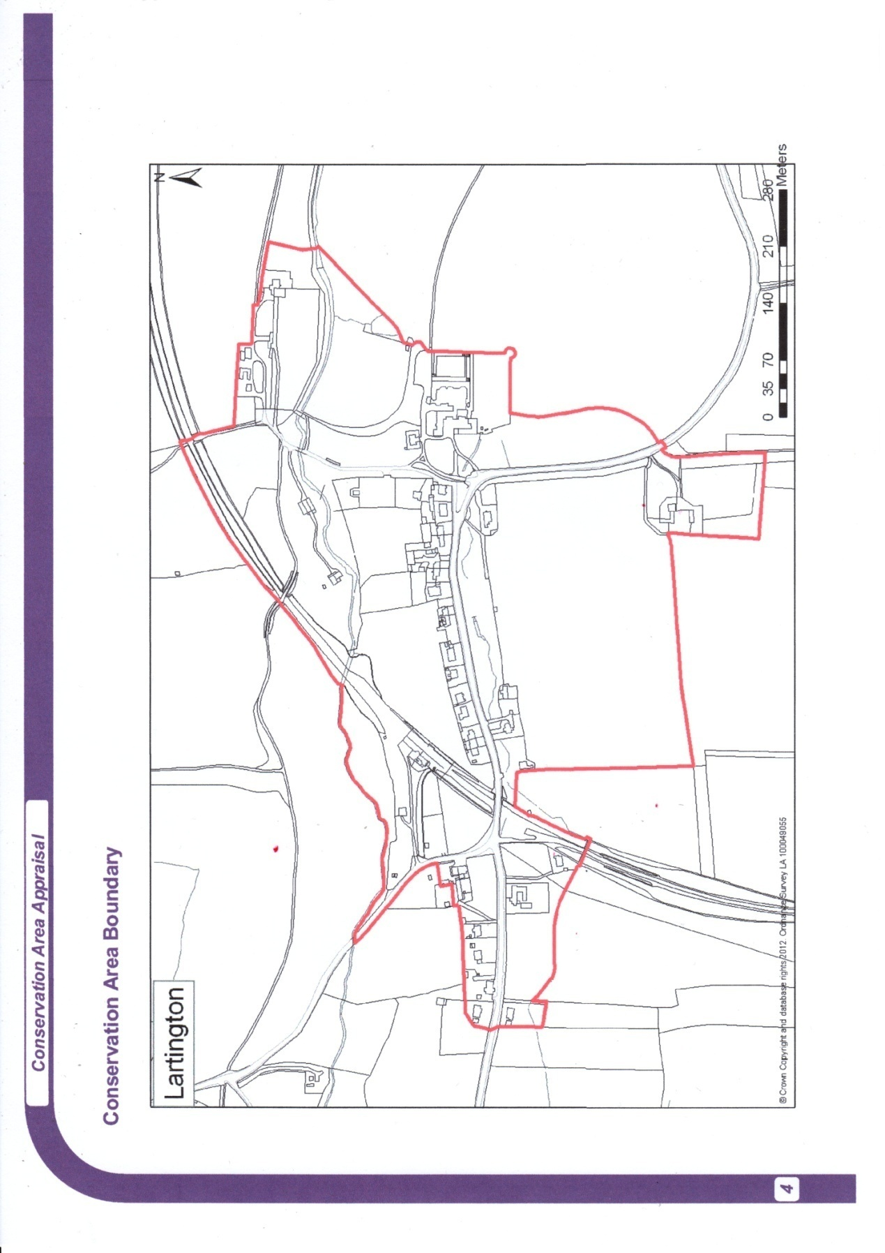
Conservation Area Boundary from Conservation Area Appraisal, Durham County Council 2012

Appendix 2 Listed Building designation (Summary).

THE THATCH AND SMITHY COTTAGE

Heritage Category: Listed Building
Grade: II
List Entry Number: 1160536
Date first listed: 17-Jun-1986
Statutory Address: THE THATCH AND SMITHY COTTAGE, LARTINGTON LANE
District: County Durham (Unitary Authority)
Parish: Lartington
National Grid Reference: NZ 01962 17760
DETAILS
LARTINGTON LARTINGTON LANE NZ 0117 (North side) The Thatch and 31/97 Smithy Cottage II Smithy Cottage shown on O.S. map as the Post Office. House and attached cottage. Early C18 house altered in late C19; C19 cottage. Coursed sandstone rubble; house has graduated green slate roof and stone stacks; cottage has stone-flagged roof and brick stack. The Thatch occupies 3 left bays; Smithy Cottage occupies right bay of house and cottage to right.
2-storey, 4-bay house with alternating quoins. Partly-glazed 4-panel door, in flush surround, in bay 2. Similar door at junction to right. Openings, altered in late C19, have replaced 4-pane sashes. Blocked first-floor window between bays 3 and 4. Raised eaves. Steeply-pitched roof with slightly-swept eaves. Rebuilt end and ridge stacks with top bands.
Lower 2-storey, one-bay cottage has replaced 4-pane sashes, low-pitched roof and right end stack.
2 linked outshuts, on rear of house, have replaced windows and low-pitched pent roofs.

