Rear range roof – Gedding Grange

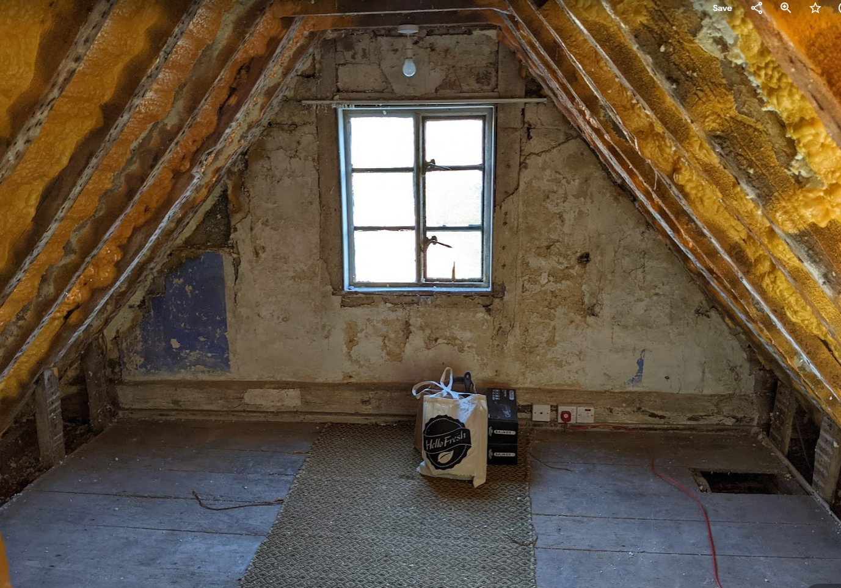

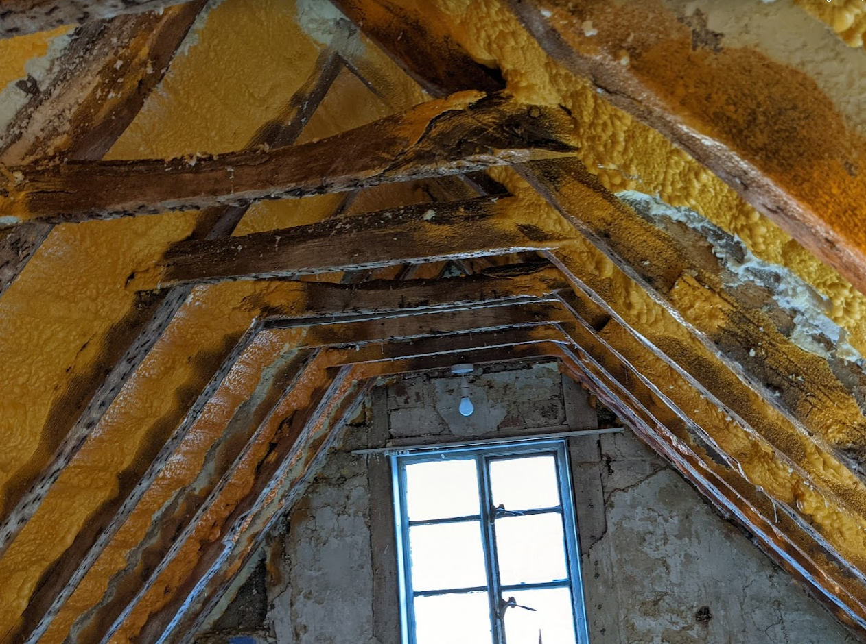
Spray foam insulation has been applied directly on the rear of the tiles in one range. There is no roof felt and it is unlikely that the tiles can be salvaged. We have undertaken some early exploration to check the soundness of the rafters and battens and both appear to be in good condition. The RICs survey on the house suggests that the foam is completely removed and a breathable felt membrane added prior to re-tiling in a suitable replacement tile before the room is insulated with a breathable wool insulation. The foam is likely to be over 20 years old and fortunately is only in this wing of the house. The roof in question is shown highlighted below. The roof has been assessed by both the RIC’s surveyor and a local roofer who will undertake the work. The tiles are a machine-made clay tile. It is likely that the foam and roof were replaced at the same time.
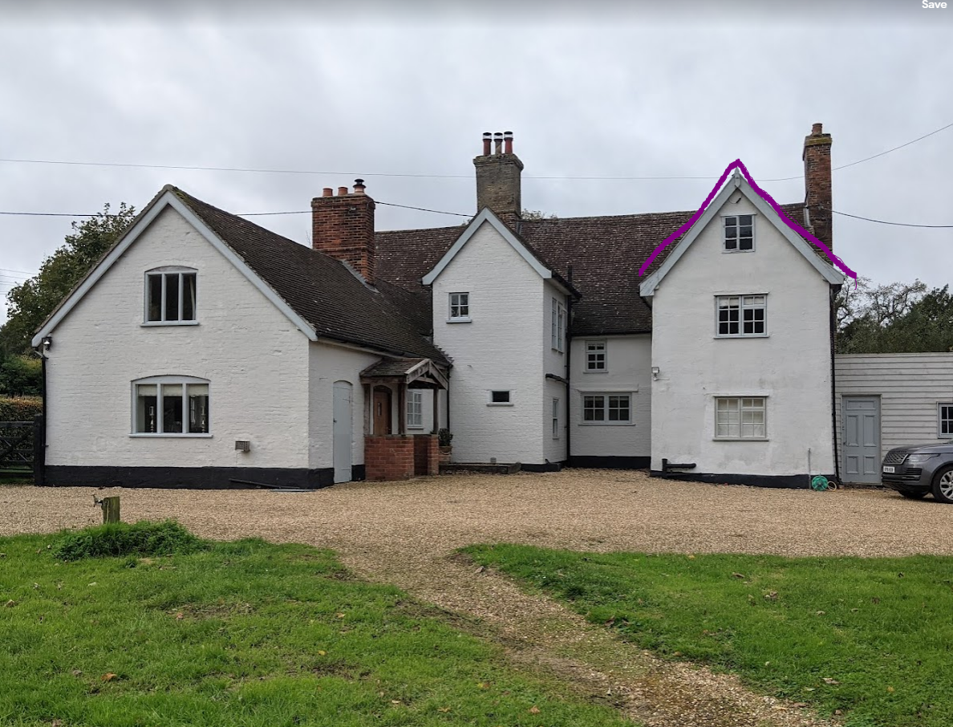

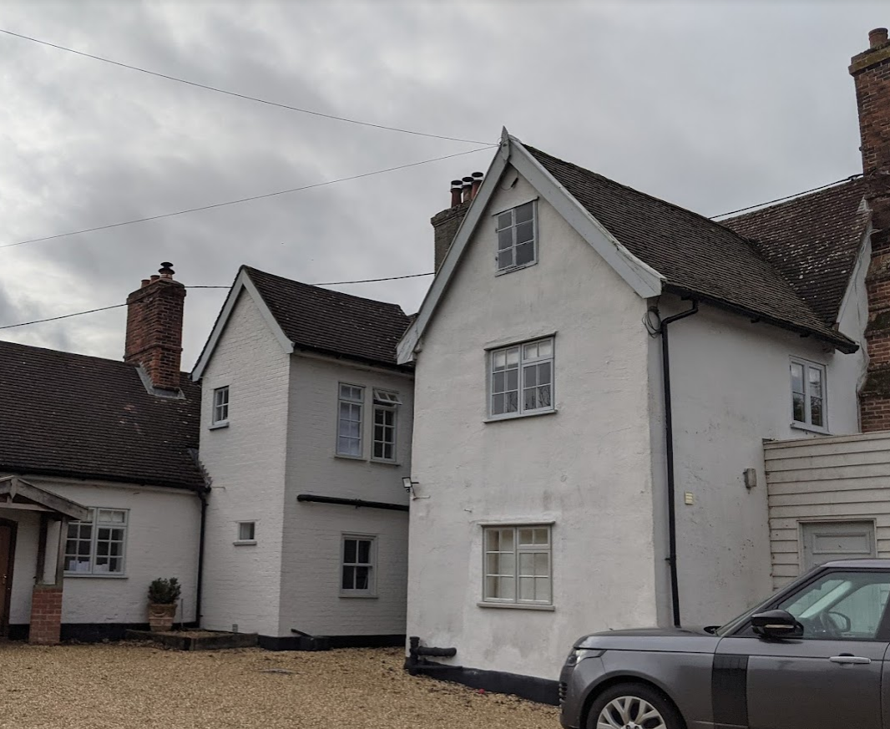

Proposed replacement tiles.

Having spoken to a local roofer who specialises in listed buildings he has suggested the following replacement tile. The tile on the left slipped off the roof to be replaced and the tile on the right is a re-claimed replacement in the same sanded effect and colour. We propose to use all re-claimed tiles as per the one on the right.

