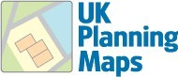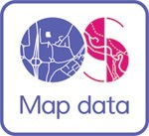
93 Glendoune Street, Girvan, KA26 0AA
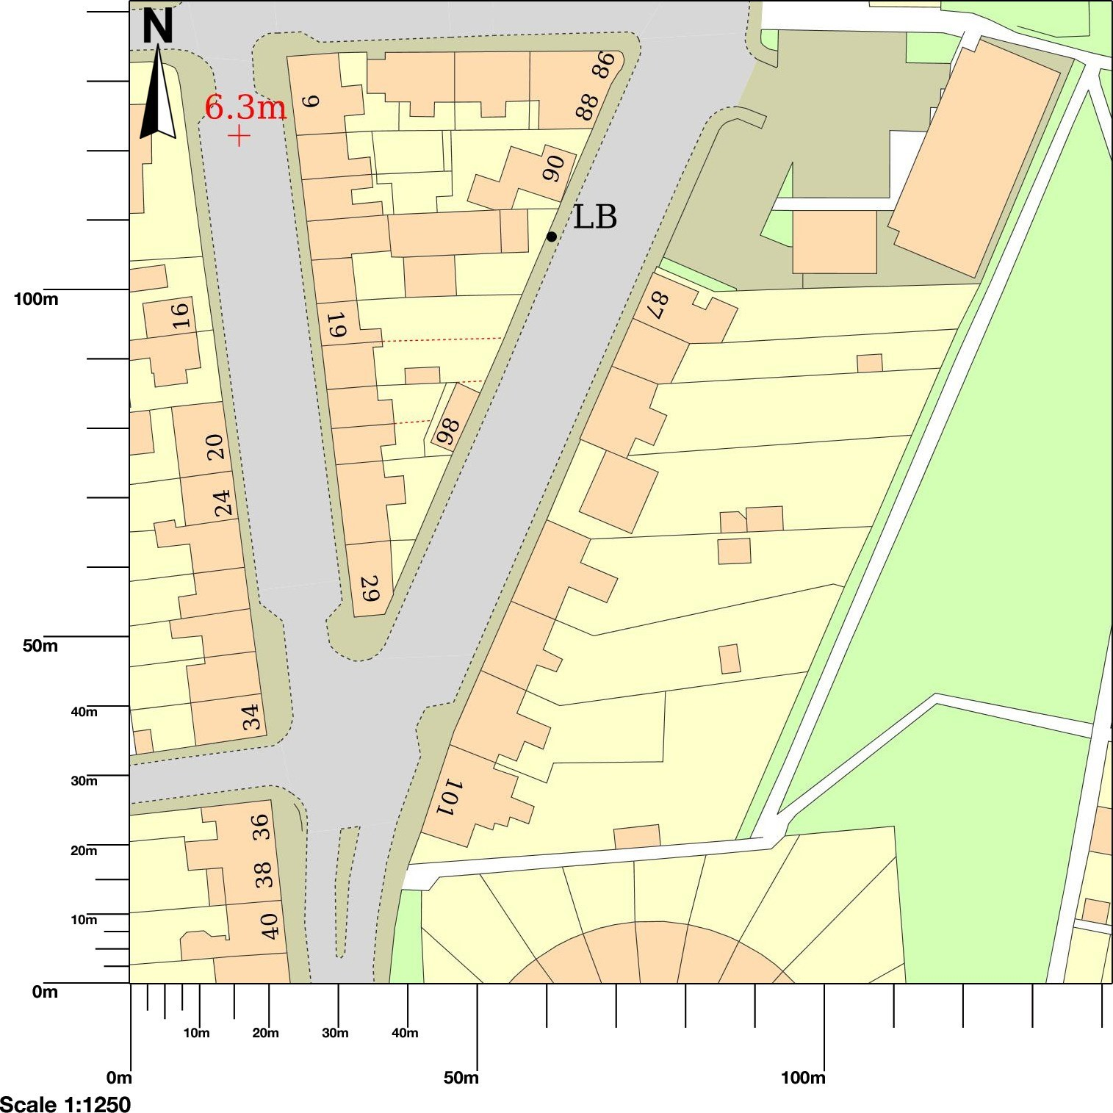
Map area bounded by: 218395,596870 218537,597012. Produced on 27 April 2022 from the OS National Geographic Database. Reproduction in whole or part is prohibited without the prior permission of Ordnance Survey. © Crown copyright 2022. Supplied by UKPlanningMaps.com a licensed OS partner (100054135). Unique plan reference: p2c/uk/789006/1067028

