Supporting Documentation

The main reason for the erection of the boundary fence is primarily to provide a privacy screen between the neighbouring properties as the existing fence does not provide any type of privacy screen whatsoever.

View from Livingroom window
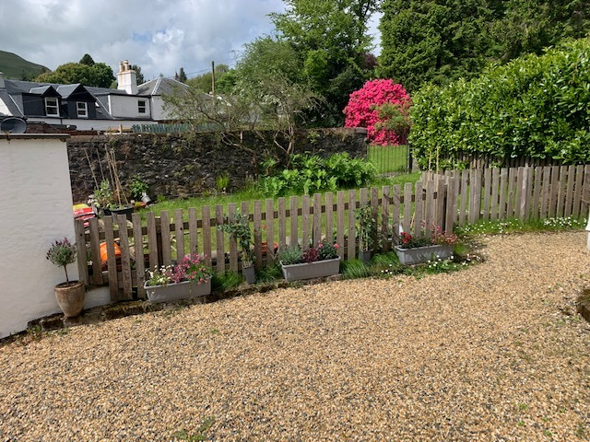

These unique circumstances have arisen as the adjacent property is being rented at present and the previous tenant only used the property on occasional weekends, the current tenant is in full habitation and thus the requirement for privacy between the properties as both are being overlooked.
This causes privacy issues as our property has three windows facing directly into the adjacent properties garden in particularly the hall window which we have to bypass to gain access from the bathroom to the bedroom after bathing.
I feel the proposed would provide adequate privacy for both properties.

` View from Hall window

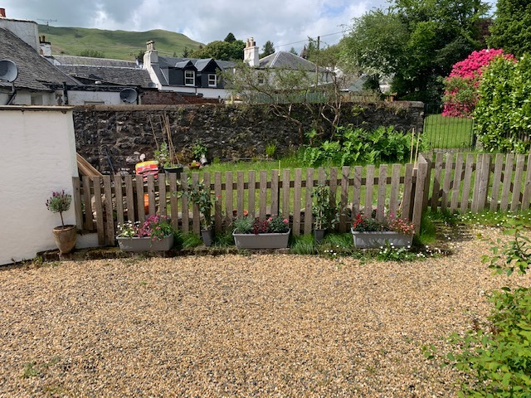

Three windows being overlooked.
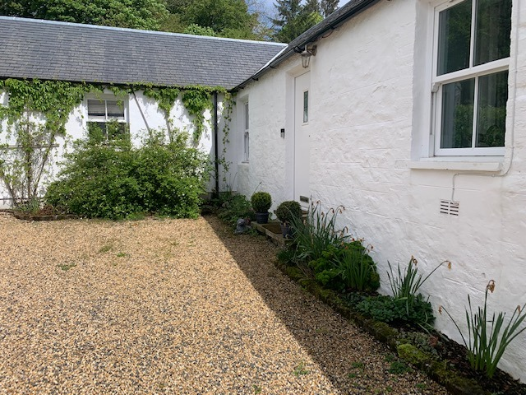

Proposed area of boundary fence

