Schedule of Works for work to 11 Allan Park.

Schedule prepared by | David Lindsay Traditional Buildings Health check and  (adjusted by McEachern Architects)
Project address | 11 Allan Park, Stirling, FK8 2QG
Conservation area | Kings Park
Listed category | B
Client | Andrew Pont
Contact details | 07975 738106
Brief description of works | General overhaul of slate roof coverings to pitched roofs.  Replacing flat roof coverings with lead sheet.  Replacing lead-lined gutter.  Repairing or replacing cast iron gutter.  Dismantling and rebuilding gable chimneys and re-pointing skew coping.
Important notes | This Schedule has been prepared by the Traditional Buildings Health Check (TBHC) on behalf of Stirling City Heritage Trust (SCHT) following inspection of the property as part of the TBHC inspection service. The inspection was restricted to elements which could be seen clearly, and no attempt was made to open up or employ any other destructive techniques.
 | SCHT shall in no circumstances be held liable for any works undertaken by the Client on any recommendation made in this Schedule.
 | Should a Contractor wish to see a copy of the TBHC Inspection Report, this should be requested directly from the Client.
Contents | Description of work for costing
 | Materials list for completion
 | Health & Safety information
 | Roof plan
 | Photographs
 | Location map
 | Historic Environment Scotland - Advisory standards of conservation and repair for the historic building environment in Scotland

Description of Work and Costs
The contractor is requested to provide costs for the following items. The Contractor should amend, qualify, quantify or add to the items as necessary to reflect their own understanding of the required works.
All works to be carried out by appropriately qualified and competent workers.
All works to be carried out in accordance with Historic Environment Scotland - Advisory standards of conservation and repair for the historic building environment in Scotland – See Appendix A
Item | Description | Qty | Unit | Rate | Cost
1.0 | PRELIMINARY WORKS
1.1 | Allow for taking a photographic record of the existing condition of all areas that will be impacted by the works. | item
1.2 | Allow for submitting materials specifications and samples for approval before starting work. | item
1.3 | Allow for submitting evidence of the contractors’ public liability insurance.  Also allow for providing the client with a copy of the contractors’ Construction Phase Plan as required under CDM (2015). | item
1.4 | Allow for providing temporary toilet/welfare facilities if not provided by the client, including obtaining local authority permits as necessary. | item
 |  | TOTAL (c/f)

Item | Description | Qty | Unit | Rate | Cost
2.0 | ACCESS  Scaffolding must be constructed in accordance with Work at Height Regulations 2005. A handover certificate for erected scaffolding must be issued and records of mandatory scaffolding inspections made available.
2.1 | Scaffolding:  Provide suitable access for safely carrying out the works described. Allow for submitting a plan showing proposed location(s) of scaffolding.  Allow for loading areas and hoisting points as required. Allow for closing off and weather sealing scaffolding anchor points with plastic caps or appropriate mortar during or immediately following dismantling.  Contractor to confirm the scaffolding hire period and associated cost and also extended scaffolding hire costs. Scaffolding must be kept in place until a final inspection of completed works has been carried out.
3.0 | ROOFING AND LEADWORK
3.1 | Pitched roofs R1 and R2 –  Overhaul roof covering.  Identify broken, slipped, and missing slates and repair or replace as necessary. Slate to be sourced and dressed to match the original and fixed to sarking board using traditional methods.  Contractor to specify quantity allowed for:
3.2 | Pitched roofs R1 and R2 –  Replace mortar fillets (mortar skews) at north gable.  Remove existing mortar fillets at the pitched roof verges and the abutment with chimney CH2.  Allow rebuilding of CH2 and re-pointing of skew coping to be carried out before replacing mortar fillets.  Apply new mortar fillets at the pitched roof verges and the abutment with chimney CH2.  mortar mix: NHL 3.5 pre mixed
3.3 | Pitched roofs R1 and R2 –  Replace mortar fillets (mortar skews) at south gable.  Remove existing mortar fillets at the pitched roof verges and the abutment with chimney CH1.  Allow rebuilding of CH1 and re-pointing of skew coping to be carried out before replacing mortar fillets.  Apply new mortar fillets at the pitched roof verges and the abutment with chimney CH1.  mortar mix: NHL 3.5 pre mixed
3.4 | Pitched roofs R3 –  Overhaul roof covering.  Identify broken, slipped, and missing slates and repair or replace as necessary. Slate to be sourced and dressed to match the original and fixed to sarking board using traditional methods.  Contractor to specify quantity allowed for:
3.5 | Pitched roofs R3 –  Install lead flashings following removal of reinforced bitumen membrane to R4.  Install lead flashings at the top of each pitched roof below the edges of flat roof R4.  Leadwork to be dressed and fitted according to recognised good practice described and illustrated in the Lead Sheet Manual issued by the Lead Sheet Training Academy.  Contractor to allow for submitting a design proposal for approval:  Code 6 Lead
3.6 | Valley between roof R3 (west) and rear elevation of main building –  Remove and replace the reinforced bitumen membrane with lead sheet.  Report any areas of defective or decayed timber roof decking to the client before fitting new lead sheet covering.  Install new lead roof sheet covering.  Leadwork to be dressed and fitted according to recognised good practice described and illustrated in the Lead Sheet Manual issued by the Lead Sheet Training Academy.  Contractor to allow for submitting a design proposal for approval:
3.7 | Flat roof R4 –  Remove and replace the reinforced bitumen membrane roof covering with lead sheet.  Report any areas of defective or decayed timber roof decking to the client before fitting new lead sheet covering.  Install new lead roof sheet roof covering.  Leadwork to be dressed and fitted according to recognised good practice described and illustrated in the Lead Sheet Manual issued by the Lead Sheet Training Academy.  Contractor to allow for submitting a design proposal for approval:  Code 7 Lead
3.8 | Lead lined parapet gutter to front elevation –  Replace ageing and defective lead sheet lining.  Remove existing lead sheet lining to the masonry gutter channel and replace with new lead sheet. Allow for raised upstand to increase gutter capacity.  Leadwork to be dressed and fitted according to recognised good practice described and illustrated in the Lead Sheet Manual issued by the Lead Sheet Training Academy.  Contractor to allow for submitting a design proposal for approval:  Code 6 Lead with T.Pren Joints
3.9 | Cast iron gutter to back elevation (main building) –  Remove and reinstate to repair corrosion and leaks.  Dismantle the half round gutter and lay aside individual sections for re-use. Advise client of any defects.  Prepare gutter sections which are suitable for re-use by removing all rust and defective paint (by wire brush or sanding). Roughen remaining paint with sandpaper to ensure new paint adheres well. Re-paint (outside and inside surfaces) using appropriate paint system (for example, zinc-based primer,  one coat of micaceous iron oxide, followed by  two coats of gloss paint).  Reinstate gutter using new bolts and oil putty to seal joints. And flow test.
3.10 | Cast iron gutters to 3 sides of rear extension –  Remove and reinstate to repair corrosion and leaks.  Dismantle the half round gutter and lay aside individual sections for re-use. Advise client of any defects.  Prepare gutter sections which are suitable for re-use by removing all rust and defective paint (by wire brush or sanding). Roughen remaining paint with sandpaper to ensure new paint adheres well. Re-paint (outside and inside surfaces) using appropriate paint system (for example, zinc-based primer,  one coat of micaceous iron oxide, followed by  two coats of gloss paint).  Reinstate gutter using new bolts and oil putty to seal joints. And flow test.
4.0 | WOODWORK
4.1 | Timber facings at 3 sides of rear extension –  Prepare and repaint.  Check all sections of timber facing behind the cast iron half round gutter and report areas of decay to the client.  Prepare the timber by removing loose and flaking paint and sanding to provide an appropriate surface to accept new paint. Re-paint using appropriate paint system (for example, primer, undercoat and top coat).
5.0 | STONEMASONRY
5.1 | Chimney CH2 (north gable) –  Dismantle and rebuild to address structural movement and replace decayed stone.  Record the position of all stones within the stack, cornice, and coping, marking individual stones as necessary to allow for re-building in the same place.  Allow for all protection necessary to prevent debris entering flues, fireplaces, and rooms below.  Remove pots, coping, and moulded cornice and lay aside for re-use. Advise client of any defects.  Dismantle the walls of the stack to roof level laying aside ashlar which is suitable for re-use. Allow for dismantling flue dividing walls as necessary.  Supply new sandstone ashlar walling to replace stone which is no longer viable. Stone to be sourced and dressed to match the original with a broached surface finish. Assume the front face of the stack will need replaced.  Re-build the chimney using stone previously laid aside and new stone supplied. Include re-building flue dividing walls as necessary. Reinstate pots and flue vents and apply appropriate mortar haunching.  Allow for submitting sandstone samples for approval.  proposed mortar mixes for building, pointing and haunching:  mortar mix: NHL 3.5 pre mixed
5.2 | Chimney CH1 (south gable) –  Dismantle and rebuild to address structural movement and replace decayed stone.  Record the position of all stones within the stack, cornice, and coping, marking individual stones as necessary to allow for re-building in the same place.  Allow for all protection necessary to prevent debris entering flues, fireplaces, and rooms below.  Remove pots, coping, and moulded cornice and lay aside for re-use. Advise client of any defects.  Dismantle the walls of the stack to roof level laying aside ashlar which is suitable for re-use. Allow for dismantling flue dividing walls as necessary.  Supply new sandstone ashlar walling to replace stone which is no longer viable. Stone to be sourced and dressed to match the original with a broached surface finish. Assume the back face of the stack will need replaced.  Re-build the chimney using stone previously laid aside and new stone supplied. Include re-building flue dividing walls as necessary. Reinstate pots and flue vents and apply appropriate mortar haunching.  Allow for submitting sandstone samples for approval.  proposed mortar mixes for building, pointing and haunching: mortar mix: NHL 3.5 pre mixed
5.3 | North gable skew coping –  Cope skews and copes need to be removed and lead detailing installed below as follows:  Carefully cut render 15mm below cope line on outer sides of both cope pitches.( this is to avoid damage to the cope stones or dislodging of the render. Where render is boss this will need to be reviewed and carefully removed.  Carefully number and remove existing copes.  Lift edge 450 width of slate down to sarking.  Inspect sarking and repair where required using same thickness sarking.  Code 6 lead sheet to be dressed below the copes. Stainless steel brackets to be inserted at each cope joint fixed through lead and overdressed with lead from next cope above.  Once copes have been replaced, Lead to be cut tight to top of render cut line and pointed in with Lime pointing. Cope joints also to be pointed in with lime pointing (colour matched to stone copes.  Narrow gutter formed adjacent to the cope in place of the cement skew.. Slates re-dressed back to form cope edge gutter line.  proposed mortar mix for re-pointing: mortar mix: NHL 3.5 pre mixed
5.4 | South gable skew coping –  Cope skews and copes need to be removed and lead detailing installed below as follows:  Carefully cut render 15mm below cope line on outer sides of both cope pitches.( this is to avoid damage to the cope stones or dislodging of the render. Where render is boss this will need to be reviewed and carefully removed.  Carefully number and remove existing copes.  Lift edge 450 width of slate down to sarking.  Inspect sarking and repair where required using same thickness sarking.  Code 6 lead sheet to be dressed below the copes. Stainless steel brackets to be inserted at each cope joint fixed through lead and overdressed with lead from next cope above.  Once copes have been replaced, Lead to be cut tight to top of render cut line and pointed in with Lime pointing. Cope joints also to be pointed in with lime pointing (colour matched to stone copes.  Narrow gutter formed adjacent to the cope in place of the cement skew.. Slates re-dressed back to form cope edge gutter line.  proposed mortar mix for re-pointing: mortar mix: NHL 3.5 pre mixed
6.0 | MISCELLANEOUS
6.1 | TV aerials –  Remove TV aerials from chimneys CH1 and CH2 and lay aside for re-use. Reinstate on completion of chimney repairs.
6.2 | The contractor is to allow for making good any damage caused during the works, including replacing slates broken during scaffolding erection and dismantling. Also allow for clearing all gutters and outlets of debris resulting from the works and flow testing.
6.3 | Tidy the site on completion of the works and following removal of the scaffolding. Remove all waste and debris from site using a SEPA registered waste carrier. Allow for obtaining local authority skip permit as necessary. Make good all damages to garden areas occurring as a result of the works.
 |  | TOTAL (c/f)

Item | Description | Qty | Unit | Rate | Cost
7.0 | PROVISIONAL WORKS (OPTIONAL OR AS NECESSARY)
7.1 | Pitched roofs R1 and R2 –  Reset displaced ridge tiles.  Lift concrete ridge tiles and lay aside for re-use. Check the ridge and advise the client of any defects identified.  Reinstate ridge tiles previously laid aside bedding on appropriate mortar.
7.2 | Flat roof R4 –  Timber decking replacement.  Remove existing timber decking and replace with new timber decking ready to accept new lead sheet covering.  Contractor to allow for submitting a design proposal for approval:
7.2 | Cast iron gutter to back elevation (main building) –Option to replace with larger capacity gutter.  Extra over item 3.9 to replace the existing cast iron gutter with a new larger capacity cast iron gutter.  Allow for replacing gutter brackets as necessary.  Paint (outside and inside surfaces) using appropriate paint system (for example, zinc-based primer,  one coat of micaceous iron oxide, followed by  two coats of gloss paint).  Contractor to advise client if there is a need to increase the rainwater downpipe diameter and or make alterations to drainage.  Contractor to allow for submitting a design proposal for approval:
 |  | TOTAL (c/f)

Summary
Preliminary works (Section 1)
Scheduled works (Sections 2-6)
Provisional works (Section 7)
TOTAL
VAT
SUM TOTAL

Contractors Notes
A Contractor, when pricing this Schedule should satisfy themselves of the need for the above items in their professional opinion, and highlight and/or qualify any differences in the Notes section below.
Continue on a separate sheet if necessary -

Materials
A materials specification is not provided and contractors are requested to provide a brief description and specification of the materials allowed for in their estimate using the tables below.
Mortars
Mortars to be accurately batched and thoroughly mixed. The substrate to be cleared of loose and decayed mortar and well washed down before placing new mortar. Masonry to be dampened down sufficiently to prevent rapid suction. Mortars to be adequately protected and appropriately cured to avoid rapid drying (wind or sun) and from rain and frost until the work has gained sufficient strength. Contractors to confirm the mortar specifications. For example, include types and classifications of lime, type of aggregate and the mix ratios to be used.
Note that cutting disks are not to be used for raking out.

Location | Details | Ratio
Sandstone replacement/indenting
Sandstone to be sourced and dressed to match the original. Stone to be free of unsightly discolouration, dries, clay pockets and other flaws.
Where possible cut out the entire depth of the stone to be replaced.
New stone to be built using appropriate traditional lime mortar. Ensure any voids to the rear of replacement stones are packed appropriately with mortar and stone pinnings. Point all joints and beds with lime mortar as described above.

Location | Details
Leadwork
Repair or replace to match the original. Ensure lead work complies with the Code of Practice for lead sheet roofing and cladding (BS6915) as illustrated and detailed in the Lead Sheet Manual issued by the Lead Sheet Training Academy. Contractors to confirm the codes of lead to be used.

Location | Details
Rainwater Goods
Where the gutter joints are leaking remove jointing bolts and separate the sections. Remove old sealant, thoroughly clean the gutter and remove rust by wire brushing and sanding as necessary. Repaint/treat any exposed metal where necessary to discourage rusting.
Remake the joints using traditional oil putty (or approved low modulus silicone sealant or specialist rubberized bitumen gutter mastic) and galvanised/zinc plated gutter bolts.
New cast iron components to match the original. All to be primed as necessary and finished with undercoat and 2 coats gloss. Gutters to be painted inside and out.

Location | Details
one coat of micaceous iron oxide, followed by
two coats of gloss paint. Any defective gutter
joints should be re-sealed with an oil putty to
stop leaks.
Timber
Repair or replace timber components affected by decay using traditional materials and techniques. Prepare and finish as necessary with exterior paint.

Roof decking –
Only expose as much roof deck as can be kept dry during the working day and be prepared to cover if rain is forecast. Sweep clean areas of decking which are to be retained and ensure the surface is free of sharp objects that can damage new waterproofing systems. Use appropriate plywood decking (typically 19 mm thick) to replace areas of defective or decayed decking. Ensure fixings are countersunk or punched beneath the surface of the decking.

Location | Details
Miscellaneous
Location | Details

Health & Safety
Including Construction Design Management (CDM)

Contractors should understand their responsibilities under Health & Safety law including:
- Health and Safety at Work etc Act 1974 (the HSW Act)
- Management of Health and Safety at Work Regulations 1999 (the Management Regulations)
- Construction (Design and Management) Regulations 2007 (CDM)
- Control of Substances Hazardous to Health Regulations 2002 (COSHH)

The Construction (Design & Management) Regulations (CDM 2015) applies to all building and construction work and includes new build, demolition, refurbishment, extensions, conversions, repair and maintenance.

Under the Construction (Design and Management) Regulations 2015 (CDM 2015) a construction phase plan is required for every construction project.

The Contractor must demonstrate an understanding of their responsibilities under CDM before construction starts.

Key points to CDM Regulations 2015

1. All projects must have:
- workers with the right skills, knowledge, training and experience
- contractors providing appropriate supervision, instruction and information
- a written construction phase plan

2. Projects involving more than one contractor (domestic or non-domestic)
- must follow Step 1 plus -
- a principal designer and principal contractor must be appointed
- a health and safety file must be produced

3. When work is scheduled to:
- last longer than 30 working days and
- have more than 20 workers working simultaneously at any point in the project
- OR exceeds 500 person days
- The project must follow all of Steps 1 and 2 PLUS the Client must notify HSE of the project

Roof Plan

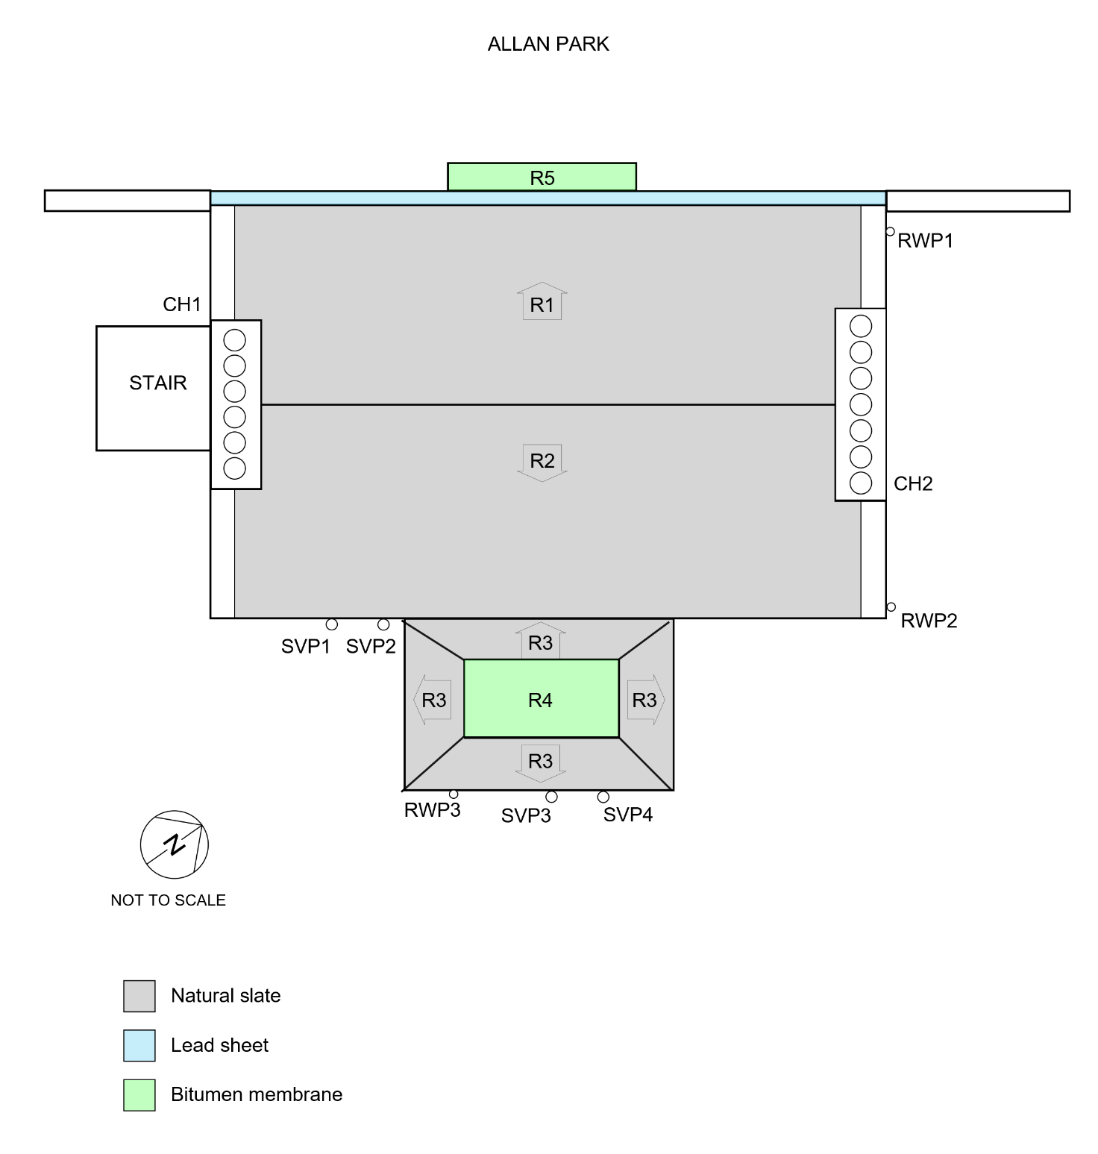

Photographs

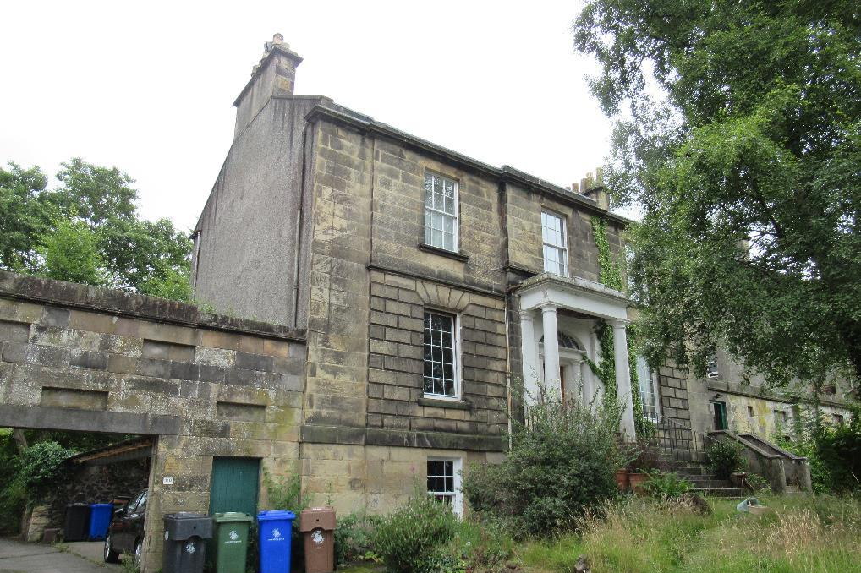  Front elevation | 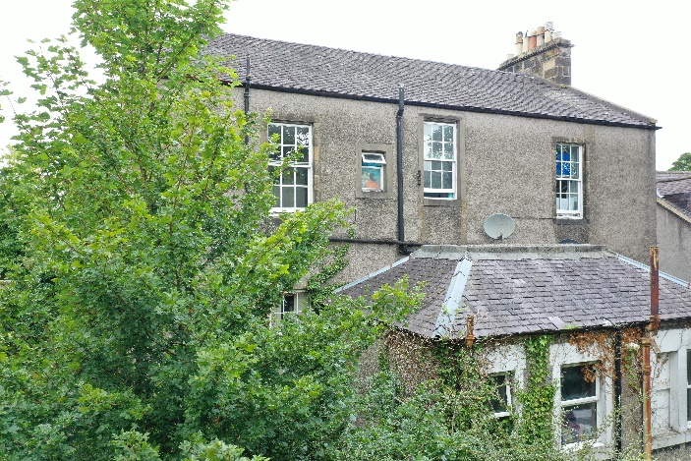  Back elevation
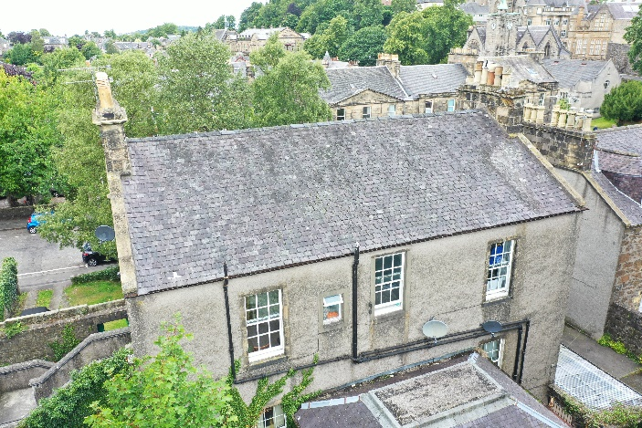  Back elevation and pitched roof R1 | 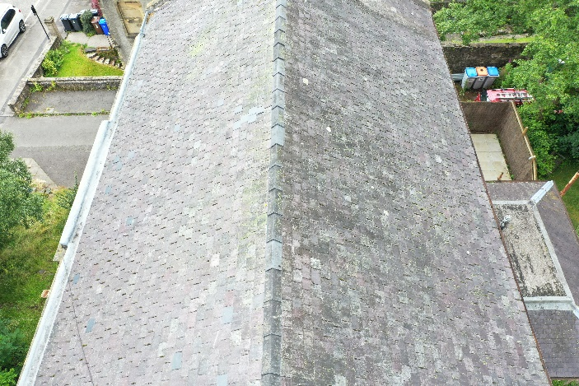  Pitched roofs R1 and R2
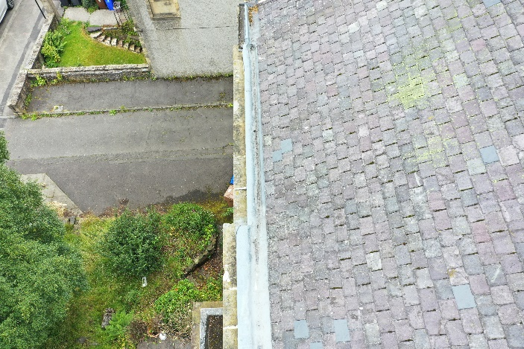  Lead-lined gutter to front | 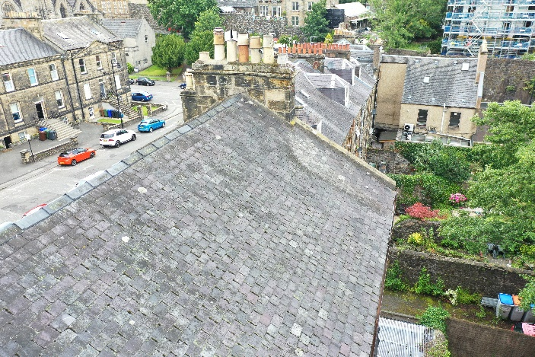  Cast iron gutter to back
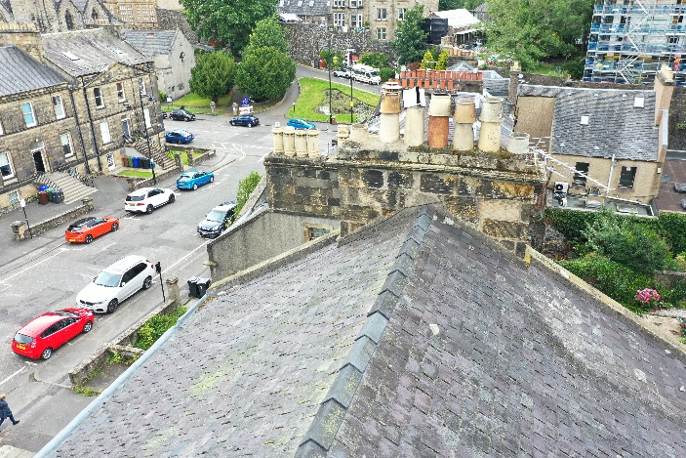  Chimney CH2 at north gable | 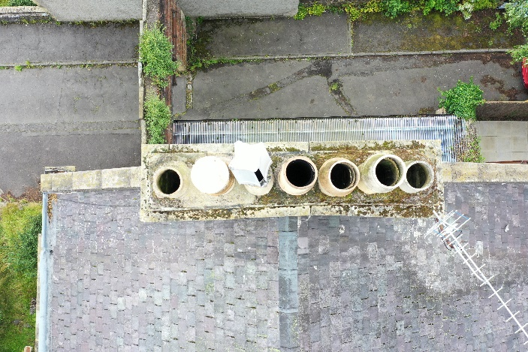  Chimney CH2 at north gable
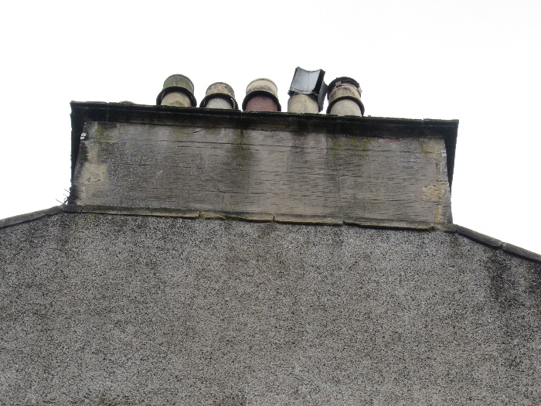  Chimney CH2 at north gable  Stone decay and mortar repairs to outer face | 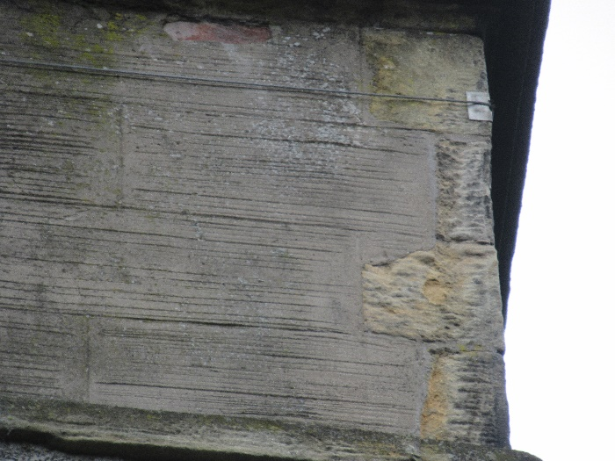  Chimney CH2 at north gable  Stone decay and mortar repairs to front face
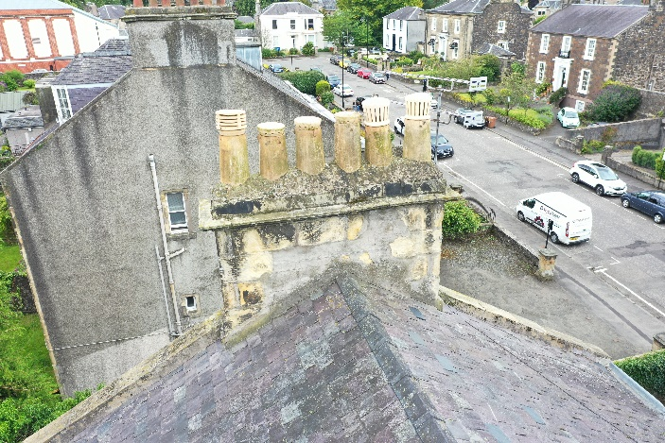Chimney CH1 at south gable  Stone decay and mortar repairs to inner face | 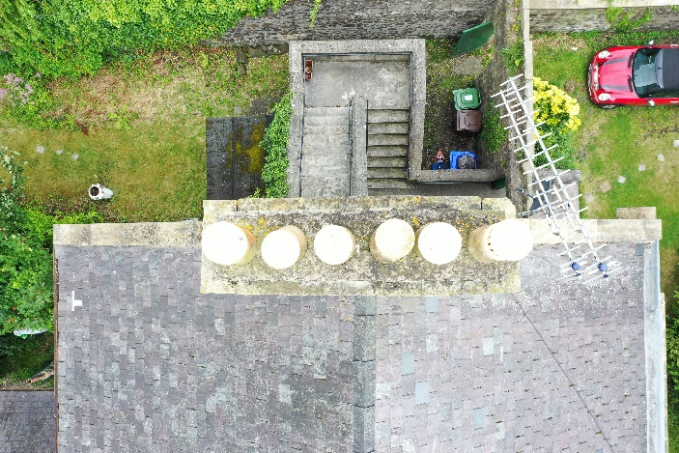  Chimney CH1 at south gable
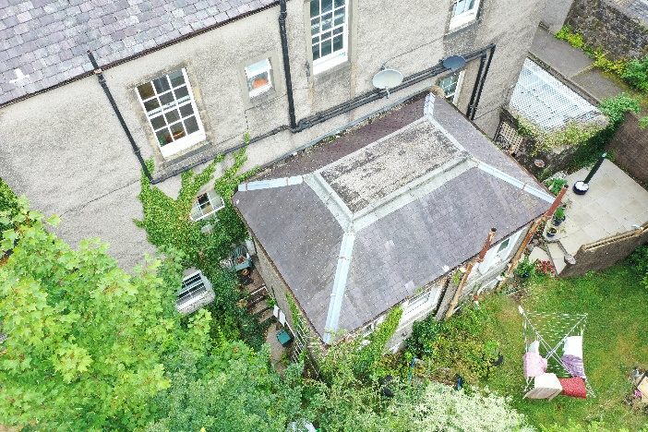  Rear extension | 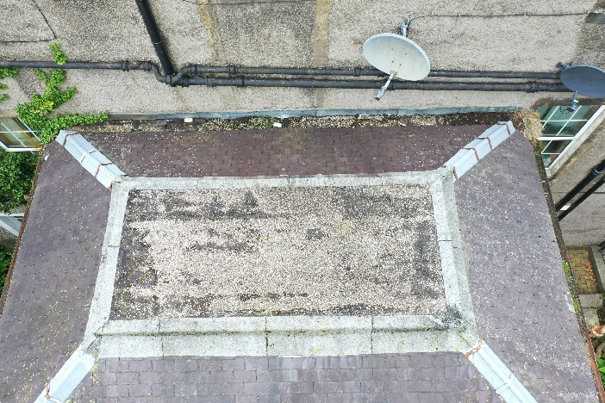  Rear extension roof R4
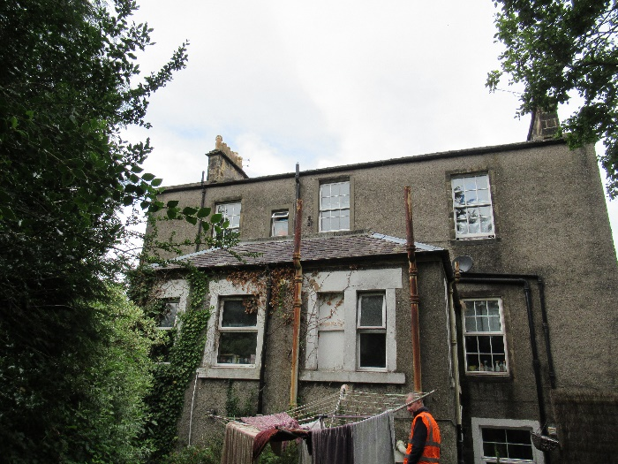  Rear extension | 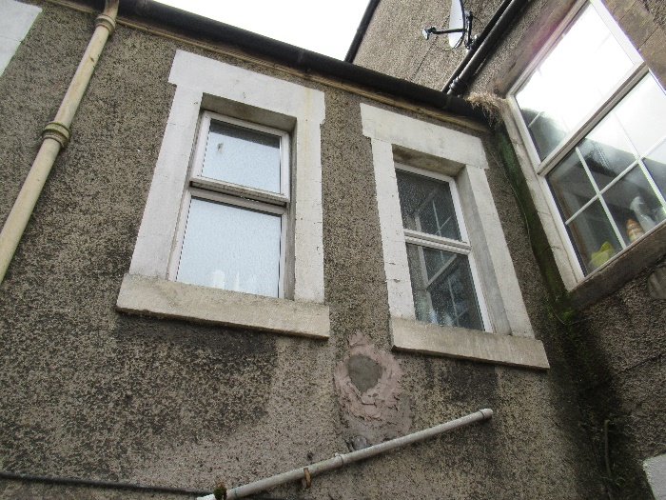  Rear extension

Location map

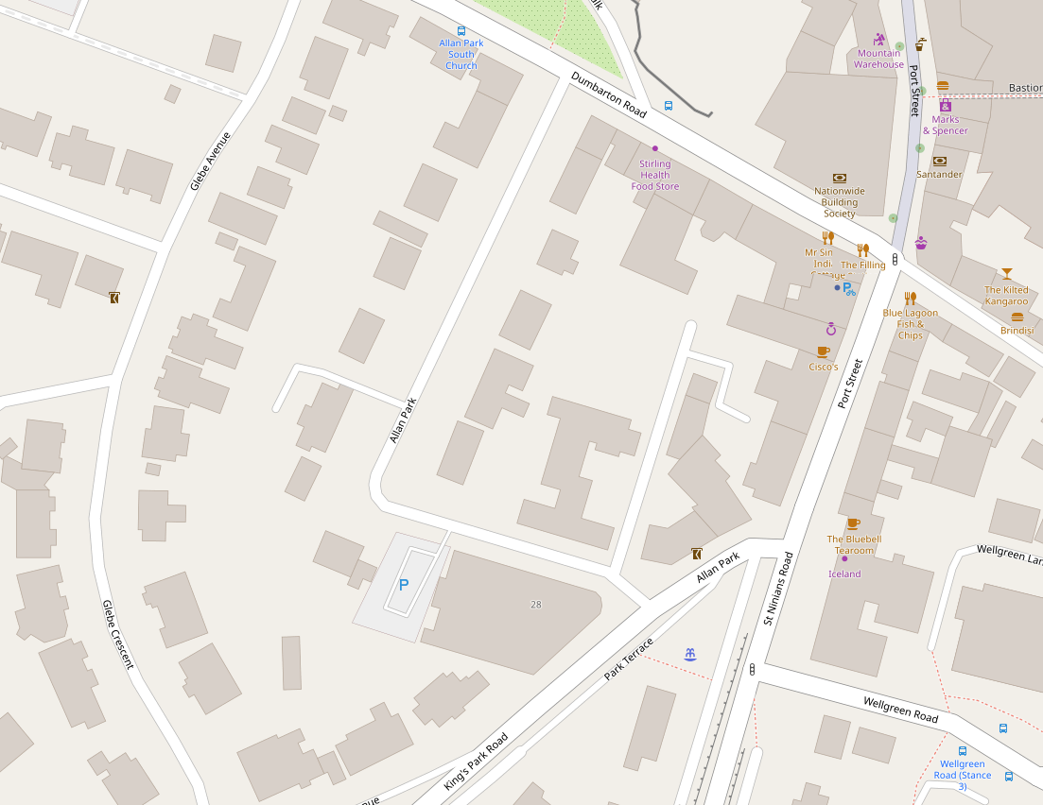

[© OpenStreetMap contributors] https://www.openstreetmap.org/copyright

