Heritage Statement
41 Dingle Road, Up Holland,WN8 0EN.

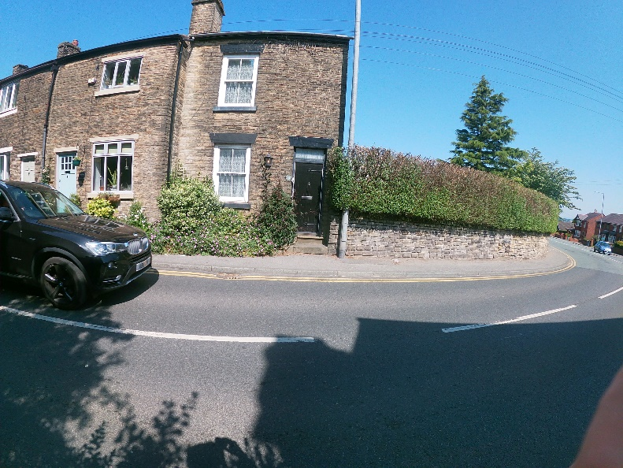

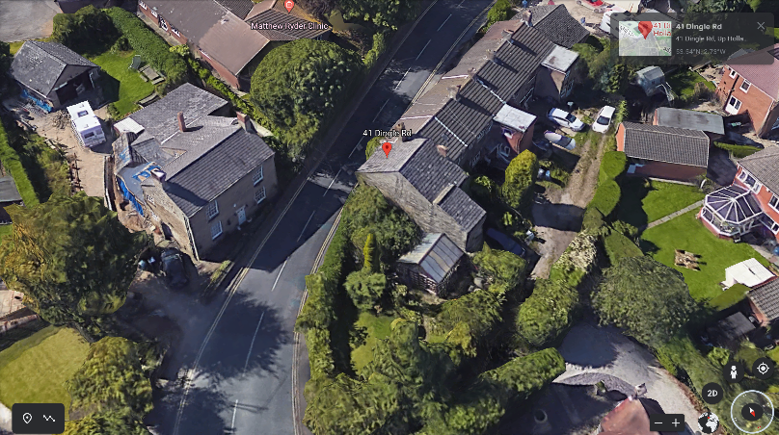

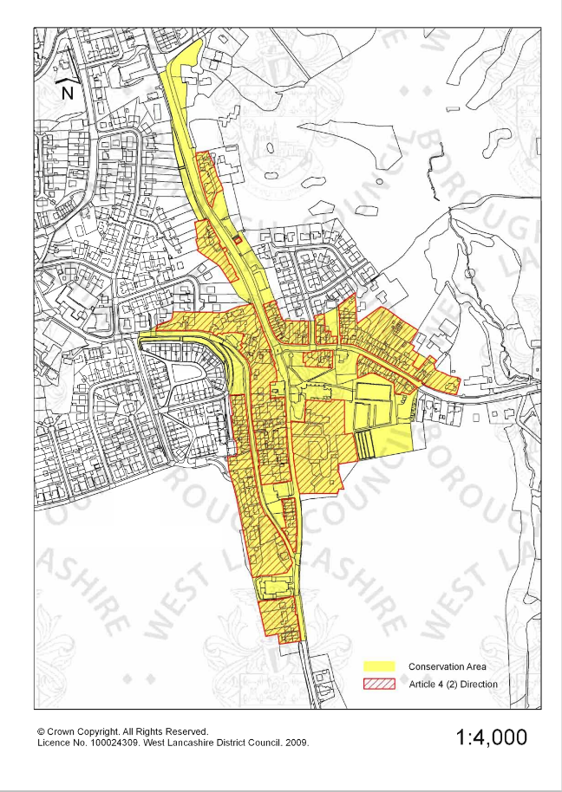

INTRODUCTION

This Heritage Statement has been made in support of Householder Planning Application 2022/0755/FUL to 41 Dingle Road, Up Holland,WN8 0EN.

USE
The property built circa early 1800s is a Stone built end terraced property which is consistent with other properties along Dingle Road. The proposal is to demolish the existing poorly built and incongruous conservatory to the side. The site is within the boundary of a Conservation Area. It is close to Hall Bridge Farmhouse which is listed as a locally important building. The proposed Conservatory is set to the side of the existing property and will have no impact upon the existing street scene due to the privet hedge along the front elevation. The proposal will create a more aesthetic appearance to the rear and side of the property and will blend in with other similar properties along the road.

AMOUNT
The proposed extension will provide much needed family living area space. The extension will lie within the site boundary .
LAYOUT
The layout of the proposed extension is modest in size and is solely being proposed to provide much needed family living area space,and to improve the property aesthetically and to improve the fabric of the property.
APPEARANCE

Due to the position of the proposed conservatory ,it cannot be seen from the road and therefore will not affect the character of the conservation area. However a substantial amount of care has been taken in the design to ensure that a number of major elements of the existing building have been reflected in the proposals in order to ensure that the original character of the property is maintained and echoed in the proposed conservatory to the side, including but not limited to:

• Procure and use stonework to match the existing property.
- Slate roof to match existing
• Proposed soffits, fascia’s and rainwater goods will all match existing.

CONCLUSION
The style of the proposed conservatory has been designed so that it is in-keeping with the character and heritage of the existing property. The appearance of the development will be in-keeping with the surrounding properties .We feel that the development proposal maintains a positive relationship with its surroundings and is appropriate to the context and character of the area and will not have a negative impact on the area.
