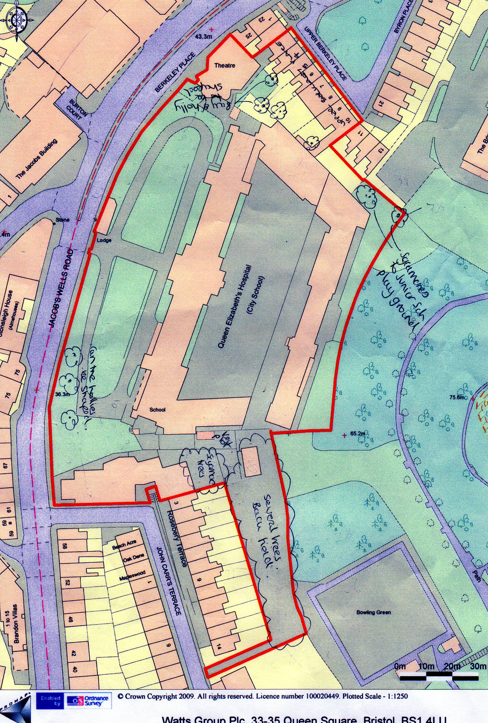
SK1 QEH SCHOOL
TREE LOCATION PLAN
(SEE ENGLEY 12 AUGUST 2022 AJE/AF 29296) APPROXIMATED TREE LOCATIONS

T12
T14 A (3 X SYCAMORE) ABOVE HOLLY SYC SEEDLINGS & bramble)
T5
T38
T39
T40
T42
T1
T2
T3
T4
T2
T7
T8
T10
T11
T21
T17
T15
T16
T20
T19
T18
T14B
T14C
FERGUS YARD

G43, X 5 Fruit trees, and 1 x Rowan
Excellent wildlife habitat, area of mixed flowers, shrubs, recently planted Field Maple, Fruit trees and Sorbus
T45

