Talbots Cottage Stuston
Proposal of repairing the existing chimney
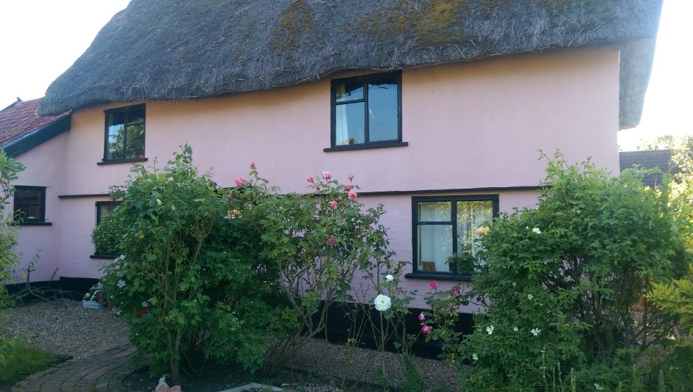
Location: TALBOTS COTTAGE, TALBOTS MEADOW, STUSTON, DISS, IP21 4AZ. STUSTON THE COMMON (SOUTH SIDE)
TM 17 NW
All pictures by: Melanie Sharman
Date pictures taken: 10th & 11th August 2022
Description: Cottage Approximately 80m North West of Willow Farmhouse
Grade: II
Date Listed: 17 November 1987
English Heritage Building ID: 280387
OS Grid Reference: TM1313778210
OS Grid Coordinates: 613137, 278210
Latitude/Longitude: 52.3605, 1.1288
Listing: House, C17 extended c20. Timber frame, roughcast with some brick casing.
Thatched roof. 2 cell lobby entry plan. 2 storeys. Entrance to left of
centre, recessed boarded door. 2-light metal frame casements. Central axial
ridge stack. Attached to left end a 1 storey 1 bay C20 roughcast brick and
pantiled extension. Interior: oven beneath stairs behind stack, stop
chamfered cross axial binding beams, arched braces in walling, jowled posts,
cambered tie beams.

Setting
Talbots Cottage is the original cottage that gave its land and name to the cul-de-sac Talbots Meadow where it is positioned surrounded by five new built cottages. The intent of the application is to add quality of life to its current occupiers whilst preserving the cottage in its own rights and beauty.

Fabric
The chimney appeared in need of urgent repointing work. On closer inspection, rebuilding of the chimney is necessary to keep it safe and secure.
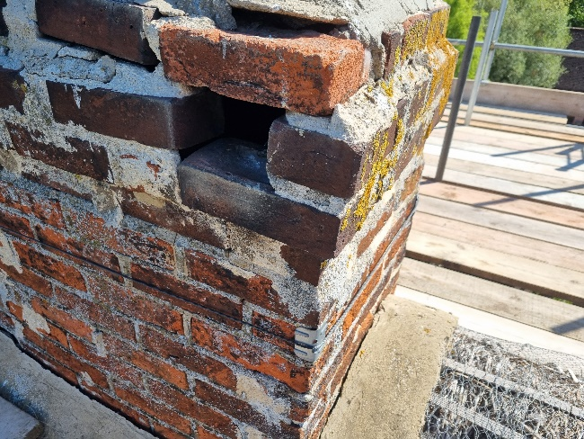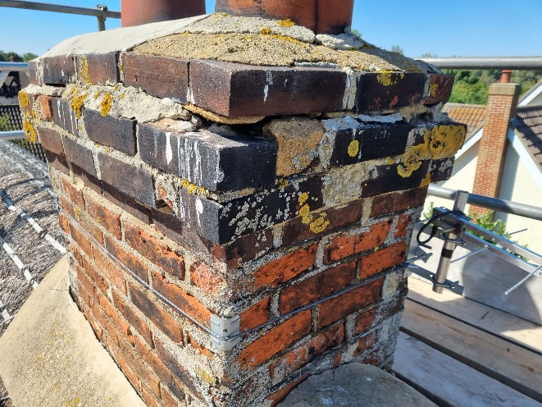
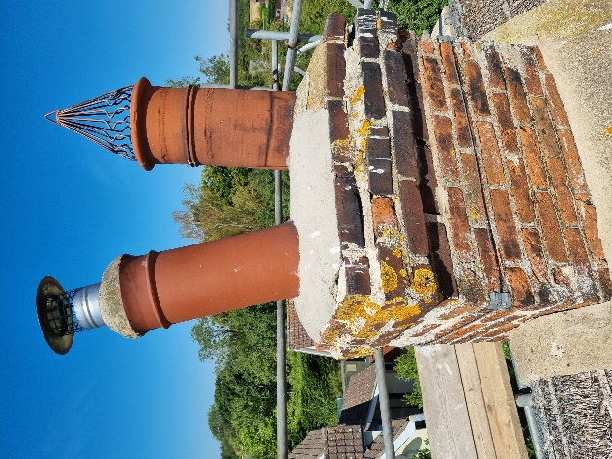

Features
The cottage and its chimney can be seen from the village road, which is hardly used by through traffic.

Principles
The works are proposed to be carried out with new hand-made bricks and to replace the concrete flashing with lead. There is no need nor intention to change the current height of the chimney.
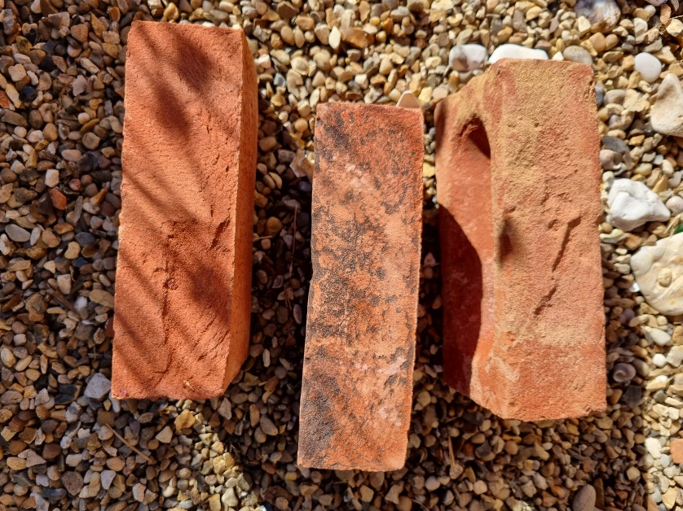

Justification
To keep the cottage in good working order and safe for its inhabitants, we would like to carry out the proposed work of rebuilding the chimney.

Mitigation
NOT RELEVANT

